**A PROJECT REPORT**

**As partial requirement for the degree of**

**Bachelor Of Computer Application**

**ON**

Staycation

**Group No: 21**

**SUBMITTED BY : University Exam No.**

1. **Yashvi K. Modi 2019026228**
2. **Rampat S. Varma 2019026270**
3. **Mohammad A. Vohra 2019026271**

**UNDER GUIDANCE OF**

**PROF. Dr. Darshna Rajput**

**COMPUTER SCIENCE DEPARTMENT,**

**Dolat-Usha Institute Of Applied Sciences And Dhiru-Sarla Institute of Management & Commerce, Valsad**

**Affiliated with**

**Veer Narmad South Gujarat University, Surat**

**\* 2021-2022 \***







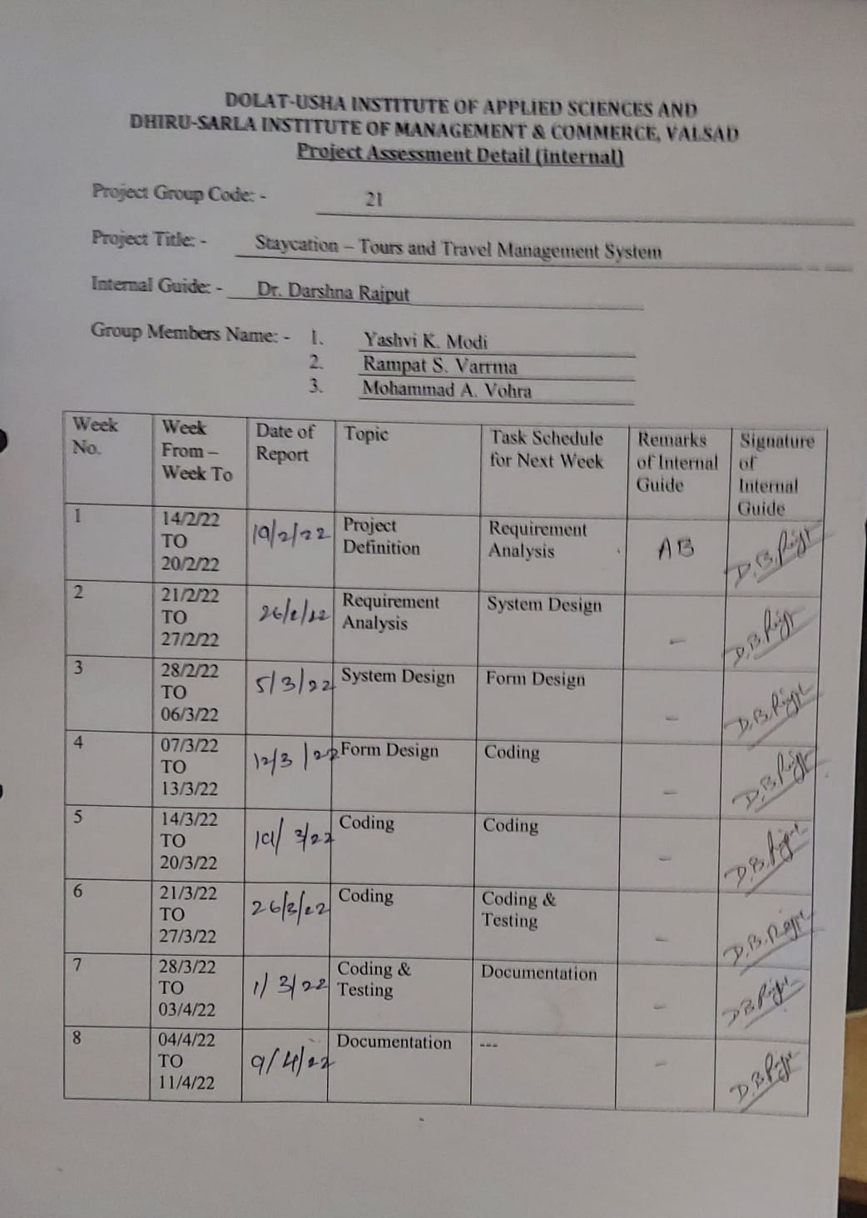

**Acknowledgement**

We thank God almighty for making my vision a success. I am indebted to my respected teacher and my supporting classmate of BCA (Bachelor of Computer Application) for providing inspiration and guidance for my seminar.

I am highly obliged to my guide Dr. Darshna Rajput for her valuable instruction , guidance and corrections in my seminar.

I am also grateful to Dr. SnehalJoshi , Head of Department of BCA for giving me such an opportunity to utilize all resources needed for the seminar.

I also want to express sincere gratitude to all my friends for their support and encouragement during the seminar presentation.

Thanking You

Yours Faithfully,

Yashvi K. Modi,

Rampat S. Varma,

Mohammad A. Vohra

**Project Documentation format**

* **Index**

|  |  |  |
| --- | --- | --- |
| SR. No | Topics | Page No |
| 1  1.1  1.2 | Project Profile  Project goal and objectives  Scope of the project | 1 |
| 2 | System Environment   Hardware Software environment | 2 |
| 3  3.1  3.2 | Platform Environment  Front End Used  Back End Used | 3 |
| 4 | System Requirement Analysis | 6 |
| 5  5.1  5.2  5.3 | System Design  System Flow Diagram  Data flow diagram  ER diagram | 8 |
| 6 | Data Dictionary | 16 |
| 7 | Form Designing and coding | 19 |
| 8 | Reports | 134 |
| 9 | Testing | 141 |
| 10 | Conclusion and Future Enhancement | 144 |
| 11 | References/ Bibliography | 145 |

1. **Project profile**
   1. **Project Goal and Objective**

**Project Goal :-**

* This website provides web based system that allows admin to manage online

Tours and travels management of different places.

* Admin can manage different category, sub-category like Packages , Hotels , Flights , Trains .
* Customer can view and Book the packages , Hotels , Flights , Trains .

**Project Objective:-**

**ADMIN :**

* Admin can login and then manage different category.
* Admin can manage different sub-category.
* Admin can manage different Packages , Hotels , Flights , Trains .
* Admin can generate the reports.
* Admin can logout.

**CUSTOMER :**

* Customer can registration.
* Customer can login and then view packages , Hotels , Flights , Trains .
* Customer can book the places.
* Customer can view the payment details.
* Customer can logout.
  1. **Scope of project:-**
* Our website can be accessed by anyone at anytime from anywhere.
* Only admin and registered customers can login into our site.
* We are handling all our activities online.
* We have created this website so that it becomes much easy for the customers to book the packages anywhere.

**2. System Environment**

**2.1 Hardware Software Environment**

**Hardware environment**

* Processor :- INTEL CORE i3
* RAM :- 4 GB
* Hard Disk :- 1 TB

**3.Platform Environment**

* 1. **Front End Used:-**
* **PHPS**



* 1. **BACK END Used:-**



* **MySQL**

MySQL was developed by Michael ‘Monty’ Widenius of the Swedish company TcXDataKonsultAB in the mid-1990s in order to address functionality problems that existed with the predeceasing software MySQL and to provide an efficient tool for delivering web-based application. The initial version of MySQL was released to open source community in May 1995. Version 8.0 of the MySQL Software was released in October 2019.

* **STUDY OF SYSTEM AND ITS LIMITATION:-**

Wamp5



WAMP5 is a server developed with PHP and installed an Apache Web server with php5 and MySQL and DiscoversPhp5.

Php requires that sever software be running on the computer in order to display these types of files in the Web Browser.

If server software is not running, you will not able to view their files in a web browser. We have installed a free server package called WAMP5.

* **APACHE SERVER**



Apache is the name of the software that allows you to run a web service on a UNIX server. Apache is very popular and access to most web-sites on the internet. It is freely available, reliable and simple to setup and configure, a nod it can provide most of the requirement for a web-site.

Apache is free is because it is written and maintained by volunteers, much in the spirit of many UNIX users.

**4.System Requirement analysis**

* Modules

1. Admin

2. Customer

**ADMIN**

**Login:-**

Admin can login.

**Manage Category:-**

Admin can manage Category.

**Manage packagedetails:-**

Admin can manage packages detail.

**Manage Booking:-**

Admin can manage the booking of several places.

**View New Orders:-**

Admin can view the New booking done by the customers.

**Reports:-**

Admin can view all the reports related to all Bookings.

**CUSTOMER**

**Registration:-**

Customer can registration in website.

**Login:-**

Customer can login using registered email id and password.

**View Packages:-**

Customer can view the packages.

**Place Bookings:-**

Customer can book the Places.

**Booking E-Tickets**

Customer can book E-Tickets online.

**Booking History :-**

They can view the old booking in order history.

**Logout:-**

They can logout.

**5. System Designing**

**System Flow Diagram**

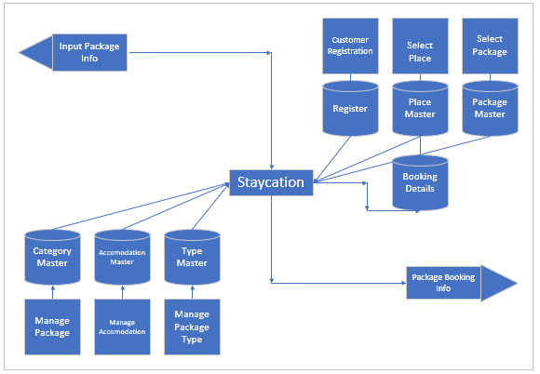

**5.2 Data Flow Diagram**

**Context Level DFD**

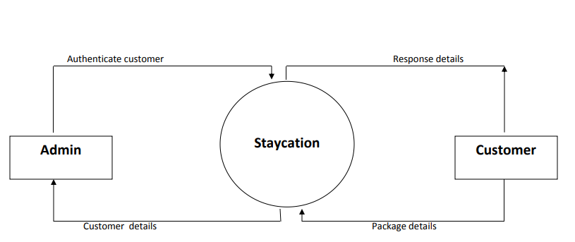

**First level DFD**

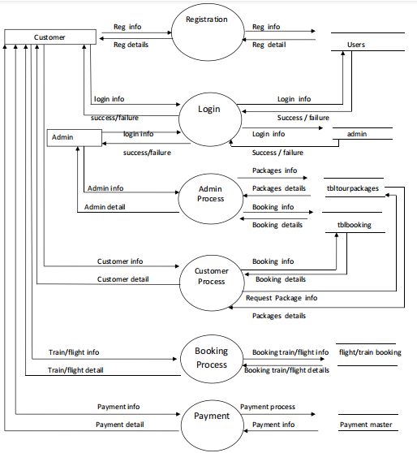

* 1. **E/R Diagram**

**ER DIAGRAM**

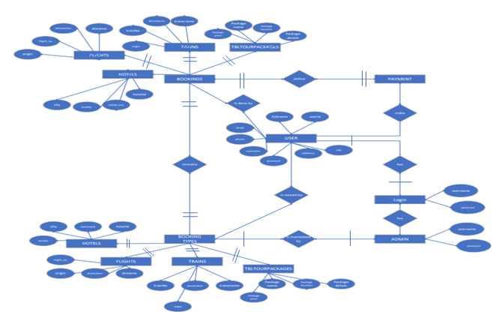

**Data Dictionary**

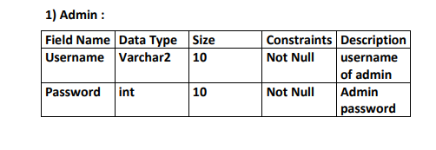

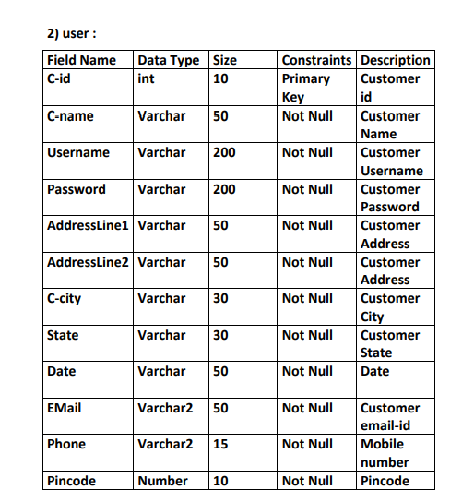

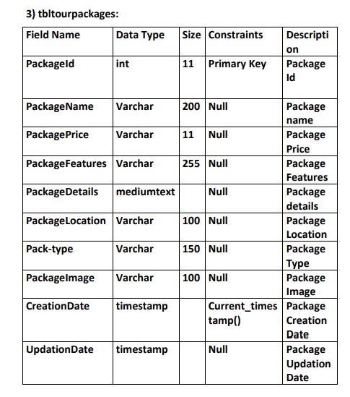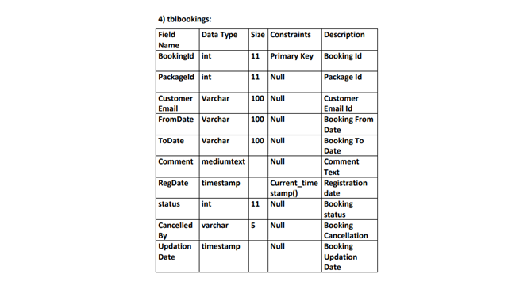

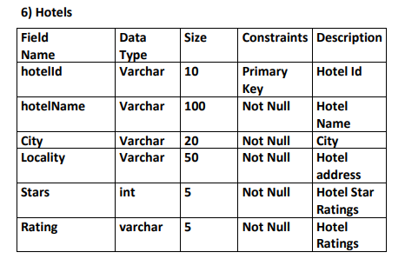

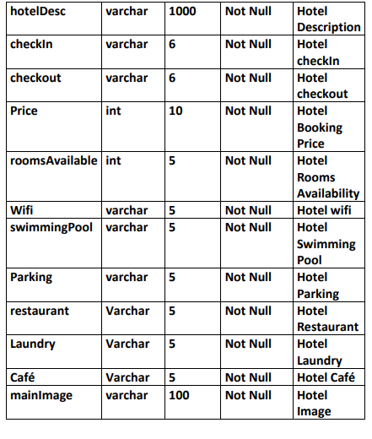

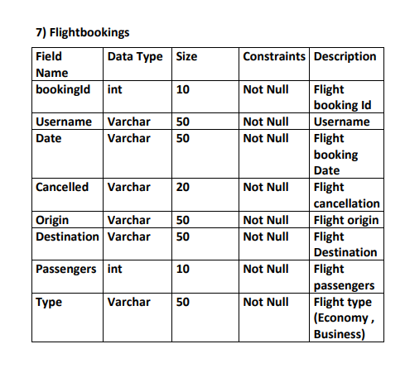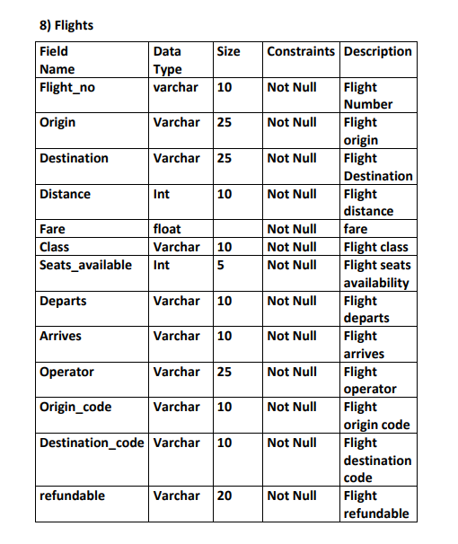

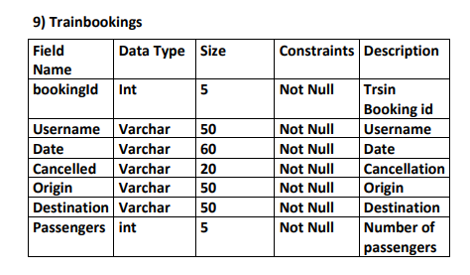

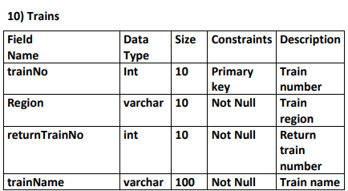

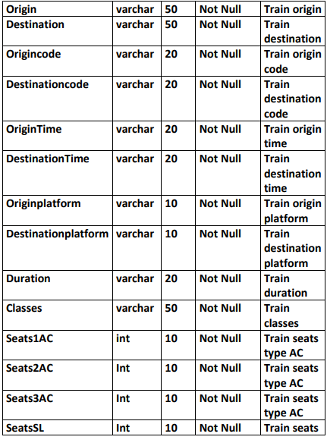

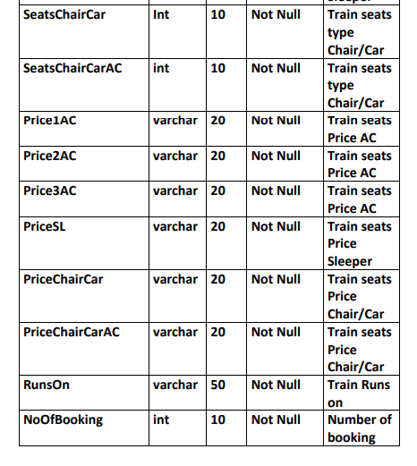

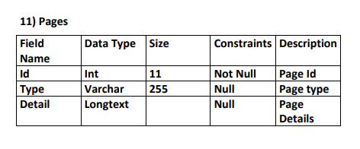

**Form Designing And Coding:**

**HOMEPAGE:**

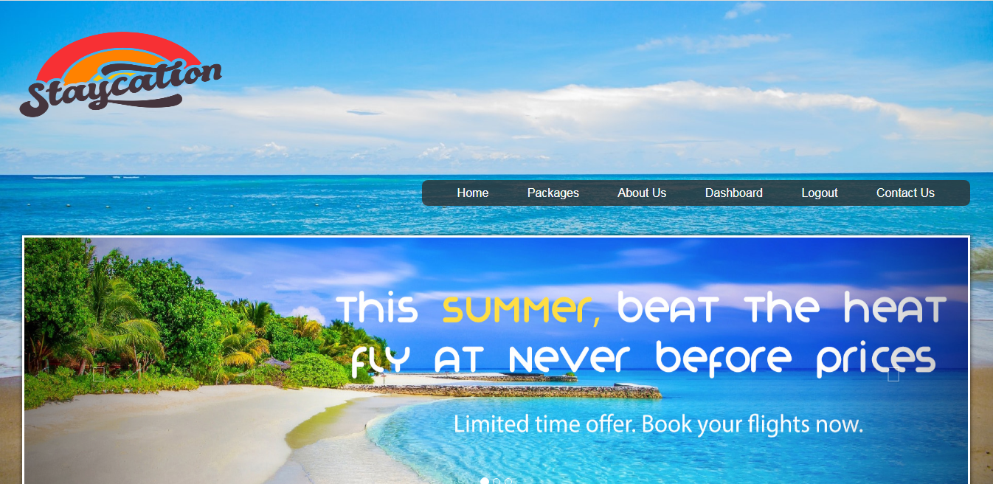

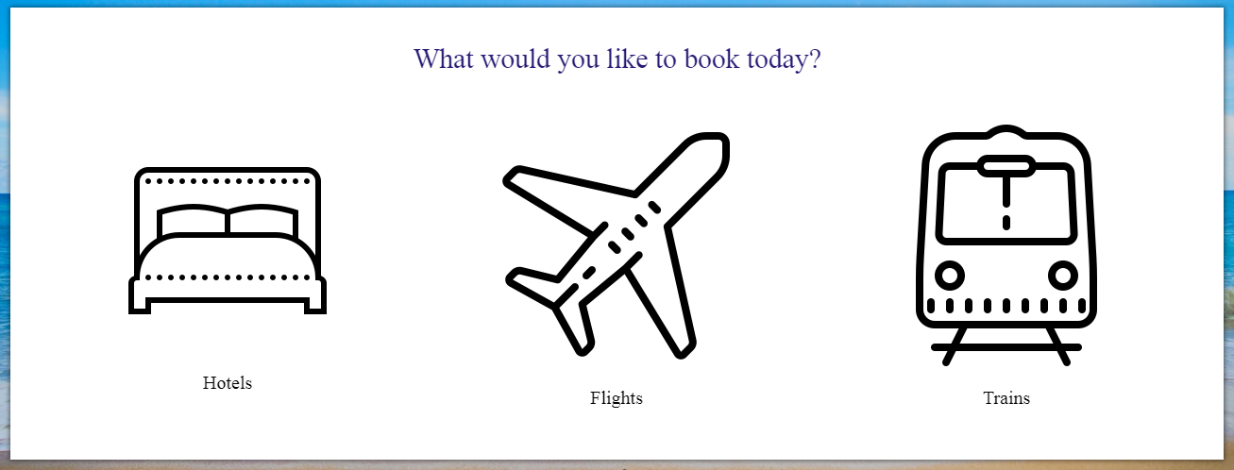

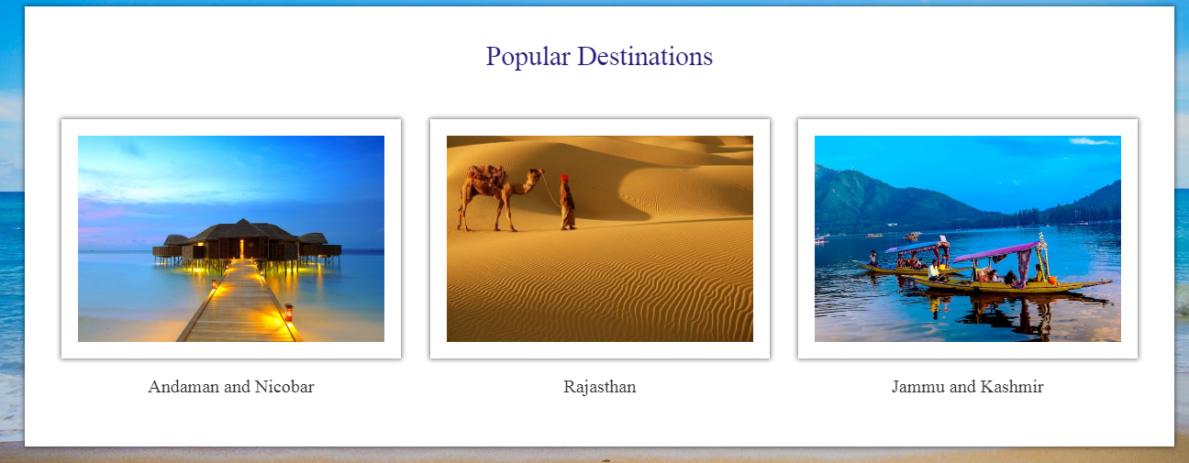

**CODING:-**

**<?php session_start(); ?>**

**<!DOCTYPE html>**

**<html>**

**<head>**

**<meta charset="UTF-8">**

**<meta name="viewport" content="width=device-width, initial-scale=1.0"/>**

**<title>Home | staycation</title>**

**<link href="css/bootstrap.min.css" rel="stylesheet"/>**

**<link href="css/hover-min.css" rel="stylesheet"/>**

**<link href="css/main.css" rel="stylesheet"/>**

**<link href="https://fonts.googleapis.com/css?family=Oswald:200,300,400|Raleway:100,300,400,500|Roboto:100,400,500,700" rel="stylesheet">**

**<link href="https://maxcdn.bootstrapcdn.com/font-awesome/4.7.0/css/font-awesome.min.css" rel="stylesheet">**

**<script src="js/jquery-3.2.1.min.js" type="text/javascript"></script>**

**<script src="js/bootstrap.min.js" type="text/javascript"></script>**

**<script src="js/main.js" type="text/javascript"></script>**

**</head>**

**<body>**

**<div class="col-xs-12 home">**

**<img src="images/carousel/stay.png" height="200" width="300">**

**<!-- HEADER SECTION STARTS -->**

**<div class="col-sm-12">**

**<div class="header">**

**<?php**

**if(!isset($_SESSION["username"])) {**

**include("common/headerTransparentLoggedOut.php");**

**}**

**else {**

**include("common/headerTransparentLoggedIn.php");**

**}**

**?>**

**</div><!-- header -->**

**</div><!-- col-sm-12 -->**

**<!-- HEADER SECTION ENDS -->**

**<!-- carousel -->**

**<div class="col-xs-12 banner">**

**<div id="myCarousel" class="carousel slide" data-ride="carousel" data-interval="3000">**

**<ol class="carousel-indicators">**

**<li data-target="#myCarousel" data-slide-to="0" class="active"></li>**

**<li data-target="#myCarousel" data-slide-to="1"></li>**

**<li data-target="#myCarousel" data-slide-to="2"></li>**

**</ol>**

**<div class="carousel-inner">**

**<div class="item active">**

**<img src="images/carousel/image1.jpg" alt="Image1">**

**</div>**

**<div class="item">**

**<img src="images/carousel/image2.jpg" alt="Image2">**

**</div>**

**<div class="item">**

**<img src="images/carousel/image3.jpg" alt="Image3">**

**</div>**

**</div>**

**<a href="#myCarousel" class="left carousel-control" data-slide="prev">**

**<span class="glyphicon glyphicon-chevron-left"></span>**

**</a>**

**<a href="#myCarousel" class="right carousel-control" data-slide="next">**

**<span class="glyphicon glyphicon-chevron-right"></span>**

**</a>**

**</div>**

**</div><!-- banner -->**

**<!---icons---->**

**<div class="col-xs-12 popularDestinationsContainer">**

**<div class="col-xs-12 destinationHolder">**

**<div class="col-xs-12 destinationQuote">**

**What would you like to book today?**

**</div>**

**<div class="col-xs-12 containerGrids hvr-buzz-out">**

**<a href="hotels.php" style="color: black;">**

**<div class="col-xs-12 icons text-center">**

**<img src="images/icons/hotel.png" alt="hotels" class="iconsDim text-center"/>**

**</div>**

**<div class="col-xs-12 heading">**

**Hotels**

**</div>**

**</a>**

**</div>**

**<div class="col-xs-12 containerGrids hvr-buzz-out">**

**<a href="flights.php" style="color: black;">**

**<div class="col-xs-12 icons text-center">**

**<img src="images/icons/flight.png" alt="flights" class="iconsDim text-center"/>**

**</div>**

**<div class="col-xs-12 heading">**

**Flights**

**</div>**

**</a>**

**</div>**

**<div class="col-xs-12 containerGrids hvr-buzz-out">**

**<a href="trains.php" style="color: black;">**

**<div class="col-xs-12 icons text-center">**

**<img src="images/icons/train.png" alt="trains" class="iconsDim text-center"/>**

**</div>**

**<div class="col-xs-12 heading">**

**Trains**

**</div>**

**</a>**

**</div>**

**</div>**

**<!--popular destinations-->**

**<div class="col-xs-12 popularDestinationsContainer">**

**<div class="col-xs-12 destinationHolder">**

**<div class="col-xs-12 destinationQuote">**

**Popular Destinations**

**</div>**

**<div class="col-xs-12 containerGrids hvr-buzz-out">**

**<div class="col-xs-12 pics text-center">**

**<img src="images/popularDestinations/imageAndaman.jpg" alt="popularDestination1" class="picDim text-center"/>**

**</div>**

**<div class="col-xs-12 heading">**

**Andaman and Nicobar**

**</div>**

**</div>**

**<div class="col-xs-12 containerGrids hvr-buzz-out">**

**<div class="col-xs-12 pics text-center">**

**<img src="images/popularDestinations/imageJaisalmer.jpg" alt="popularDestination1" class="picDim text-center"/>**

**</div>**

**<div class="col-xs-12 heading">**

**Rajasthan**

**</div>**

**</div>**

**<div class="col-xs-12 containerGrids hvr-buzz-out">**

**<div class="col-xs-12 pics text-center">**

**<img src="images/popularDestinations/imageKashmir.jpg" alt="popularDestination1" class="picDim text-center"/>**

**</div>**

**<div class="col-xs-12 heading">**

**Jammu and Kashmir**

**</div>**

**</div>**

**</div>**

**</div>**

**</div><!-- home -->**

**<!-- FOOTER SECTION STARTS -->**

**<div class="footerMod col-sm-12">**

**<div class="col-sm-4">**

**<div class="footerHeading">**

**Contact Us**

**</div>**

**<div class="footerText">**

**Staycation <br> Nr veg market,Valsad, India**

**</div>**

**<div class="footerText">**

**E-mail: staycation@contactus.com**

**</div>**

**</div>**

**<div class="col-sm-4">**

**</div>**

**<div class="col-sm-4">**

**<div class="footerHeading">**

**Social Links**

**</div>**

**<div class="socialLinks">**

**<div class="fb">**

**facebook.com/staycation**

**</div>**

**<div class="gp">**

**plus.google.com/staycation**

**</div>**

**<div class="tw">**

**twitter.com/staycation**

**</div>**

**<div class="in">**

**linkedin.com/staycation**

**</div>**

**</div><!-- social links -->**

**</div>**

**<div class="col-sm-12">**

**<div class="copyrightContainer">**

**<div class="copyright">**

**Copyright &copy; 2022 Staycation**

**</div>**

**</div>**

**</div>**

**</div><!-- footer -->**

**<!-- FOOTER SECTION ENDS -->**

**</body>**

**</html>**

**Login :**

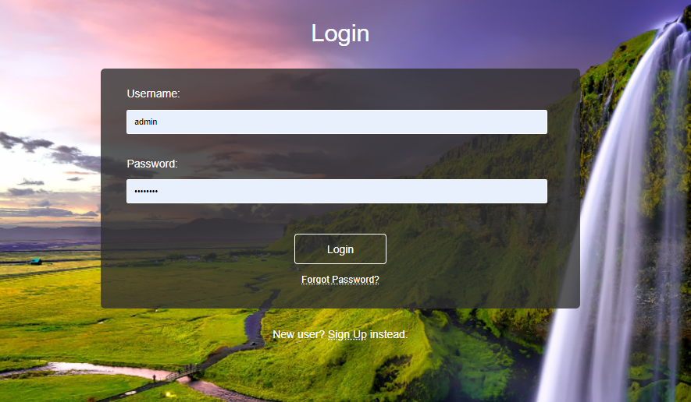

**Coding :**

**<!DOCTYPE html>**

**<html lang="en">**

**<!-- HEAD TAG STARTS -->**

**<head>**

**<meta charset="UTF-8">**

**<meta name="viewport" content="width=device-width, initial-scale=1.0"/>**

**<title>Login | travel_management</title>**

**<link href="css/main.css" rel="stylesheet">**

**<link href="css/bootstrap.min.css" rel="stylesheet">**

**<link href="css/bootstrap-select.css" rel="stylesheet">**

**<link href="css/bootstrap-datetimepicker.css" rel="stylesheet">**

**<link href="https://fonts.googleapis.com/css?family=Oswald:200,300,400|Raleway:100,300,400,500|Roboto:100,400,500,700" rel="stylesheet">**

**<link href="https://maxcdn.bootstrapcdn.com/font-awesome/4.7.0/css/font-awesome.min.css" rel="stylesheet">**

**<script src="js/jquery-3.2.1.min.js"></script>**

**<script src="js/main.js"></script>**

**<script src="js/bootstrap.min.js"></script>**

**<script src="js/bootstrap-select.js"></script>**

**<script src="js/bootstrap-dropdown.js"></script>**

**<script src="js/jquery-2.1.1.min.js"></script>**

**<script src="js/moment-with-locales.js"></script>**

**<script src="js/bootstrap-datetimepicker.js"></script>**

**</head>**

**<!-- HEAD TAG ENDS -->**

**<!-- BODY TAG STARTS -->**

**<body>**

**<div class="container-fluid">**

**<div class="login">**

**<div class="col-sm-12">**

**<div class="heading text-center">**

**Login**

**</div>**

**</div>**

**<div class="col-sm-6 col-sm-offset-3">**

**<div class="containerBox">**

**<form action="loginAction.php" method="POST">**

**<label for="username">Username:</label>**

**<input type="text" class="input" name="username" placeholder="Enter username here" required>**

**<label for="password">Password:</label>**

**<input type="password" class="input" name="password" placeholder="Enter password here" required>**

**<div class="col-sm-12 text-center">**

**<input type="submit" class="button" name="login" value="Login">**

**</div>**

**<a href="forgotPassword.php"><p class="col-xs-12 dots" style="color: white; font-size: 1.1em; margin-top: 1em; text-align: center;">Forgot Password?</p></a>**

**</form>**

**<div class="col-sm-12 text-center">**

**<div class="signupPrompt">**

**New user? <a href="signup.php"><span class="dots">Sign Up</span></a> instead.**

**</div>**

**</div>**

**</div>**

**</div>**

**</div>**

**</div><!-- container-fluid -->**

**</body>**

**<!-- BODY TAG ENDS -->**

**</html>**

**Sign Up :**

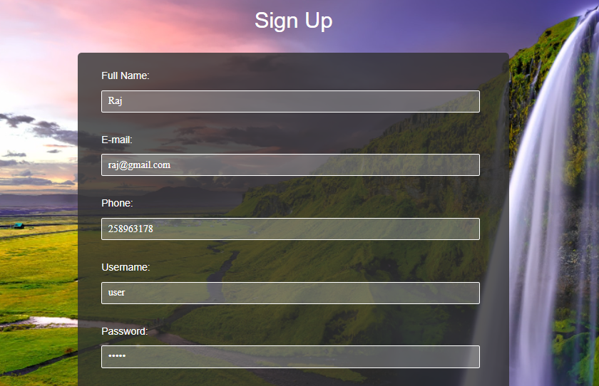

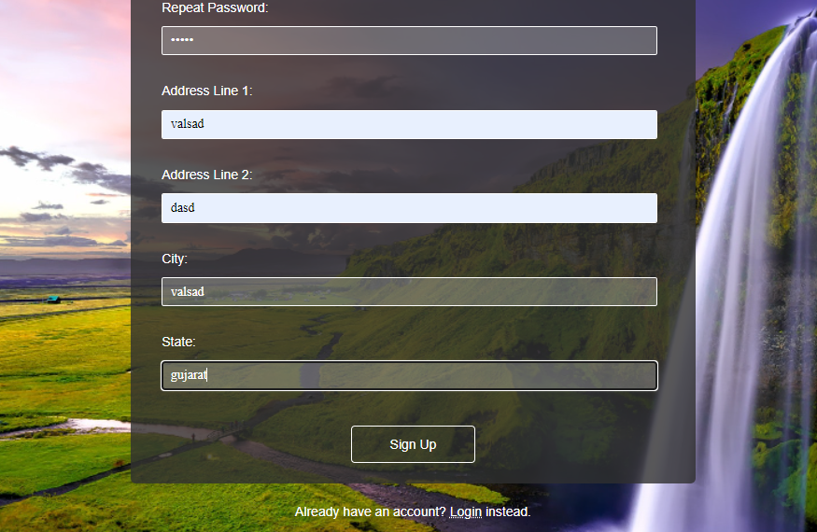

**Coding :**

**<!DOCTYPE html>**

**<html lang="en">**

**<!-- HEAD TAG STARTS -->**

**<head>**

**<meta charset="UTF-8">**

**<meta name="viewport" content="width=device-width, initial-scale=1.0"/>**

**<title>Sign Up | tourism_management</title>**

**<link href="css/main.css" rel="stylesheet">**

**<link href="css/bootstrap.min.css" rel="stylesheet">**

**<link href="css/bootstrap-select.css" rel="stylesheet">**

**<link href="css/bootstrap-datetimepicker.css" rel="stylesheet">**

**<link href="https://fonts.googleapis.com/css?family=Oswald:200,300,400|Raleway:100,300,400,500|Roboto:100,400,500,700" rel="stylesheet">**

**<link href="https://maxcdn.bootstrapcdn.com/font-awesome/4.7.0/css/font-awesome.min.css" rel="stylesheet">**

**<script src="js/jquery-3.2.1.min.js"></script>**

**<script src="js/main.js"></script>**

**<script src="js/bootstrap.min.js"></script>**

**<script src="js/bootstrap-select.js"></script>**

**<script src="js/bootstrap-dropdown.js"></script>**

**<script src="js/jquery-2.1.1.min.js"></script>**

**<script src="js/moment-with-locales.js"></script>**

**<script src="js/bootstrap-datetimepicker.js"></script>**

**</head>**

**<!-- HEAD TAG ENDS -->**

**<!------------------------------------------------------------------------------------------------------**

**ADD CONDITION TO PREVENT USERS FROM SIGNING UP IN CASE THE CHOSEN USERNAME ALREADY EXISTS**

**------------------------------------------------------------------------------------------------------->**

**<!-- BODY TAG STARTS -->**

**<body>**

**<div class="container-fluid">**

**<div class="signup">**

**<div class="col-sm-12">**

**<div class="heading text-center">**

**Sign Up**

**</div>**

**</div>**

**<div class="col-sm-6 col-sm-offset-3">**

**<div class="containerBox">**

**<form action="signupAction.php" method="POST">**

**<label for="name">Full Name:</label>**

**<input type="text" class="input" name="name" placeholder="Enter your full name here" id="fullname" required>**

**<label for="email">E-mail:</label>**

**<input type="email" class="input" name="email" placeholder="Enter your email here" required>**

**<label for="phone">Phone:</label>**

**<input type="text" class="input" name="phone" placeholder="Enter your phone no. here" id="phone" required>**

**<label for="username">Username:</label>**

**<input type="text" class="input" name="username" placeholder="Enter a username here" id="username" required>**

**<p id="usernameExists" style="font-size: 1.2em; color: red; font-weight: 400; margin-top: -1.75em; text-align: center; background: rgba(0,0,0,0.4); display: none;">This username already exists. Please choose a different one.</p>**

**<label for="password">Password:</label>**

**<input type="password" class="input" name="password" placeholder="Enter a password here" id="password" required>**

**<label for="repeatPassword">Repeat Password:</label>**

**<input type="password" class="input" name="repeatPassword" placeholder="Enter the same password again" id="repeatPassword" required>**

**<label for="addressLine1">Address Line 1:</label>**

**<input type="text" class="input" name="addressLine1" placeholder="Enter your House No./ Flat No. or Apartment No." required>**

**<label for="addressLine2">Address Line 2:</label>**

**<input type="text" class="input" name="addressLine2" placeholder="Enter the name of your Lane, Locality" required>**

**<label for="city">City:</label>**

**<input type="text" class="input" name="city" placeholder="Enter the name of your city here" id="city" required>**

**<label for="addressLine2">State:</label>**

**<input type="text" class="input" name="state" placeholder="Enter the name of your state here" id="state" required>**

**<div class="col-sm-12 text-center">**

**<input type="submit" class="button" name="signup" value="Sign Up" id="signupButton">**

**</div>**

**</form>**

**<div class="col-sm-12 text-center">**

**<div class="loginPrompt">**

**Already have an account? <a href="login.php"><span class="dots">Login</span></a> instead.**

**</div>**

**</div>**

**</div>**

**</div>**

**</div>**

**</div><!-- container-fluid -->**

**</body>**

**<!-- BODY TAG ENDS -->**

**</html>**

**HOTEL BOOKING WITHOUT PACKAGES:**

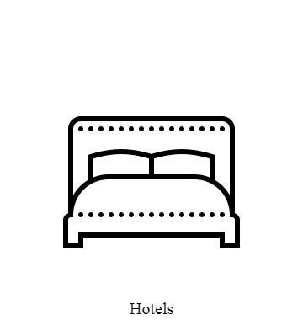

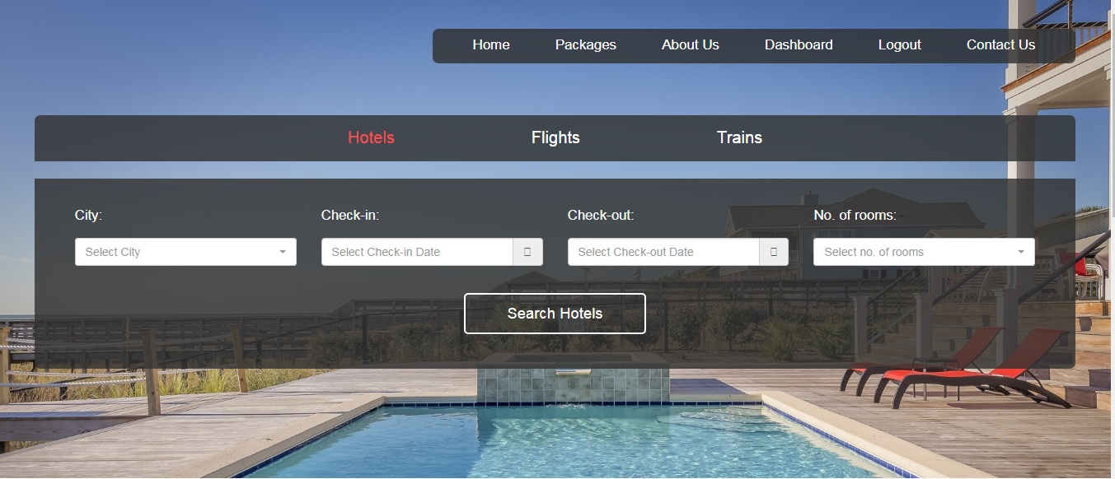

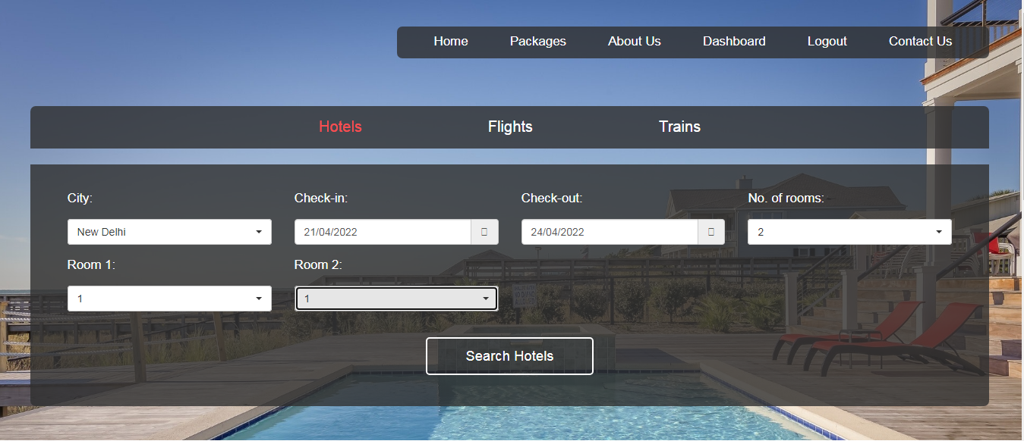

**CODING:**

<?php session_start();

if(!isset($_SESSION["username"]))

{

header("Location:blockedBooking.php");

$_SESSION['url'] = $_SERVER['REQUEST_URI'];

}

?>

<!DOCTYPE html>

<html lang="en">

<!-- HEAD TAG STARTS -->

<head>

<meta charset="UTF-8">

<meta name="viewport" content="width=device-width, initial-scale=1.0"/>

<title>Hotels | tourism_management</title>

<link href="css/main.css" rel="stylesheet">

<link href="css/bootstrap.min.css" rel="stylesheet">

<link href="css/bootstrap-select.css" rel="stylesheet">

<link href="css/bootstrap-datetimepicker.css" rel="stylesheet">

<link href="https://fonts.googleapis.com/css?family=Oswald:200,300,400|Raleway:100,300,400,500|Roboto:100,400,500,700" rel="stylesheet">

<link href="https://maxcdn.bootstrapcdn.com/font-awesome/4.7.0/css/font-awesome.min.css" rel="stylesheet">

<script src="js/jquery-3.2.1.min.js"></script>

<script src="js/main.js"></script>

<script src="js/bootstrap.min.js"></script>

<script src="js/bootstrap-select.js"></script>

<script src="js/bootstrap-dropdown.js"></script>

<script src="js/jquery-2.1.1.min.js"></script>

<script src="js/moment-with-locales.js"></script>

<script src="js/bootstrap-datetimepicker.js"></script>

<script type="text/javascript">

$(function () {

$('#datetimepicker5').datetimepicker({

format: 'L',

locale: 'en-gb',

useCurrent: false,

minDate: moment()

});

$('#datetimepicker6').datetimepicker({

useCurrent: false,

format: 'L',

locale: 'en-gb'

});

$("#datetimepicker5").on("dp.change", function (e) {

$('#datetimepicker6').data("DateTimePicker").minDate(e.date);

});

$("#datetimepicker2").on("dp.change", function (e) {

$('#datetimepicker6').data("DateTimePicker").maxDate(e.date);

});

});

</script>

</head>

<!-- HEAD TAG ENDS -->

<!-- BODY TAG STARTS -->

<body>

<div class="container-fluid">

<div class="hotels col-sm-12">

<!-- HEADER SECTION STARTS -->

<div class="col-sm-12">

<div class="header">

<?php include("common/headerTransparentLoggedIn.php"); ?>

<div class="col-sm-12">

<div class="menu text-center">

<ul>

<li class="selected">Hotels</li>

<a href="flights.php"><li>Flights</li></a>

<a href="trains.php"><li>Trains</li></a>

</ul>

</div>

</div>

</div><!-- header -->

</div><!-- col-sm-12 -->

<!-- HEADER SECTION ENDS -->

<!-- HOTELS SEARCH SECTION STARTS -->

<div class="col-sm-12">

<div class="search" id="searchHotel">

<div class="content">

<form action="hotelSearch.php" method="GET">

<div class="col-sm-3">

<div class="form-group">

<label for="city">City:<p></p></label>

<select id= "city" data-live-search="true" class="selectpicker form-control" data-size="5" title="Select City" name="city" required>

<option value="New Delhi" data-tokens="DEL New Delhi">New Delhi</option>

<option value="Mumbai" data-tokens="BOM Mumbai">Mumbai</option>

<option value="Kolkata" data-tokens="CCU Kolkata">Kolkata</option>

<option value="Bangalore" data-tokens="BLR Bangalore">Bangalore</option>

<option value="Chennai" data-tokens="MAA Chennai">Chennai</option>

<option value="Pune" data-tokens="PNQ Pune">Pune</option>

<option value="Kerala" data-tokens="KER Kerala">Kerala</option>

<option value="Guwahati" data-tokens="GAU Guwahati">Guwahati</option>

<option value="Manali" data-tokens="MAN Manali">Manali</option>

<option value="Shillong" data-tokens="SHL Shillong">Shillong</option>

</select>

</div>

</div>

<div class="col-sm-3">

<div class="form-group">

<label for="datetime5">Check-in:<p></p></label>

<div class="input-group date" id="datetimepicker5">

<input id="datetime5" type="text" class="inputDate form-control" placeholder="Select Check-in Date" name="checkIn" required/>

<span class="input-group-addon">

<span class="fa fa-calendar"></span>

</span>

</div>

</div>

</div>

<div class="col-sm-3">

<div class="form-group">

<label for="datetime6">Check-out:<p></p></label>

<div class="input-group date" id="datetimepicker6">

<input id="datetime6" type="text" class="inputDate form-control" placeholder="Select Check-out Date" name="checkOut" required/>

<span class="input-group-addon">

<span class="fa fa-calendar"></span>

</span>

</div>

</div>

</div>

<div class="col-sm-3">

<label for="rooms">No. of rooms:<p></p></label>

<div class="form-group">

<select id= "rooms" class="selectpicker form-control" data-size="5" title="Select no. of rooms" name="rooms" required>

<option value="1">1</option>

<option value="2">2</option>

<option value="3">3</option>

<option value="4">4</option>

</select>

</div>

</div>

<div class="col-sm-3" id="r1">

<label for="room1">Room 1:<p></p></label>

<div class="form-group">

<select id= "room1" class="selectpicker form-control" data-size="5" title="Select no. of guests" name="room1">

<option value="1">1</option>

<option value="2">2</option>

<option value="3">3</option>

<option value="4">4</option>

</select>

</div>

</div>

<div class="col-sm-3" id="r2">

<label for="room2">Room 2:<p></p></label>

<div class="form-group">

<select id= "room2" class="selectpicker form-control" data-size="5" title="Select no. of guests" name="room2">

<option value="1">1</option>

<option value="2">2</option>

<option value="3">3</option>

<option value="4">4</option>

</select>

</div>

</div>

<div class="col-sm-3" id="r3">

<label for="room3">Room 3:<p></p></label>

<div class="form-group">

<select id= "room3" class="selectpicker form-control" data-size="5" title="Select no. of guests" name="room3">

<option value="1">1</option>

<option value="2">2</option>

<option value="3">3</option>

<option value="4">4</option>

</select>

</div>

</div>

<div class="col-sm-3" id="r4">

<label for="room3">Room 4:<p></p></label>

<div class="form-group">

<select id= "room4" class="selectpicker form-control" data-size="5" title="Select no. of guests" name="room4">

<option value="1">1</option>

<option value="2">2</option>

<option value="3">3</option>

<option value="4">4</option>

</select>

</div>

</div>

<div class="col-sm-12 text-center">

<input type="submit" class="button" name="searchHotels" value="Search Hotels" id="searchHotelButton">

</div>

</form>

</div><!-- content -->

</div><!-- search -->

</div>

<!-- TRAIN SEARCH SECTION ENDS -->

</div><!-- trains -->

<!-- POPULAR BUS SECTION STARTS -->

<!-- <div class="col-sm-12"> -->

<div class="popularHotels col-sm-12">

<div class="heading">

Popular Cities

</div>

<div class="bg">

<div class="col-sm-4">

<div class="listItem">

<div class="imageContainer text-center">

<img src="images/hotels/cities/NewDelhi/piccadily.jpg" alt="New Delhi Hotels">

</div>

<div class="headings">

New Delhi

</div>

<div class="info">

3-star hotels averaging ₹ 2000

</div>

<div class="info">

5-star hotels averaging ₹ 6500

</div>

</div><!-- listItem 1 -->

</div><!-- col-sm-4 -->

<div class="col-sm-4">

<div class="listItem">

<div class="imageContainer text-center">

<img src="images/hotels/cities/Mumbai/JWMarriott.jpg" alt="Mumbai Hotels">

</div>

<div class="headings">

Mumbai

</div>

<div class="info">

3-star hotels averaging ₹ 3900

</div>

<div class="info">

5-star hotels averaging ₹ 9700

</div>

</div><!-- listItem 2 -->

</div><!-- col-sm-4 -->

<div class="col-sm-4">

<div class="listItem">

<div class="imageContainer text-center">

<img src="images/hotels/cities/Kolkata/HyattRegency.jpg" alt="kolkata Hotels">

</div>

<div class="headings">

Kolkata

</div>

<div class="info">

3-star hotels averaging ₹ 3000

</div>

<div class="info">

5-star hotels averaging ₹ 7750

</div>

</div><!-- listItem 3 -->

</div><!-- col-sm-4 -->

</div><!-- bg -->

</div><!-- popularBus -->

<!-- </div> -->

<!-- POPULAR BUS SECTION ENDS -->

<!-- FOOTER SECTION STARTS -->

<div class="footer col-sm-12">

<div class="col-sm-4">

<div class="footerHeading">

Contact Us

</div>

<div class="footerText">

CUSAT, Cochin,<br> Kerala,India

</div>

<div class="footerText">

E-mail: queries@tourism_management.com

</div>

</div>

<div class="col-sm-4">

</div>

<div class="col-sm-4">

<div class="footerHeading">

Social Links

</div>

<div class="socialLinks">

<div class="fb">

facebook.com/tourism_management

</div>

<div class="gp">

plus.google.com/tourism_management

</div>

<div class="tw">

twitter.com/tourism_management

</div>

<div class="in">

linkedin.com/tourism_management

</div>

</div><!-- social links -->

</div>

<div class="col-sm-12">

<div class="copyrightContainer">

<div class="copyright">

Copyright &copy; 2021 Alisha Anand

</div>

</div>

</div>

</div><!-- footer -->

<!-- FOOTER SECTION ENDS -->

</div><!-- container-fluid -->

</body>

<!-- BODY TAG ENDS -->

</html>

**Hotels Availability By selected Destination :**

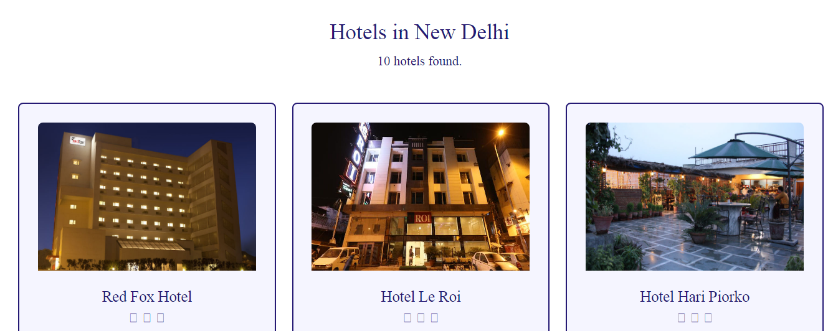

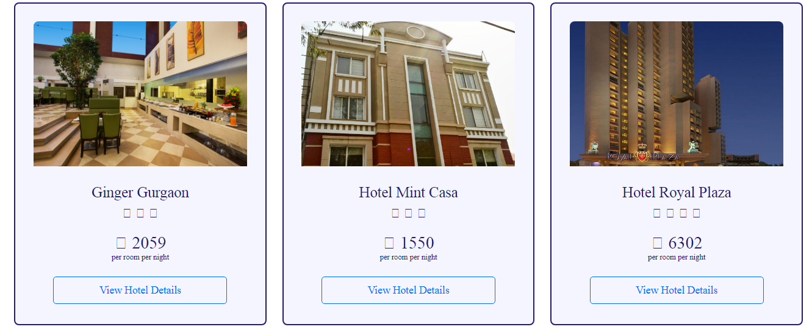

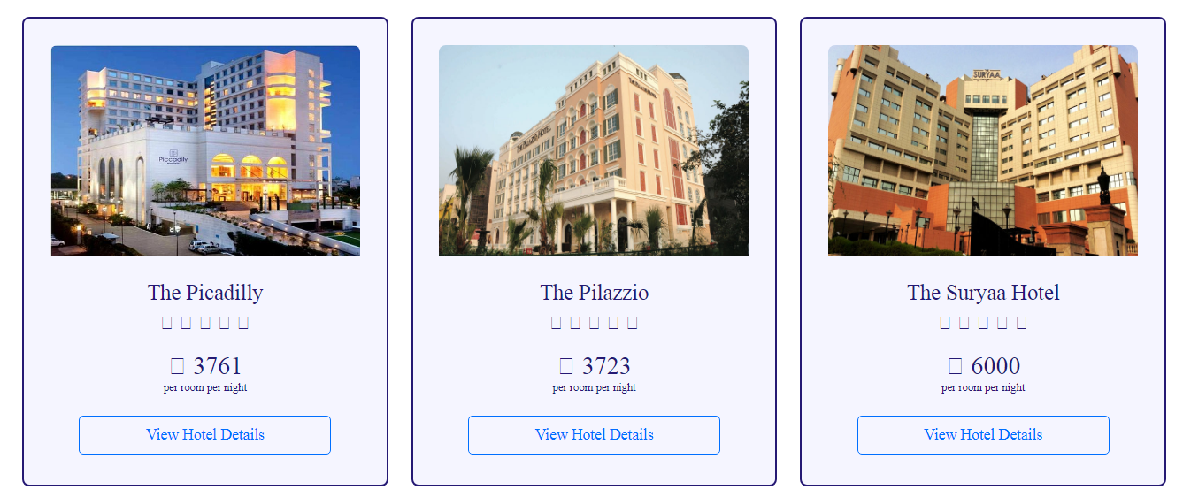

**CODING:**

<?php session_start();

if(!isset($_SESSION["username"]))

{

header("Location:blocked.php");

$_SESSION['url'] = $_SERVER['REQUEST_URI'];

}

?>

<!DOCTYPE html>

<html lang="en">

<!-- HEAD TAG STARTS -->

<head>

<meta charset="UTF-8">

<meta name="viewport" content="width=device-width, initial-scale=1.0"/>

<title>Hotel Search | tourism_management</title>

<link href="css/main.css" rel="stylesheet">

<link href="css/bootstrap.min.css" rel="stylesheet">

<link href="https://fonts.googleapis.com/css?family=Oswald:200,300,400|Raleway:100,300,400,500|Roboto:100,400,500,700" rel="stylesheet">

<link href="https://maxcdn.bootstrapcdn.com/font-awesome/4.7.0/css/font-awesome.min.css" rel="stylesheet">

<script src="js/jquery-3.2.1.min.js"></script>

<script src="js/main.js"></script>

<script src="js/bootstrap.min.js"></script>

</head>

<!-- HEAD TAG ENDS -->

<!-- BODY TAG STARTS -->

<body>

<?php include("common/headerLoggedIn.php"); ?>

<?php

$city=$_GET["city"];

$checkIn=$_GET["checkIn"];

$checkOut=$_GET["checkOut"];

$noOfRooms=$_GET["rooms"];

if($noOfRooms=="1") {

$room1=$_GET["room1"];

}

elseif($noOfRooms=="2") {

$room1=$_GET["room1"];

$room2=$_GET["room2"];

}

elseif($noOfRooms=="3") {

$room1=$_GET["room1"];

$room2=$_GET["room2"];

$room3=$_GET["room3"];

}

elseif($noOfRooms=="4") {

$room1=$_GET["room1"];

$room2=$_GET["room2"];

$room3=$_GET["room3"];

$room4=$_GET["room4"];

}

$_SESSION["city"]=$city;

$_SESSION["checkIn"]=$checkIn;

$_SESSION["checkOut"]=$checkOut;

$_SESSION["noOfRooms"]=$noOfRooms;

if($noOfRooms=="1") {

$_SESSION["room1"]=$room1;

$_SESSION["noOfGuests"]=(int)$room1;

}

elseif($noOfRooms=="2") {

$_SESSION["room1"]=$room1;

$_SESSION["room2"]=$room2;

$_SESSION["noOfGuests"]=(int)$room1+(int)$room2;

}

elseif($noOfRooms=="3") {

$_SESSION["room1"]=$room1;

$_SESSION["room2"]=$room2;

$_SESSION["room3"]=$room3;

$_SESSION["noOfGuests"]=(int)$room1+(int)$room2+(int)$room3;

}

elseif($noOfRooms=="4") {

$_SESSION["room1"]=$room1;

$_SESSION["room2"]=$room2;

$_SESSION["room3"]=$room3;

$_SESSION["room4"]=$room4;

$_SESSION["noOfGuests"]=(int)$room1+(int)$room2+(int)$room3+(int)$room4;

}

?>

<div class="spacer">a</div>

<div class="searchHotels">

<div class="query">

Hotels in <?php echo $city; ?>

</div>

<?php

$servername = "localhost";

$username = "root";

$password = "";

$dbname = "projectmeteor";

// Creating a connection to MySQL database

$conn = new mysqli($servername, $username, $password, $dbname);

// Checking if we've successfully connected to the database

if ($conn->connect_error) {

die("Connection failed: " . $conn->connect_error);

}

$sql = "SELECT * FROM hotels WHERE city='$city'";

$rowcount = mysqli_num_rows(mysqli_query($conn,$sql));

$result = $conn->query($sql);

if ($result->num_rows > 0) {

?>

<div class="col-sm-12 noOfHotels">

<?php echo $rowcount ." hotels found.";?>

</div>

</div><!-- search hotels -->

<div class="col-sm-12 searchHotels">

<?php

while($row = $result->fetch_assoc()) {

?>

<div class="col-sm-4 text-center">

<div class="col-sm-12 listItem">

<!-- hotel INFO STARTS -->

<div class="col-sm-12 imageContainer text-center">

<img src="<?php echo $row["mainImage"]; ?>" alt="<?php echo $row["hotelName"] ?>">

</div>

<div class="col-sm-12 hotelName"><?php echo $row["hotelName"]; ?></div>

<div class="col-sm-12 starContainer">

<?php

$noOfStars=$row["stars"];

for($i=0; $i<$noOfStars; $i++) {?>

<i class="fa fa-star"></i>

<?php } ?>

</div>

<div class="col-sm-12 priceContainer">

₹ <?php echo $row["price"] ?>

</div>

<div class="col-sm-12 priceNote">

per room per night

</div>

<div class="col-sm-12 view">

<a href="hotelDetails.php?hotelId=<?php echo $row["hotelID"]; ?>"><input type="button" class="viewDetails" name="viewDetails" value="View Hotel Details"/></a>

</div>

</div><!-- listItem 1 -->

</div>

<?php

} ?>

</div>

<?php } else {

?>

<div class="col-sm-12 searchHotels">

<div class="noHotels">

No hotels found.

</div>

</div>

<?php

}

?>

<?php $conn->close(); //closing the connection to the database ?>

<div class="spacerLarge">.</div><!-- just a dummy class for creating some space -->

<?php include("common/footer.php"); ?>

</body>

<!-- BODY TAG ENDS -->

</html>

**HOTEL DETAILS:**

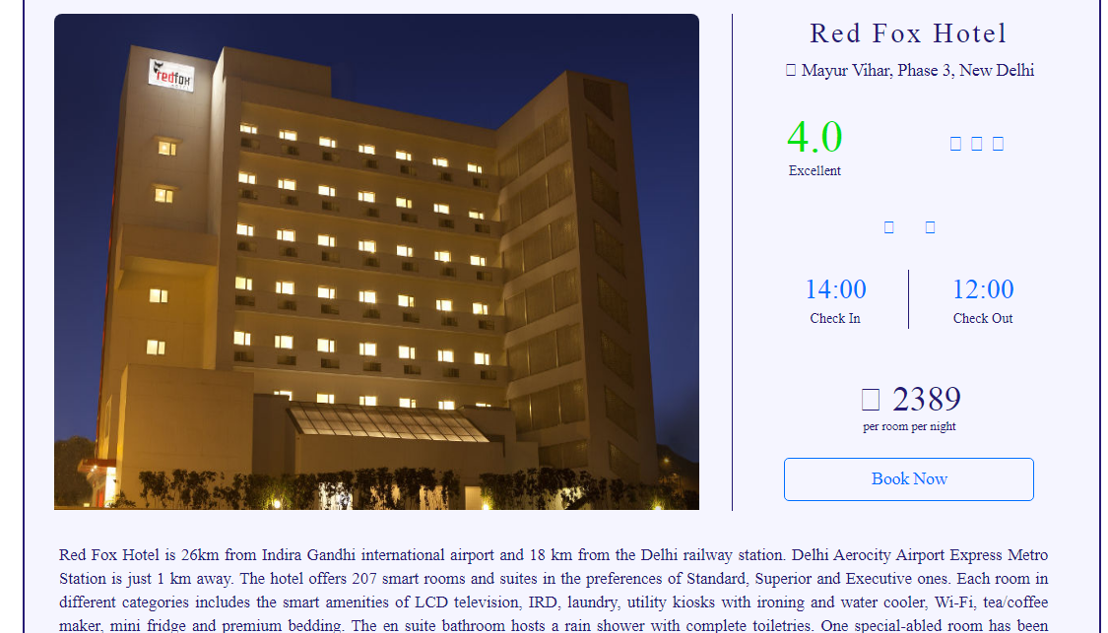



**CODING:**

<?php session_start();

if(!isset($_SESSION["username"]))

{

header("Location:blocked.php");

$_SESSION['url'] = $_SERVER['REQUEST_URI'];

}

?>

<!DOCTYPE html>

<html lang="en">

<!-- HEAD TAG STARTS -->

<head>

<meta charset="UTF-8">

<meta name="viewport" content="width=device-width, initial-scale=1.0"/>

<title>Hotel Details | tourism_management</title>

<link href="css/main.css" rel="stylesheet">

<link href="css/bootstrap.min.css" rel="stylesheet">

<link href="https://fonts.googleapis.com/css?family=Oswald:200,300,400|Raleway:100,300,400,500|Roboto:100,400,500,700" rel="stylesheet">

<link href="https://maxcdn.bootstrapcdn.com/font-awesome/4.7.0/css/font-awesome.min.css" rel="stylesheet">

<script src="js/jquery-3.2.1.min.js"></script>

<script src="js/hotelDetails.js"></script>

<script src="js/bootstrap.min.js"></script>

</head>

<!-- HEAD TAG ENDS -->

<!-- BODY TAG STARTS -->

<body>

<?php include("common/headerLoggedIn.php"); ?>

<?php

$hotelID=$_GET["hotelId"];

?>

<div class="spacer">a</div>

<div class="spacer">a</div>

<?php

$servername = "localhost";

$username = "root";

$password = "";

$dbname = "projectmeteor";

// Creating a connection to MySQL database

$conn = new mysqli($servername, $username, $password, $dbname);

// Checking if we've successfully connected to the database

if ($conn->connect_error) {

die("Connection failed: " . $conn->connect_error);

}

$sql = "SELECT * FROM hotels WHERE hotelID='$hotelID'";

$result = $conn->query($sql);

$row = $result->fetch_assoc()

?>

<div class="col-sm-1"></div><!-- empty div -->

<div class="col-sm-10 hotelDetails">

<div class="col-sm-12 listItem">

<div class="col-sm-8 leftBox">

<div class="col-sm-12 imageContainer">

<img src="<?php echo $row["mainImage"]; ?>" alt="Image not found" />

</div>

</div>

<div class="col-sm-4 rightBox borderLeft">

<div class="hotelName col-sm-12 text-center noMargin">

<?php echo $row["hotelName"]; ?>

</div>

<div class="location col-sm-12 text-center">

<span class="fa fa-map-marker"></span><?php echo $row["locality"].', '.$row["city"]; ?>

</div>

<div class="col-sm-5 text-center">

<div class="col-sm-12 rating noMargin">

<?php echo $row["rating"]; ?>

</div>

<div class="col-sm-12 ratingText noMargin">

<?php

$rating=$row["rating"];

if($rating>=4): ?>

Excellent

<?php

elseif($rating>=3 and $rating<4): ?>

Average

<?php

elseif($rating<3): ?>

Bad

<?php endif; ?>

</div>

</div>

<div class="col-sm-7 text-center">

<div class="col-sm-12 starContainer">

<?php

$noOfStars=$row["stars"];

for($i=0; $i<$noOfStars; $i++) {?>

<i class="fa fa-star"></i>

<?php } ?>

</div>

</div>

<div class="col-sm-12 amenities text-center">

<ul>

<?php if($row["wifi"]=="Yes") {?>

<li class="fa fa-wifi icons" id="wifi"></li>

<?php } ?>

<?php if($row["swimmingPool"]=="Yes") {?>

<li class="fa fa-life-buoy icons" id="pool"></li>

<?php } ?>

<?php if($row["parking"]=="Yes") {?>

<li class="fa fa-car icons" id="parking"></li>

<?php } ?>

<?php if($row["restaurant"]=="Yes") {?>

<li class="fa fa-cutlery icons" id="restaurant"></li>

<?php } ?>

<?php if($row["laundry"]=="Yes") {?>

<li class="fa fa-shirtsinbulk icons" id="laundry"></li>

<?php } ?>

<?php if($row["cafe"]=="Yes") {?>

<li class="fa fa-coffee icons" id="cafe"></li>

<?php } ?>

</ul>

</div><!-- amenities -->

<div class="col-sm-12 checkInOut text-center">

<div class="col-sm-6 checkIn">

<div class="col-sm-12 time">

<?php echo $row["checkIn"]; ?>

</div>

<div class="col-sm-12 timeTag">

Check In

</div>

</div>

<div class="col-sm-6 checkOut">

<div class="col-sm-12 time">

<?php echo $row["checkOut"]; ?>

</div>

<div class="col-sm-12 timeTag">

Check Out

</div>

</div>

</div><!-- checkInOut -->

<div class="col-sm-12 priceContainer text-center">

₹ <?php echo $row["price"]; ?>

</div>

<div class="col-sm-12 priceNote text-center">

per room per night

</div>

<!-- creating a form -->

<form action="booking.php" method="POST">

<div class="col-sm-12 text-center">

<input type="submit" class="bookNow" value="Book Now" />

</div>

<input type="hidden" name="modeHidden" value="hotel" />

<input type="hidden" name="hotelIDHidden" value="<?php echo $hotelID; ?>" />

</form>

</div><!-- right box -->

<div class="col-sm-12 hotelDesc">

<?php echo $row["hotelDesc"]; ?>

</div>

</div>

</div>

<div class="col-sm-1"></div><!-- empty div -->

<div class="col-sm-12 spacer">.</div><!-- just a dummy class for creating some space -->

<div class="col-sm-12 spacer">.</div><!-- just a dummy class for creating some space -->

<div class="col-sm-12 spacer">.</div><!-- just a dummy class for creating some space -->

<?php include("common/footer.php"); ?>

</body>

<!-- BODY TAG ENDS -->

</html>

**CONFIRM BOOKING:**

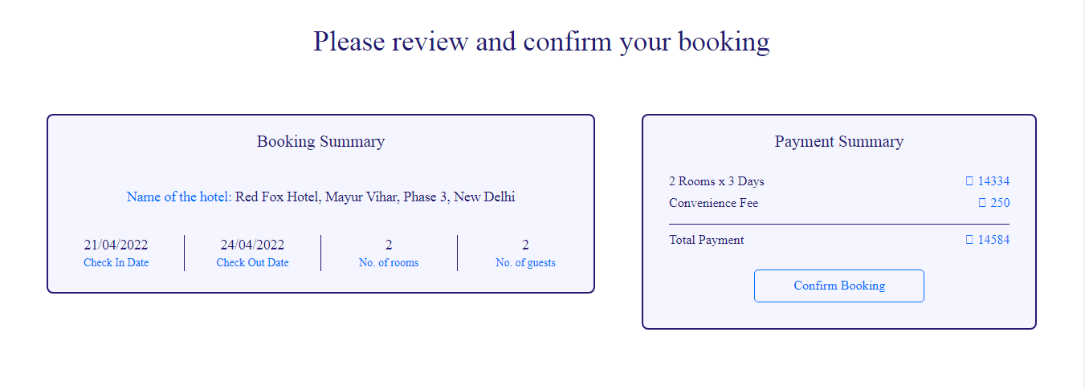

**CODING:**

<?php session_start();

if(!isset($_SESSION["username"]))

{

header("Location:blocked.php");

$_SESSION['url'] = $_SERVER['REQUEST_URI'];

}

?>

<!DOCTYPE html>

<html lang="en">

<!-- HEAD TAG STARTS -->

<head>

<meta charset="UTF-8">

<meta name="viewport" content="width=device-width, initial-scale=1.0"/>

<title>Booking | tourism_management</title>

<link href="css/main.css" rel="stylesheet">

<link href="css/bootstrap.min.css" rel="stylesheet">

<link href="https://fonts.googleapis.com/css?family=Oswald:200,300,400|Raleway:100,300,400,500|Roboto:100,400,500,700" rel="stylesheet">

<link href="https://maxcdn.bootstrapcdn.com/font-awesome/4.7.0/css/font-awesome.min.css" rel="stylesheet">

<script src="js/jquery-3.2.1.min.js"></script>

<script src="js/main.js"></script>

<script src="js/bootstrap.min.js"></script>

</head>

<!-- HEAD TAG ENDS -->

<!-- BODY TAG STARTS -->

<body>

<?php include("common/headerLoggedIn.php"); ?>

<?php

$mode=$_POST["modeHidden"];

?>

<?php

$servername = "localhost";

$username = "root";

$password = "";

$dbname = "projectmeteor";

// Creating a connection to MySQL database

$conn = new mysqli($servername, $username, $password, $dbname);

// Checking if successfully connected to the database

if ($conn->connect_error) {

die("Connection failed: " . $conn->connect_error);

}

?>

<div class="spacer">a</div>

<div class="bookingWrapper">

<div class="headingOne">

Please review and confirm your booking

</div>

<!-- changing contents of the page based on mode -->

<!----------------------------- ONE WAY FLIGHT --------------------------------->

<?php if($mode=="OneWayFlight"): ?>

<div class="col-sm-12 bookingOneWayFlight">

<?php

$type=$_POST["typeHidden"];

$class=$_POST["classHidden"];

$origin=$_POST["originHidden"];

$destination=$_POST["destinationHidden"];

$depart=$_POST["departHidden"];

$return=$_POST["returnHidden"];

$adults=$_POST["adultsHidden"];

$children=$_POST["childrenHidden"];

$noOfPassengers=(int)$adults+(int)$children;

if($type=="Return Trip") {

$flightNoOutbound=$_POST["flightNoOutboundHidden"];

$flightNoInbound=$_POST["flightNoInboundHidden"];

}

elseif($type=="One Way") {

$flightNoOutbound=$_POST["flightNoOutboundHidden"];

}

if($class=="Economy Class")

$className="Economy";

else

$className="Business";

$outboundFlightSQL = "SELECT * FROM `flights` WHERE flight_no='$flightNoOutbound'";

$outboundFlightQuery = $conn->query($outboundFlightSQL);

$row = $outboundFlightQuery->fetch_assoc();

?>

<div class="col-sm-7"><!-- departure container -->

<div class="col-sm-12">

<div class="boxLeftOneWayFlight">

<div class="col-sm-12 mode">Departure</div>

<div class="col-sm-4">

<div class="origin"><?php echo $origin; ?></div>

<div class="departs">Departs <?php echo $depart; ?> at: <?php echo $row["departs"]; ?></div>

</div>

<div class="col-sm-4">

<div class="arrow"></div>

</div>

<div class="col-sm-4">

<div class="destination"><?php echo $destination; ?></div>

<div class="arrives">Arrives <?php echo $depart; ?> at: <?php echo $row["arrives"]; ?></div>

</div>

<div class="col-sm-3 borderRight">

<div class="operator"><?php echo $row["operator"]; ?></div>

<div class="operatorSubscript">Operator</div>

</div>

<div class="col-sm-3 borderRight">

<div class="class"><?php echo $className; ?></div>

<div class="classSubscript">Class</div>

</div>

<div class="col-sm-3 borderRight">

<div class="adults"><?php echo $adults; ?></div>

<div class="adultsSubscript">Adults</div>

</div>

<div class="col-sm-3">

<div class="children"><?php echo $children; ?></div>

<div class="childrenSubscript">Children</div>

</div>

</div>

</div><!-- col-sm-7 Departure -->

</div>

<div class="col-sm-5"><!-- fare container -->

<div class="col-sm-12">

<div class="boxRightOneWayFlight">

<div class="col-sm-12 fareSummary">Fare Summary</div>

<div class="col-sm-8">

<div class="heading"><?php echo $adults; ?> Adults</div>

<div class="heading"><?php echo $children; ?> Children</div>

<div class="heading">Convenience Fee</div>

</div>

<div class="col-sm-4">

<div class="price"><span class="sansSerif">₹ </span><?php echo $adults*$row["fare"]; ?></div>

<div class="price"><span class="sansSerif">₹ </span><?php echo $children*$row["fare"]; ?></div>

<div class="price"><span class="sansSerif">₹ </span>250</div>

</div>

<div class="col-sm-12">

<div class="calcBar"></div>

</div>

<div class="col-sm-8">

<div class="headingTotal">Total Fare</div>

</div>

<div class="col-sm-4">

<div class="priceTotal"><span class="sansSerif">₹ </span><?php echo ($adults*$row["fare"])+($children*$row["fare"])+250; ?></div>

</div>

<form action="passengers.php" method="POST">

<div class="bookingButton text-center">

<input type="submit" class="confirmButton" value="Confirm Booking">

</div>

<?php $totalFare = ($adults*$row["fare"])+($children*$row["fare"])+250 ?>

<input type="hidden" name="fareHidden" value="<?php echo $totalFare; ?>">

<input type="hidden" name="typeHidden" value="<?php echo $type; ?>">

<input type="hidden" name="classHidden" value="<?php echo $class; ?>">

<input type="hidden" name="originHidden" value="<?php echo $origin; ?>">

<input type="hidden" name="destinationHidden" value="<?php echo $destination; ?>">

<input type="hidden" name="departHidden" value="<?php echo $depart; ?>">

<input type="hidden" name="returnHidden" value="<?php echo $return; ?>">

<input type="hidden" name="adultsHidden" value="<?php echo $adults; ?>">

<input type="hidden" name="childrenHidden" value="<?php echo $children; ?>">

<input type="hidden" name="flightNoOutboundHidden" value="<?php echo $row["flight_no"]; ?>">

<input type="hidden" name="modeHidden" value="<?php echo "OneWayFlight" ?>">

</form>

</div>

</div><!-- col-sm-5 Fare -->

</div><!-- fare container -->

</div><!-- bookingOneWayFlight -->

<!----------------------------- RETURN TRIP FLIGHT --------------------------------->

<?php elseif($mode=="ReturnTripFlight"): ?>

<div class="col-sm-12 bookingReturnTripFlight">

<?php

$type=$_POST["typeHidden"];

$class=$_POST["classHidden"];

$origin=$_POST["originHidden"];

$destination=$_POST["destinationHidden"];

$depart=$_POST["departHidden"];

$return=$_POST["returnHidden"];

$adults=$_POST["adultsHidden"];

$children=$_POST["childrenHidden"];

$noOfPassengers=(int)$adults+(int)$children;

if($type=="Return Trip") {

$flightNoOutbound=$_POST["flightNoOutboundHidden"];

$flightNoInbound=$_POST["flightNoInboundHidden"];

}

elseif($type=="One Way") {

$flightNoOutbound=$_POST["flightNoOutboundHidden"];

}

if($class=="Economy Class")

$className="Economy";

else

$className="Business";

$outboundFlightSQL = "SELECT * FROM `flights` WHERE flight_no='$flightNoOutbound'";

$outboundFlightQuery = $conn->query($outboundFlightSQL);

$rowOutbound = $outboundFlightQuery->fetch_assoc();

$inboundFlightSQL = "SELECT * FROM `flights` WHERE flight_no='$flightNoInbound'";

$inboundFlightQuery = $conn->query($inboundFlightSQL);

$rowInbound = $inboundFlightQuery->fetch_assoc();

?>

<div class="col-sm-7"><!-- departure return container -->

<div class="col-sm-12">

<div class="boxLeftOneWayFlight">

<div class="col-sm-12 mode">Departure</div>

<div class="col-sm-4">

<div class="origin"><?php echo $rowOutbound["origin"]; ?></div>

<div class="departs">Departs <?php echo $depart; ?> at: <?php echo $rowOutbound["departs"]; ?></div>

</div>

<div class="col-sm-4">

<div class="arrow"></div>

</div>

<div class="col-sm-4">

<div class="destination"><?php echo $rowOutbound["destination"]; ?></div>

<div class="arrives">Arrives <?php echo $depart; ?> at: <?php echo $rowOutbound["arrives"]; ?></div>

</div>

<div class="col-sm-3 borderRight">

<div class="operator"><?php echo $rowOutbound["operator"]; ?></div>

<div class="operatorSubscript">Operator</div>

</div>

<div class="col-sm-3 borderRight">

<div class="class"><?php echo $className; ?></div>

<div class="classSubscript">Class</div>

</div>

<div class="col-sm-3 borderRight">

<div class="adults"><?php echo $adults; ?></div>

<div class="adultsSubscript">Adults</div>

</div>

<div class="col-sm-3">

<div class="children"><?php echo $children; ?></div>

<div class="childrenSubscript">Children</div>

</div>

</div>

</div><!-- col-sm-7 Departure -->

<div class="col-sm-12">

<div class="boxLeftOneWayFlight">

<div class="col-sm-12 mode">Return</div>

<div class="col-sm-4">

<div class="origin"><?php echo $rowInbound["origin"]; ?></div>

<div class="departs">Departs <?php echo $return; ?> at: <?php echo $rowInbound["departs"]; ?></div>

</div>

<div class="col-sm-4">

<div class="arrow"></div>

</div>

<div class="col-sm-4">

<div class="destination"><?php echo $rowInbound["destination"]; ?></div>

<div class="arrives">Arrives <?php echo $return; ?> at: <?php echo $rowInbound["arrives"]; ?></div>

</div>

<div class="col-sm-3 borderRight">

<div class="operator"><?php echo $rowInbound["operator"]; ?></div>

<div class="operatorSubscript">Operator</div>

</div>

<div class="col-sm-3 borderRight">

<div class="class"><?php echo $className; ?></div>

<div class="classSubscript">Class</div>

</div>

<div class="col-sm-3 borderRight">

<div class="adults"><?php echo $adults; ?></div>

<div class="adultsSubscript">Adults</div>

</div>

<div class="col-sm-3">

<div class="children"><?php echo $children; ?></div>

<div class="childrenSubscript">Children</div>

</div>

</div>

</div><!-- col-sm-7 Return -->

</div><!-- departure return container -->

<div class="col-sm-5"><!-- fare container -->

<div class="col-sm-12">

<div class="boxRightOneWayFlight">

<div class="col-sm-12 fareSummary">Fare Summary</div>

<div class="col-sm-8">

<div class="heading"><?php echo $adults; ?> Adults</div>

<div class="heading"><?php echo $children; ?> Children</div>

<div class="heading">Convenience Fee</div>

</div>

<div class="col-sm-4">

<div class="price"><span class="sansSerif">₹ </span><?php echo $adults*($rowOutbound["fare"]+$rowInbound["fare"]); ?></div>

<div class="price"><span class="sansSerif">₹ </span><?php echo $children*($rowOutbound["fare"]+$rowInbound["fare"]); ?></div>

<div class="price"><span class="sansSerif">₹ </span>250</div>

</div>

<div class="col-sm-12">

<div class="calcBar"></div>

</div>

<div class="col-sm-8">

<div class="headingTotal">Total Fare</div>

</div>

<div class="col-sm-4">

<div class="priceTotal"><span class="sansSerif">₹ </span><?php echo ($adults*($rowOutbound["fare"]+$rowInbound["fare"]))+($children*($rowOutbound["fare"]+$rowInbound["fare"]))+250; ?></div><!-- CHANGE -->

</div>

<form action="passengers.php" method="POST">

<div class="bookingButton text-center">

<input type="submit" class="confirmButton" value="Confirm Booking">

</div>

<?php $totalFare = ($adults*($rowOutbound["fare"]+$rowInbound["fare"]))+($children*($rowOutbound["fare"]+$rowInbound["fare"]))+250 ?>

<!-- CHANGE -->

<input type="hidden" name="fareHidden" value="<?php echo $totalFare; ?>">

<input type="hidden" name="typeHidden" value="<?php echo $type; ?>">

<input type="hidden" name="classHidden" value="<?php echo $class; ?>">

<input type="hidden" name="originHidden" value="<?php echo $origin; ?>">

<input type="hidden" name="destinationHidden" value="<?php echo $destination; ?>">

<input type="hidden" name="departHidden" value="<?php echo $depart; ?>">

<input type="hidden" name="returnHidden" value="<?php echo $return; ?>">

<input type="hidden" name="adultsHidden" value="<?php echo $adults; ?>">

<input type="hidden" name="childrenHidden" value="<?php echo $children; ?>">

<input type="hidden" name="flightNoOutboundHidden" value="<?php echo $rowOutbound["flight_no"]; ?>">

<input type="hidden" name="flightNoInboundHidden" value="<?php echo $rowInbound["flight_no"]; ?>">

<input type="hidden" name="modeHidden" value="<?php echo "ReturnTripFlight" ?>">

</form>

</div>

</div><!-- col-sm-5 Fare -->

</div><!-- fare return container -->

</div><!-- bookingReturnTripFlight -->

<!----------------------------- HOTEL --------------------------------->

<?php elseif($mode=="hotel"): ?>

<div class="col-sm-12 bookingHotel">

<?php

$hotelID = $_POST["hotelIDHidden"];

$hotelSQL = "SELECT * FROM `hotels` WHERE hotelID='$hotelID'";

$hotelQuery = $conn->query($hotelSQL);

$row = $hotelQuery->fetch_assoc();

?>

<div class="col-sm-7"><!-- hotel summary container -->

<div class="col-sm-12">

<div class="boxLeftHotel">

<div class="col-sm-12 hotelMode">Booking Summary</div>

<div class="col-sm-12 hotelName">

Name of the hotel: <span class="nameText"><?php echo $row["hotelName"].', '.$row["locality"].', '.$row["city"]; ?></span>

</div>

<div class="col-sm-3 borderRight">

<div class="checkIn"><?php echo $_SESSION["checkIn"]; ?></div>

<div class="checkInSubscript">Check In Date</div>

</div>

<div class="col-sm-3 borderRight">

<div class="checkOut"><?php echo $_SESSION["checkOut"]; ?></div>

<div class="checkOutSubscript">Check Out Date</div>

</div>

<div class="col-sm-3 borderRight">

<div class="noOfRooms"><?php echo $_SESSION["noOfRooms"]; ?></div>

<div class="noOfRoomsSubscript">No. of rooms</div>

</div>

<div class="col-sm-3">

<div class="noOfGuests"><?php echo $_SESSION["noOfGuests"]; ?></div>

<div class="noOfGuestsSubscript">No. of guests</div>

</div>

</div><!-- boxLeft -->

</div><!-- col-sm-7 bookings -->

</div>

<div class="col-sm-5"><!-- fare container -->

<div class="col-sm-12">

<div class="boxRightHotel">

<div class="col-sm-12 fareSummary">Payment Summary</div>

<div class="col-sm-8">

<?php

$var1 = $_SESSION["checkIn"];

$var2 = $_SESSION["checkOut"];

$date1 = date_create(str_replace('/', '-', $var1));

$date2 = date_create(str_replace('/', '-', $var2));

$diff=date_diff($date1,$date2);

?>

<div class="heading"><?php echo $_SESSION["noOfRooms"]; ?> Rooms x <?php echo $diff->format("%a Days"); ?></div>

<div class="heading">Convenience Fee</div>

</div>

<?php $noOfDays = $diff->format("%a"); ?>

<div class="col-sm-4">

<div class="price"><span class="sansSerif">₹ </span><?php echo $_SESSION["noOfRooms"]*$row["price"]*$noOfDays; ?></div>

<div class="price"><span class="sansSerif">₹ </span>250</div>

</div>

<div class="col-sm-12">

<div class="calcBar"></div>

</div>

<div class="col-sm-8">

<div class="headingTotal">Total Payment</div>

</div>

<div class="col-sm-4">

<div class="priceTotal"><span class="sansSerif">₹ </span><?php echo ($_SESSION["noOfRooms"]*$row["price"]*$noOfDays)+250; ?></div>

</div>

<form action="payment.php" method="POST">

<div class="bookingButton text-center">

<input type="submit" class="confirmButton" value="Confirm Booking">

</div>

<?php $totalFare = ($_SESSION["noOfRooms"]*$row["price"]*$noOfDays)+250; ?>

<input type="hidden" name="fareHidden" value="<?php echo $totalFare; ?>">

<input type="hidden" name="hotelIDHidden" value="<?php echo $hotelID; ?>">

<input type="hidden" name="modeHidden" value="<?php echo "hotel" ?>">

</form>

</div>

</div><!-- col-sm-5 Fare -->

</div><!-- fare container -->

</div><!-- hotel -->

<!-------------------------------------------------train----------------------------------------->

<?php elseif($mode=="train"): ?>

<div class="col-sm-12 bookingTrain">

<?php

$trainID = $_POST["trainIdPass"];

$date=$_POST["dateHidden"];

$day=$_POST["dayHidden"];

$origin=$_POST["originHidden"];

$destination=$_POST["destinationHidden"];

$class=$_POST["classHidden"];

$noOfPassengers= $_POST["passengersHidden"];

$priceClass = trim('price'.$class);

$trainFinderSQL = "SELECT * FROM `trains` WHERE trainNo='$trainID'";

$trainFinderQuery = $conn->query($trainFinderSQL);

$row = $trainFinderQuery->fetch_assoc();

?>

<div class="col-sm-7"><!-- departure container -->

<div class="col-sm-12">

<div class="boxLeftBus">

<div class="col-sm-12 mode">Departure</div>

<div class="col-sm-4">

<div class="origin"><?php echo $origin; ?></div>

<div class="departs">Departs at: <?php echo $row["originTime"]; ?></div>

</div>

<div class="col-sm-4">

<div class="arrow"></div>

</div>

<div class="col-sm-4">

<div class="destination"><?php echo $destination; ?></div>

<div class="arrives">Arrives at: <?php echo $row["destinationTime"]; ?></div>

</div>

<div class="col-sm-3 borderRight">

<div class="class"><?php echo $date; ?></div>

<div class="classSubscript">Date of journey</div>

</div>

<div class="col-sm-5 borderRight">

<div class="operator"><?php echo $row["trainName"]; ?></div>

<div class="operatorSubscript">Name of the train</div>

</div>

<div class="col-sm-2 borderRight">

<div class="operator"><?php echo $class; ?></div>

<div class="operatorSubscript">Class</div>

</div>

<div class="col-sm-2">

<div class="adults"><?php echo $noOfPassengers; ?></div>

<div class="adultsSubscript">Passengers</div>

</div>

</div>

</div><!-- col-sm-7 Departure -->

</div>

<div class="col-sm-5"><!-- fare container -->

<div class="col-sm-12">

<div class="boxRightBus">

<div class="col-sm-12 fareSummary">Fare Summary</div>

<div class="col-sm-8">

<div class="heading"><?php echo $noOfPassengers; ?> Passengers</div>

<div class="heading">Convenience Fee</div>

</div>

<div class="col-sm-4">

<div class="price"><span class="sansSerif">₹ </span><?php echo $noOfPassengers*$row[$priceClass]; ?></div>

<div class="price"><span class="sansSerif">₹ </span>250</div>

</div>

<div class="col-sm-12">

<div class="calcBar"></div>

</div>

<div class="col-sm-8">

<div class="headingTotal">Total Fare</div>

</div>

<div class="col-sm-4">

<div class="priceTotal"><span class="sansSerif">₹ </span><?php echo ($noOfPassengers*$row[$priceClass])+250; ?></div>

</div>

<form action="passengers.php" method="POST">

<div class="bookingButton text-center">

<input type="submit" class="confirmButton" value="Confirm Booking">

</div>

<?php $totalFare = ($noOfPassengers*$row[$priceClass])+250; ?>

<input type="hidden" name="fareHidden" value="<?php echo $totalFare; ?>">

<input type="hidden" name="dateHidden" value="<?php echo $date; ?>">

<input type="hidden" name="dayHidden" value="<?php echo $day; ?>">

<input type="hidden" name="originHidden" value="<?php echo $origin; ?>">

<input type="hidden" name="destinationHidden" value="<?php echo $destination; ?>">

<input type="hidden" name="classHidden" value="<?php echo $class; ?>">

<input type="hidden" name="noOfPassengersHidden" value="<?php echo $noOfPassengers; ?>">

<input type="hidden" name="modeHidden" value="<?php echo "train"; ?>">

<input type="hidden" name="trainIDHidden" value="<?php echo $trainID; ?>">

</form>

</div>

</div><!-- col-sm-5 Fare -->

</div><!-- fare container -->

</div><!-- train -->

<?php endif; ?>

</div><!--bookingWrapper -->

<div class="spacerLarge">.</div><!-- just a dummy class for creating some space -->

<?php include("common/footer.php"); ?>

</body>

<!-- BODY TAG ENDS -->

</html>

**PAYMENT :**

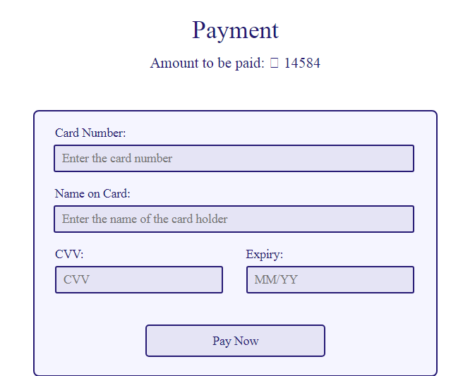

**CODING:**

<?php session_start();

if(!isset($_SESSION["username"]))

{

header("Location:blocked.php");

$_SESSION['url'] = $_SERVER['REQUEST_URI'];

}

?>

<!DOCTYPE html>

<html lang="en">

<!-- HEAD TAG STARTS -->

<head>

<meta charset="UTF-8">

<meta name="viewport" content="width=device-width, initial-scale=1.0"/>

<title>Payment | tourism_management</title>

<link href="css/main.css" rel="stylesheet">

<link href="css/bootstrap.min.css" rel="stylesheet">

<link href="https://fonts.googleapis.com/css?family=Oswald:200,300,400|Raleway:100,300,400,500|Roboto:100,400,500,700" rel="stylesheet">

<link href="https://maxcdn.bootstrapcdn.com/font-awesome/4.7.0/css/font-awesome.min.css" rel="stylesheet">

<script src="js/jquery-3.2.1.min.js"></script>

<script src="js/main.js"></script>

<script src="js/bootstrap.min.js"></script>

</head>

<!-- HEAD TAG ENDS -->

<!-- BODY TAG STARTS -->

<body>

<?php include("common/headerLoggedIn.php"); ?>

<?php

$mode=$_POST["modeHidden"];

if($mode=="ReturnTripFlight" or $mode=="OneWayFlight") {

$totalPassengers=$_POST["totalPassengersHidden"];

for($i=1; $i<=$totalPassengers; $i++) {

$name[$i]=$_POST["name$i"];

$gender[$i]=$_POST["gender$i"];

}

$fare=$_POST["fareHidden"];

$type=$_POST["typeHidden"];

$class=$_POST["classHidden"];

$origin=$_POST["originHidden"];

$destination=$_POST["destinationHidden"];

$depart=$_POST["departHidden"];

$return=$_POST["returnHidden"];

$adults=$_POST["adultsHidden"];

$children=$_POST["childrenHidden"];

$noOfPassengers=(int)$adults+(int)$children;

if($type=="Return Trip") {

$flightNoOutbound=$_POST["flightNoOutboundHidden"];

$flightNoInbound=$_POST["flightNoInboundHidden"];

}

elseif($type=="One Way") {

$flightNoOutbound=$_POST["flightNoOutboundHidden"];

}

if($class=="Economy Class")

$className="Economy";

else

$className="Business";

} // for flights

elseif($mode=="hotel") {

$fare=$_POST["fareHidden"];

$hotelID=$_POST["hotelIDHidden"];

} //for hotels

//elseif($mode=="cabs") {

// $fare=$_SESSION["cabsFare"];

// $carID=$_SESSION["carID"];

//} //for hotels

//elseif($mode=="bus") {

// $totalPassengers=$_POST["totalPassengersHidden"];

// $fare=$_POST["fareHidden"];

// $busID=$_POST["busIDHidden"];

// $origin=$_POST["originHidden"];

// $destination=$_POST["destinationHidden"];

// for($i=1; $i<=$totalPassengers; $i++) {

// $name[$i]=$_POST["name$i"];

// $gender[$i]=$_POST["gender$i"];

// }

//} //for bus

elseif($mode=="train") {

$totalPassengers=$_POST["totalPassengersHidden"];

$fare=$_POST["fareHidden"];

$trainID=$_POST["trainIDHidden"];

$origin=$_POST["originHidden"];

$destination=$_POST["destinationHidden"];

$date=$_POST["dateHidden"];

$day=$_POST["dayHidden"];

$class=$_POST["classHidden"];

for($i=1; $i<=$totalPassengers; $i++) {

$name[$i]=$_POST["name$i"];

$gender[$i]=$_POST["gender$i"];

}

} //for train

?>

<div class="spacer">a</div>

<div class="col-sm-12 paymentWrapper">

<div class="headingOne">

Payment

</div>

<div class="totalAmount">

Amount to be paid: <span class="sansSerif">₹</span><?php echo $fare; ?>

</div>

<!--<div class="col-sm-3"></div>-->

<div class="col-sm-3"></div>

<div class="col-sm-6">

<div class="boxCenter">

<div class="col-sm-12 tag">

Card Number:

</div>

<div class="col-sm-12">

<input type="text" class="input" name="cardNumber" placeholder="Enter the card number" id="cardNumber"/>

</div>

<div class="col-sm-12 tag">

Name on Card:

</div>

<div class="col-sm-12">

<input type="text" class="input" name="nameOnCard" placeholder="Enter the name of the card holder" id="nameOnCard"/>

</div>

<div class="col-sm-6 tag">

CVV:

</div>

<div class="col-sm-6 tag">

Expiry:

</div>

<div class="col-sm-6">

<input type="password" class="inputSmall" name="cvv" placeholder="CVV" id="cvv"/>

</div>

<div class="col-sm-6">

<input type="text" class="inputSmall" name="expiry" placeholder="MM/YY" id="cardExpiry"/>

</div>

<!-- flights -->

<?php if($mode=="ReturnTripFlight" or $mode=="OneWayFlight"): ?>

<form action="generateTicket.php" method="POST">

<div class="col-sm-12 bookingButton text-center">

<input type="submit" class="paymentButton" value="Pay Now">

</div>

<input type="hidden" name="totalPassengersHidden" value="<?php echo $totalPassengers; ?>">

<input type="hidden" name="fareHidden" value="<?php echo $fare; ?>">

<input type="hidden" name="typeHidden" value="<?php echo $type; ?>">

<input type="hidden" name="classHidden" value="<?php echo $class; ?>">

<input type="hidden" name="originHidden" value="<?php echo $origin; ?>">

<input type="hidden" name="destinationHidden" value="<?php echo $destination; ?>">

<input type="hidden" name="departHidden" value="<?php echo $depart; ?>">

<input type="hidden" name="returnHidden" value="<?php echo $return; ?>">

<input type="hidden" name="adultsHidden" value="<?php echo $adults; ?>">

<input type="hidden" name="childrenHidden" value="<?php echo $children; ?>">

<input type="hidden" name="modeHidden" value="<?php echo $mode ?>">

<?php for($i=1; $i<=$totalPassengers; $i++) {?>

<input type="hidden" name="nameHidden<?php echo $i; ?>" value="<?php echo $name[$i]; ?>">

<input type="hidden" name="genderHidden<?php echo $i; ?>" value="<?php echo $gender[$i]; ?>">

<?php } ?>

<?php if($type=="Return Trip") { ?>

<input type="hidden" name="flightNoOutboundHidden" value="<?php echo $flightNoOutbound; ?>">

<input type="hidden" name="flightNoInboundHidden" value="<?php echo $flightNoInbound; ?>">

<?php } elseif($type=="One Way") { ?>

<input type="hidden" name="flightNoOutboundHidden" value="<?php echo $flightNoOutbound; ?>">

<?php } ?>

</form>

<!-- hotels -->

<?php elseif($mode=="hotel"): ?>

<form action="generateReceipt.php" method="POST">

<div class="col-sm-12 bookingButton text-center">

<input type="submit" class="paymentButton" value="Pay Now">

</div>

<input type="hidden" name="hotelIDHidden" value="<?php echo $hotelID; ?>">

<input type="hidden" name="fareHidden" value="<?php echo $fare; ?>">

</form>

<!--trains--->

<?php elseif($mode=="train"): ?>

<form action="generateTrainTicket.php" method="POST">

<div class="col-sm-12 bookingButton text-center">

<?php $date=$_POST["dateHidden"]; ?>

<input type="hidden" name="dateHidden" value="<?php echo $date; ?>">

<input type="hidden" name="dayHidden" value="<?php echo $day; ?>">

<input type="hidden" name="classHidden" value="<?php echo $class; ?>">

<input type="submit" class="paymentButton" value="Pay Now">

</div>

<input type="hidden" name="totalPassengersHidden" value="<?php echo $totalPassengers; ?>">

<input type="hidden" name="fareHidden" value="<?php echo $fare; ?>">

<input type="hidden" name="originHidden" value="<?php echo $origin; ?>">

<input type="hidden" name="destinationHidden" value="<?php echo $destination; ?>">

<input type="hidden" name="modeHidden" value="<?php echo $mode ?>">

<?php for($i=1; $i<=$totalPassengers; $i++) {?>

<input type="hidden" name="nameHidden<?php echo $i; ?>" value="<?php echo $name[$i]; ?>">

<input type="hidden" name="genderHidden<?php echo $i; ?>" value="<?php echo $gender[$i]; ?>">

<?php } ?>

<input type="hidden" name="trainIDHidden" value="<?php echo $trainID; ?>">

</form>

<?php endif; ?>

</div>

</div>

<div class="col-sm-3"></div>

</div><!-- paymentWrapper -->

<div class="spacerLarge">.</div><!-- just a dummy class for creating some space -->

<?php include("common/footer.php"); ?>

</body>

<!-- BODY TAG ENDS -->

</html>

**BOOKING RECEIPT:**

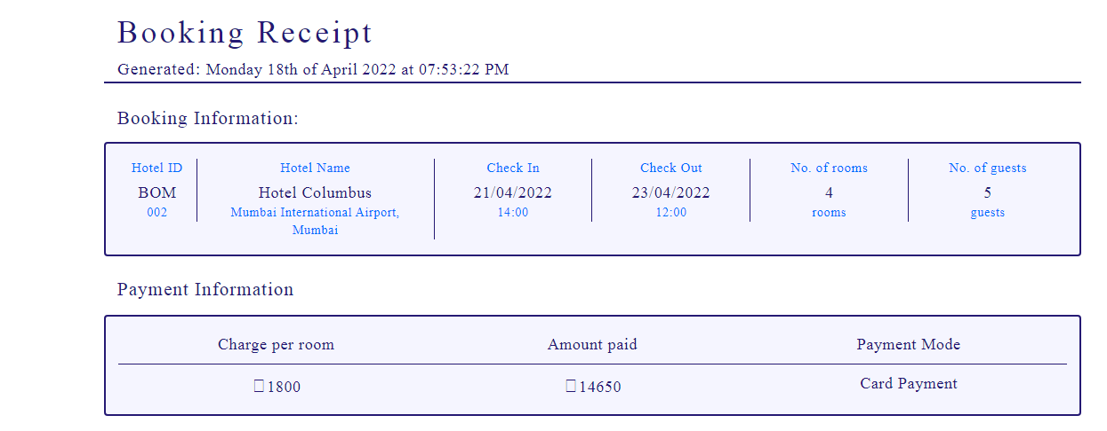

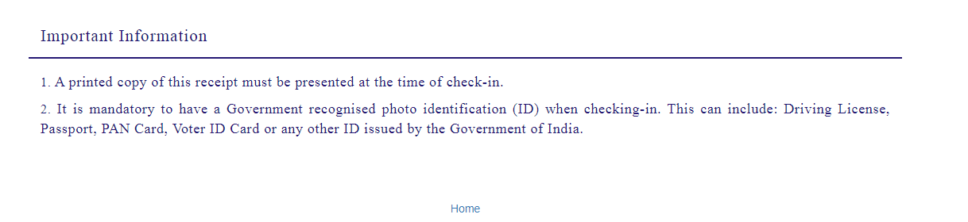

**CODING:**

<?php session_start();

if(!isset($_SESSION["username"]))

{

header("Location:blocked.php");

$_SESSION['url'] = $_SERVER['REQUEST_URI'];

}

?>

<!-- dumping the current page to buffer -->

<?php

ob_start();

?>

<!DOCTYPE html>

<html lang="en">

<!-- HEAD TAG STARTS -->

<head>

<meta charset="UTF-8">

<meta name="viewport" content="width=device-width, initial-scale=1.0"/>

<title>Receipt | tourism_management</title>

<link href="css/main.css" rel="stylesheet">

<link href="css/bootstrap.min.css" rel="stylesheet">

<link href="https://fonts.googleapis.com/css?family=Oswald:200,300,400|Raleway:100,300,400,500|Roboto:100,400,500,700" rel="stylesheet">

<link href="https://maxcdn.bootstrapcdn.com/font-awesome/4.7.0/css/font-awesome.min.css" rel="stylesheet">

<script src="js/jquery-3.2.1.min.js"></script>

<script src="js/main.js"></script>

<script src="js/bootstrap.min.js"></script>

</head>

<!-- HEAD TAG ENDS -->

<!-- BODY TAG STARTS -->

<body>

<div class="spacer">a</div>

<?php

date_default_timezone_set("Asia/Kolkata");

$date=date('l jS \of F Y \a\t h:i:s A');

$hotelID=$_POST["hotelIDHidden"];

$fare=$_POST["fareHidden"];

?>

<?php

$servername = "localhost";

$username = "root";

$password = "";

$dbname = "projectmeteor";

// Creating a connection to MySQL database

$conn = new mysqli($servername, $username, $password, $dbname);

// Checking if we've successfully connected to the database

if ($conn->connect_error) {

die("Connection failed: " . $conn->connect_error);

}

?>

<div class="col-sm-12 generateReceipt">

<div class="commonHeader">

<div class="col-sm-1"></div>

<div class="col-sm-7 text-left">

<div class="headingOne">

Booking Receipt

</div>

<div class="dateTime">

<span class="generated">Generated: </span><?php echo $date; ?>

</div>

</div>

<div class="col-sm-3 text-right">

</div>

<div class="col-sm-1"></div>

<div class="col-sm-12"></div>

<div class="col-sm-1"></div>

<div class="col-sm-10 bar"></div>

<div class="col-sm-1"></div>

</div><!-- contains the header -->

<div class="col-sm-12"></div><!-- empty class -->

<div class="col-sm-1"></div>

<div class="col-sm-10">

<div class="subHeading">

Booking Information:

</div>

</div>

<div class="col-sm-12"></div><!-- empty class -->

<div class="col-sm-1"></div>

<div class="col-sm-10 boxCenter"><!-- outboundFlight Box -->

<?php

$sql = "SELECT * FROM hotels WHERE hotelID='$hotelID'";

$result = $conn->query($sql);

$row = $result->fetch_assoc()

?>

<div class="col-sm-1 borderRight text-center">

<div class="flightOperatorHeading">

Hotel ID

</div>

<div class="flightOperator">

<?php $hotelID=$row["hotelID"];

echo substr($hotelID,0,3) ?>

</div>

<div class="flightNo">

<?php $hotelID=$row["hotelID"];

echo substr($hotelID,3) ?>

</div>

</div><!-- col-sm-4 -->

<div class="col-sm-3 borderRight text-center">

<div class="flightOperatorHeading">

Hotel Name

</div>

<div class="flightOperator">

<?php echo $row["hotelName"]; ?>

</div>

<div class="flightNo">

<?php echo $row["locality"].', '.$row["city"]; ?>

</div>

</div><!-- col-sm-4 -->

<div class="col-sm-2 borderRight text-center">

<div class="departsHeading">

Check In

</div>

<div class="departs">

<?php echo $_SESSION["checkIn"]; ?>

</div>

<div class="departsSubscript">

<?php echo $row["checkIn"]; ?>

</div>

</div><!-- col-sm-4 -->

<div class="col-sm-2 borderRight text-center">

<div class="arrivesHeading">

Check Out

</div>

<div class="arrives">

<?php echo $_SESSION["checkOut"]; ?>

</div>

<div class="arrivesSubscript">

<?php echo $row["checkOut"]; ?>

</div>

</div><!-- col-sm-4 -->

<div class="col-sm-2 borderRight text-center">

<div class="originHeading">

No. of rooms

</div>

<div class="origin">

<?php echo $_SESSION["noOfRooms"]; ?>

</div>

<div class="originSubscript">

rooms

</div>

</div><!-- col-sm-4 -->

<div class="col-sm-2 text-center">

<div class="destinationHeading">

No. of guests

</div>

<div class="origin">

<?php echo $_SESSION["noOfGuests"]; ?>

</div>

<div class="destinationSubscript">

guests

</div>

</div><!-- col-sm-4 -->

</div><!-- outboundFlight Box -->

<div class="col-sm-12 spacer">a</div>

<div class="col-sm-1"></div>

<div class="col-sm-10">

<div class="subHeading">

Payment Information

</div>

</div>

<div class="col-sm-12"></div><!-- empty class -->

<div class="col-sm-1"></div>

<div class="col-sm-12"></div><!-- empty class -->

<div class="col-sm-1"></div>

<div class="col-sm-10 boxCenter">

<div class="columnHeaders">

<div class="col-sm-4 borderBottom">

<div class="serialNoHeader text-center">

Charge per room

</div>

</div>

<div class="col-sm-4 borderBottom">

<div class="passengerNameHeader text-center">

Amount paid

</div>

</div>

<div class="col-sm-4 borderBottom">

<div class="genderHeader text-center">

Payment Mode

</div>

</div>

</div><!-- columnHeaders -->

<div class="col-sm-4">

<div class="serialNo text-center">

<span class="rupee">₹</span><?php echo $row["price"]; ?>

</div>

</div>

<div class="col-sm-4">

<div class="serialNo text-center">

<span class="rupee">₹</span><?php echo $fare ?>

</div>

</div>

<div class="col-sm-4">

<div class="serialNo text-center">

Card Payment

</div>

</div>

</div><!-- boxCenter -->

<div class="col-sm-1"></div>

<div class="importantInfo">

<div class="col-sm-12"></div><!-- empty class -->

<div class="col-sm-12 spacer">a</div>

<div class="col-sm-12 spacer">a</div>

<div class="col-sm-1"></div>

<div class="col-sm-10">

<div class="subHeading">

Important Information

</div>

</div>

<div class="col-sm-1"></div>

<div class="col-sm-12"></div>

<div class="col-sm-1"></div>

<div class="col-sm-10 bar"></div>

<div class="col-sm-1"></div>

<div class="col-sm-12"></div>

<div class="col-sm-1"></div>

<div class="col-sm-10">

<div class="info">

<span class="strong">1.</span> A printed copy of this receipt must be presented at the time of check-in.

</div>

<div class="info">

<span class="strong">2.</span> It is mandatory to have a Government recognised photo identification (ID) when checking-in. This can include: Driving License, Passport, PAN Card, Voter ID Card or any other ID issued by the Government of India.

</div>

</div>

<div class="col-sm-1"></div>

<div class="col-sm-12 spacer">a</div>

<div class="col-sm-12"></div><!-- empty class -->

</div><!-- importantInfo -->

</div><!-- generateTicket -->

<div class="spacer">a</div>

<center><a href="index.php"> Home </a></center>

<br>

<br>

</body>

<!-- BODY TAG ENDS -->

</html>

<!-- after user login system is built push the username using the curent session to the database -->

<?php

$user = $_SESSION["username"];

$dateFormatted = date("d-m-Y"); //formatting the date as DD-MM-YY

$hotelName = $row["hotelName"].', '.$row["locality"].', '.$row["city"];

$bookingDataInsertSQL = "INSERT INTO `hotelbookings`(hotelName,date,username,cancelled) VALUES('$hotelName','$dateFormatted','$user','no')";

$bookingDataInsertQuery = $conn->query($bookingDataInsertSQL);

$bookingIDSQL = "SELECT * FROM `hotelbookings` ORDER BY `bookingID` DESC LIMIT 1";

$bookingIDQuery = $conn->query($bookingIDSQL);

$bookingIDGet = $bookingIDQuery ->fetch_array(MYSQLI_NUM);

$latestBookingID = $bookingIDGet[0];

$currentBookingID = $latestBookingID;

?>

<!-- saving the file as temp.html -->

<?php

file_put_contents('receipts\receipt'.$currentBookingID.'.html', ob_get_contents());

?>

**FLIGHTS BOOKING WITHOUT PACKAGES:**



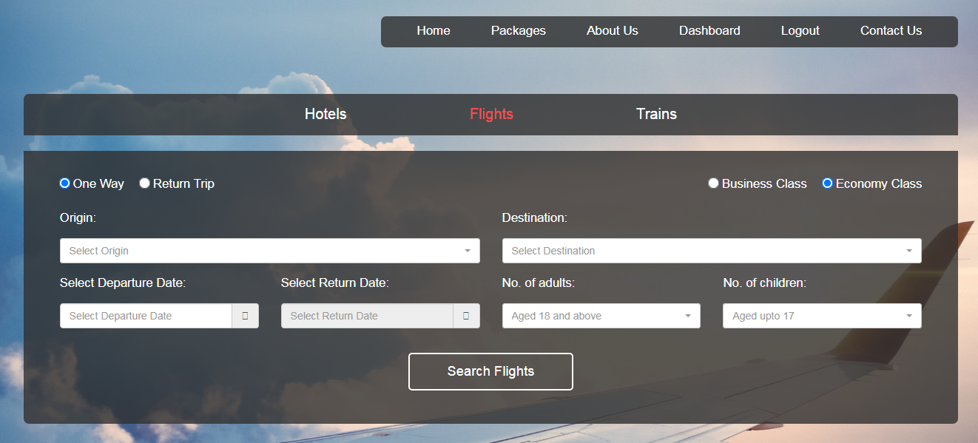

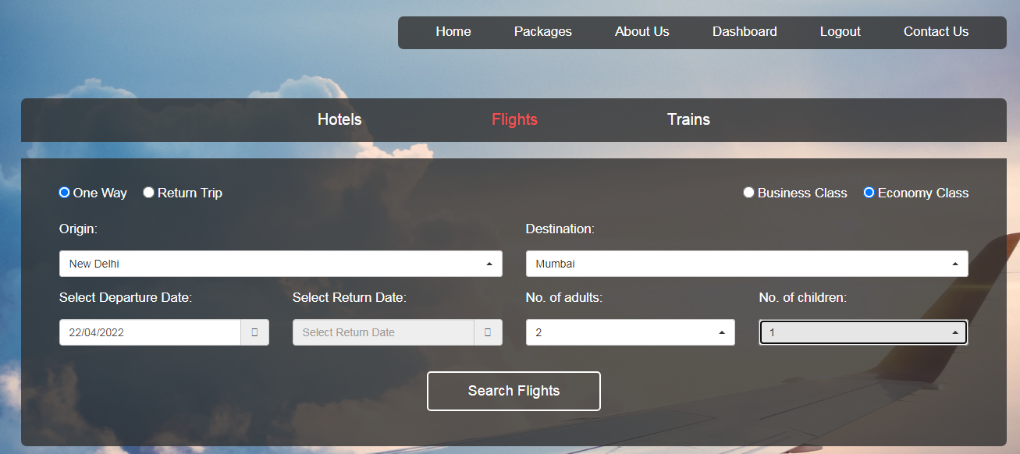

**CODING:**

<?php session_start();

if(!isset($_SESSION["username"]))

{

header("Location:blockedBooking.php");

$_SESSION['url'] = $_SERVER['REQUEST_URI'];

}

?>

<!DOCTYPE html>

<html lang="en">

<!-- HEAD TAG STARTS -->

<head>

<meta charset="UTF-8">

<meta name="viewport" content="width=device-width, initial-scale=1.0"/>

<title>Flights | tourism_management</title>

<link href="css/main.css" rel="stylesheet">

<link href="css/bootstrap.min.css" rel="stylesheet">

<link href="css/bootstrap-select.css" rel="stylesheet">

<link href="css/bootstrap-datetimepicker.css" rel="stylesheet">

<link href="https://fonts.googleapis.com/css?family=Oswald:200,300,400|Raleway:100,300,400,500|Roboto:100,400,500,700" rel="stylesheet">

<link href="https://maxcdn.bootstrapcdn.com/font-awesome/4.7.0/css/font-awesome.min.css" rel="stylesheet">

<script src="js/jquery-3.2.1.min.js"></script>

<script src="js/main.js"></script>

<script src="js/bootstrap.min.js"></script>

<script src="js/bootstrap-select.js"></script>

<script src="js/bootstrap-dropdown.js"></script>

<script src="js/jquery-2.1.1.min.js"></script>

<script src="js/moment-with-locales.js"></script>

<script src="js/bootstrap-datetimepicker.js"></script>

<script src="js/scrolling-nav.js"></script>

<script src="js/jquery.easing.min.js"></script>

<script type="text/javascript">

$(function () {

$('#datetimepicker1').datetimepicker({

format: 'L',

locale: 'en-gb',

useCurrent: false,

minDate: moment()

});

$('#datetimepicker2').datetimepicker({

useCurrent: false,

format: 'L',

locale: 'en-gb',

minDate: moment()

});

$("#datetimepicker1").on("dp.change", function (e) {

$('#datetimepicker2').data("DateTimePicker").minDate(e.date);

});

$("#datetimepicker2").on("dp.change", function (e) {

$('#datetimepicker1').data("DateTimePicker").maxDate(e.date);

});

});

</script>

</head>

<!-- HEAD TAG ENDS -->

<!-- BODY TAG STARTS -->

<body>

<div class="container-fluid" id="book">

<div class="flights col-sm-12">

<!-- HEADER SECTION STARTS -->

<div class="col-sm-12">

<div class="header">

<?php include("common/headerTransparentLoggedIn.php"); ?>

<div class="col-sm-12">

<div class="menu text-center">

<ul>

<a href="hotels.php"><li>Hotels</li></a>

<li class="selected">Flights</li>

<a href="trains.php"><li>Trains</li></a>

</ul>

</div>

</div>

</div><!-- header -->

</div><!-- col-sm-12 -->

<!-- HEADER SECTION ENDS -->

<!-- FLIGHT SEARCH SECTION STARTS -->

<div class="col-sm-12">

<div class="search">

<div class="content">

<form name="flightSearch" action="returnTripOutboundFlightSearch.php" method="POST">

<div class="radioContainer">

<div class="col-sm-6 text-left">

<input type="radio" name="flightType" value="One Way" id="oneWay">

<label for="oneWay"><span class="radioLeft">One Way</span></label>

<input type="radio" name="flightType" value="Return Trip" id="returnTrip" checked>

<label for="returnTrip"><span class="radioLeft">Return Trip</span></label>

</div>

<div class="col-sm-6 text-right">

<input type="radio" name="flightClass" value="Business Class" id="businessClass">

<label for="businessClass"><span class="radioRight">Business Class</span></label>

<input type="radio" name="flightClass" value="Economy Class" id="economyClass" checked>

<label for="economyClass"><span class="radioRight">Economy Class</span></label>

</div>

</div><!-- radioContainer -->

<div class="col-sm-6">

<div class="form-group">

<label for="origin">Origin:<p></p></label>

<select id= "origin" data-live-search="true" class="selectpicker form-control" data-size="5" title="Select Origin" name="origin" required>

<option value="New Delhi" data-subtext="DEL" data-tokens="DEL New Delhi">New Delhi</option>

<option value="Mumbai" data-subtext="BOM" data-tokens="BOM Mumbai">Mumbai</option>

<option value="Kolkata" data-subtext="CCU" data-tokens="CCU Kolkata">Kolkata</option>

<option value="Bengaluru" data-subtext="BLR" data-tokens="BLR Bengaluru">Bengaluru</option>

<option value="Pune" data-subtext="PNQ" data-tokens="PNQ Pune">Pune</option>

<option value="Chennai" data-subtext="MAA" data-tokens="MAA Chennai">Chennai</option>

<option value="Guwahati" data-subtext="GAU" data-tokens="GAU Guwahati">Guwahati</option>

<option value="Bhopal" data-subtext="BHO" data-tokens="BHI Bhopal">Bhopal</option>

<option value="Jaipur" data-subtext="JAI" data-tokens="JAI Jaipur">Jaipur</option>

<option value="Ahmedabad" data-subtext="AMD" data-tokens="AMD Ahmedabad">Ahmedabad</option>

<option value="Hyderabad" data-subtext="HYD" data-tokens="HYD Hyderabad">Hyderabad</option>

</select>

</div>

</div>

<div class="col-sm-6">

<div class="form-group">

<label for="destination">Destination:<p></p></label>

<select id= "destination" data-live-search="true" class="selectpicker form-control" data-size="5" title="Select Destination" name="destination" required>

<option value="New Delhi" data-subtext="DEL" data-tokens="DEL New Delhi">New Delhi</option>

<option value="Mumbai" data-subtext="BOM" data-tokens="BOM Mumbai">Mumbai</option>

<option value="Kolkata" data-subtext="CCU" data-tokens="CCU Kolkata">Kolkata</option>

<option value="Bengaluru" data-subtext="BLR" data-tokens="BLR Bengaluru">Bengaluru</option>

<option value="Pune" data-subtext="PNQ" data-tokens="PNQ Pune">Pune</option>

<option value="Chennai" data-subtext="MAA" data-tokens="MAA Chennai">Chennai</option>

<option value="Guwahati" data-subtext="GAU" data-tokens="GAU Guwahati">Guwahati</option>

<option value="Bhopal" data-subtext="BHO" data-tokens="BHI Bhopal">Bhopal</option>

<option value="Jaipur" data-subtext="JAI" data-tokens="JAI Jaipur">Jaipur</option>

<option value="Ahmedabad" data-subtext="AMD" data-tokens="AMD Ahmedabad">Ahmedabad</option>

<option value="Hyderabad" data-subtext="HYD" data-tokens="HYD Hyderabad">Hyderabad</option>

</select>

</div>

</div>

<div class="col-sm-3">

<div class="form-group">

<label for="datetime1">Select Departure Date:<p></p></label>

<div class="input-group date" id="datetimepicker1">

<input id="datetime1" type="text" class="inputDate form-control" placeholder="Select Departure Date" name="depart" required/>

<span class="input-group-addon">

<span class="fa fa-calendar"></span>

</span>

</div>

</div>

</div>

<div class="col-sm-3">

<div class="form-group">

<label for="datetime2">Select Return Date:<p></p></label>

<div class="input-group date" id="datetimepicker2">

<input id="datetime2" type="text" class="inputDate form-control" placeholder="Select Return Date" name="return" required/>

<span class="input-group-addon">

<span class="fa fa-calendar"></span>

</span>

</div>

</div>

</div>

<div class="col-sm-3">

<label for="adults">No. of adults:<p></p></label>

<div class="form-group">

<select id= "adults" class="selectpicker form-control" data-size="5" title="Aged 18 and above" name="adults" required>

<option value="1">1</option>

<option value="2">2</option>

<option value="3">3</option>

<option value="4">4</option>

<option value="5">5</option>

<option value="6">6</option>

</select>

</div>

</div>

<div class="col-sm-3">

<label for="children">No. of children:<p></p></label>

<div class="form-group">

<select id= "children" class="selectpicker form-control" data-size="5" title="Aged upto 17" name="children" required>

<option value="0">0</option>

<option value="1">1</option>

<option value="2">2</option>

<option value="3">3</option>

<option value="4">4</option>

<option value="5">5</option>

<option value="6">6</option>

</select>

</div>

</div>

<div class="col-sm-12 text-center">

<input type="submit" class="button" name="searchFlights" value="Search Flights">

</div>

</form>

</div><!-- content -->

</div><!-- search -->

</div>

<!-- FLIGHT SEARCH SECTION ENDS -->

</div><!-- flights -->

<!-- FOOTER SECTION STARTS -->

<div class="footer col-sm-12">

<div class="col-sm-4">

<div class="footerHeading">

Contact Us

</div>

<div class="footerText">

CUSAT,Cochin <br> Kerala, India

</div>

<div class="footerText">

E-mail: queries@tourism_management.com

</div>

</div>

<div class="col-sm-4">

</div>

<div class="col-sm-4">

<div class="footerHeading">

Social Links

</div>

<div class="socialLinks">

<div class="fb">

facebook.com/tourism_management

</div>

<div class="gp">

plus.google.com/tourism_management

</div>

<div class="tw">

twitter.com/tourism_management

</div>

<div class="in">

linkedin.com/tourism_management

</div>

</div><!-- social links -->

</div>

<div class="col-sm-12">

<div class="copyrightContainer">

<div class="copyright">

Copyright &copy; 2021 Alisha Anand

</div>

</div>

</div>

</div><!-- footer -->

<!-- FOOTER SECTION ENDS -->

</div><!-- container-fluid -->

</body>

<!-- BODY TAG ENDS -->

</html>

**ONE WAY FLIGHT BOOKING:**

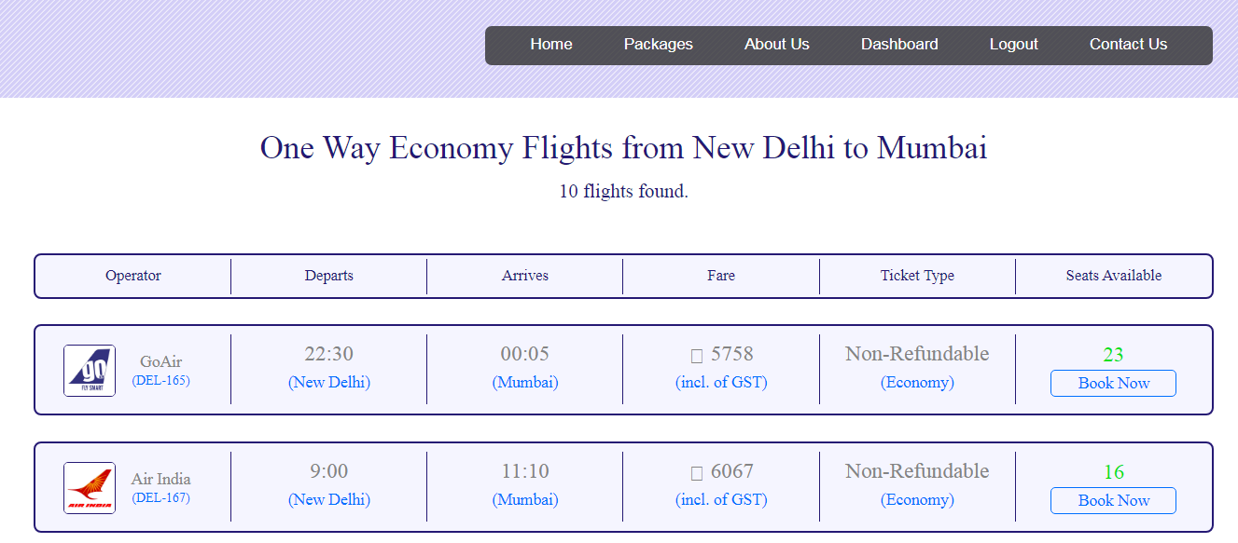

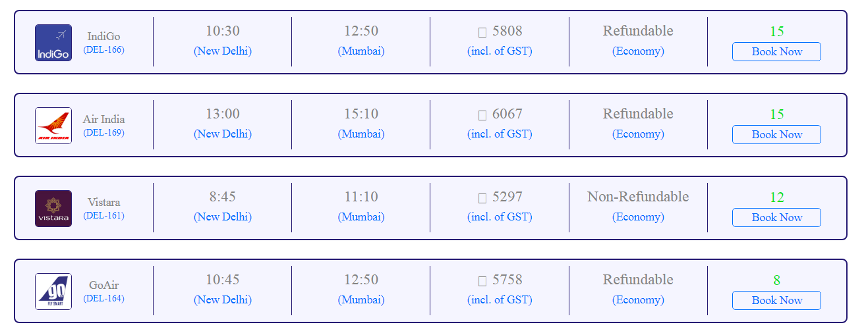

**CODING: (One Way flight Booking)**

<?php session_start();

if(!isset($_SESSION["username"]))

{

header("Location:blocked.php");

$_SESSION['url'] = $_SERVER['REQUEST_URI'];

}

?>

<!DOCTYPE html>

<html lang="en">

<!-- HEAD TAG STARTS -->

<head>

<meta charset="UTF-8">

<meta name="viewport" content="width=device-width, initial-scale=1.0"/>

<title>Flight Search | tourism_management</title>

<link href="css/main.css" rel="stylesheet">

<link href="css/bootstrap.min.css" rel="stylesheet">

<link href="https://fonts.googleapis.com/css?family=Oswald:200,300,400|Raleway:100,300,400,500|Roboto:100,400,500,700" rel="stylesheet">

<link href="https://maxcdn.bootstrapcdn.com/font-awesome/4.7.0/css/font-awesome.min.css" rel="stylesheet">

<script src="js/jquery-3.2.1.min.js"></script>

<script src="js/main.js"></script>

<script src="js/bootstrap.min.js"></script>

</head>

<!-- HEAD TAG ENDS -->

<!-- BODY TAG STARTS -->

<body>

<?php include("common/headerLoggedIn.php"); ?>

<?php

$type=$_POST["flightType"];

$class=$_POST["flightClass"];

$origin=$_POST["origin"];

$destination=$_POST["destination"];

$depart=$_POST["depart"];

if($type=="Return Trip") { //let's store the return value only if the flightType is a Return Trip

$return=$_POST["return"];

}

$adults=$_POST["adults"];

$children=$_POST["children"];

$noOfPassengers=(int)$adults+(int)$children;

if($class=="Economy Class")

$className="Economy";

else

$className="Business";

?>

<div class="spacer">a</div>

<div class="searchFlights">

<div class="query">

<?php echo $type; ?><?php echo $className; ?> Flights from <?php echo $origin; ?> to <?php echo $destination; ?>

</div>

<?php

$servername = "localhost";

$username = "root";

$password = "";

$dbname = "projectmeteor";

// Creating a connection to MySQL database

$conn = new mysqli($servername, $username, $password, $dbname);

// Checking if we've successfully connected to the database

if ($conn->connect_error) {

die("Connection failed: " . $conn->connect_error);

}

//flight search query

$sql = "SELECT * FROM flights WHERE origin='$origin' AND destination='$destination' AND class='$className' ORDER BY seats_available DESC";

$rowcount = mysqli_num_rows(mysqli_query($conn,$sql));

$result = $conn->query($sql);

if ($result->num_rows > 0) {

?>

<div class="noOfFlights">

<?php echo $rowcount ." flights found.";?>

</div>

<div class="listItemMenuContainer">

<div class="col-sm-2 text-center">

<div class="headings">

Operator

</div>

</div>

<div class="col-sm-2 text-center">

<div class="headings">

Departs

</div>

</div>

<div class="col-sm-2 text-center">

<div class="headings">

Arrives

</div>

</div>

<div class="col-sm-2 text-center">

<div class="headings">

Fare

</div>

</div>

<div class="col-sm-2 text-center">

<div class="headings">

Ticket Type

</div>

</div>

<div class="col-sm-2 text-center">

<div class="headings">

Seats Available

</div>

</div>

</div><!-- listItemMenuContainer -->

<div class="spacerLarge">.</div><!-- just a dummy class for creating some space -->

</div><!-- searchFlights -->

<?php

while($row = $result->fetch_assoc()) {

?>

<div class="searchFlights">

<div class="listItem">

<!-- FLIGHT INFO STARTS -->

<form action="booking.php" method="POST">

<div class="col-sm-2 text-center">

<div class="col-sm-4 text-center">

<div class="operatorLogo text-center">

<?php if($row["operator"]=="IndiGo"): ?>

<img src="images/flights/operatorLogos/indigo.jpg">

<?php elseif($row["operator"]=="AirIndia"): ?>

<img src="images/flights/operatorLogos/airindia.jpg">

<?php elseif($row["operator"]=="Vistara"): ?>

<img src="images/flights/operatorLogos/vistara.jpg">

<?php elseif($row["operator"]=="Jet Airways"): ?>

<img src="images/flights/operatorLogos/jetairways.jpg">

<?php elseif($row["operator"]=="Spicejet"): ?>

<img src="images/flights/operatorLogos/spicejet.jpg">

<?php elseif($row["operator"]=="GoAir"): ?>

<img src="images/flights/operatorLogos/goair.jpg">

<?php elseif($row["operator"]=="AirAsia"): ?>

<img src="images/flights/operatorLogos/airasia.jpg">

<?php endif; ?>

<!-- ADD OTHER OPERATORS HERE -->

</div>

</div>

<div class="col-sm-8 text-center">

<div class="values flightOperator">

<?php if($row["operator"]=="IndiGo"): ?>

IndiGo

<?php elseif($row["operator"]=="AirIndia"): ?>

Air India

<?php elseif($row["operator"]=="Vistara"): ?>

Vistara

<?php elseif($row["operator"]=="Jet Airways"): ?>

Jet Air.

<?php elseif($row["operator"]=="Spicejet"): ?>

Spicejet

<?php elseif($row["operator"]=="GoAir"): ?>

GoAir

<?php elseif($row["operator"]=="AirAsia"): ?>

AirAsia

<?php endif; ?>

<!-- ADD OTHER OPERATORS HERE -->

</div>

<div class="flightNoSubscript">

<?php echo $row["flight_no"]; ?>

</div>

</div>

</div>

<!-- FLIGHT INFO ENDS -->

<!-- DEPARTS STARTS -->

<div class="col-sm-2 text-center">

<div class="values departs">

<?php echo $row["departs"]; ?>

</div>

<div class="departsSubscript">

<?php echo $row["origin"]; ?>

</div>

</div>

<!-- DEPARTS ENDS -->

<!-- DESTINATION STARTS -->

<div class="col-sm-2 text-center">

<div class="values arrives">

<?php echo $row["arrives"]; ?>

</div>

<div class="arrivesSubscript">

<?php echo $row["destination"]; ?>

</div>

</div>

<!-- DESTINATION ENDS -->

<!-- FARE STARTS -->

<div class="col-sm-2 text-center">

<div class="values fare">

<?php echo $row["fare"]; ?>

</div>

<div class="fareSubscript">

incl. of GST

</div>

</div>

<!-- FARE ENDS -->

<!-- TYPE STARTS -->

<div class="col-sm-2 text-center">

<div class="values type">

<?php echo $row["refundable"]; ?>

</div>

<div class="typeSubscript">

<?php echo $row["class"]; ?>

</div>

</div>

<!-- TYPE ENDS -->

<!-- SEATS AVAILABLE STARTS -->

<?php

$flightNo = $row["flight_no"];

$getSeatsAvailableSQL = "SELECT seats_available FROM `flights` WHERE flight_no='$flightNo'";

$getSeatsAvailableQuery = $conn->query($getSeatsAvailableSQL);

$SeatsAvailableGet = $getSeatsAvailableQuery ->fetch_array(MYSQLI_NUM);

$seatsAvailable = $SeatsAvailableGet[0];

?>

<!-- allowing only those flights to be booked which have enough seats -->

<?php if($seatsAvailable>=$noOfPassengers): ?>

<div class="col-sm-2 text-center" style="border-right: none;">

<div class="values availabilityGreen">

<?php echo $row["seats_available"]; ?>

</div>

<div class="availabilitySubscript">

<input type="submit" class="availabilityBookingButton" value="Book Now">

</div>

</div>

<?php else: ?>

<div class="col-sm-2 text-center" style="border-right: none;">

<div class="values availabilityRed">

Unavailable

</div>

<div class="unavailabilitySubscript">

Sold Out

</div>

</div>

<?php endif;?>

<!-- SEATS AVAILABLE ENDS -->

<!-- Passing the $_POST values to the next page using hidden text boxes -->

<input type="hidden" name="typeHidden" value="<?php echo $type; ?>">

<input type="hidden" name="classHidden" value="<?php echo $class; ?>">

<input type="hidden" name="originHidden" value="<?php echo $origin; ?>">

<input type="hidden" name="destinationHidden" value="<?php echo $destination; ?>">

<input type="hidden" name="departHidden" value="<?php echo $depart; ?>">

<input type="hidden" name="returnHidden" value="<?php echo $return; ?>">

<input type="hidden" name="adultsHidden" value="<?php echo $adults; ?>">

<input type="hidden" name="childrenHidden" value="<?php echo $children; ?>">

<input type="hidden" name="flightNoOutboundHidden" value="<?php echo $row["flight_no"]; ?>">

<input type="hidden" name="modeHidden" value="<?php echo "OneWayFlight" ?>">

</form>

</div><!-- listItem 1 -->

</div>

<?php

}

} else {

?>

<div class="searchFlights">

<div class="noFlights">

No flights found.

</div>

</div>

<?php

}

?>

<?php $conn->close(); //closing the connection to the database ?>

<div class="spacerLarge">.</div><!-- just a dummy class for creating some space -->

<?php include("common/footer.php"); ?>

</body>

<!-- BODY TAG ENDS -->

</html>

**CONFIRM BOOKING:**

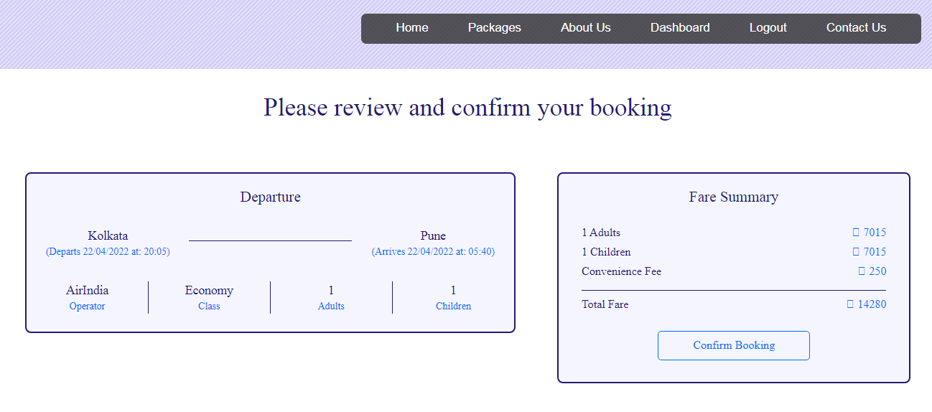

**CODING:**

<?php session_start();

if(!isset($_SESSION["username"]))

{

header("Location:blocked.php");

$_SESSION['url'] = $_SERVER['REQUEST_URI'];

}

?>

<!DOCTYPE html>

<html lang="en">

<!-- HEAD TAG STARTS -->

<head>

<meta charset="UTF-8">

<meta name="viewport" content="width=device-width, initial-scale=1.0"/>

<title>Booking | tourism_management</title>

<link href="css/main.css" rel="stylesheet">

<link href="css/bootstrap.min.css" rel="stylesheet">

<link href="https://fonts.googleapis.com/css?family=Oswald:200,300,400|Raleway:100,300,400,500|Roboto:100,400,500,700" rel="stylesheet">

<link href="https://maxcdn.bootstrapcdn.com/font-awesome/4.7.0/css/font-awesome.min.css" rel="stylesheet">

<script src="js/jquery-3.2.1.min.js"></script>

<script src="js/main.js"></script>

<script src="js/bootstrap.min.js"></script>

</head>

<!-- HEAD TAG ENDS -->

<!-- BODY TAG STARTS -->

<body>

<?php include("common/headerLoggedIn.php"); ?>

<?php

$mode=$_POST["modeHidden"];

?>

<?php

$servername = "localhost";

$username = "root";

$password = "";

$dbname = "projectmeteor";

// Creating a connection to MySQL database

$conn = new mysqli($servername, $username, $password, $dbname);

// Checking if successfully connected to the database

if ($conn->connect_error) {

die("Connection failed: " . $conn->connect_error);

}

?>

<div class="spacer">a</div>

<div class="bookingWrapper">

<div class="headingOne">

Please review and confirm your booking

</div>

<!-- changing contents of the page based on mode -->

<!----------------------------- ONE WAY FLIGHT --------------------------------->

<?php if($mode=="OneWayFlight"): ?>

<div class="col-sm-12 bookingOneWayFlight">

<?php

$type=$_POST["typeHidden"];

$class=$_POST["classHidden"];

$origin=$_POST["originHidden"];

$destination=$_POST["destinationHidden"];

$depart=$_POST["departHidden"];

$return=$_POST["returnHidden"];

$adults=$_POST["adultsHidden"];

$children=$_POST["childrenHidden"];

$noOfPassengers=(int)$adults+(int)$children;

if($type=="Return Trip") {

$flightNoOutbound=$_POST["flightNoOutboundHidden"];

$flightNoInbound=$_POST["flightNoInboundHidden"];

}

elseif($type=="One Way") {

$flightNoOutbound=$_POST["flightNoOutboundHidden"];

}

if($class=="Economy Class")

$className="Economy";

else

$className="Business";

$outboundFlightSQL = "SELECT * FROM `flights` WHERE flight_no='$flightNoOutbound'";

$outboundFlightQuery = $conn->query($outboundFlightSQL);

$row = $outboundFlightQuery->fetch_assoc();

?>

<div class="col-sm-7"><!-- departure container -->

<div class="col-sm-12">

<div class="boxLeftOneWayFlight">

<div class="col-sm-12 mode">Departure</div>

<div class="col-sm-4">

<div class="origin"><?php echo $origin; ?></div>

<div class="departs">Departs <?php echo $depart; ?> at: <?php echo $row["departs"]; ?></div>

</div>

<div class="col-sm-4">

<div class="arrow"></div>

</div>

<div class="col-sm-4">

<div class="destination"><?php echo $destination; ?></div>

<div class="arrives">Arrives <?php echo $depart; ?> at: <?php echo $row["arrives"]; ?></div>

</div>

<div class="col-sm-3 borderRight">

<div class="operator"><?php echo $row["operator"]; ?></div>

<div class="operatorSubscript">Operator</div>

</div>

<div class="col-sm-3 borderRight">

<div class="class"><?php echo $className; ?></div>

<div class="classSubscript">Class</div>

</div>

<div class="col-sm-3 borderRight">

<div class="adults"><?php echo $adults; ?></div>

<div class="adultsSubscript">Adults</div>

</div>

<div class="col-sm-3">

<div class="children"><?php echo $children; ?></div>

<div class="childrenSubscript">Children</div>

</div>

</div>

</div><!-- col-sm-7 Departure -->

</div>

<div class="col-sm-5"><!-- fare container -->

<div class="col-sm-12">

<div class="boxRightOneWayFlight">

<div class="col-sm-12 fareSummary">Fare Summary</div>

<div class="col-sm-8">

<div class="heading"><?php echo $adults; ?> Adults</div>

<div class="heading"><?php echo $children; ?> Children</div>

<div class="heading">Convenience Fee</div>

</div>

<div class="col-sm-4">

<div class="price"><span class="sansSerif">₹ </span><?php echo $adults*$row["fare"]; ?></div>

<div class="price"><span class="sansSerif">₹ </span><?php echo $children*$row["fare"]; ?></div>

<div class="price"><span class="sansSerif">₹ </span>250</div>

</div>

<div class="col-sm-12">

<div class="calcBar"></div>

</div>

<div class="col-sm-8">

<div class="headingTotal">Total Fare</div>

</div>

<div class="col-sm-4">

<div class="priceTotal"><span class="sansSerif">₹ </span><?php echo ($adults*$row["fare"])+($children*$row["fare"])+250; ?></div>

</div>

<form action="passengers.php" method="POST">

<div class="bookingButton text-center">

<input type="submit" class="confirmButton" value="Confirm Booking">

</div>

<?php $totalFare = ($adults*$row["fare"])+($children*$row["fare"])+250 ?>

<input type="hidden" name="fareHidden" value="<?php echo $totalFare; ?>">

<input type="hidden" name="typeHidden" value="<?php echo $type; ?>">

<input type="hidden" name="classHidden" value="<?php echo $class; ?>">

<input type="hidden" name="originHidden" value="<?php echo $origin; ?>">

<input type="hidden" name="destinationHidden" value="<?php echo $destination; ?>">

<input type="hidden" name="departHidden" value="<?php echo $depart; ?>">

<input type="hidden" name="returnHidden" value="<?php echo $return; ?>">

<input type="hidden" name="adultsHidden" value="<?php echo $adults; ?>">

<input type="hidden" name="childrenHidden" value="<?php echo $children; ?>">

<input type="hidden" name="flightNoOutboundHidden" value="<?php echo $row["flight_no"]; ?>">

<input type="hidden" name="modeHidden" value="<?php echo "OneWayFlight" ?>">

</form>

</div>

</div><!-- col-sm-5 Fare -->

</div><!-- fare container -->

</div><!-- bookingOneWayFlight -->

<!----------------------------- RETURN TRIP FLIGHT --------------------------------->

<?php elseif($mode=="ReturnTripFlight"): ?>

<div class="col-sm-12 bookingReturnTripFlight">

<?php

$type=$_POST["typeHidden"];

$class=$_POST["classHidden"];

$origin=$_POST["originHidden"];

$destination=$_POST["destinationHidden"];

$depart=$_POST["departHidden"];

$return=$_POST["returnHidden"];

$adults=$_POST["adultsHidden"];

$children=$_POST["childrenHidden"];

$noOfPassengers=(int)$adults+(int)$children;

if($type=="Return Trip") {

$flightNoOutbound=$_POST["flightNoOutboundHidden"];

$flightNoInbound=$_POST["flightNoInboundHidden"];

}

elseif($type=="One Way") {

$flightNoOutbound=$_POST["flightNoOutboundHidden"];

}

if($class=="Economy Class")

$className="Economy";

else

$className="Business";

$outboundFlightSQL = "SELECT * FROM `flights` WHERE flight_no='$flightNoOutbound'";

$outboundFlightQuery = $conn->query($outboundFlightSQL);

$rowOutbound = $outboundFlightQuery->fetch_assoc();

$inboundFlightSQL = "SELECT * FROM `flights` WHERE flight_no='$flightNoInbound'";

$inboundFlightQuery = $conn->query($inboundFlightSQL);

$rowInbound = $inboundFlightQuery->fetch_assoc();

?>

<div class="col-sm-7"><!-- departure return container -->

<div class="col-sm-12">

<div class="boxLeftOneWayFlight">

<div class="col-sm-12 mode">Departure</div>

<div class="col-sm-4">

<div class="origin"><?php echo $rowOutbound["origin"]; ?></div>

<div class="departs">Departs <?php echo $depart; ?> at: <?php echo $rowOutbound["departs"]; ?></div>

</div>

<div class="col-sm-4">

<div class="arrow"></div>

</div>

<div class="col-sm-4">

<div class="destination"><?php echo $rowOutbound["destination"]; ?></div>

<div class="arrives">Arrives <?php echo $depart; ?> at: <?php echo $rowOutbound["arrives"]; ?></div>

</div>

<div class="col-sm-3 borderRight">

<div class="operator"><?php echo $rowOutbound["operator"]; ?></div>

<div class="operatorSubscript">Operator</div>

</div>

<div class="col-sm-3 borderRight">

<div class="class"><?php echo $className; ?></div>

<div class="classSubscript">Class</div>

</div>

<div class="col-sm-3 borderRight">

<div class="adults"><?php echo $adults; ?></div>

<div class="adultsSubscript">Adults</div>

</div>

<div class="col-sm-3">

<div class="children"><?php echo $children; ?></div>

<div class="childrenSubscript">Children</div>

</div>

</div>

</div><!-- col-sm-7 Departure -->

<div class="col-sm-12">

<div class="boxLeftOneWayFlight">

<div class="col-sm-12 mode">Return</div>

<div class="col-sm-4">

<div class="origin"><?php echo $rowInbound["origin"]; ?></div>

<div class="departs">Departs <?php echo $return; ?> at: <?php echo $rowInbound["departs"]; ?></div>

</div>

<div class="col-sm-4">

<div class="arrow"></div>

</div>

<div class="col-sm-4">

<div class="destination"><?php echo $rowInbound["destination"]; ?></div>

<div class="arrives">Arrives <?php echo $return; ?> at: <?php echo $rowInbound["arrives"]; ?></div>

</div>

<div class="col-sm-3 borderRight">

<div class="operator"><?php echo $rowInbound["operator"]; ?></div>

<div class="operatorSubscript">Operator</div>

</div>

<div class="col-sm-3 borderRight">

<div class="class"><?php echo $className; ?></div>

<div class="classSubscript">Class</div>

</div>

<div class="col-sm-3 borderRight">

<div class="adults"><?php echo $adults; ?></div>

<div class="adultsSubscript">Adults</div>

</div>

<div class="col-sm-3">

<div class="children"><?php echo $children; ?></div>

<div class="childrenSubscript">Children</div>

</div>

</div>

</div><!-- col-sm-7 Return -->

</div><!-- departure return container -->

<div class="col-sm-5"><!-- fare container -->

<div class="col-sm-12">

<div class="boxRightOneWayFlight">

<div class="col-sm-12 fareSummary">Fare Summary</div>

<div class="col-sm-8">

<div class="heading"><?php echo $adults; ?> Adults</div>

<div class="heading"><?php echo $children; ?> Children</div>

<div class="heading">Convenience Fee</div>

</div>

<div class="col-sm-4">

<div class="price"><span class="sansSerif">₹ </span><?php echo $adults*($rowOutbound["fare"]+$rowInbound["fare"]); ?></div>

<div class="price"><span class="sansSerif">₹ </span><?php echo $children*($rowOutbound["fare"]+$rowInbound["fare"]); ?></div>

<div class="price"><span class="sansSerif">₹ </span>250</div>

</div>

<div class="col-sm-12">

<div class="calcBar"></div>

</div>

<div class="col-sm-8">

<div class="headingTotal">Total Fare</div>

</div>

<div class="col-sm-4">

<div class="priceTotal"><span class="sansSerif">₹ </span><?php echo ($adults*($rowOutbound["fare"]+$rowInbound["fare"]))+($children*($rowOutbound["fare"]+$rowInbound["fare"]))+250; ?></div><!-- CHANGE -->

</div>

<form action="passengers.php" method="POST">

<div class="bookingButton text-center">

<input type="submit" class="confirmButton" value="Confirm Booking">

</div>

<?php $totalFare = ($adults*($rowOutbound["fare"]+$rowInbound["fare"]))+($children*($rowOutbound["fare"]+$rowInbound["fare"]))+250 ?>

<!-- CHANGE -->

<input type="hidden" name="fareHidden" value="<?php echo $totalFare; ?>">

<input type="hidden" name="typeHidden" value="<?php echo $type; ?>">

<input type="hidden" name="classHidden" value="<?php echo $class; ?>">

<input type="hidden" name="originHidden" value="<?php echo $origin; ?>">

<input type="hidden" name="destinationHidden" value="<?php echo $destination; ?>">

<input type="hidden" name="departHidden" value="<?php echo $depart; ?>">

<input type="hidden" name="returnHidden" value="<?php echo $return; ?>">

<input type="hidden" name="adultsHidden" value="<?php echo $adults; ?>">

<input type="hidden" name="childrenHidden" value="<?php echo $children; ?>">

<input type="hidden" name="flightNoOutboundHidden" value="<?php echo $rowOutbound["flight_no"]; ?>">

<input type="hidden" name="flightNoInboundHidden" value="<?php echo $rowInbound["flight_no"]; ?>">

<input type="hidden" name="modeHidden" value="<?php echo "ReturnTripFlight" ?>">

</form>

</div>

</div><!-- col-sm-5 Fare -->

</div><!-- fare return container -->

</div><!-- bookingReturnTripFlight -->

<!----------------------------- HOTEL --------------------------------->

<?php elseif($mode=="hotel"): ?>

<div class="col-sm-12 bookingHotel">

<?php

$hotelID = $_POST["hotelIDHidden"];

$hotelSQL = "SELECT * FROM `hotels` WHERE hotelID='$hotelID'";

$hotelQuery = $conn->query($hotelSQL);

$row = $hotelQuery->fetch_assoc();

?>

<div class="col-sm-7"><!-- hotel summary container -->

<div class="col-sm-12">

<div class="boxLeftHotel">

<div class="col-sm-12 hotelMode">Booking Summary</div>

<div class="col-sm-12 hotelName">

Name of the hotel: <span class="nameText"><?php echo $row["hotelName"].', '.$row["locality"].', '.$row["city"]; ?></span>

</div>

<div class="col-sm-3 borderRight">

<div class="checkIn"><?php echo $_SESSION["checkIn"]; ?></div>

<div class="checkInSubscript">Check In Date</div>

</div>

<div class="col-sm-3 borderRight">

<div class="checkOut"><?php echo $_SESSION["checkOut"]; ?></div>

<div class="checkOutSubscript">Check Out Date</div>

</div>

<div class="col-sm-3 borderRight">

<div class="noOfRooms"><?php echo $_SESSION["noOfRooms"]; ?></div>

<div class="noOfRoomsSubscript">No. of rooms</div>

</div>

<div class="col-sm-3">

<div class="noOfGuests"><?php echo $_SESSION["noOfGuests"]; ?></div>

<div class="noOfGuestsSubscript">No. of guests</div>

</div>

</div><!-- boxLeft -->

</div><!-- col-sm-7 bookings -->

</div>

<div class="col-sm-5"><!-- fare container -->

<div class="col-sm-12">

<div class="boxRightHotel">

<div class="col-sm-12 fareSummary">Payment Summary</div>

<div class="col-sm-8">

<?php

$var1 = $_SESSION["checkIn"];

$var2 = $_SESSION["checkOut"];

$date1 = date_create(str_replace('/', '-', $var1));

$date2 = date_create(str_replace('/', '-', $var2));

$diff=date_diff($date1,$date2);

?>

<div class="heading"><?php echo $_SESSION["noOfRooms"]; ?> Rooms x <?php echo $diff->format("%a Days"); ?></div>

<div class="heading">Convenience Fee</div>

</div>

<?php $noOfDays = $diff->format("%a"); ?>

<div class="col-sm-4">

<div class="price"><span class="sansSerif">₹ </span><?php echo $_SESSION["noOfRooms"]*$row["price"]*$noOfDays; ?></div>

<div class="price"><span class="sansSerif">₹ </span>250</div>

</div>

<div class="col-sm-12">

<div class="calcBar"></div>

</div>

<div class="col-sm-8">

<div class="headingTotal">Total Payment</div>

</div>

<div class="col-sm-4">

<div class="priceTotal"><span class="sansSerif">₹ </span><?php echo ($_SESSION["noOfRooms"]*$row["price"]*$noOfDays)+250; ?></div>

</div>

<form action="payment.php" method="POST">

<div class="bookingButton text-center">

<input type="submit" class="confirmButton" value="Confirm Booking">

</div>

<?php $totalFare = ($_SESSION["noOfRooms"]*$row["price"]*$noOfDays)+250; ?>

<input type="hidden" name="fareHidden" value="<?php echo $totalFare; ?>">

<input type="hidden" name="hotelIDHidden" value="<?php echo $hotelID; ?>">

<input type="hidden" name="modeHidden" value="<?php echo "hotel" ?>">

</form>

</div>

</div><!-- col-sm-5 Fare -->

</div><!-- fare container -->

</div><!-- hotel -->

<!-------------------------------------------------train----------------------------------------->

<?php elseif($mode=="train"): ?>

<div class="col-sm-12 bookingTrain">

<?php

$trainID = $_POST["trainIdPass"];

$date=$_POST["dateHidden"];

$day=$_POST["dayHidden"];

$origin=$_POST["originHidden"];

$destination=$_POST["destinationHidden"];

$class=$_POST["classHidden"];

$noOfPassengers= $_POST["passengersHidden"];

$priceClass = trim('price'.$class);

$trainFinderSQL = "SELECT * FROM `trains` WHERE trainNo='$trainID'";

$trainFinderQuery = $conn->query($trainFinderSQL);

$row = $trainFinderQuery->fetch_assoc();

?>

<div class="col-sm-7"><!-- departure container -->

<div class="col-sm-12">

<div class="boxLeftBus">

<div class="col-sm-12 mode">Departure</div>

<div class="col-sm-4">

<div class="origin"><?php echo $origin; ?></div>

<div class="departs">Departs at: <?php echo $row["originTime"]; ?></div>

</div>

<div class="col-sm-4">

<div class="arrow"></div>

</div>

<div class="col-sm-4">

<div class="destination"><?php echo $destination; ?></div>

<div class="arrives">Arrives at: <?php echo $row["destinationTime"]; ?></div>

</div>

<div class="col-sm-3 borderRight">

<div class="class"><?php echo $date; ?></div>

<div class="classSubscript">Date of journey</div>

</div>

<div class="col-sm-5 borderRight">

<div class="operator"><?php echo $row["trainName"]; ?></div>

<div class="operatorSubscript">Name of the train</div>

</div>

<div class="col-sm-2 borderRight">

<div class="operator"><?php echo $class; ?></div>

<div class="operatorSubscript">Class</div>

</div>

<div class="col-sm-2">

<div class="adults"><?php echo $noOfPassengers; ?></div>

<div class="adultsSubscript">Passengers</div>

</div>

</div>

</div><!-- col-sm-7 Departure -->

</div>

<div class="col-sm-5"><!-- fare container -->

<div class="col-sm-12">

<div class="boxRightBus">

<div class="col-sm-12 fareSummary">Fare Summary</div>

<div class="col-sm-8">

<div class="heading"><?php echo $noOfPassengers; ?> Passengers</div>

<div class="heading">Convenience Fee</div>

</div>

<div class="col-sm-4">

<div class="price"><span class="sansSerif">₹ </span><?php echo $noOfPassengers*$row[$priceClass]; ?></div>

<div class="price"><span class="sansSerif">₹ </span>250</div>

</div>

<div class="col-sm-12">

<div class="calcBar"></div>

</div>

<div class="col-sm-8">

<div class="headingTotal">Total Fare</div>

</div>

<div class="col-sm-4">

<div class="priceTotal"><span class="sansSerif">₹ </span><?php echo ($noOfPassengers*$row[$priceClass])+250; ?></div>

</div>

<form action="passengers.php" method="POST">

<div class="bookingButton text-center">

<input type="submit" class="confirmButton" value="Confirm Booking">

</div>

<?php $totalFare = ($noOfPassengers*$row[$priceClass])+250; ?>

<input type="hidden" name="fareHidden" value="<?php echo $totalFare; ?>">

<input type="hidden" name="dateHidden" value="<?php echo $date; ?>">

<input type="hidden" name="dayHidden" value="<?php echo $day; ?>">

<input type="hidden" name="originHidden" value="<?php echo $origin; ?>">

<input type="hidden" name="destinationHidden" value="<?php echo $destination; ?>">

<input type="hidden" name="classHidden" value="<?php echo $class; ?>">

<input type="hidden" name="noOfPassengersHidden" value="<?php echo $noOfPassengers; ?>">

<input type="hidden" name="modeHidden" value="<?php echo "train"; ?>">

<input type="hidden" name="trainIDHidden" value="<?php echo $trainID; ?>">

</form>

</div>

</div><!-- col-sm-5 Fare -->

</div><!-- fare container -->

</div><!-- train -->

<?php endif; ?>

</div><!--bookingWrapper -->

<div class="spacerLarge">.</div><!-- just a dummy class for creating some space -->

<?php include("common/footer.php"); ?>

</body>

<!-- BODY TAG ENDS -->

</html>

**PASSENGER DETAILS:**

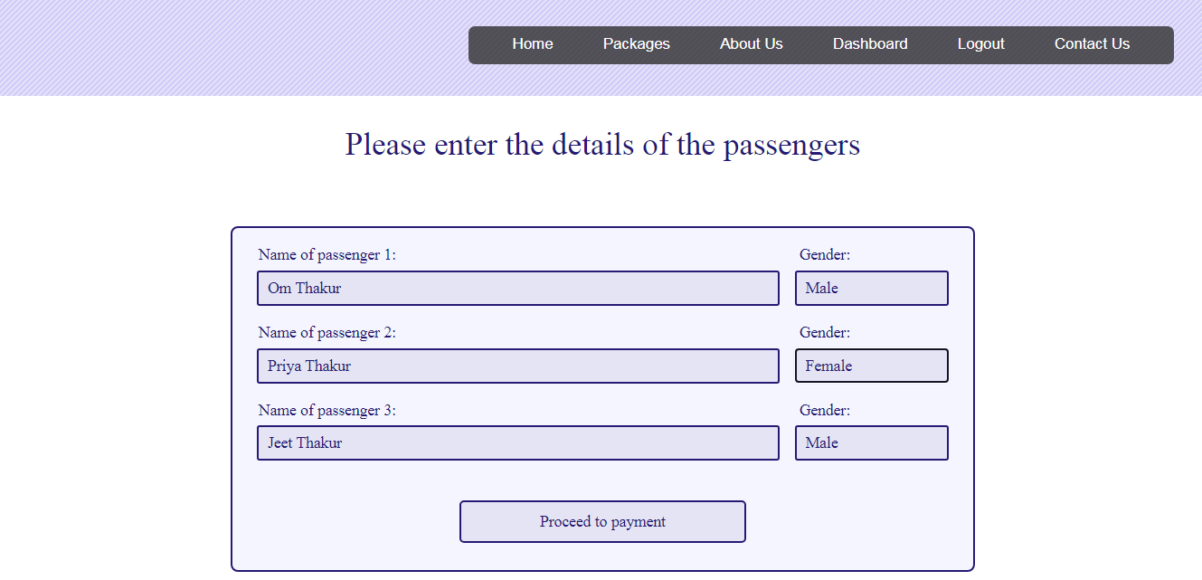

**CODING:**

<?php session_start();

if(!isset($_SESSION["username"]))

{

header("Location:blocked.php");

$_SESSION['url'] = $_SERVER['REQUEST_URI'];

}

?>

<!DOCTYPE html>

<html lang="en">

<!-- HEAD TAG STARTS -->

<head>

<meta charset="UTF-8">

<meta name="viewport" content="width=device-width, initial-scale=1.0"/>

<title>Passengers | tourism_management</title>

<link href="css/main.css" rel="stylesheet">

<link href="css/bootstrap.min.css" rel="stylesheet">

<link href="https://fonts.googleapis.com/css?family=Oswald:200,300,400|Raleway:100,300,400,500|Roboto:100,400,500,700" rel="stylesheet">

<link href="https://maxcdn.bootstrapcdn.com/font-awesome/4.7.0/css/font-awesome.min.css" rel="stylesheet">

<script src="js/jquery-3.2.1.min.js"></script>

<script src="js/main.js"></script>

<script src="js/bootstrap.min.js"></script>

</head>

<!-- HEAD TAG ENDS -->

<!-- BODY TAG STARTS -->

<body>

<?php include("common/headerLoggedIn.php"); ?>

<?php

$fare=$_POST["fareHidden"];

$mode=$_POST["modeHidden"];

if($mode=="OneWayFlight" || $mode=="ReturnTripFlight") {

$type=$_POST["typeHidden"];

$class=$_POST["classHidden"];

$origin=$_POST["originHidden"];

$destination=$_POST["destinationHidden"];

$depart=$_POST["departHidden"];

$return=$_POST["returnHidden"];

$adults=$_POST["adultsHidden"];

$children=$_POST["childrenHidden"];

$totalPassengers=(int)$adults+(int)$children;

if($type=="Return Trip") {

$flightNoOutbound=$_POST["flightNoOutboundHidden"];

$flightNoInbound=$_POST["flightNoInboundHidden"];

}

elseif($type=="One Way") {

$flightNoOutbound=$_POST["flightNoOutboundHidden"];

}

if($class=="Economy Class")

$className="Economy";

else

$className="Business";

}

elseif($mode=="bus") {

$date = $_POST["dateHidden"];

$busID = $_POST["busIDHidden"];

$totalPassengers=$_POST["noOfPassengersHidden"];

$origin=$_POST["originHidden"];

$destination=$_POST["destinationHidden"];

}

elseif($mode=="train") {

$date = $_POST["dateHidden"];

$day = $_POST["dayHidden"];

$trainID = $_POST["trainIDHidden"];

$totalPassengers=$_POST["noOfPassengersHidden"];

$origin=$_POST["originHidden"];

$destination=$_POST["destinationHidden"];

$class=$_POST["classHidden"];

}

?>

<div class="spacer">a</div>

<div class="col-sm-12 passengersWrapper">

<div class="headingOne">

Please enter the details of the passengers

</div>

<div class="col-sm-2"></div>

<div class="col-sm-8">

<div class="boxCenter">

<form action="payment.php" method="POST">

<?php for($i=1; $i<=$totalPassengers; $i++) {?>

<div class="col-sm-9 nameTag">Name of passenger <?php echo $i; ?>:</div>

<div class="col-sm-3 ageTag">Gender:</div>

<input type="text" class="inputPassengerName" name="name<?php echo $i; ?>" placeholder="Enter the full name of the passenger <?php echo $i; ?>" />

<select class="inputSmall" name="gender<?php echo $i; ?>" />

<option value="Male">Male</option>

<option value="Female">Female</option>

</select>

<?php } ?>

<div class="text-center">

<input type="submit" class="continueButton" value="Proceed to payment">

<input type="hidden" name="totalPassengersHidden" value="<?php echo $totalPassengers; ?>">

<input type="hidden" name="fareHidden" value="<?php echo $fare; ?>">

<input type="hidden" name="typeHidden" value="<?php echo $type; ?>">

<input type="hidden" name="classHidden" value="<?php echo $class; ?>">

<input type="hidden" name="originHidden" value="<?php echo $origin; ?>">

<input type="hidden" name="destinationHidden" value="<?php echo $destination; ?>">

<input type="hidden" name="departHidden" value="<?php echo $depart; ?>">

<input type="hidden" name="returnHidden" value="<?php echo $return; ?>">

<input type="hidden" name="adultsHidden" value="<?php echo $adults; ?>">

<input type="hidden" name="childrenHidden" value="<?php echo $children; ?>">

<input type="hidden" name="modeHidden" value="<?php echo $mode; ?>">

<?php if($mode=="bus") { ?>

<input type="hidden" name="dateHidden" value="<?php echo $date; ?>">

<input type="hidden" name="busIDHidden" value="<?php echo $busID; ?>">

<?php } ?>

<?php if($mode=="train") { ?>

<input type="hidden" name="dateHidden" value="<?php echo $date; ?>">

<input type="hidden" name="dayHidden" value="<?php echo $day; ?>">

<input type="hidden" name="classHidden" value="<?php echo $class; ?>">

<input type="hidden" name="trainIDHidden" value="<?php echo $trainID; ?>">

<?php } ?>

<?php if($mode=="OneWayFlight" || $mode=="ReturnTripFlight") {?>

<?php if($type=="Return Trip") { ?>

<input type="hidden" name="flightNoOutboundHidden" value="<?php echo $flightNoOutbound; ?>">

<input type="hidden" name="flightNoInboundHidden" value="<?php echo $flightNoInbound; ?>">

<?php } elseif($type=="One Way") { ?>

<input type="hidden" name="flightNoOutboundHidden" value="<?php echo $flightNoOutbound; ?>">

<?php } ?>

<?php } ?>

</form>

</div>

</div>

</div>

<div class="col-sm-2"></div>

</div>

<div class="spacerLarge">.</div><!-- just a dummy class for creating some space -->

<?php include("common/footer.php"); ?>

</body>

<!-- BODY TAG ENDS -->

</html>

**PAYMENT:**

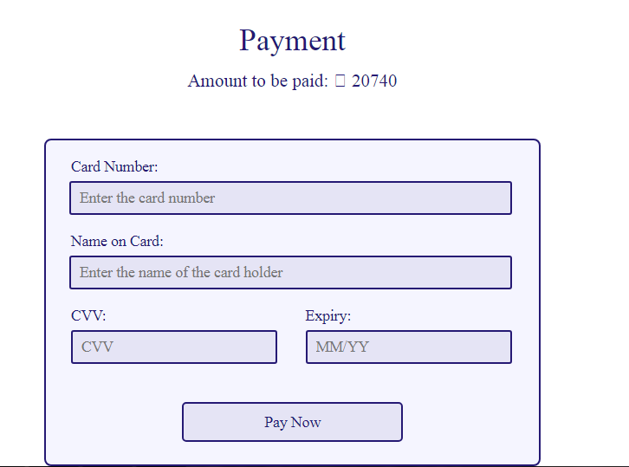

**CODING:**

<?php session_start();

if(!isset($_SESSION["username"]))

{

header("Location:blocked.php");

$_SESSION['url'] = $_SERVER['REQUEST_URI'];

}

?>

<!DOCTYPE html>

<html lang="en">

<!-- HEAD TAG STARTS -->

<head>

<meta charset="UTF-8">

<meta name="viewport" content="width=device-width, initial-scale=1.0"/>

<title>Payment | tourism_management</title>

<link href="css/main.css" rel="stylesheet">

<link href="css/bootstrap.min.css" rel="stylesheet">

<link href="https://fonts.googleapis.com/css?family=Oswald:200,300,400|Raleway:100,300,400,500|Roboto:100,400,500,700" rel="stylesheet">

<link href="https://maxcdn.bootstrapcdn.com/font-awesome/4.7.0/css/font-awesome.min.css" rel="stylesheet">

<script src="js/jquery-3.2.1.min.js"></script>

<script src="js/main.js"></script>

<script src="js/bootstrap.min.js"></script>

</head>

<!-- HEAD TAG ENDS -->

<!-- BODY TAG STARTS -->

<body>

<?php include("common/headerLoggedIn.php"); ?>

<?php

$mode=$_POST["modeHidden"];

if($mode=="ReturnTripFlight" or $mode=="OneWayFlight") {

$totalPassengers=$_POST["totalPassengersHidden"];

for($i=1; $i<=$totalPassengers; $i++) {

$name[$i]=$_POST["name$i"];

$gender[$i]=$_POST["gender$i"];

}

$fare=$_POST["fareHidden"];

$type=$_POST["typeHidden"];

$class=$_POST["classHidden"];

$origin=$_POST["originHidden"];

$destination=$_POST["destinationHidden"];

$depart=$_POST["departHidden"];

$return=$_POST["returnHidden"];

$adults=$_POST["adultsHidden"];

$children=$_POST["childrenHidden"];

$noOfPassengers=(int)$adults+(int)$children;

if($type=="Return Trip") {

$flightNoOutbound=$_POST["flightNoOutboundHidden"];

$flightNoInbound=$_POST["flightNoInboundHidden"];

}

elseif($type=="One Way") {

$flightNoOutbound=$_POST["flightNoOutboundHidden"];

}

if($class=="Economy Class")

$className="Economy";

else

$className="Business";

} // for flights

elseif($mode=="hotel") {

$fare=$_POST["fareHidden"];

$hotelID=$_POST["hotelIDHidden"];

} //for hotels

//elseif($mode=="cabs") {

// $fare=$_SESSION["cabsFare"];

// $carID=$_SESSION["carID"];

//} //for hotels

//elseif($mode=="bus") {

// $totalPassengers=$_POST["totalPassengersHidden"];

// $fare=$_POST["fareHidden"];

// $busID=$_POST["busIDHidden"];

// $origin=$_POST["originHidden"];

// $destination=$_POST["destinationHidden"];

// for($i=1; $i<=$totalPassengers; $i++) {

// $name[$i]=$_POST["name$i"];

// $gender[$i]=$_POST["gender$i"];

// }

//} //for bus

elseif($mode=="train") {

$totalPassengers=$_POST["totalPassengersHidden"];

$fare=$_POST["fareHidden"];

$trainID=$_POST["trainIDHidden"];

$origin=$_POST["originHidden"];

$destination=$_POST["destinationHidden"];

$date=$_POST["dateHidden"];

$day=$_POST["dayHidden"];

$class=$_POST["classHidden"];

for($i=1; $i<=$totalPassengers; $i++) {

$name[$i]=$_POST["name$i"];

$gender[$i]=$_POST["gender$i"];

}

} //for train

?>

<div class="spacer">a</div>

<div class="col-sm-12 paymentWrapper">

<div class="headingOne">

Payment

</div>

<div class="totalAmount">

Amount to be paid: <span class="sansSerif">₹</span><?php echo $fare; ?>

</div>

<!--<div class="col-sm-3"></div>-->

<div class="col-sm-3"></div>

<div class="col-sm-6">

<div class="boxCenter">

<div class="col-sm-12 tag">

Card Number:

</div>

<div class="col-sm-12">

<input type="text" class="input" name="cardNumber" placeholder="Enter the card number" id="cardNumber"/>

</div>

<div class="col-sm-12 tag">

Name on Card:

</div>

<div class="col-sm-12">

<input type="text" class="input" name="nameOnCard" placeholder="Enter the name of the card holder" id="nameOnCard"/>

</div>

<div class="col-sm-6 tag">

CVV:

</div>

<div class="col-sm-6 tag">

Expiry:

</div>

<div class="col-sm-6">

<input type="password" class="inputSmall" name="cvv" placeholder="CVV" id="cvv"/>

</div>

<div class="col-sm-6">

<input type="text" class="inputSmall" name="expiry" placeholder="MM/YY" id="cardExpiry"/>

</div>

<!-- flights -->

<?php if($mode=="ReturnTripFlight" or $mode=="OneWayFlight"): ?>

<form action="generateTicket.php" method="POST">

<div class="col-sm-12 bookingButton text-center">

<input type="submit" class="paymentButton" value="Pay Now">

</div>

<input type="hidden" name="totalPassengersHidden" value="<?php echo $totalPassengers; ?>">

<input type="hidden" name="fareHidden" value="<?php echo $fare; ?>">

<input type="hidden" name="typeHidden" value="<?php echo $type; ?>">

<input type="hidden" name="classHidden" value="<?php echo $class; ?>">

<input type="hidden" name="originHidden" value="<?php echo $origin; ?>">

<input type="hidden" name="destinationHidden" value="<?php echo $destination; ?>">

<input type="hidden" name="departHidden" value="<?php echo $depart; ?>">

<input type="hidden" name="returnHidden" value="<?php echo $return; ?>">

<input type="hidden" name="adultsHidden" value="<?php echo $adults; ?>">

<input type="hidden" name="childrenHidden" value="<?php echo $children; ?>">

<input type="hidden" name="modeHidden" value="<?php echo $mode ?>">

<?php for($i=1; $i<=$totalPassengers; $i++) {?>

<input type="hidden" name="nameHidden<?php echo $i; ?>" value="<?php echo $name[$i]; ?>">

<input type="hidden" name="genderHidden<?php echo $i; ?>" value="<?php echo $gender[$i]; ?>">

<?php } ?>

<?php if($type=="Return Trip") { ?>

<input type="hidden" name="flightNoOutboundHidden" value="<?php echo $flightNoOutbound; ?>">

<input type="hidden" name="flightNoInboundHidden" value="<?php echo $flightNoInbound; ?>">

<?php } elseif($type=="One Way") { ?>

<input type="hidden" name="flightNoOutboundHidden" value="<?php echo $flightNoOutbound; ?>">

<?php } ?>

</form>

<!-- hotels -->

<?php elseif($mode=="hotel"): ?>

<form action="generateReceipt.php" method="POST">

<div class="col-sm-12 bookingButton text-center">

<input type="submit" class="paymentButton" value="Pay Now">

</div>

<input type="hidden" name="hotelIDHidden" value="<?php echo $hotelID; ?>">

<input type="hidden" name="fareHidden" value="<?php echo $fare; ?>">

</form>

<!--trains--->

<?php elseif($mode=="train"): ?>

<form action="generateTrainTicket.php" method="POST">

<div class="col-sm-12 bookingButton text-center">

<?php $date=$_POST["dateHidden"]; ?>

<input type="hidden" name="dateHidden" value="<?php echo $date; ?>">

<input type="hidden" name="dayHidden" value="<?php echo $day; ?>">

<input type="hidden" name="classHidden" value="<?php echo $class; ?>">

<input type="submit" class="paymentButton" value="Pay Now">

</div>

<input type="hidden" name="totalPassengersHidden" value="<?php echo $totalPassengers; ?>">

<input type="hidden" name="fareHidden" value="<?php echo $fare; ?>">

<input type="hidden" name="originHidden" value="<?php echo $origin; ?>">

<input type="hidden" name="destinationHidden" value="<?php echo $destination; ?>">

<input type="hidden" name="modeHidden" value="<?php echo $mode ?>">

<?php for($i=1; $i<=$totalPassengers; $i++) {?>

<input type="hidden" name="nameHidden<?php echo $i; ?>" value="<?php echo $name[$i]; ?>">

<input type="hidden" name="genderHidden<?php echo $i; ?>" value="<?php echo $gender[$i]; ?>">

<?php } ?>

<input type="hidden" name="trainIDHidden" value="<?php echo $trainID; ?>">

</form>

<?php endif; ?>

</div>

</div>

<div class="col-sm-3"></div>

</div><!-- paymentWrapper -->

<div class="spacerLarge">.</div><!-- just a dummy class for creating some space -->

<?php include("common/footer.php"); ?>

</body>

<!-- BODY TAG ENDS -->

</html>

**E-Ticket :**

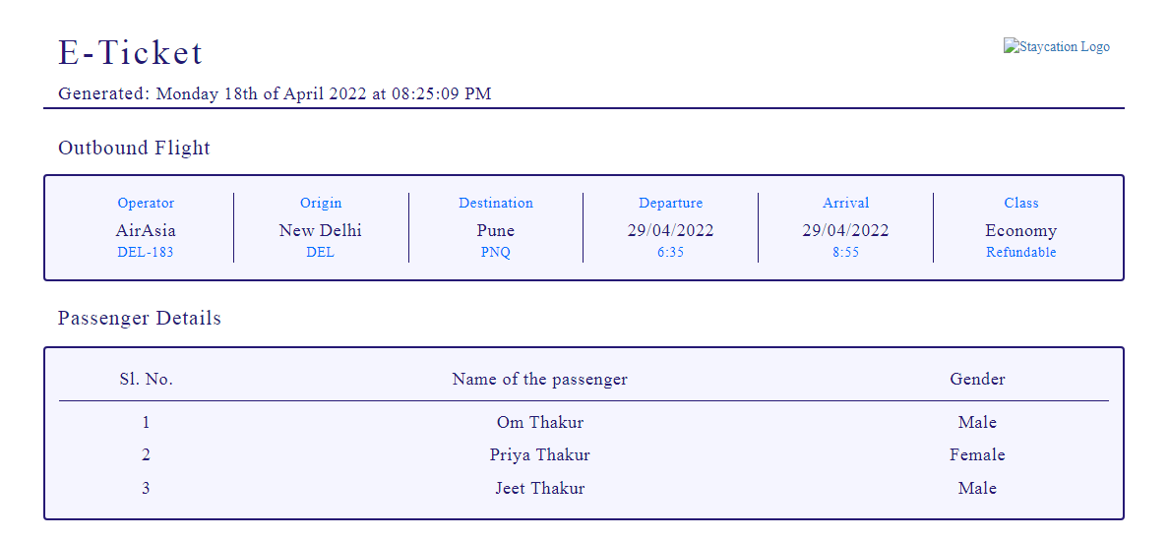

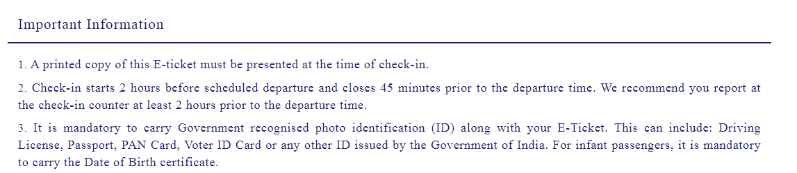

**CODING:**

<?php session_start();

if(!isset($_SESSION["username"]))

{

header("Location:blocked.php");

$_SESSION['url'] = $_SERVER['REQUEST_URI'];

}

?>

<!-- dumping the current page to buffer -->

<?php

ob_start();

?>

<!DOCTYPE html>

<html lang="en">

<!-- HEAD TAG STARTS -->

<head>

<meta charset="UTF-8">

<meta name="viewport" content="width=device-width, initial-scale=1.0"/>

<title>E-Ticket | tourism_management</title>

<link href="css/main.css" rel="stylesheet">

<link href="css/bootstrap.min.css" rel="stylesheet">

<link href="https://fonts.googleapis.com/css?family=Oswald:200,300,400|Raleway:100,300,400,500|Roboto:100,400,500,700" rel="stylesheet">

<link href="https://maxcdn.bootstrapcdn.com/font-awesome/4.7.0/css/font-awesome.min.css" rel="stylesheet">

<script src="js/jquery-3.2.1.min.js"></script>

<script src="js/main.js"></script>

<script src="js/bootstrap.min.js"></script>

</head>

<!-- HEAD TAG ENDS -->

<!-- BODY TAG STARTS -->

<body>

<div class="spacer">a</div>

<?php

date_default_timezone_set("Asia/Kolkata");

$date=date('l jS \of F Y \a\t h:i:s A');

$totalPassengers=$_POST["totalPassengersHidden"];

for($i=1; $i<=$totalPassengers; $i++) {

$name[$i]=$_POST["nameHidden$i"];

$gender[$i]=$_POST["genderHidden$i"];

}

$mode=$_POST["modeHidden"];

$fare=$_POST["fareHidden"];

$type=$_POST["typeHidden"];

$class=$_POST["classHidden"];

$origin=$_POST["originHidden"];

$destination=$_POST["destinationHidden"];

$depart=$_POST["departHidden"];

$return=$_POST["returnHidden"];

$adults=$_POST["adultsHidden"];

$children=$_POST["childrenHidden"];

$noOfPassengers=(int)$adults+(int)$children;

if($type=="Return Trip") {

$flightNoOutbound=$_POST["flightNoOutboundHidden"];

$flightNoInbound=$_POST["flightNoInboundHidden"];

}

elseif($type=="One Way") {

$flightNoOutbound=$_POST["flightNoOutboundHidden"];

}

if($class=="Economy Class")

$className="Economy";

else

$className="Business";

?>

<?php

$servername = "localhost";

$username = "root";

$password = "";

$dbname = "projectmeteor";

// Creating a connection to MySQL database

$conn = new mysqli($servername, $username, $password, $dbname);

// Checking if we've successfully connected to the database

if ($conn->connect_error) {

die("Connection failed: " . $conn->connect_error);

}

if($mode=="ReturnTripFlight"){

$getBookedSeatsOutboundSQL = "SELECT noOfBookings FROM `flights` WHERE flight_no='$flightNoOutbound'";

$getBookedSeatsOutboundQuery = $conn->query($getBookedSeatsOutboundSQL);

$bookedSeatsOutboundGet = $getBookedSeatsOutboundQuery ->fetch_array(MYSQLI_NUM);

$bookedSeatsOutbound = $bookedSeatsOutboundGet[0];

$newBookedSeats = $bookedSeatsOutbound+$totalPassengers;

//updating the no. of outbound bookings

$outboundBookingUpdateSQL = "UPDATE `flights` SET noOfBookings='$newBookedSeats' WHERE flight_no='$flightNoOutbound'";

$outboundBookingUpdateQuery = $conn->query($outboundBookingUpdateSQL);

$getBookedSeatsInboundSQL = "SELECT noOfBookings FROM `flights` WHERE flight_no='$flightNoInbound'";

$getBookedSeatsInboundQuery = $conn->query($getBookedSeatsInboundSQL);

$bookedSeatsInboundGet = $getBookedSeatsInboundQuery ->fetch_array(MYSQLI_NUM);

$bookedSeatsInbound = $bookedSeatsInboundGet[0];

$newBookedSeats = $bookedSeatsInbound+$totalPassengers;

//updating the no. of outbound bookings

$inboundBookingUpdateSQL = "UPDATE `flights` SET noOfBookings='$newBookedSeats' WHERE flight_no='$flightNoInbound'";

$inboundBookingUpdateQuery = $conn->query($inboundBookingUpdateSQL);

$getSeatsAvailableOutboundSQL = "SELECT seats_available FROM `flights` WHERE flight_no='$flightNoOutbound'";

$getSeatsAvailableOutboundQuery = $conn->query($getSeatsAvailableOutboundSQL);

$SeatsAvailableOutboundGet = $getSeatsAvailableOutboundQuery ->fetch_array(MYSQLI_NUM);

$seatsAvailableOutbound = $SeatsAvailableOutboundGet[0];

$newseatsAvailable = $seatsAvailableOutbound-$totalPassengers;

//updating the no. of outbound seats available

$outboundSeatUpdateSQL = "UPDATE `flights` SET seats_available='$newseatsAvailable' WHERE flight_no='$flightNoOutbound'";

$outboundSeatUpdateQuery = $conn->query($outboundSeatUpdateSQL);

$getSeatsAvailableInboundSQL = "SELECT seats_available FROM `flights` WHERE flight_no='$flightNoInbound'";

$getSeatsAvailableInboundQuery = $conn->query($getSeatsAvailableInboundSQL);

$SeatsAvailableInboundGet = $getSeatsAvailableInboundQuery ->fetch_array(MYSQLI_NUM);

$seatsAvailableInbound = $SeatsAvailableInboundGet[0];

$newseatsAvailable = $seatsAvailableInbound-$totalPassengers;

//updating the no. of outbound seats available

$inboundSeatUpdateSQL = "UPDATE `flights` SET seats_available='$newseatsAvailable' WHERE flight_no='$flightNoInbound'";

$inboundSeatUpdateQuery = $conn->query($inboundSeatUpdateSQL);

}

elseif($mode=="OneWayFlight"){

$getBookedSeatsOutboundSQL = "SELECT noOfBookings FROM `flights` WHERE flight_no='$flightNoOutbound'";

$getBookedSeatsOutboundQuery = $conn->query($getBookedSeatsOutboundSQL);

$bookedSeatsOutboundGet = $getBookedSeatsOutboundQuery ->fetch_array(MYSQLI_NUM);

$bookedSeatsOutbound = $bookedSeatsOutboundGet[0];

$newBookedSeats = $bookedSeatsOutbound+$totalPassengers;

//updating the no. of bookings

$outboundBookingUpdateSQL = "UPDATE `flights` SET noOfBookings='$newBookedSeats' WHERE flight_no='$flightNoOutbound'";

$outboundBookingUpdateQuery = $conn->query($outboundBookingUpdateSQL);

$getSeatsAvailableOutboundSQL = "SELECT seats_available FROM `flights` WHERE flight_no='$flightNoOutbound'";

$getSeatsAvailableOutboundQuery = $conn->query($getSeatsAvailableOutboundSQL);

$SeatsAvailableOutboundGet = $getSeatsAvailableOutboundQuery ->fetch_array(MYSQLI_NUM);

$seatsAvailableOutbound = $SeatsAvailableOutboundGet[0];

$newseatsAvailable = $seatsAvailableOutbound-$totalPassengers;

//updating the no. of seats available

$outboundSeatUpdateSQL = "UPDATE `flights` SET seats_available='$newseatsAvailable' WHERE flight_no='$flightNoOutbound'";

$outboundSeatUpdateQuery = $conn->query($outboundSeatUpdateSQL);

}

?>

<div class="col-sm-12 generateTicket">

<div class="commonHeader">

<div class="col-sm-1"></div>

<div class="col-sm-7 text-left">

<div class="headingOne">

E-Ticket

</div>

<div class="dateTime">

<span class="generated">Generated: </span><?php echo $date; ?>

</div>

</div>

<div class="col-sm-3 text-right">

<a href="./"><img src="images/stay.img" alt="Staycation Logo" /></a>

</div>

<div class="col-sm-1"></div>

<div class="col-sm-12"></div>

<div class="col-sm-1"></div>

<div class="col-sm-10 bar"></div>

<div class="col-sm-1"></div>

</div><!-- contains the header and logo -->

<!-- changing contents of the page based on mode -->

<?php if($mode=="OneWayFlight"): ?>

<div class="col-sm-12"></div><!-- empty class -->

<div class="col-sm-1"></div>

<div class="col-sm-10">

<div class="subHeading">

Outbound Flight

</div>

</div>

<div class="col-sm-12"></div><!-- empty class -->

<div class="col-sm-1"></div>

<div class="col-sm-10 boxCenter"><!-- outboundFlight Box -->

<?php

$outboundFlightSQL = "SELECT * FROM `flights` WHERE flight_no='$flightNoOutbound'";

$outboundFlightQuery = $conn->query($outboundFlightSQL);

$row = $outboundFlightQuery->fetch_assoc();

?>

<div class="col-sm-2 borderRight text-center">

<div class="flightOperatorHeading">

Operator

</div>

<div class="flightOperator">

<?php echo $row["operator"]; ?>

</div>

<div class="flightNo">

<?php echo $flightNoOutbound; ?>

</div>

</div><!-- col-sm-4 -->

<div class="col-sm-2 borderRight text-center">

<div class="originHeading">

Origin

</div>

<div class="origin">

<?php echo $row["origin"]; ?>

</div>

<div class="originSubscript">

<?php echo $row["origin_code"]; ?>

</div>

</div><!-- col-sm-4 -->

<div class="col-sm-2 borderRight text-center">

<div class="destinationHeading">

Destination

</div>

<div class="origin">

<?php echo $row["destination"]; ?>

</div>

<div class="destinationSubscript">

<?php echo $row["destination_code"]; ?>

</div>

</div><!-- col-sm-4 -->

<div class="col-sm-2 borderRight text-center">

<div class="departsHeading">

Departure

</div>

<div class="departs">

<?php echo $depart; ?>

</div>

<div class="departsSubscript">

<?php echo $row["departs"]; ?>

</div>

</div><!-- col-sm-4 -->

<div class="col-sm-2 borderRight text-center">

<div class="arrivesHeading">

Arrival

</div>

<div class="arrives">

<?php echo $depart; ?>

</div>

<div class="arrivesSubscript">

<?php echo $row["arrives"]; ?>

</div>

</div><!-- col-sm-4 -->

<div class="col-sm-2 text-center">

<div class="classHeading">

Class

</div>

<div class="class">

<?php echo $className; ?>

</div>

<div class="classSubscript">

<?php echo $row["refundable"]; ?>

</div>

</div><!-- col-sm-4 -->

</div><!-- outboundFlight Box -->

<div class="col-sm-12 spacer">a</div>

<div class="col-sm-1"></div>

<div class="col-sm-10">

<div class="subHeading">

Passenger Details

</div>

</div>

<div class="col-sm-12"></div><!-- empty class -->

<div class="col-sm-1"></div>

<div class="col-sm-12"></div><!-- empty class -->

<div class="col-sm-1"></div>

<div class="col-sm-10 boxCenter">

<div class="columnHeaders">

<div class="col-sm-2 borderBottom">

<div class="serialNoHeader text-center">

Sl. No.

</div>

</div>

<div class="col-sm-7 borderBottom">

<div class="passengerNameHeader text-center">

Name of the passenger

</div>

</div>

<div class="col-sm-3 borderBottom">

<div class="genderHeader text-center">

Gender

</div>

</div>

</div><!-- columnHeaders -->

<?php for($i=1; $i<=$totalPassengers; $i++) {?>

<div class="col-sm-2">

<div class="serialNo text-center">

<?php echo $i; ?>

</div>

</div>

<div class="col-sm-7">

<div class="passengerName text-center">

<?php echo $name[$i]; ?>

</div>

</div>

<div class="col-sm-3">

<div class="gender text-center">

<?php echo $gender[$i]; ?>

</div>

</div>

<?php } ?>

</div><!-- boxCenter -->

<div class="col-sm-1"></div>

<?php elseif($mode=="ReturnTripFlight"): ?>

<div class="col-sm-12"></div><!-- empty class -->

<div class="col-sm-1"></div>

<div class="col-sm-10">

<div class="subHeading">

Outbound Flight

</div>

</div>

<div class="col-sm-12"></div><!-- empty class -->

<div class="col-sm-1"></div>

<div class="col-sm-10 boxCenter"><!-- outboundFlight Box -->

<?php

$outboundFlightSQL = "SELECT * FROM `flights` WHERE flight_no='$flightNoOutbound'";

$outboundFlightQuery = $conn->query($outboundFlightSQL);

$rowOutbound = $outboundFlightQuery->fetch_assoc();

?>

<div class="col-sm-2 borderRight text-center">

<div class="flightOperatorHeading">

Operator

</div>

<div class="flightOperator">

<?php echo $rowOutbound["operator"]; ?>

</div>

<div class="flightNo">

<?php echo $flightNoOutbound; ?>

</div>

</div><!-- col-sm-4 -->

<div class="col-sm-2 borderRight text-center">

<div class="originHeading">

Origin

</div>

<div class="origin">

<?php echo $rowOutbound["origin"]; ?>

</div>

<div class="originSubscript">

<?php echo $rowOutbound["origin_code"]; ?>

</div>

</div><!-- col-sm-4 -->

<div class="col-sm-2 borderRight text-center">

<div class="destinationHeading">

Destination

</div>

<div class="origin">

<?php echo $rowOutbound["destination"]; ?>

</div>

<div class="destinationSubscript">

<?php echo $rowOutbound["destination_code"]; ?>

</div>

</div><!-- col-sm-4 -->

<div class="col-sm-2 borderRight text-center">

<div class="departsHeading">

Departure

</div>

<div class="departs">

<?php echo $depart; ?>

</div>

<div class="departsSubscript">

<?php echo $rowOutbound["departs"]; ?>

</div>

</div><!-- col-sm-4 -->

<div class="col-sm-2 borderRight text-center">

<div class="arrivesHeading">

Arrival

</div>

<div class="arrives">

<?php echo $depart; ?>

</div>

<div class="arrivesSubscript">

<?php echo $rowOutbound["arrives"]; ?>

</div>

</div><!-- col-sm-4 -->

<div class="col-sm-2 text-center">

<div class="classHeading">

Class

</div>

<div class="class">

<?php echo $className; ?>

</div>

<div class="classSubscript">

<?php echo $rowOutbound["refundable"]; ?>

</div>

</div><!-- col-sm-4 -->

</div><!-- outboundFlight Box -->

<div class="col-sm-1"></div>

<div class="col-sm-12 spacer">a</div>

<div class="col-sm-1"></div>

<div class="col-sm-10">

<div class="subHeading">

Inbound Flight

</div>

</div>

<div class="col-sm-12"></div><!-- empty class -->

<div class="col-sm-1"></div>

<div class="col-sm-10 boxCenter"><!-- inboundFlight Box -->

<?php

$outboundFlightSQL = "SELECT * FROM `flights` WHERE flight_no='$flightNoInbound'";

$inboundFlightQuery = $conn->query($outboundFlightSQL);

$rowInbound = $inboundFlightQuery->fetch_assoc()

?>

<div class="col-sm-2 borderRight text-center">

<div class="flightOperatorHeading">

Operator

</div>

<div class="flightOperator">

<?php echo $rowInbound["operator"]; ?>

</div>

<div class="flightNo">

<?php echo $flightNoInbound; ?>

</div>

</div><!-- col-sm-4 -->

<div class="col-sm-2 borderRight text-center">

<div class="originHeading">

Origin

</div>

<div class="origin">

<?php echo $rowInbound["origin"]; ?>

</div>

<div class="originSubscript">

<?php echo $rowInbound["origin_code"]; ?>

</div>

</div><!-- col-sm-4 -->

<div class="col-sm-2 borderRight text-center">

<div class="destinationHeading">

Destination

</div>

<div class="origin">

<?php echo $rowInbound["destination"]; ?>

</div>

<div class="destinationSubscript">

<?php echo $rowInbound["destination_code"]; ?>

</div>

</div><!-- col-sm-4 -->

<div class="col-sm-2 borderRight text-center">

<div class="departsHeading">

Departure

</div>

<div class="departs">

<?php echo $return; ?>

</div>

<div class="departsSubscript">

<?php echo $rowInbound["departs"]; ?>

</div>

</div><!-- col-sm-4 -->

<div class="col-sm-2 borderRight text-center">

<div class="arrivesHeading">

Arrival

</div>

<div class="arrives">

<?php echo $return; ?>

</div>

<div class="arrivesSubscript">

<?php echo $rowInbound["arrives"]; ?>

</div>

</div><!-- col-sm-4 -->

<div class="col-sm-2 text-center">

<div class="classHeading">

Class

</div>

<div class="class">

<?php echo $className; ?>

</div>

<div class="classSubscript">

<?php echo $rowInbound["refundable"]; ?>

</div>

</div><!-- col-sm-4 -->

</div><!-- inboundFlight Box -->

<div class="col-sm-12 spacer">a</div>

<div class="col-sm-1"></div>

<div class="col-sm-10">

<div class="subHeading">

Passenger Details

</div>

</div>

<div class="col-sm-12"></div><!-- empty class -->

<div class="col-sm-1"></div>

<div class="col-sm-12"></div><!-- empty class -->

<div class="col-sm-1"></div>

<div class="col-sm-10 boxCenter">

<div class="columnHeaders">

<div class="col-sm-2 borderBottom">

<div class="serialNoHeader text-center">

Sl. No.

</div>

</div>

<div class="col-sm-7 borderBottom">

<div class="passengerNameHeader text-center">

Name of the passenger

</div>

</div>

<div class="col-sm-3 borderBottom">

<div class="genderHeader text-center">

Gender

</div>

</div>

</div><!-- columnHeaders -->

<?php for($i=1; $i<=$totalPassengers; $i++) {?>

<div class="col-sm-2">

<div class="serialNo text-center">

<?php echo $i; ?>

</div>

</div>

<div class="col-sm-7">

<div class="passengerName text-center">

<?php echo $name[$i]; ?>

</div>

</div>

<div class="col-sm-3">

<div class="gender text-center">

<?php echo $gender[$i]; ?>

</div>

</div>

<?php } ?>

</div><!-- boxCenter -->

<div class="col-sm-1"></div>

<?php else: ?><!-- add buses, cabs, trains here -->

<div class="headingOne">

None

</div>

<?php endif; ?>

<div class="importantInfo">

<div class="col-sm-12"></div><!-- empty class -->

<div class="col-sm-12 spacer">a</div>

<div class="col-sm-12 spacer">a</div>

<div class="col-sm-1"></div>

<div class="col-sm-10">

<div class="subHeading">

Important Information

</div>

</div>

<div class="col-sm-1"></div>

<div class="col-sm-12"></div>

<div class="col-sm-1"></div>

<div class="col-sm-10 bar"></div>

<div class="col-sm-1"></div>

<div class="col-sm-12"></div>

<div class="col-sm-1"></div>

<div class="col-sm-10">

<div class="info">

<span class="strong">1.</span> A printed copy of this E-ticket must be presented at the time of check-in.

</div>

<div class="info">

<span class="strong">2.</span> Check-in starts 2 hours before scheduled departure and closes 45 minutes prior to the departure time. We recommend you report at the check-in counter at least 2 hours prior to the departure time.

</div>

<div class="info">

<span class="strong">3.</span> It is mandatory to carry Government recognised photo identification (ID) along with your E-Ticket. This can include: Driving License, Passport, PAN Card, Voter ID Card or any other ID issued by the Government of India. For infant passengers, it is mandatory to carry the Date of Birth certificate.

</div>

</div>

<div class="col-sm-1"></div>

<div class="col-sm-12 spacer">a</div>

<div class="col-sm-12"></div><!-- empty class -->

</div><!-- importantInfo -->

</div><!-- generateTicket -->

<div class="spacer">a</div>

</body>

<!-- BODY TAG ENDS -->

</html>

<!-- after user login system is built push the username using the curent session to the database -->

<?php

$user = $_SESSION["username"];

$dateFormatted=date("d-m-Y"); //formatting the date as DD-MM-YY

$bookingDataInsertSQL = "INSERT INTO `flightbookings`(username,date,cancelled,origin,destination,passengers,type) VALUES('$user','$dateFormatted','no','$origin','$destination','$totalPassengers','$mode')";

$bookingDataInsertQuery = $conn->query($bookingDataInsertSQL);

$bookingIDSQL = "SELECT * FROM `flightbookings` ORDER BY `bookingID` DESC LIMIT 1";

$bookingIDQuery = $conn->query($bookingIDSQL);

$bookingIDGet = $bookingIDQuery ->fetch_array(MYSQLI_NUM);

$latestBookingID = $bookingIDGet[0];

$currentBookingID = $latestBookingID;

?>

<!-- saving the file as temp.html -->

<?php

file_put_contents('tickets\ticket'.$currentBookingID.'.html', ob_get_contents());

?>

**USER DASHBOARD PROFILE:**

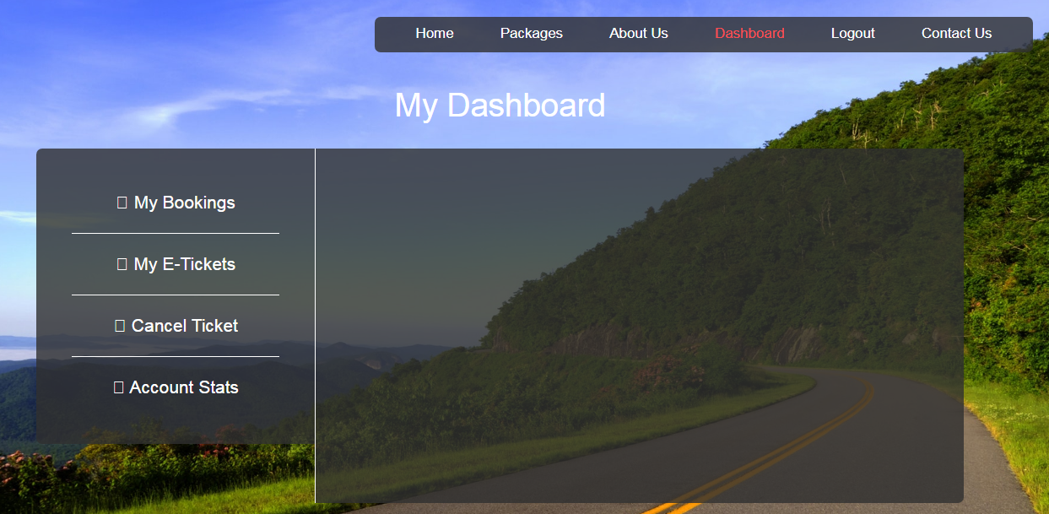

**CODING:**

<?php session_start();

if(!isset($_SESSION["username"]))

{

header("Location:blocked.php");

$_SESSION['url'] = $_SERVER['REQUEST_URI'];

}

?>

<!DOCTYPE html>

<html lang="en">

<!-- HEAD TAG STARTS -->

<head>

<meta charset="UTF-8">

<meta name="viewport" content="width=device-width, initial-scale=1.0"/>

<title>Dashboard | tourism_management</title>

<link href="css/main.css" rel="stylesheet">

<link href="css/bootstrap.min.css" rel="stylesheet">

<link href="css/bootstrap-select.css" rel="stylesheet">

<link href="css/bootstrap-datetimepicker.css" rel="stylesheet">

<link href="https://fonts.googleapis.com/css?family=Oswald:200,300,400|Raleway:100,300,400,500|Roboto:100,400,500,700" rel="stylesheet">

<link href="https://maxcdn.bootstrapcdn.com/font-awesome/4.7.0/css/font-awesome.min.css" rel="stylesheet">

<script src="js/jquery-3.2.1.min.js"></script>

<script src="js/userDashboard.js"></script>

<script src="js/bootstrap.min.js"></script>

<script src="js/bootstrap-select.js"></script>

<script src="js/bootstrap-dropdown.js"></script>

<script src="js/jquery-2.1.1.min.js"></script>

<script src="js/moment-with-locales.js"></script>

<script src="js/bootstrap-datetimepicker.js"></script>

</head>

<!-- HEAD TAG ENDS -->

<!-- BODY TAG STARTS -->

<?php

$servername = "localhost";

$username = "root";

$password = "";

$dbname = "projectmeteor";

// Creating a connection to MySQL database

$conn = new mysqli($servername, $username, $password, $dbname);

// Checking if successfully connected to the database

if ($conn->connect_error) {

die("Connection failed: " . $conn->connect_error);

}

?>

<body>

<div class="container-fluid">

<div class="col-sm-12 userDashboard text-center">

<?php include("common/headerDashboardTransparentLoggedIn.php"); ?>

<div class="col-sm-12">

<div class="heading text-center">

My Dashboard

</div>

</div>

<div class="col-sm-1"></div>

<div class="col-sm-3 containerBoxLeft">

<a href="userDashboardBookings.php">

<div class="col-sm-12 menuContainer bottomBorder">

<span class="fa fa-copy"></span> My Bookings

</div>

</a>

<a href="userDashboardETickets.php">

<div class="col-sm-12 menuContainer bottomBorder">

<span class="fa fa-clone"></span> My E-Tickets

</div>

</a>

<a href="userDashboardCancelTicket.php">

<div class="col-sm-12 menuContainer bottomBorder">

<span class="fa fa-close"></span> Cancel Ticket

</div>

</a>

<a href="userDashboardAccountSettings.php">

<div class="col-sm-12 menuContainer">

<span class="fa fa-bar-chart"></span> Account Stats

</div>

</a>

</div>

<div class="col-sm-7 containerBoxRight text-left">

<?php

$user = $_SESSION["username"];

//users query

$profileSQL = "SELECT * FROM `users` WHERE Username='$user'";

$profileQuery = $conn->query($profileSQL);

$row = $profileQuery->fetch_assoc();

?>

</div>

<div class="col-sm-1"></div>

<div class="col-sm-12 spacer">a</div>

<div class="col-sm-12 spacer">a</div>

</div>

</div><!-- container-fluid -->

<?php include("common/footer.php"); ?>

</body>

<!-- BODY TAG ENDS -->

</html>

**MY BOOKINGS:**

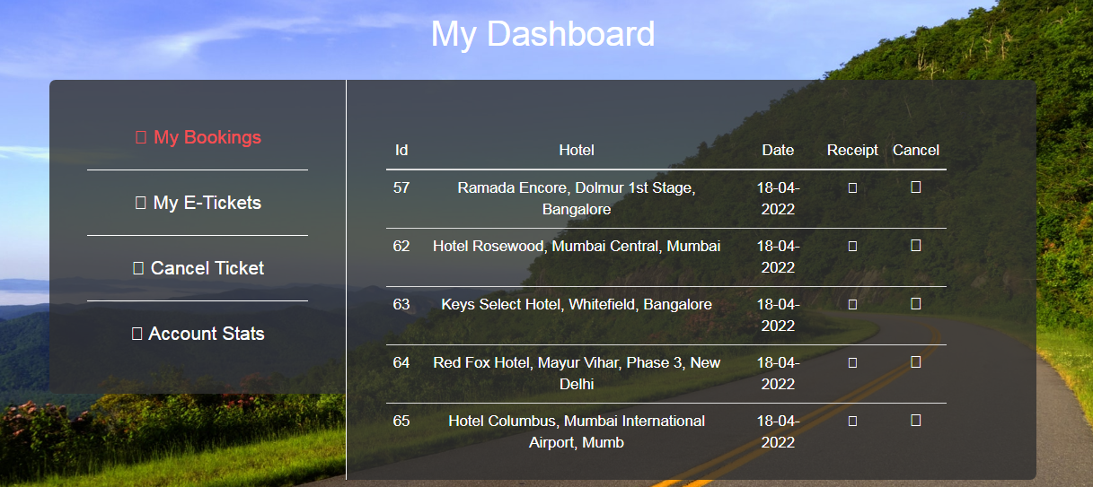

**CODING:**

<?php session_start();

if(!isset($_SESSION["username"]))

{

header("Location:blocked.php");

$_SESSION['url'] = $_SERVER['REQUEST_URI'];

}

?>

<!DOCTYPE html>

<html lang="en">

<!-- HEAD TAG STARTS -->

<head>

<meta charset="UTF-8">

<meta name="viewport" content="width=device-width, initial-scale=1.0"/>

<title>Dashboard | tourism_management</title>

<link href="css/main.css" rel="stylesheet">

<link href="css/bootstrap.min.css" rel="stylesheet">

<link href="css/bootstrap-select.css" rel="stylesheet">

<link href="css/bootstrap-datetimepicker.css" rel="stylesheet">

<link href="https://fonts.googleapis.com/css?family=Oswald:200,300,400|Raleway:100,300,400,500|Roboto:100,400,500,700" rel="stylesheet">

<link href="https://maxcdn.bootstrapcdn.com/font-awesome/4.7.0/css/font-awesome.min.css" rel="stylesheet">

<script src="js/jquery-3.2.1.min.js"></script>

<script src="js/userDashboard.js"></script>

<script src="js/bootstrap.min.js"></script>

<script src="js/bootstrap-select.js"></script>

<script src="js/bootstrap-dropdown.js"></script>

<script src="js/jquery-2.1.1.min.js"></script>

<script src="js/moment-with-locales.js"></script>

<script src="js/bootstrap-datetimepicker.js"></script>

</head>

<!-- HEAD TAG ENDS -->

<!-- BODY TAG STARTS -->

<?php

$servername = "localhost";

$username = "root";

$password = "";

$dbname = "projectmeteor";

// Creating a connection to MySQL database

$conn = new mysqli($servername, $username, $password, $dbname);

// Checking if successfully connected to the database

if ($conn->connect_error) {

die("Connection failed: " . $conn->connect_error);

}

?>

<body>

<div class="container-fluid">

<div class="col-sm-12 userDashboard text-center">

<?php include("common/headerDashboardTransparentLoggedIn.php"); ?>

<div class="col-sm-12">

<div class="heading">

My Dashboard

</div>

</div>

<div class="col-sm-1"></div>

<div class="col-sm-3 containerBoxLeft">

<div class="col-sm-12 menuContainer bottomBorder active">

<span class="fa fa-copy"></span> My Bookings

</div>

<a href="userDashboardETickets.php">

<div class="col-sm-12 menuContainer bottomBorder">

<span class="fa fa-clone"></span> My E-Tickets

</div>

</a>

<a href="userDashboardCancelTicket.php">

<div class="col-sm-12 menuContainer bottomBorder">

<span class="fa fa-close"></span> Cancel Ticket

</div>

</a>

<a href="userDashboardAccountSettings.php">

<div class="col-sm-12 menuContainer noBottomBorder">

<span class="fa fa-bar-chart"></span> Account Stats

</div>

</a>

</div>

<div class="col-sm-7 containerBoxRightHotel text-left">

<div class="col-sm-12 tickets">

<?php

$user = $_SESSION["username"];

$hotelBookingsSQL = "SELECT COUNT(*) FROM `hotelbookings` WHERE Username='$user' AND cancelled='no'";

$hotelBookingsQuery = $conn->query($hotelBookingsSQL);

$noOfHotelBookings = $hotelBookingsQuery->fetch_array(MYSQLI_NUM);

if($noOfHotelBookings[0]>0): ?>

<div class="col-sm-12 ticketTableContainer pullABitLeft" id="hotelBookingsWrapper">

<table class="table table-responsive">

<thead>

<tr>

<th class="tableHeaderTags text-center" style="vertical-align: middle;">Id</th>

<th class="tableHeaderTags text-center" style="vertical-align: middle;">Hotel</th>

<th class="tableHeaderTags text-center" style="vertical-align: middle;">Date</th>

<th class="tableHeaderTags text-center" style="vertical-align: middle;">Receipt</th>

<th class="tableHeaderTags text-center" style="vertical-align: middle;">Cancel</th>

</tr>

</thead>

<?php

//checking hotel booking query

$hotelBooksSQL = "SELECT * FROM `hotelbookings` WHERE username='$user' AND cancelled='no'";

$hotelBooksQuery = $conn->query($hotelBooksSQL);

while($hotelBooksRow = $hotelBooksQuery->fetch_assoc()) {

?>

<tr>

<td class="tableElementTagsNoHover text-center"><?php echo $hotelBooksRow["bookingID"]; ?></td>

<td class="tableElementTagsNoHover text-center"><?php echo $hotelBooksRow["hotelName"]; ?></td>

<td class="tableElementTagsNoHover text-center"><?php echo $hotelBooksRow["date"]; ?></td>

<td class="text-center"><a href="receipts/receipt<?php echo $hotelBooksRow["bookingID"]; ?>.html" target="_blank"><span class="fa fa-download tableElementTags pullSpan"></span></a></td>

<td class="tableElementTags text-center"><span class="fa fa-remove tableElementTags pullTop cancelBooking"></span></td>

</tr>

<?php } ?>

</table>

</div>

<?php else: ?>

<div class="col-sm-12 ticketTableContainer" id="flightTicketsWrapper">

<div class="noBooking">

Looks like you haven't booked any flight with us yet.

</div>

</div>

<?php endif; ?>

?>

</div>

<div class="col-sm-1"></div>

</div>

<div class="col-sm-12 spacer">a</div>

<div class="col-sm-12 spacer">a</div>

</div>

</div><!-- container-fluid -->

<?php include("common/footer.php"); ?>

</body>

<!-- BODY TAG ENDS -->

</html>

**MY E-TICKETS :**

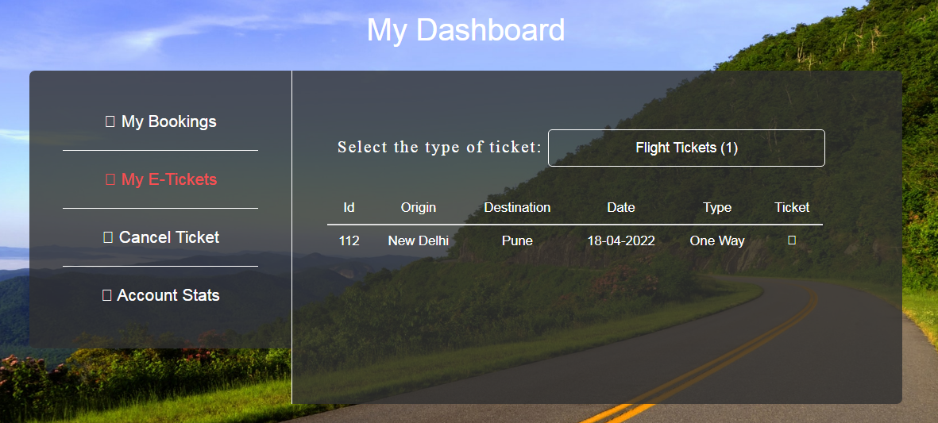

**CODING:**

<?php session_start();

if(!isset($_SESSION["username"]))

{

header("Location:blocked.php");

$_SESSION['url'] = $_SERVER['REQUEST_URI'];

}

?>

<!DOCTYPE html>

<html lang="en">

<!-- HEAD TAG STARTS -->

<head>

<meta charset="UTF-8">

<meta name="viewport" content="width=device-width, initial-scale=1.0"/>

<title>Dashboard | tourism_management</title>

<link href="css/main.css" rel="stylesheet">

<link href="css/bootstrap.min.css" rel="stylesheet">

<link href="css/bootstrap-select.css" rel="stylesheet">

<link href="css/bootstrap-datetimepicker.css" rel="stylesheet">

<link href="https://fonts.googleapis.com/css?family=Oswald:200,300,400|Raleway:100,300,400,500|Roboto:100,400,500,700" rel="stylesheet">

<link href="https://maxcdn.bootstrapcdn.com/font-awesome/4.7.0/css/font-awesome.min.css" rel="stylesheet">

<script src="js/jquery-3.2.1.min.js"></script>

<script src="js/userDashboard.js"></script>

<script src="js/bootstrap.min.js"></script>

<script src="js/bootstrap-select.js"></script>

<script src="js/bootstrap-dropdown.js"></script>

<script src="js/jquery-2.1.1.min.js"></script>

<script src="js/moment-with-locales.js"></script>

<script src="js/bootstrap-datetimepicker.js"></script>

</head>

<!-- HEAD TAG ENDS -->

<!-- BODY TAG STARTS -->

<?php

$servername = "localhost";

$username = "root";

$password = "";

$dbname = "projectmeteor";

// Creating a connection to MySQL database

$conn = new mysqli($servername, $username, $password, $dbname);

// Checking if successfully connected to the database

if ($conn->connect_error) {

die("Connection failed: " . $conn->connect_error);

}

?>

<body>

<div class="container-fluid">

<div class="col-sm-12 userDashboard text-center">

<?php include("common/headerDashboardTransparentLoggedIn.php"); ?>

<div class="col-sm-12">

<div class="heading text-center">

My Dashboard

</div>

</div>

<div class="col-sm-1"></div>

<div class="col-sm-3 containerBoxLeft">

<a href="userDashboardBookings.php">

<div class="col-sm-12 menuContainer bottomBorder">

<span class="fa fa-copy"></span> My Bookings

</div>

</a>

<div class="col-sm-12 menuContainer bottomBorder active">

<span class="fa fa-clone"></span> My E-Tickets

</div>

<a href="userDashboardCancelTicket.php">

<div class="col-sm-12 menuContainer bottomBorder">

<span class="fa fa-close"></span> Cancel Ticket

</div>

</a>

<a href="userDashboardAccountSettings.php">

<div class="col-sm-12 menuContainer">

<span class="fa fa-bar-chart"></span> Account Stats

</div>

</a>

</div>

<div class="col-sm-7 containerBoxRight text-left">

<?php

$user = $_SESSION["username"];

//flight bookings query

$flightBookingsSQL = "SELECT COUNT(*) FROM `flightbookings` WHERE Username='$user' AND cancelled='no'";

$flightBookingsQuery = $conn->query($flightBookingsSQL);

$noOfFlightBookings = $flightBookingsQuery->fetch_array(MYSQLI_NUM);

// train bookings query

$trainBookingsSQL = "SELECT COUNT(*) FROM `trainbookings` WHERE username='$user' AND cancelled='no'";

$trainBookingsQuery = $conn->query($trainBookingsSQL);

$noOfTrainBookings = $trainBookingsQuery->fetch_array(MYSQLI_NUM);

?>

<div class="col-sm-12 tickets">

<div class="col-sm-6 ticketsWrapper topMargin">

<div class="tag">Select the type of ticket: </div>

</div>

<div class="col-sm-6 topMargin pullLeft">

<select class="input" name="ticketTypeSelector" id="ticketTypeSelector"/>

<option value="flightTickets">Flight Tickets (<?php echo $noOfFlightBookings[0]; ?>)</option>

<option value="trainTickets">Train Tickets (<?php echo $noOfTrainBookings[0]; ?>)</option><!-- change echo -->

</select>

</div>

<?php if($noOfFlightBookings[0]>0): ?>

<!-------------------------------------------------------------------------------------------------

FLIGHT TICKETS SECTION STARTS

--------------------------------------------------------------------------------------------------->

<div class="col-sm-12 ticketTableContainer pullABitLeft" id="flightTicketsWrapper">

<table class="table table-responsive">

<thead>

<tr>

<th class="tableHeaderTags text-center" style="vertical-align: middle;">Id</th>

<th class="tableHeaderTags text-center" style="vertical-align: middle;">Origin</th>

<th class="tableHeaderTags text-center" style="vertical-align: middle;">Destination</th>

<th class="tableHeaderTags text-center" style="vertical-align: middle;">Date</th>

<th class="tableHeaderTags text-center" style="vertical-align: middle;">Type</th>

<th class="tableHeaderTags text-center" style="vertical-align: middle;">Ticket</th>

</tr>

</thead>

<?php

$flightTicketsSQL = "SELECT * FROM `flightbookings` WHERE username='$user' AND cancelled='no'";

$flightTicketsQuery = $conn->query($flightTicketsSQL);

while($flightTicketsRow = $flightTicketsQuery->fetch_assoc()) {

$modeDB=$flightTicketsRow["type"];

if($modeDB=="OneWayFlight") {

$modePrint="One Way";

}

else if($modeDB=="ReturnTripFlight") {

$modePrint="Return Trip";

}

?>

<tr>

<td class="tableElementTagsNoHover text-center"><?php echo $flightTicketsRow["bookingID"]; ?></td>

<td class="tableElementTagsNoHover text-center"><?php echo $flightTicketsRow["origin"]; ?></td>

<td class="tableElementTagsNoHover text-center"><?php echo $flightTicketsRow["destination"]; ?></td>

<td class="tableElementTagsNoHover text-center"><?php echo $flightTicketsRow["date"]; ?></td>

<td class="tableElementTagsNoHover text-center"><?php echo $modePrint; ?></td>

<td class="text-center"><a href="tickets/ticket<?php echo $flightTicketsRow["bookingID"]; ?>.html" target="_blank"><span class="fa fa-download tableElementTags pullSpan"></span></a></td>

</tr>

<?php } ?>

</table>

</div>

<?php else: ?>

<div class="col-sm-12 ticketTableContainer" id="flightTicketsWrapper">

<div class="noBooking">

Looks like you haven't booked any flight with us yet.

</div>

</div>

<?php endif; ?>

<!-------------------------------------------------------------------------------------------------

FLIGHT TICKETS SECTION ENDS

--------------------------------------------------------------------------------------------------->

<?php if($noOfTrainBookings[0]>0): ?>

<!-------------------------------------------------------------------------------------------------

TRAIN TICKETS SECTION STARTS

--------------------------------------------------------------------------------------------------->

<div class="col-sm-12 ticketTableContainer pullABitLeft" id="trainTicketsWrapper">

<table class="table table-responsive">

<thead>

<tr>

<th class="tableHeaderTags text-center" style="vertical-align: middle;">Id</th>

<th class="tableHeaderTags text-center" style="vertical-align: middle;">Origin</th>

<th class="tableHeaderTags text-center" style="vertical-align: middle;">Destination</th>

<th class="tableHeaderTags text-center" style="vertical-align: middle;">Date</th>

<th class="tableHeaderTags text-center" style="vertical-align: middle;">Ticket</th>

</tr>

</thead>

<?php

$trainTicketsSQL = "SELECT * FROM `trainbookings` WHERE username='$user' AND cancelled='no'";

$trainTicketsQuery = $conn->query($trainTicketsSQL);

while($trainTicketsRow = $trainTicketsQuery->fetch_assoc()) {

?>

<tr>

<td class="tableElementTagsNoHover text-center"><?php echo $trainTicketsRow["bookingID"]; ?></td>

<td class="tableElementTagsNoHover text-center"><?php echo $trainTicketsRow["origin"]; ?></td>

<td class="tableElementTagsNoHover text-center"><?php echo $trainTicketsRow["destination"]; ?></td>

<td class="tableElementTagsNoHover text-center"><?php echo $trainTicketsRow["date"]; ?></td>

<td class="text-center"><a href="tickets/trainTicket<?php echo $trainTicketsRow["bookingID"]; ?>.html" target="_blank"><span class="fa fa-download tableElementTags pullSpan"></span></a></td>

</tr>

<?php } ?>

</table>

</div>

<?php else: ?>

<div class="col-sm-12 ticketTableContainer" id="trainTicketsWrapper">

<div class="noBooking">

Looks like you haven't booked any train with us yet. This area will list all your train bookings once you start booking trains.

</div>

</div>

<?php endif; ?>

<!-------------------------------------------------------------------------------------------------

TRAIN TICKETS SECTION ENDS

--------------------------------------------------------------------------------------------------->

</div>

</div><!-- containerBoxRight -->

<div class="col-sm-1"></div>

<div class="col-sm-12 spacer">a</div>

<div class="col-sm-12 spacer">a</div>

</div>

</div><!-- container-fluid -->

<?php include("common/footer.php"); ?>

</body>

<!-- BODY TAG ENDS -->

</html>

**CANCEL TICKET:**

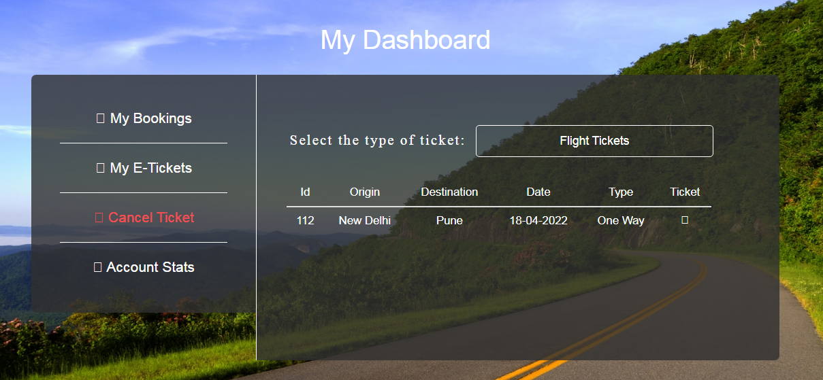

**CODING:**

<?php session_start();

if(!isset($_SESSION["username"]))

{

header("Location:blocked.php");

$_SESSION['url'] = $_SERVER['REQUEST_URI'];

}

?>

<!DOCTYPE html>

<html lang="en">

<!-- HEAD TAG STARTS -->

<head>

<meta charset="UTF-8">

<meta name="viewport" content="width=device-width, initial-scale=1.0"/>

<title>Dashboard | tourism_management</title>

<link href="css/main.css" rel="stylesheet">

<link href="css/bootstrap.min.css" rel="stylesheet">

<link href="css/bootstrap-select.css" rel="stylesheet">

<link href="css/bootstrap-datetimepicker.css" rel="stylesheet">

<link href="https://fonts.googleapis.com/css?family=Oswald:200,300,400|Raleway:100,300,400,500|Roboto:100,400,500,700" rel="stylesheet">

<link href="https://maxcdn.bootstrapcdn.com/font-awesome/4.7.0/css/font-awesome.min.css" rel="stylesheet">

<script src="js/jquery-3.2.1.min.js"></script>

<script src="js/userDashboard.js"></script>

<script src="js/bootstrap.min.js"></script>

<script src="js/bootstrap-select.js"></script>

<script src="js/bootstrap-dropdown.js"></script>

<script src="js/jquery-2.1.1.min.js"></script>

<script src="js/moment-with-locales.js"></script>

<script src="js/bootstrap-datetimepicker.js"></script>

</head>

<!-- HEAD TAG ENDS -->

<!-- BODY TAG STARTS -->

<?php

$servername = "localhost";

$username = "root";

$password = "";

$dbname = "projectmeteor";

// Creating a connection to MySQL database

$conn = new mysqli($servername, $username, $password, $dbname);

// Checking if successfully connected to the database

if ($conn->connect_error) {

die("Connection failed: " . $conn->connect_error);

}

?>

<body>

<div class="container-fluid">

<div class="col-sm-12 userDashboard text-center">

<?php include("common/headerDashboardTransparentLoggedIn.php"); ?>

<div class="col-sm-12">

<div class="heading text-center">

My Dashboard

</div>

</div>

<div class="col-sm-1"></div>

<div class="col-sm-3 containerBoxLeft">

<a href="userDashboardBookings.php">

<div class="col-sm-12 menuContainer bottomBorder">

<span class="fa fa-copy"></span> My Bookings

</div>

</a>

<a href="userDashboardETickets.php">

<div class="col-sm-12 menuContainer bottomBorder">

<span class="fa fa-clone"></span> My E-Tickets

</div>

</a>

<div class="col-sm-12 menuContainer bottomBorder active">

<span class="fa fa-close"></span> Cancel Ticket

</div>

<a href="userDashboardAccountSettings.php">

<div class="col-sm-12 menuContainer noBottomBorder">

<span class="fa fa-bar-chart"></span> Account Stats

</div>

</a>

</div>

<div class="col-sm-7 containerBoxRight">

<?php

$user = $_SESSION["username"];

//flight booking check query

$flightBookingsSQL = "SELECT COUNT(*) FROM `flightbookings` WHERE Username='$user' AND cancelled='no'";

$flightBookingsQuery = $conn->query($flightBookingsSQL);

$noOfFlightBookings = $flightBookingsQuery->fetch_array(MYSQLI_NUM);

//trains bookings check query

$trainBookingsSQL = "SELECT COUNT(*) FROM `trainbookings` WHERE Username='$user' AND cancelled='no'";

$trainBookingsQuery = $conn->query($trainBookingsSQL);

$noOfTrainBookings = $trainBookingsQuery->fetch_array(MYSQLI_NUM);

?>

<div class="col-sm-12 tickets">

<div class="col-sm-6 ticketsWrapper topMargin">

<div class="tagLeft">Select the type of ticket: </div>

</div>

<div class="col-sm-6 topMargin pullLeft">

<select class="input" name="ticketTypeSelector" id="ticketTypeSelector"/>

<option value="flightTickets">Flight Tickets</option>

<option value="trainTickets">Train Tickets</option><!-- change echo -->

</select>

</div>

<?php if($noOfFlightBookings[0]>0): ?>

<!-------------------------------------------------------------------------------------------------

FLIGHT TICKETS SECTION STARTS

--------------------------------------------------------------------------------------------------->

<div class="col-sm-12 ticketTableContainer pullABitLeft" id="flightTicketsWrapper">

<table class="table table-responsive">

<thead>

<tr>

<th class="tableHeaderTags text-center" style="vertical-align: middle;">Id</th>

<th class="tableHeaderTags text-center" style="vertical-align: middle;">Origin</th>

<th class="tableHeaderTags text-center" style="vertical-align: middle;">Destination</th>

<th class="tableHeaderTags text-center" style="vertical-align: middle;">Date</th>

<th class="tableHeaderTags text-center" style="vertical-align: middle;">Type</th>

<th class="tableHeaderTags text-center" style="vertical-align: middle;">Ticket</th>

</tr>

</thead>

<?php

$flightTicketsSQL = "SELECT * FROM `flightbookings` WHERE username='$user' AND cancelled='no'";

$flightTicketsQuery = $conn->query($flightTicketsSQL);

while($flightTicketsRow = $flightTicketsQuery->fetch_assoc()) {

$modeDB=$flightTicketsRow["type"];

if($modeDB=="OneWayFlight") {

$modePrint="One Way";

}

else if($modeDB=="ReturnTripFlight") {

$modePrint="Return Trip";

}

?>

<tr>

<td class="tableElementTagsNoHover text-center"><?php echo $flightTicketsRow["bookingID"]; ?></td>

<td class="tableElementTagsNoHover text-center"><?php echo $flightTicketsRow["origin"]; ?></td>

<td class="tableElementTagsNoHover text-center"><?php echo $flightTicketsRow["destination"]; ?></td>

<td class="tableElementTagsNoHover text-center"><?php echo $flightTicketsRow["date"]; ?></td>

<td class="tableElementTagsNoHover text-center"><?php echo $modePrint; ?></td>

<td class="text-center"><span class="fa fa-remove tableElementTags pullSpan cancelTicket"></span></td>

</tr>

<?php } ?>

</table>

</div>

<?php else: ?>

<div class="col-sm-12 ticketTableContainer" id="flightTicketsWrapper">

<div class="noBooking">

Looks like you haven't booked any flight with us yet.

</div>

</div>

<?php endif; ?>

<!-------------------------------------------------------------------------------------------------

FLIGHT TICKETS SECTION ENDS

--------------------------------------------------------------------------------------------------->

<?php if($noOfTrainBookings[0]>0): ?>

<!-------------------------------------------------------------------------------------------------

TRAIN TICKETS SECTION STARTS

--------------------------------------------------------------------------------------------------->

<div class="col-sm-12 ticketTableContainer pullABitLeft" id="trainTicketsWrapper">

<table class="table table-responsive">

<thead>

<tr>

<th class="tableHeaderTags text-center" style="vertical-align: middle;">Id</th>

<th class="tableHeaderTags text-center" style="vertical-align: middle;">Origin</th>

<th class="tableHeaderTags text-center" style="vertical-align: middle;">Destination</th>

<th class="tableHeaderTags text-center" style="vertical-align: middle;">Date</th>

<th class="tableHeaderTags text-center" style="vertical-align: middle;">Ticket</th>

</tr>

</thead>

<?php

$trainTicketsSQL = "SELECT * FROM `trainbookings` WHERE username='$user' AND cancelled='no'";

$trainTicketsQuery = $conn->query($trainTicketsSQL);

while($trainTicketsRow = $trainTicketsQuery->fetch_assoc()) {

?>

<tr>

<td class="tableElementTagsNoHover text-center"><?php echo $trainTicketsRow["bookingID"]; ?></td>

<td class="tableElementTagsNoHover text-center"><?php echo $trainTicketsRow["origin"]; ?></td>

<td class="tableElementTagsNoHover text-center"><?php echo $trainTicketsRow["destination"]; ?></td>

<td class="tableElementTagsNoHover text-center"><?php echo $trainTicketsRow["date"]; ?></td>

<td class="text-center"><span class="fa fa-remove tableElementTags pullSpan cancelTrainTicket"></span></td>

</tr>

<?php } ?>

</table>

</div>

<?php else: ?>

<div class="col-sm-12 ticketTableContainer" id="trainTicketsWrapper">

<div class="noBooking">

Looks like you haven't booked any train with us yet. This area will list all your train bookings once you start booking trains.

</div>

</div>

<?php endif; ?>

<!-------------------------------------------------------------------------------------------------

TRAIN TICKETS SECTION ENDS

--------------------------------------------------------------------------------------------------->

</div>

</div>

<div class="col-sm-1"></div>

<div class="col-sm-12 spacer">a</div>

<div class="col-sm-12 spacer">a</div>

</div>

</div><!-- container-fluid -->

<?php include("common/footer.php"); ?>

</body>

<!-- BODY TAG ENDS -->

</html>

**ACCOUNT STATS:**

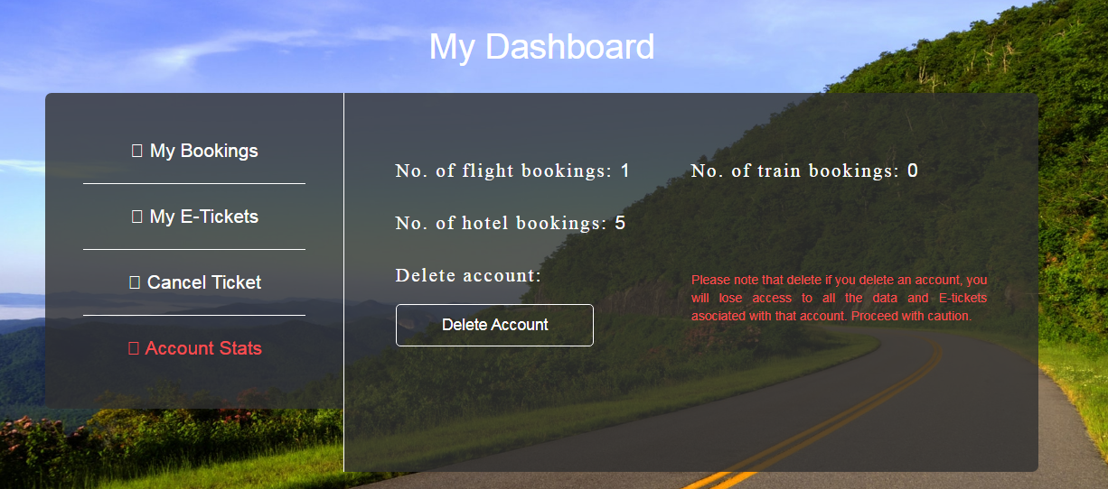

**CODING:**

<?php session_start();

if(!isset($_SESSION["username"]))

{

header("Location:blocked.php");

$_SESSION['url'] = $_SERVER['REQUEST_URI'];

}

?>

<!DOCTYPE html>

<html lang="en">

<!-- HEAD TAG STARTS -->

<head>

<meta charset="UTF-8">

<meta name="viewport" content="width=device-width, initial-scale=1.0"/>

<title>Dashboard | tourism_management</title>

<link href="css/main.css" rel="stylesheet">

<link href="css/bootstrap.min.css" rel="stylesheet">

<link href="css/bootstrap-select.css" rel="stylesheet">

<link href="css/bootstrap-datetimepicker.css" rel="stylesheet">

<link href="https://fonts.googleapis.com/css?family=Oswald:200,300,400|Raleway:100,300,400,500|Roboto:100,400,500,700" rel="stylesheet">

<link href="https://maxcdn.bootstrapcdn.com/font-awesome/4.7.0/css/font-awesome.min.css" rel="stylesheet">

<script src="js/jquery-3.2.1.min.js"></script>

<script src="js/userDashboard.js"></script>

<script src="js/bootstrap.min.js"></script>

<script src="js/bootstrap-select.js"></script>

<script src="js/bootstrap-dropdown.js"></script>

<script src="js/jquery-2.1.1.min.js"></script>

<script src="js/moment-with-locales.js"></script>

<script src="js/bootstrap-datetimepicker.js"></script>

</head>

<!-- HEAD TAG ENDS -->

<!-- BODY TAG STARTS -->

<?php

$servername = "localhost";

$username = "root";

$password = "";

$dbname = "projectmeteor";

// Creating a connection to MySQL database

$conn = new mysqli($servername, $username, $password, $dbname);

// Checking if successfully connected to the database

if ($conn->connect_error) {

die("Connection failed: " . $conn->connect_error);

}

?>

<body>

<div class="container-fluid">

<div class="col-sm-12 userDashboard text-center">

<?php include("common/headerDashboardTransparentLoggedIn.php"); ?>

<div class="col-sm-12">

<div class="heading">

My Dashboard

</div>

</div>

<div class="col-sm-1"></div>

<div class="col-sm-3 containerBoxLeft">

<a href="userDashboardBookings.php">

<div class="col-sm-12 menuContainer bottomBorder">

<span class="fa fa-copy"></span> My Bookings

</div>

</a>

<a href="userDashboardETickets.php">

<div class="col-sm-12 menuContainer bottomBorder">

<span class="fa fa-clone"></span> My E-Tickets

</div>

</a>

<a href="userDashboardCancelTicket.php">

<div class="col-sm-12 menuContainer bottomBorder">

<span class="fa fa-close"></span> Cancel Ticket

</div>

</a>

<div class="col-sm-12 menuContainer active">

<span class="fa fa-bar-chart"></span> Account Stats

</div>

</div>

<div class="col-sm-7 containerBoxRight text-left">

<?php

$user = $_SESSION["username"];

$flightBookingsSQL = "SELECT COUNT(*) FROM `flightbookings` WHERE Username='$user'";

$flightBookingsQuery = $conn->query($flightBookingsSQL);

$noOfFlightBookings = $flightBookingsQuery->fetch_array(MYSQLI_NUM);

$hotelBookingsSQL = "SELECT COUNT(*) FROM `hotelbookings` WHERE Username='$user'";

$hotelBookingsQuery = $conn->query($hotelBookingsSQL);

$noOfHotelBookings = $hotelBookingsQuery->fetch_array(MYSQLI_NUM);

$trainBookingsSQL = "SELECT COUNT(*) FROM `trainbookings` WHERE Username='$user'";

$trainBookingsQuery = $conn->query($trainBookingsSQL);

$noOfTrainBookings = $trainBookingsQuery->fetch_array(MYSQLI_NUM);

?>

<div class="col-sm-12 settings">

<div class="col-sm-6 settingsWrapper topMargin">

<span class="tag">No. of flight bookings: </span><span class="content"><?php echo $noOfFlightBookings[0]; ?></span>

</div>

<div class="col-sm-6 settingsWrapper topMargin">

<span class="tag">No. of train bookings: </span><span class="content text"><?php echo $noOfTrainBookings[0];?></span>

</div><!-- change echo -->

<div class="col-sm-12 settingsWrapper">

<span class="tag">No. of hotel bookings: </span><span class="content"><?php echo $noOfHotelBookings[0]; ; ?></span>

</div><!-- change echo -->

<div class="col-sm-6 settingsWrapper">

<span class="tag">Delete account: </span>

<input type="button" class="button" id="deleteAccount" name="deleteAccount" value="Delete Account">

</div><!-- change echo -->

<div class="col-sm-6 settingsWrapper warning">

Please note that delete if you delete an account, you will lose access to all the data and E-tickets asociated with that account. Proceed with caution.

</div>

</div>

</div>

<div class="col-sm-1"></div>

<div class="col-sm-12 spacer">a</div>

<div class="col-sm-12 spacer">a</div>

</div>

</div><!-- container-fluid -->

<?php include("common/footer.php"); ?>

</body>

<!-- BODY TAG ENDS -->

</html>

**Trains :**

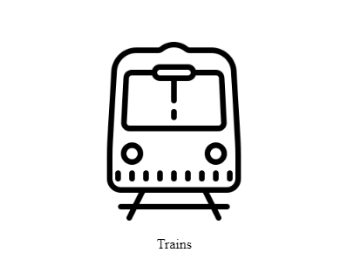

**Coding :**

<?php session_start(); ?>

<!DOCTYPE html>

<html>

<head>

<meta charset="UTF-8">

<meta name="viewport" content="width=device-width, initial-scale=1.0"/>

<title>Home | staycation</title>

<link href="css/bootstrap.min.css" rel="stylesheet"/>

<link href="css/hover-min.css" rel="stylesheet"/>

<link href="css/main.css" rel="stylesheet"/>

<link href="https://fonts.googleapis.com/css?family=Oswald:200,300,400|Raleway:100,300,400,500|Roboto:100,400,500,700" rel="stylesheet">

<link href="https://maxcdn.bootstrapcdn.com/font-awesome/4.7.0/css/font-awesome.min.css" rel="stylesheet">

<script src="js/jquery-3.2.1.min.js" type="text/javascript"></script>

<script src="js/bootstrap.min.js" type="text/javascript"></script>

<script src="js/main.js" type="text/javascript"></script>

</head>

<body>

<div class="col-xs-12 home">

<img src="images/carousel/stay.png" height="200" width="300">

<!-- HEADER SECTION STARTS -->

<div class="col-sm-12">

<div class="header">

<?php

if(!isset($_SESSION["username"])) { include("common/headerTransparentLoggedOut.php");

}

else { include("common/headerTransparentLoggedIn.php");

}

?>

</div><!-- header -->

</div><!-- col-sm-12 -->

<!-- HEADER SECTION ENDS -->

<!-- carousel -->

<div class="col-xs-12 banner">

<div id="myCarousel" class="carousel slide" data-ride="carousel" data-interval="3000">

<ol class="carousel-indicators">

<li data-target="#myCarousel" data-slide-to="0" class="active"></li>

<li data-target="#myCarousel" data-slide-to="1"></li>

<li data-target="#myCarousel" data-slide-to="2"></li>

</ol>

<div class="carousel-inner">

<div class="item active">

<img src="images/carousel/image1.jpg" alt="Image1">

</div>

<div class="item">

<img src="images/carousel/image2.jpg" alt="Image2">

</div>

<div class="item">

<img src="images/carousel/image3.jpg" alt="Image3">

</div>

</div>

<a href="#myCarousel" class="left carousel-control" data-slide="prev">

<span class="glyphicon glyphicon-chevron-left"></span>

</a>

<a href="#myCarousel" class="right carousel-control" data-slide="next">

<span class="glyphicon glyphicon-chevron-right"></span>

</a>

</div>

</div><!-- banner -->

<!---icons---->

<div class="col-xs-12 popularDestinationsContainer">

<div class="col-xs-12 destinationHolder">

<div class="col-xs-12 destinationQuote">

What would you like to book today?

</div>

<div class="col-xs-12 containerGrids hvr-buzz-out">

<a href="hotels.php" style="color: black;">

<div class="col-xs-12 icons text-center">

<img src="images/icons/hotel.png" alt="hotels" class="iconsDim text-center"/>

</div>

<div class="col-xs-12 heading">

Hotels

</div>

</a>

</div>

<div class="col-xs-12 containerGrids hvr-buzz-out">

<a href="flights.php" style="color: black;">

<div class="col-xs-12 icons text-center">

<img src="images/icons/flight.png" alt="flights" class="iconsDim text-center"/>

</div>

<div class="col-xs-12 heading">

Flights

</div>

</a>

</div>

<div class="col-xs-12 containerGrids hvr-buzz-out">

<a href="trains.php" style="color: black;">

<div class="col-xs-12 icons text-center">

<img src="images/icons/train.png" alt="trains" class="iconsDim text-center"/>

</div>

<div class="col-xs-12 heading">

Trains

</div>

</a>

</div>

</div>

<!--popular destinations-->

<div class="col-xs-12 popularDestinationsContainer">

<div class="col-xs-12 destinationHolder">

<div class="col-xs-12 destinationQuote">

Popular Destinations

</div>

<div class="col-xs-12 containerGrids hvr-buzz-out">

<div class="col-xs-12 pics text-center">

<img src="images/popularDestinations/imageAndaman.jpg" alt="popularDestination1" class="picDim text-center"/>

</div>

<div class="col-xs-12 heading">

Andaman and Nicobar

</div>

</div>

<div class="col-xs-12 containerGrids hvr-buzz-out">

<div class="col-xs-12 pics text-center">

<img src="images/popularDestinations/imageJaisalmer.jpg" alt="popularDestination1" class="picDim text-center"/>

</div>

<div class="col-xs-12 heading">

Rajasthan

</div>

</div>

<div class="col-xs-12 containerGrids hvr-buzz-out">

<div class="col-xs-12 pics text-center">

<img src="images/popularDestinations/imageKashmir.jpg" alt="popularDestination1" class="picDim text-center"/>

</div>

<div class="col-xs-12 heading">

Jammu and Kashmir

</div>

</div>

</div>

</div>

</div><!-- home -->

<!-- FOOTER SECTION STARTS -->

<div class="footerMod col-sm-12">

<div class="col-sm-4">

<div class="footerHeading">

Contact Us

</div>

<div class="footerText">

Staycation <br> Nr veg market,Valsad, India

</div>

<div class="footerText">

E-mail: staycation@contactus.com

</div>

</div>

<div class="col-sm-4">

</div>

<div class="col-sm-4">

<div class="footerHeading">

Social Links

</div>

<div class="socialLinks">

<div class="fb">

facebook.com/staycation

</div>

<div class="gp">

plus.google.com/staycation

</div>

<div class="tw">

twitter.com/staycation

</div>

<div class="in">

linkedin.com/staycation

</div>

</div><!-- social links -->

</div>

<div class="col-sm-12">

<div class="copyrightContainer">

<div class="copyright">

Copyright &copy; 2022 Staycation

</div>

</div>

</div>

</div><!-- footer -->

<!-- FOOTER SECTION ENDS -->

</body>

</html>

**Train Booking Without Packages :**

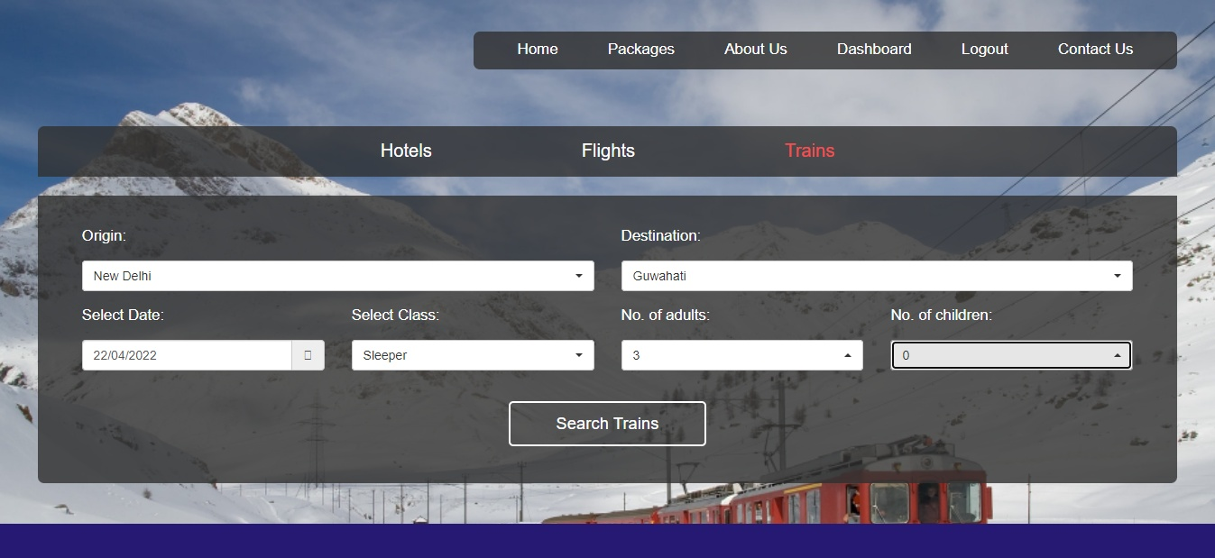

**Coding :**

<?php session_start();

if(!isset($_SESSION["username"]))

{

header("Location:blockedBooking.php");

$_SESSION['url'] = $_SERVER['REQUEST_URI'];

}

?>

<!DOCTYPE html>

<html lang="en">

<!-- HEAD TAG STARTS -->

<head>

<meta charset="UTF-8">

<meta name="viewport" content="width=device-width, initial-scale=1.0"/>

<title>Trains | tourism_management</title>

<link href="css/main.css" rel="stylesheet">

<link href="css/bootstrap.min.css" rel="stylesheet">

<link href="css/bootstrap-select.css" rel="stylesheet">

<link href="css/bootstrap-datetimepicker.css" rel="stylesheet">

<link href="https://fonts.googleapis.com/css?family=Oswald:200,300,400|Raleway:100,300,400,500|Roboto:100,400,500,700" rel="stylesheet">

<link href="https://maxcdn.bootstrapcdn.com/font-awesome/4.7.0/css/font-awesome.min.css" rel="stylesheet">

<script src="js/jquery-3.2.1.min.js"></script>

<script src="js/main.js"></script>

<script src="js/bootstrap.min.js"></script>

<script src="js/bootstrap-select.js"></script>

<script src="js/bootstrap-dropdown.js"></script>

<script src="js/jquery-2.1.1.min.js"></script>

<script src="js/moment-with-locales.js"></script>

<script src="js/bootstrap-datetimepicker.js"></script>

<script type="text/javascript">

$(function () {

$('#datetimepicker3').datetimepicker({

format: 'L',

locale: 'en-gb',

useCurrent: false,

minDate: moment()

});

$('#datetimepicker3').on('dp.change',function(e){

console.log(e.date.format('dddd'));

$('#dayTrain').val(e.date.format('dddd'));

});

});

</script>

</head>

<!-- HEAD TAG ENDS -->

<!-- BODY TAG STARTS -->

<body>

<div class="container-fluid">

<div class="trains col-sm-12">

<!-- HEADER SECTION STARTS -->

<div class="col-sm-12">

<div class="header">

<?php include("common/headerTransparentLoggedIn.php"); ?>

<div class="col-sm-12">

<div class="menu text-center">

<ul>

<a href="hotels.php"><li>Hotels</li></a>

<a href="flights.php"><li>Flights</li></a>

<li class="selected">Trains</li></a>

</ul>

</div>

</div>

</div><!-- header -->

</div><!-- col-sm-12 -->

<!-- HEADER SECTION ENDS -->

<!-- TRAIN SEARCH SECTION STARTS -->

<div class="col-sm-12">

<div class="search">

<div class="content">

<form action="trainSearch.php" method="POST">

<div class="col-sm-6">

<div class="form-group">

<label for="originTrain">Origin:<p></p></label>

<select id= "originTrain" data-live-search="true" class="selectpicker form-control" data-size="5" title="Select Origin Station" name="origin" required>

<option value="New Delhi" data-subtext="DLI" data-tokens="DLI New Delhi">New Delhi</option>

<option value="Howrah" data-subtext="HWH" data-tokens="HWH Howrah">Howrah</option>

<option value="Guwahati" data-subtext="GHY" data-tokens="GHY Guwahati">Guwahati</option>

<option value="Silchar" data-subtext="SCL" data-tokens="SCL Silchar">Silchar</option>

<option value="Dimapur" data-subtext="DMV" data-tokens="DMV Dimapur">Dimapur</option>

</select>

</div>

</div>

<div class="col-sm-6">

<div class="form-group">

<label for="destinationTrain">Destination:<p></p></label>

<select id= "destinationTrain" data-live-search="true" class="selectpicker form-control" data-size="5" title="Select Destination Station" name="destination" required>

<option value="New Delhi" data-subtext="DLI" data-tokens="DLI New Delhi">New Delhi</option>

<option value="Howrah" data-subtext="HWH" data-tokens="HWH Howrah">Howrah</option>

<option value="Guwahati" data-subtext="GHY" data-tokens="GHY Guwahati">Guwahati</option>

<option value="Silchar" data-subtext="SCL" data-tokens="SCL Silchar">Silchar</option>

<option value="Dimapur" data-subtext="DMV" data-tokens="DMV Dimapur">Dimapur</option>

</select>

</div>

</div>

<div class="col-sm-3">

<div class="form-group">

<label for="datetime3">Select Date:<p></p></label>

<div class="input-group date" id="datetimepicker3">

<input id="datetime3" type="text" class="inputDate form-control" placeholder="Select Date" name="date" required/>

<span class="input-group-addon">

<span class="fa fa-calendar"></span>

</span>

</div>

</div>

</div>

<div class="col-sm-3">

<label for="class">Select Class: <p></p></label>

<div class="form-group">

<select id= "class" class="selectpicker form-control" data-size="5" title="Select Class" name="class" required>

<option value="1AC">First AC</option>

<option value="2AC">Second AC</option>

<option value="3AC">Third AC</option>

<option value="SL">Sleeper</option>

<option value="CC">AC Chair Car</option>

</select>

</div>

</div>

<div class="col-sm-3">

<label for="adults">No. of adults:<p></p></label>

<div class="form-group">

<select id= "adults" class="selectpicker form-control" data-size="5" title="Aged 18 and above" name="adults" required>

<option value="1">1</option>

<option value="2">2</option>

<option value="3">3</option>

<option value="4">4</option>

<option value="5">5</option>

<option value="6">6</option>

</select>

</div>

</div>

<div class="col-sm-3">

<label for="children">No. of children:<p></p></label>

<div class="form-group">

<select id= "children" class="selectpicker form-control" data-size="5" title="Aged upto 17" name="children" required>

<option value="0">0</option>

<option value="1">1</option>

<option value="2">2</option>

<option value="3">3</option>

<option value="4">4</option>

<option value="5">5</option>

<option value="6">6</option>

</select>

</div>

</div>

<input type="hidden" name="day" value="null" id="dayTrain"/>

<div class="col-sm-12 text-center">

<input type="submit" class="button" name="searchTrains" value="Search Trains">

</div>

</form>

</div><!-- content -->

</div><!-- search -->

</div>

<!-- TRAIN SEARCH SECTION ENDS -->

</div><!-- trains -->

<div class="footer col-sm-12">

</div>

<!-- FOOTER SECTION STARTS -->

<div class="footer col-sm-12">

<div class="col-sm-4">

<div class="footerHeading">

Contact Us

</div>

<div class="footerText">

CUSAT,Cochin, <br> Kerala,India

</div>

<div class="footerText">

E-mail: queries@tourism_management.com

</div>

</div>

<div class="col-sm-4">

</div>

<div class="col-sm-4">

<div class="footerHeading">

Social Links

</div>

<div class="socialLinks">

<div class="fb"> facebook.com/tourism_management

</div>

<div class="gp"> plus.google.com/tourism_management

</div>

<div class="tw">

twitter.com/tourism_management

</div>

<div class="in">

linkedin.com/tourism_management

</div>

</div><!-- social links -->

</div>

<div class="col-sm-12">

<div class="copyrightContainer">

<div class="copyright">

Copyright &copy; 2021 Alisha Anand

</div>

</div>

</div>

</div><!-- footer -->

<!-- FOOTER SECTION ENDS -->

</div><!-- container-fluid -->

</body>

<!-- BODY TAG ENDS -->

</html>

**Train Booking :**

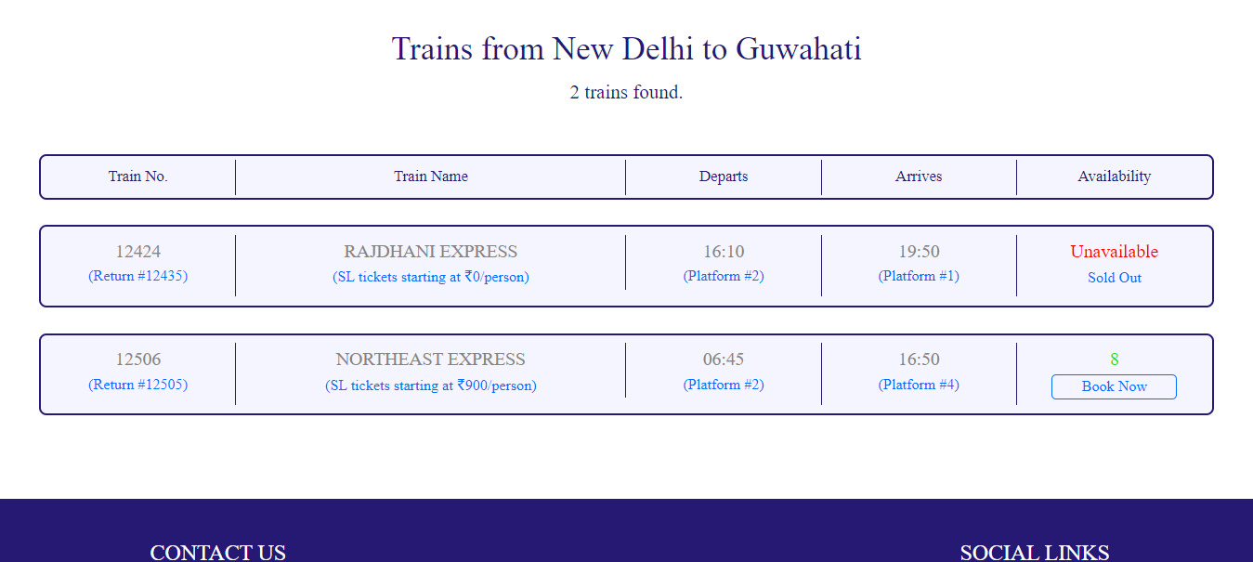

**Coding :**

<?php session_start();

if(!isset($_SESSION["username"]))

{

header("Location:blocked.php");

$_SESSION['url'] = $_SERVER['REQUEST_URI'];

}

?>

<!DOCTYPE html>

<html lang="en">

<!-- HEAD TAG STARTS -->

<head>

<meta charset="UTF-8">

<meta name="viewport" content="width=device-width, initial-scale=1.0"/>

<title>Train Search | tourism_management</title>

<link href="css/main.css" rel="stylesheet">

<link href="css/bootstrap.min.css" rel="stylesheet">

<link href="https://fonts.googleapis.com/css?family=Oswald:200,300,400|Raleway:100,300,400,500|Roboto:100,400,500,700" rel="stylesheet">

<link href="https://maxcdn.bootstrapcdn.com/font-awesome/4.7.0/css/font-awesome.min.css" rel="stylesheet">

<script src="js/jquery-3.2.1.min.js"></script>

<script src="js/main.js"></script>

<script src="js/bootstrap.min.js"></script>

</head>

<!-- HEAD TAG ENDS -->

<!-- BODY TAG STARTS -->

<body>

<?php include("common/headerLoggedIn.php"); ?>

<?php

$origin=$_POST["origin"];

$destination=$_POST["destination"];

$day=$_POST["day"];

$date=$_POST["date"];

$class=$_POST["class"];

$adults=$_POST["adults"];

$children=$_POST["children"];

$trimDay=substr($day,0,2);

$seatsClass = trim('seats'.$class);

$priceClass = trim('price'.$class);

?>

<div class="spacer">a</div>

<div class="searchBus">

<div class="query">

Trains from <?php echo $origin; ?> to <?php echo $destination; ?>

</div>

<?php

$servername = "localhost";

$username = "root";

$password = "";

$dbname = "projectmeteor";

// Creating a connection to MySQL database

$conn = new mysqli($servername, $username, $password, $dbname);

// Checking if successfully connected to the database

if ($conn->connect_error) {

die("Connection failed: " . $conn->connect_error);

}

$sql = "SELECT * FROM trains WHERE origin='$origin' AND destination='$destination' AND runsOn LIKE '%$trimDay%'";

$rowcount = mysqli_num_rows(mysqli_query($conn,$sql));

$result = $conn->query($sql);

if ($result->num_rows > 0) {

?>

<div class="noOfBus">

<?php echo $rowcount ." trains found.";?>

</div>

<div class="listItemMenuContainer">

<div class="col-sm-2 text-center">

<div class="headings">

Train No.

</div>

</div>

<div class="col-sm-4 text-center">

<div class="headings">

Train Name

</div>

</div>

<div class="col-sm-2 text-center">

<div class="headings">

Departs

</div>

</div>

<div class="col-sm-2 text-center">

<div class="headings">

Arrives

</div>

</div>

<div class="col-sm-2 text-center">

<div class="headings">

Availability

</div>

</div>

</div><!-- listItemMenuContainer -->

<div class="spacerLarge">.</div><!-- just a dummy class for creating some space -->

</div><!-- search Trains -->

<?php

while($row = $result->fetch_assoc()) {

?>

<div class="searchBus">

<div class="listItem">

<!-- TRAIN INFO STARTS -->

<form action="booking.php" method="POST">

<div class="col-sm-2 text-center heightAdjustBusSearch">

<div class="values operators">

<?php echo $row["trainNo"]; ?>

</div>

<div class="departsSubscript">

Return #<?php echo $row["returnTrainNo"]; ?>

</div>

</div>

<!-- TRAIN INFO ENDS -->

<!-- DEPARTS STARTS -->

<div class="col-sm-4 text-center">

<div class="values departs">

<?php echo $row["trainName"]; ?>

</div>

<div class="departsSubscript">

<?php echo $class." tickets starting at "; ?><span style="font-family: sans-serif;">₹</span><?php echo $row[$priceClass]."/person"; ?>

</div>

</div>

<!-- DEPARTS ENDS -->

<!-- DESTINATION STARTS -->

<div class="col-sm-2 text-center">

<div class="values arrives">

<?php echo $row["originTime"]; ?>

</div>

<div class="arrivesSubscript">

Platform #<?php echo $row["originPlatform"]; ?>

</div>

</div>

<!-- DESTINATION ENDS -->

<!-- FARE STARTS -->

<div class="col-sm-2 text-center">

<div class="values arrives">

<?php echo $row["destinationTime"]; ?>

</div>

<div class="arrivesSubscript">

Platform #<?php echo $row["destinationPlatform"]; ?>

</div>

</div>

<!-- FARE ENDS -->

<!-- SEATS AVAILABLE STARTS -->

<?php

$trainID = $row["trainNo"];

//checking availability of tickets query

$getSeatsAvailableSQL = "SELECT $seatsClass FROM `trains` WHERE trainNo='$trainID'";

$getSeatsAvailableQuery = $conn->query($getSeatsAvailableSQL);

$SeatsAvailableGet = $getSeatsAvailableQuery ->fetch_array(MYSQLI_NUM);

$seatsAvailable = $SeatsAvailableGet[0];

?>

<!-- allowing only those trains to be booked which have enough seats -->

<?php if($seatsAvailable>=(int)$adults+(int)$children): ?>

<div class="col-sm-2 text-center" style="border-right: none;">

<div class="values availabilityGreen">

<?php echo $row[$seatsClass]; ?>

</div>

<div class="availabilitySubscript">

<input type="submit" class="availabilityBookingButton" value="Book Now">

<input type="hidden" name="trainIdPass" value="<?php echo $trainID; ?>"/>

</div>

</div>

<?php else: ?>

<div class="col-sm-2 text-center" style="border-right: none;">

<div class="values availabilityRed">

Unavailable

</div>

<div class="unavailabilitySubscript">

Sold Out

</div>

</div>

<?php endif;?>

<!-- SEATS AVAILABLE ENDS -->

<!-- Passing the $_POST values to the next page using hidden text boxes -->

<input type="hidden" name="dateHidden" value="<?php echo $date; ?>">

<input type="hidden" name="dayHidden" value="<?php echo $day; ?>">

<input type="hidden" name="originHidden" value="<?php echo $origin; ?>">

<input type="hidden" name="destinationHidden" value="<?php echo $destination; ?>">

<input type="hidden" name="classHidden" value="<?php echo $class; ?>">

<input type="hidden" name="passengersHidden" value="<?php echo (int)$adults+(int)$children; ?>">

<input type="hidden" name="modeHidden" value="<?php echo "train"; ?>">

</form>

</div><!-- listItem 1 -->

</div>

<?php

}

} else {

?>

<div class="searchFlights">

<div class="noFlights">

No trains found.

</div>

</div>

<?php

}

?>

<?php $conn->close(); //closing the connection to the database ?>

<div class="spacerLarge">.</div><!-- just a dummy class for creating some space -->

<?php include("common/footer.php"); ?>

</body>

<!-- BODY TAG ENDS -->

</html>

**Confirm Train Booking :**

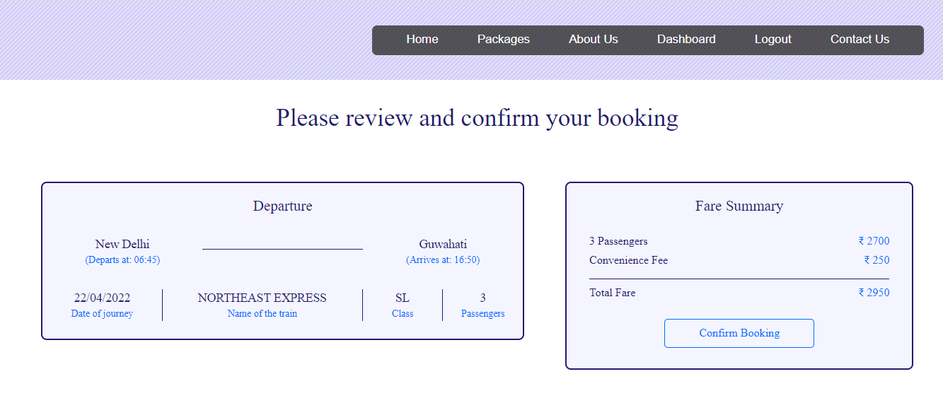

**Coding :**

<?php session_start();

if(!isset($_SESSION["username"]))

{

header("Location:blocked.php");

$_SESSION['url'] = $_SERVER['REQUEST_URI'];

}

?>

<!DOCTYPE html>

<html lang="en">

<!-- HEAD TAG STARTS -->

<head>

<meta charset="UTF-8">

<meta name="viewport" content="width=device-width, initial-scale=1.0"/>

<title>Booking | tourism_management</title>

<link href="css/main.css" rel="stylesheet">

<link href="css/bootstrap.min.css" rel="stylesheet">

<link href="https://fonts.googleapis.com/css?family=Oswald:200,300,400|Raleway:100,300,400,500|Roboto:100,400,500,700" rel="stylesheet">

<link href="https://maxcdn.bootstrapcdn.com/font-awesome/4.7.0/css/font-awesome.min.css" rel="stylesheet">

<script src="js/jquery-3.2.1.min.js"></script>

<script src="js/main.js"></script>

<script src="js/bootstrap.min.js"></script>

</head>

<!-- HEAD TAG ENDS -->

<!-- BODY TAG STARTS -->

<body>

<?php include("common/headerLoggedIn.php"); ?>

<?php

$mode=$_POST["modeHidden"];

?>

<?php

$servername = "localhost";

$username = "root";

$password = "";

$dbname = "projectmeteor";

// Creating a connection to MySQL database

$conn = new mysqli($servername, $username, $password, $dbname);

// Checking if successfully connected to the database

if ($conn->connect_error) {

die("Connection failed: " . $conn->connect_error);

}

?>

<div class="spacer">a</div>

<div class="bookingWrapper">

<div class="headingOne">

Please review and confirm your booking

</div>

<!-- changing contents of the page based on mode -->

<!----------------------------- ONE WAY FLIGHT --------------------------------->

<?php if($mode=="OneWayFlight"): ?>

<div class="col-sm-12 bookingOneWayFlight">

<?php

$type=$_POST["typeHidden"];

$class=$_POST["classHidden"];

$origin=$_POST["originHidden"];

$destination=$_POST["destinationHidden"];

$depart=$_POST["departHidden"];

$return=$_POST["returnHidden"];

$adults=$_POST["adultsHidden"];

$children=$_POST["childrenHidden"];

$noOfPassengers=(int)$adults+(int)$children;

if($type=="Return Trip") { $flightNoOutbound=$_POST["flightNoOutboundHidden"];

$flightNoInbound=$_POST["flightNoInboundHidden"];

}

elseif($type=="One Way") { $flightNoOutbound=$_POST["flightNoOutboundHidden"];

}

if($class=="Economy Class")

$className="Economy";

else

$className="Business";

$outboundFlightSQL = "SELECT * FROM `flights` WHERE flight_no='$flightNoOutbound'";

$outboundFlightQuery = $conn->query($outboundFlightSQL);

$row = $outboundFlightQuery->fetch_assoc();

?>

<div class="col-sm-7"><!-- departure container --

<div class="col-sm-12">

<div class="boxLeftOneWayFlight">

<div class="col-sm-12 mode">Departure</div>

<div class="col-sm-4">

<div class="origin"><?php echo $origin; ?></div>

<div class="departs">Departs <?php echo $depart; ?> at: <?php echo $row["departs"]; ?></div>

</div>

<div class="col-sm-4">

<div class="arrow"></div>

</div>

<div class="col-sm-4">

<div class="destination"><?php echo $destination; ?></div>

<div class="arrives">Arrives <?php echo $depart; ?> at: <?php echo $row["arrives"]; ?></div>

</div>

<div class="col-sm-3 borderRight">

<div class="operator"><?php echo $row["operator"]; ?></div>

<div class="operatorSubscript">Operator</div>

</div>

<div class="col-sm-3 borderRight">

<div class="class"><?php echo $className; ?></div>

<div class="classSubscript">Class</div>

</div>

<div class="col-sm-3 borderRight">

<div class="adults"><?php echo $adults; ?></div>

<div class="adultsSubscript">Adults</div>

</div>

<div class="col-sm-3">

<div class="children"><?php echo $children; ?></div>

<div class="childrenSubscript">Children</div>

</div>

</div>

</div><!-- col-sm-7 Departure -->

</div>

<div class="col-sm-5"><!-- fare container -->

<div class="col-sm-12">

<div class="boxRightOneWayFlight">

<div class="col-sm-12 fareSummary">Fare Summary</div>

<div class="col-sm-8">

<div class="heading"><?php echo $adults; ?> Adults</div>

<div class="heading"><?php echo $children; ?> Children</div>

<div class="heading">Convenience Fee</div>

</div>

<div class="col-sm-4">

<div class="price"><span class="sansSerif">₹ </span><?php echo $adults*$row["fare"]; ?></div>

<div class="price"><span class="sansSerif">₹ </span><?php echo $children*$row["fare"]; ?></div>

<div class="price"><span class="sansSerif">₹ </span>250</div>

</div>

<div class="col-sm-12">

<div class="calcBar"></div>

</div>

<div class="col-sm-8">

<div class="headingTotal">Total Fare</div>

</div>

<div class="col-sm-4">

<div class="priceTotal"><span class="sansSerif">₹ </span><?php echo ($adults*$row["fare"])+($children*$row["fare"])+250; ?></div>

</div>

<form action="passengers.php" method="POST">

<div class="bookingButton text-center">

<input type="submit" class="confirmButton" value="Confirm Booking">

</div>

<?php $totalFare = ($adults*$row["fare"])+($children*$row["fare"])+250 ?>

<input type="hidden" name="fareHidden" value="<?php echo $totalFare; ?>">

<input type="hidden" name="typeHidden" value="<?php echo $type; ?>">

<input type="hidden" name="classHidden" value="<?php echo $class; ?>">

<input type="hidden" name="originHidden" value="<?php echo $origin; ?>">

<input type="hidden" name="destinationHidden" value="<?php echo $destination; ?>">

<input type="hidden" name="departHidden" value="<?php echo $depart; ?>">

<input type="hidden" name="returnHidden" value="<?php echo $return; ?>">

<input type="hidden" name="adultsHidden" value="<?php echo $adults; ?>">

<input type="hidden" name="childrenHidden" value="<?php echo $children; ?>">

<input type="hidden" name="flightNoOutboundHidden" value="<?php echo $row["flight_no"]; ?>">

<input type="hidden" name="modeHidden" value="<?php echo "OneWayFlight" ?>">

</form>

</div>

</div><!-- col-sm-5 Fare -->

</div><!-- fare container -->

</div><!-- bookingOneWayFlight -->

<!----------------------------- RETURN TRIP FLIGHT --------------------------------->

<?php elseif($mode=="ReturnTripFlight"): ?>

<div class="col-sm-12 bookingReturnTripFlight">

<?php

$type=$_POST["typeHidden"];

$class=$_POST["classHidden"];

$origin=$_POST["originHidden"];

$destination=$_POST["destinationHidden"];

$depart=$_POST["departHidden"];

$return=$_POST["returnHidden"];

$adults=$_POST["adultsHidden"];

$children=$_POST["childrenHidden"];

$noOfPassengers=(int)$adults+(int)$children;

if($type=="Return Trip") { $flightNoOutbound=$_POST["flightNoOutboundHidden"]; $flightNoInbound=$_POST["flightNoInboundHidden"];

}

elseif($type=="One Way") { $flightNoOutbound=$_POST["flightNoOutboundHidden"];

}

if($class=="Economy Class")

$className="Economy";

else

$className="Business";

$outboundFlightSQL = "SELECT * FROM `flights` WHERE flight_no='$flightNoOutbound'";

$outboundFlightQuery = $conn->query($outboundFlightSQL);

$rowOutbound = $outboundFlightQuery->fetch_assoc();

$inboundFlightSQL = "SELECT * FROM `flights` WHERE flight_no='$flightNoInbound'";

$inboundFlightQuery = $conn->query($inboundFlightSQL);

$rowInbound = $inboundFlightQuery->fetch_assoc();

?>

<div class="col-sm-7"><!-- departure return container -->

<div class="col-sm-12">

<div class="boxLeftOneWayFlight">

<div class="col-sm-12 mode">Departure</div>

<div class="col-sm-4">

<div class="origin"><?php echo $rowOutbound["origin"]; ?></div>

<div class="departs">Departs <?php echo $depart; ?> at: <?php echo $rowOutbound["departs"]; ?></div>

</div>

<div class="col-sm-4">

<div class="arrow"></div>

</div>

<div class="col-sm-4">

<div class="destination"><?php echo $rowOutbound["destination"]; ?></div>

<div class="arrives">Arrives <?php echo $depart; ?> at: <?php echo $rowOutbound["arrives"]; ?></div>

</div>

<div class="col-sm-3 borderRight">

<div class="operator"><?php echo $rowOutbound["operator"]; ?></div>

<div class="operatorSubscript">Operator</div>

</div>

<div class="col-sm-3 borderRight">

<div class="class"><?php echo $className; ?></div>

<div class="classSubscript">Class</div>

</div>

<div class="col-sm-3 borderRight">

<div class="adults"><?php echo $adults; ?></div>

<div class="adultsSubscript">Adults</div>

</div>

<div class="col-sm-3">

<div class="children"><?php echo $children; ?></div>

<div class="childrenSubscript">Children</div>

</div>

</div>

</div><!-- col-sm-7 Departure -->

<div class="col-sm-12">

<div class="boxLeftOneWayFlight">

<div class="col-sm-12 mode">Return</div>

<div class="col-sm-4">

<div class="origin"><?php echo $rowInbound["origin"]; ?></div>

<div class="departs">Departs <?php echo $return; ?> at: <?php echo $rowInbound["departs"]; ?></div>

</div>

<div class="col-sm-4">

<div class="arrow"></div>

</div>

<div class="col-sm-4">

<div class="destination"><?php echo $rowInbound["destination"]; ?></div>

<div class="arrives">Arrives <?php echo $return; ?> at: <?php echo $rowInbound["arrives"]; ?></div>

</div>

<div class="col-sm-3 borderRight">

<div class="operator"><?php echo $rowInbound["operator"]; ?></div>

<div class="operatorSubscript">Operator</div>

</div>

<div class="col-sm-3 borderRight">

<div class="class"><?php echo $className; ?></div>

<div class="classSubscript">Class</div>

</div>

<div class="col-sm-3 borderRight">

<div class="adults"><?php echo $adults; ?></div>

<div class="adultsSubscript">Adults</div>

</div>

<div class="col-sm-3">

<div class="children"><?php echo $children; ?></div>

<div class="childrenSubscript">Children</div>

</div>

</div>

</div><!-- col-sm-7 Return -->

</div><!-- departure return container -->

<div class="col-sm-5"><!-- fare container -->

<div class="col-sm-12">

<div class="boxRightOneWayFlight">

<div class="col-sm-12 fareSummary">Fare Summary</div>

<div class="col-sm-8">

<div class="heading"><?php echo $adults; ?> Adults</div>

<div class="heading"><?php echo $children; ?> Children</div>

<div class="heading">Convenience Fee</div>

</div>

<div class="col-sm-4">

<div class="price"><span class="sansSerif">₹ </span><?php echo $adults*($rowOutbound["fare"]+$rowInbound["fare"]); ?></div>

<div class="price"><span class="sansSerif">₹ </span><?php echo $children*($rowOutbound["fare"]+$rowInbound["fare"]); ?></div>

<div class="price"><span class="sansSerif">₹ </span>250</div>

</div>

<div class="col-sm-12">

<div class="calcBar"></div>

</div>

<div class="col-sm-8">

<div class="headingTotal">Total Fare</div>

</div>

<div class="col-sm-4">

<div class="priceTotal"><span class="sansSerif">₹ </span><?php echo ($adults*($rowOutbound["fare"]+$rowInbound["fare"]))+($children*($rowOutbound["fare"]+$rowInbound["fare"]))+250; ?></div><!-- CHANGE -->

</div>

<form action="passengers.php" method="POST">

<div class="bookingButton text-center">

<input type="submit" class="confirmButton" value="Confirm Booking">

</div>

<?php $totalFare = ($adults*($rowOutbound["fare"]+$rowInbound["fare"]))+($children*($rowOutbound["fare"]+$rowInbound["fare"]))+250 ?>

<!-- CHANGE -->

<input type="hidden" name="fareHidden" value="<?php echo $totalFare; ?>">

<input type="hidden" name="typeHidden" value="<?php echo $type; ?>">

<input type="hidden" name="classHidden" value="<?php echo $class; ?>">

<input type="hidden" name="originHidden" value="<?php echo $origin; ?>">

<input type="hidden" name="destinationHidden" value="<?php echo $destination; ?>">

<input type="hidden" name="departHidden" value="<?php echo $depart; ?>">

<input type="hidden" name="returnHidden" value="<?php echo $return; ?>">

<input type="hidden" name="adultsHidden" value="<?php echo $adults; ?>">

<input type="hidden" name="childrenHidden" value="<?php echo $children; ?>">

<input type="hidden" name="flightNoOutboundHidden" value="<?php echo $rowOutbound["flight_no"]; ?>">

<input type="hidden" name="flightNoInboundHidden" value="<?php echo $rowInbound["flight_no"]; ?>">

<input type="hidden" name="modeHidden" value="<?php echo "ReturnTripFlight" ?>">

</form>

</div>

</div><!-- col-sm-5 Fare -->

</div><!-- fare return container -->

</div><!-- bookingReturnTripFlight -->

<!----------------------------- HOTEL --------------------------------->

<?php elseif($mode=="hotel"): ?>

<div class="col-sm-12 bookingHotel">

<?php

$hotelID = $_POST["hotelIDHidden"];

$hotelSQL = "SELECT * FROM `hotels` WHERE hotelID='$hotelID'";

$hotelQuery = $conn->query($hotelSQL);

$row = $hotelQuery->fetch_assoc();

?>

<div class="col-sm-7"><!-- hotel summary container -->

<div class="col-sm-12">

<div class="boxLeftHotel">

<div class="col-sm-12 hotelMode">Booking Summary</div>

<div class="col-sm-12 hotelName">

Name of the hotel: <span class="nameText"><?php echo $row["hotelName"].', '.$row["locality"].', '.$row["city"]; ?></span>

</div>

<div class="col-sm-3 borderRight">

<div class="checkIn"><?php echo $_SESSION["checkIn"]; ?></div>

<div class="checkInSubscript">Check In Date</div>

</div>

<div class="col-sm-3 borderRight">

<div class="checkOut"><?php echo $_SESSION["checkOut"]; ?></div>

<div class="checkOutSubscript">Check Out Date</div>

</div>

<div class="col-sm-3 borderRight">

<div class="noOfRooms"><?php echo $_SESSION["noOfRooms"]; ?></div>

<div class="noOfRoomsSubscript">No. of rooms</div>

</div>

<div class="col-sm-3">

<div class="noOfGuests"><?php echo $_SESSION["noOfGuests"]; ?></div>

<div class="noOfGuestsSubscript">No. of guests</div>

</div>

</div><!-- boxLeft -->

</div><!-- col-sm-7 bookings -->

</div>

<div class="col-sm-5"><!-- fare container -->

<div class="col-sm-12">

<div class="boxRightHotel">

<div class="col-sm-12 fareSummary">Payment Summary</div>

<div class="col-sm-8">

<?php

$var1 = $_SESSION["checkIn"];

$var2 = $_SESSION["checkOut"];

$date1 = date_create(str_replace('/', '-', $var1));

$date2 = date_create(str_replace('/', '-', $var2));

$diff=date_diff($date1,$date2);

?>

<div class="heading"><?php echo $_SESSION["noOfRooms"]; ?> Rooms x <?php echo $diff->format("%a Days"); ?></div>

<div class="heading">Convenience Fee</div>

</div>

<?php $noOfDays = $diff->format("%a"); ?>

<div class="col-sm-4">

<div class="price"><span class="sansSerif">₹ </span><?php echo $_SESSION["noOfRooms"]*$row["price"]*$noOfDays; ?></div>

<div class="price"><span class="sansSerif">₹ </span>250</div>

</div>

<div class="col-sm-12">

<div class="calcBar"></div>

</div>

<div class="col-sm-8">

<div class="headingTotal">Total Payment</div>

</div>

<div class="col-sm-4">

<div class="priceTotal"><span class="sansSerif">₹ </span><?php echo ($_SESSION["noOfRooms"]*$row["price"]*$noOfDays)+250; ?></div>

</div>

<form action="payment.php" method="POST">

<div class="bookingButton text-center">

<input type="submit" class="confirmButton" value="Confirm Booking">

</div>

<?php $totalFare = ($_SESSION["noOfRooms"]*$row["price"]*$noOfDays)+250; ?>

<input type="hidden" name="fareHidden" value="<?php echo $totalFare; ?>">

<input type="hidden" name="hotelIDHidden" value="<?php echo $hotelID; ?>">

<input type="hidden" name="modeHidden" value="<?php echo "hotel" ?>">

</form>

</div>

</div><!-- col-sm-5 Fare -->

</div><!-- fare container -->

</div><!-- hotel -->

<!-------------------------------------------------train----------------------------------------->

<?php elseif($mode=="train"): ?>

<div class="col-sm-12 bookingTrain">

<?php

$trainID = $_POST["trainIdPass"];

$date=$_POST["dateHidden"];

$day=$_POST["dayHidden"];

$origin=$_POST["originHidden"];

$destination=$_POST["destinationHidden"];

$class=$_POST["classHidden"];

$noOfPassengers= $_POST["passengersHidden"];

$priceClass = trim('price'.$class);

$trainFinderSQL = "SELECT * FROM `trains` WHERE trainNo='$trainID'";

$trainFinderQuery = $conn->query($trainFinderSQL);

$row = $trainFinderQuery->fetch_assoc();

?>

<div class="col-sm-7"><!-- departure container -->

<div class="col-sm-12">

<div class="boxLeftBus">

<div class="col-sm-12 mode">Departure</div>

<div class="col-sm-4">

<div class="origin"><?php echo $origin; ?></div>

<div class="departs">Departs at: <?php echo $row["originTime"]; ?></div>

</div>

<div class="col-sm-4">

<div class="arrow"></div>

</div>

<div class="col-sm-4">

<div class="destination"><?php echo $destination; ?></div>

<div class="arrives">Arrives at: <?php echo $row["destinationTime"]; ?></div>

</div>

<div class="col-sm-3 borderRight">

<div class="class"><?php echo $date; ?></div>

<div class="classSubscript">Date of journey</div>

</div>

<div class="col-sm-5 borderRight">

<div class="operator"><?php echo $row["trainName"]; ?></div>

<div class="operatorSubscript">Name of the train</div>

</div>

<div class="col-sm-2 borderRight">

<div class="operator"><?php echo $class; ?></div>

<div class="operatorSubscript">Class</div>

</div>

<div class="col-sm-2">

<div class="adults"><?php echo $noOfPassengers; ?></div>

<div class="adultsSubscript">Passengers</div>

</div>

</div>

</div><!-- col-sm-7 Departure -->

</div>

<div class="col-sm-5"><!-- fare container -->

<div class="col-sm-12">

<div class="boxRightBus">

<div class="col-sm-12 fareSummary">Fare Summary</div>

<div class="col-sm-8">

<div class="heading"><?php echo $noOfPassengers; ?> Passengers</div>

<div class="heading">Convenience Fee</div>

</div>

<div class="col-sm-4">

<div class="price"><span class="sansSerif">₹ </span><?php echo $noOfPassengers*$row[$priceClass]; ?></div>

<div class="price"><span class="sansSerif">₹ </span>250</div>

</div>

<div class="col-sm-12">

<div class="calcBar"></div>

</div>

<div class="col-sm-8">

<div class="headingTotal">Total Fare</div>

</div>

<div class="col-sm-4">

<div class="priceTotal"><span class="sansSerif">₹ </span><?php echo ($noOfPassengers*$row[$priceClass])+250; ?></div>

</div>

<form action="passengers.php" method="POST">

<div class="bookingButton text-center">

<input type="submit" class="confirmButton" value="Confirm Booking">

</div>

<?php $totalFare = ($noOfPassengers*$row[$priceClass])+250; ?>

<input type="hidden" name="fareHidden" value="<?php echo $totalFare; ?>">

<input type="hidden" name="dateHidden" value="<?php echo $date; ?>">

<input type="hidden" name="dayHidden" value="<?php echo $day; ?>">

<input type="hidden" name="originHidden" value="<?php echo $origin; ?>">

<input type="hidden" name="destinationHidden" value="<?php echo $destination; ?>">

<input type="hidden" name="classHidden" value="<?php echo $class; ?>">

<input type="hidden" name="noOfPassengersHidden" value="<?php echo $noOfPassengers; ?>">

<input type="hidden" name="modeHidden" value="<?php echo "train"; ?>">

<input type="hidden" name="trainIDHidden" value="<?php echo $trainID; ?>">

</form>

</div>

</div><!-- col-sm-5 Fare -->

</div><!-- fare container -->

</div><!-- train -->

<?php endif; ?>

</div><!--bookingWrapper -->

<div class="spacerLarge">.</div><!-- just a dummy class for creating some space -->

<?php include("common/footer.php"); ?>

</body>

<!-- BODY TAG ENDS -->

</html>

**Passenger Details :**

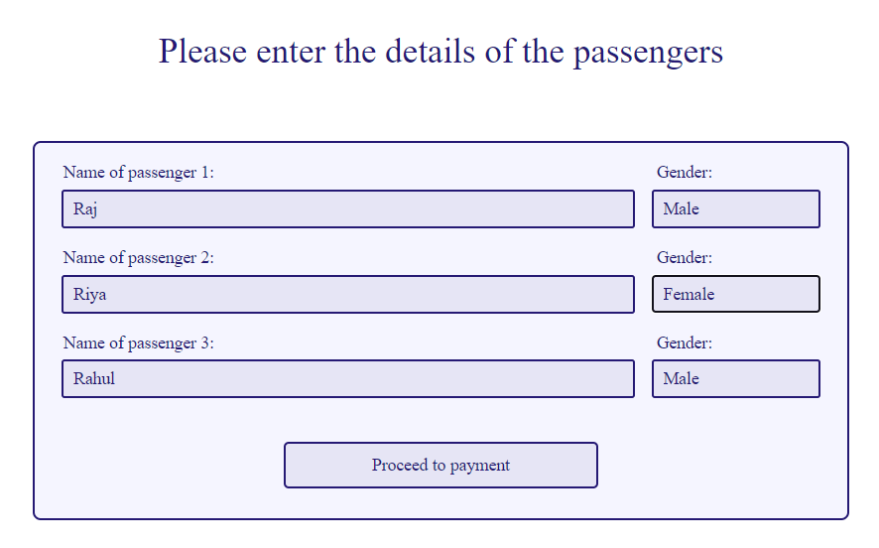

**Coding :**

<?php session_start();

if(!isset($_SESSION["username"]))

{

header("Location:blocked.php");

$_SESSION['url'] = $_SERVER['REQUEST_URI'];

}

?>

<!DOCTYPE html>

<html lang="en">

<!-- HEAD TAG STARTS -->

<head>

<meta charset="UTF-8">

<meta name="viewport" content="width=device-width, initial-scale=1.0"/>

<title>Passengers | tourism_management</title>

<link href="css/main.css" rel="stylesheet">

<link href="css/bootstrap.min.css" rel="stylesheet">

<link href="https://fonts.googleapis.com/css?family=Oswald:200,300,400|Raleway:100,300,400,500|Roboto:100,400,500,700" rel="stylesheet">

<link href="https://maxcdn.bootstrapcdn.com/font-awesome/4.7.0/css/font-awesome.min.css" rel="stylesheet">

<script src="js/jquery-3.2.1.min.js"></script>

<script src="js/main.js"></script>

<script src="js/bootstrap.min.js"></script>

</head>

<!-- HEAD TAG ENDS -->

<!-- BODY TAG STARTS -->

<body>

<?php include("common/headerLoggedIn.php"); ?>

<?php

$fare=$_POST["fareHidden"];

$mode=$_POST["modeHidden"];

if($mode=="OneWayFlight" || $mode=="ReturnTripFlight") {

$type=$_POST["typeHidden"];

$class=$_POST["classHidden"];

$origin=$_POST["originHidden"];

$destination=$_POST["destinationHidden"];

$depart=$_POST["departHidden"];

$return=$_POST["returnHidden"];

$adults=$_POST["adultsHidden"];

$children=$_POST["childrenHidden"];

$totalPassengers=(int)$adults+(int)$children;

if($type=="Return Trip") { $flightNoOutbound=$_POST["flightNoOutboundHidden"];

$flightNoInbound=$_POST["flightNoInboundHidden"];

}

elseif($type=="One Way") {

$flightNoOutbound=$_POST["flightNoOutboundHidden"];

}

if($class=="Economy Class")

$className="Economy";

else

$className="Business";

}

elseif($mode=="bus") {

$date = $_POST["dateHidden"];

$busID = $_POST["busIDHidden"];

$totalPassengers=$_POST["noOfPassengersHidden"];

$origin=$_POST["originHidden"];

$destination=$_POST["destinationHidden"];

}

elseif($mode=="train") {

$date = $_POST["dateHidden"];

$day = $_POST["dayHidden"];

$trainID = $_POST["trainIDHidden"];

$totalPassengers=$_POST["noOfPassengersHidden"];

$origin=$_POST["originHidden"];

$destination=$_POST["destinationHidden"];

$class=$_POST["classHidden"];

}

?>

<div class="spacer">a</div>

<div class="col-sm-12 passengersWrapper">

<div class="headingOne">

Please enter the details of the passengers

</div>

<div class="col-sm-2"></div>

<div class="col-sm-8">

<div class="boxCenter">

<form action="payment.php" method="POST">

<?php for($i=1; $i<=$totalPassengers; $i++) {?>

<div class="col-sm-9 nameTag">Name of passenger <?php echo $i; ?>:</div>

<div class="col-sm-3 ageTag">Gender:</div>

<input type="text" class="inputPassengerName" name="name<?php echo $i; ?>" placeholder="Enter the full name of the passenger <?php echo $i; ?>" />

<select class="inputSmall" name="gender<?php echo $i; ?>" />

<option value="Male">Male</option>

<option value="Female">Female</option>

</select>

<?php } ?>

<div class="text-center">

<input type="submit" class="continueButton" value="Proceed to payment">

<input type="hidden" name="totalPassengersHidden" value="<?php echo $totalPassengers; ?>">

<input type="hidden" name="fareHidden" value="<?php echo $fare; ?>">

<input type="hidden" name="typeHidden" value="<?php echo $type; ?>">

<input type="hidden" name="classHidden" value="<?php echo $class; ?>">

<input type="hidden" name="originHidden" value="<?php echo $origin; ?>">

<input type="hidden" name="destinationHidden" value="<?php echo $destination; ?>">

<input type="hidden" name="departHidden" value="<?php echo $depart; ?>">

<input type="hidden" name="returnHidden" value="<?php echo $return; ?>">

<input type="hidden" name="adultsHidden" value="<?php echo $adults; ?>">

<input type="hidden" name="childrenHidden" value="<?php echo $children; ?>">

<input type="hidden" name="modeHidden" value="<?php echo $mode; ?>">

<?php if($mode=="bus") { ?>

<input type="hidden" name="dateHidden" value="<?php echo $date; ?>">

<input type="hidden" name="busIDHidden" value="<?php echo $busID; ?>">

<?php } ?>

<?php if($mode=="train") { ?>

<input type="hidden" name="dateHidden" value="<?php echo $date; ?>">

<input type="hidden" name="dayHidden" value="<?php echo $day; ?>">

<input type="hidden" name="classHidden" value="<?php echo $class; ?>">

<input type="hidden" name="trainIDHidden" value="<?php echo $trainID; ?>">

<?php } ?>

<?php if($mode=="OneWayFlight" || $mode=="ReturnTripFlight") {?>

<?php if($type=="Return Trip") { ?>

<input type="hidden" name="flightNoOutboundHidden" value="<?php echo $flightNoOutbound; ?>">

<input type="hidden" name="flightNoInboundHidden" value="<?php echo $flightNoInbound; ?>">

<?php } elseif($type=="One Way") { ?>

<input type="hidden" name="flightNoOutboundHidden" value="<?php echo $flightNoOutbound; ?>">

<?php } ?>

<?php } ?>

</form>

</div>

</div>

</div>

<div class="col-sm-2"></div>

</div>

<div class="spacerLarge">.</div><!-- just a dummy class for creating some space -->

<?php include("common/footer.php"); ?>

</body>

<!-- BODY TAG ENDS -->

</html>

**Payment :**

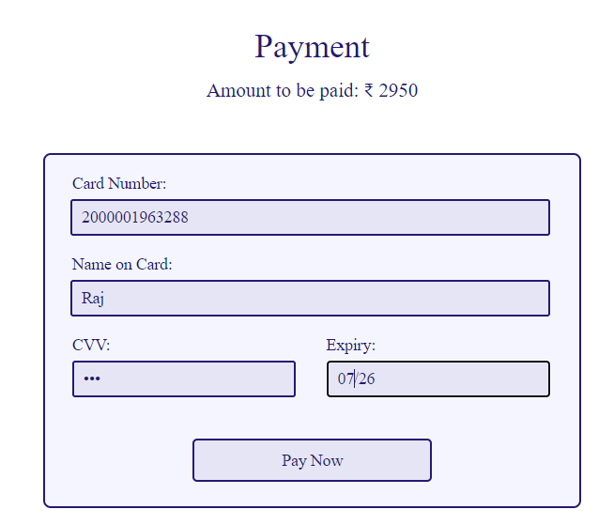

**Coding :**

<?php session_start();

if(!isset($_SESSION["username"]))

{

header("Location:blocked.php");

$_SESSION['url'] = $_SERVER['REQUEST_URI'];

}

?>

<!DOCTYPE html>

<html lang="en">

<!-- HEAD TAG STARTS -->

<head>

<meta charset="UTF-8">

<meta name="viewport" content="width=device-width, initial-scale=1.0"/>

<title>Payment | tourism_management</title>

<link href="css/main.css" rel="stylesheet">

<link href="css/bootstrap.min.css" rel="stylesheet">

<link href="https://fonts.googleapis.com/css?family=Oswald:200,300,400|Raleway:100,300,400,500|Roboto:100,400,500,700" rel="stylesheet">

<link href="https://maxcdn.bootstrapcdn.com/font-awesome/4.7.0/css/font-awesome.min.css" rel="stylesheet">

<script src="js/jquery-3.2.1.min.js"></script>

<script src="js/main.js"></script>

<script src="js/bootstrap.min.js"></script>

</head>

<!-- HEAD TAG ENDS -->

<!-- BODY TAG STARTS -->

<body>

<?php include("common/headerLoggedIn.php"); ?>

<?php

$mode=$_POST["modeHidden"];

if($mode=="ReturnTripFlight" or $mode=="OneWayFlight") {

$totalPassengers=$_POST["totalPassengersHidden"];

for($i=1; $i<=$totalPassengers; $i++) {

$name[$i]=$_POST["name$i"];

$gender[$i]=$_POST["gender$i"];

}

$fare=$_POST["fareHidden"];

$type=$_POST["typeHidden"];

$class=$_POST["classHidden"];

$origin=$_POST["originHidden"];

$destination=$_POST["destinationHidden"];

$depart=$_POST["departHidden"];

$return=$_POST["returnHidden"];

$adults=$_POST["adultsHidden"];

$children=$_POST["childrenHidden"];

$noOfPassengers=(int)$adults+(int)$children;

if($type=="Return Trip") { $flightNoOutbound=$_POST["flightNoOutboundHidden"];

$flightNoInbound=$_POST["flightNoInboundHidden"];

}

elseif($type=="One Way") {

$flightNoOutbound=$_POST["flightNoOutboundHidden"];

}

if($class=="Economy Class")

$className="Economy";

else

$className="Business";

} // for flights

elseif($mode=="hotel") {

$fare=$_POST["fareHidden"];

$hotelID=$_POST["hotelIDHidden"];

} //for hotels

//elseif($mode=="cabs") {

// $fare=$_SESSION["cabsFare"];

// $carID=$_SESSION["carID"];

//} //for hotels

//elseif($mode=="bus") {

// $totalPassengers=$_POST["totalPassengersHidden"];

// $fare=$_POST["fareHidden"];

// $busID=$_POST["busIDHidden"];

// $origin=$_POST["originHidden"];

// $destination=$_POST["destinationHidden"];

// for($i=1; $i<=$totalPassengers; $i++) {

// $name[$i]=$_POST["name$i"];

// $gender[$i]=$_POST["gender$i"];

// }

//} //for bus

elseif($mode=="train") {

$totalPassengers=$_POST["totalPassengersHidden"];

$fare=$_POST["fareHidden"];

$trainID=$_POST["trainIDHidden"];

$origin=$_POST["originHidden"];

$destination=$_POST["destinationHidden"];

$date=$_POST["dateHidden"];

$day=$_POST["dayHidden"];

$class=$_POST["classHidden"];

for($i=1; $i<=$totalPassengers; $i++) {

$name[$i]=$_POST["name$i"];

$gender[$i]=$_POST["gender$i"];

}

} //for train

?>

<div class="spacer">a</div>

<div class="col-sm-12 paymentWrapper">

<div class="headingOne">

Payment

</div>

<div class="totalAmount">

Amount to be paid: <span class="sansSerif">₹</span><?php echo $fare; ?>

</div>

<!--<div class="col-sm-3"></div>-->

<div class="col-sm-3"></div>

<div class="col-sm-6">

<div class="boxCenter">

<div class="col-sm-12 tag">

Card Number:

</div>

<div class="col-sm-12">

<input type="text" class="input" name="cardNumber" placeholder="Enter the card number" id="cardNumber"/>

</div>

<div class="col-sm-12 tag">

Name on Card:

</div>

<div class="col-sm-12">

<input type="text" class="input" name="nameOnCard" placeholder="Enter the name of the card holder" id="nameOnCard"/>

</div>

<div class="col-sm-6 tag">

CVV:

</div>

<div class="col-sm-6 tag">

Expiry:

</div>

<div class="col-sm-6">

<input type="password" class="inputSmall" name="cvv" placeholder="CVV" id="cvv"/>

</div>

<div class="col-sm-6">

<input type="text" class="inputSmall" name="expiry" placeholder="MM/YY" id="cardExpiry"/>

</div>

<!-- flights -->

<?php if($mode=="ReturnTripFlight" or $mode=="OneWayFlight"): ?>

<form action="generateTicket.php" method="POST">

<div class="col-sm-12 bookingButton text-center">

<input type="submit" class="paymentButton" value="Pay Now">

</div>

<input type="hidden" name="totalPassengersHidden" value="<?php echo $totalPassengers; ?>">

<input type="hidden" name="fareHidden" value="<?php echo $fare; ?>">

<input type="hidden" name="typeHidden" value="<?php echo $type; ?>">

<input type="hidden" name="classHidden" value="<?php echo $class; ?>">

<input type="hidden" name="originHidden" value="<?php echo $origin; ?>">

<input type="hidden" name="destinationHidden" value="<?php echo $destination; ?>">

<input type="hidden" name="departHidden" value="<?php echo $depart; ?>">

<input type="hidden" name="returnHidden" value="<?php echo $return; ?>">

<input type="hidden" name="adultsHidden" value="<?php echo $adults; ?>">

<input type="hidden" name="childrenHidden" value="<?php echo $children; ?>">

<input type="hidden" name="modeHidden" value="<?php echo $mode ?>">

<?php for($i=1; $i<=$totalPassengers; $i++) {?>

<input type="hidden" name="nameHidden<?php echo $i; ?>" value="<?php echo $name[$i]; ?>">

<input type="hidden" name="genderHidden<?php echo $i; ?>" value="<?php echo $gender[$i]; ?>">

<?php } ?>

<?php if($type=="Return Trip") { ?>

<input type="hidden" name="flightNoOutboundHidden" value="<?php echo $flightNoOutbound; ?>">

<input type="hidden" name="flightNoInboundHidden" value="<?php echo $flightNoInbound; ?>">

<?php } elseif($type=="One Way") { ?>

<input type="hidden" name="flightNoOutboundHidden" value="<?php echo $flightNoOutbound; ?>">

<?php } ?>

</form>

<!-- hotels -->

<?php elseif($mode=="hotel"): ?>

<form action="generateReceipt.php" method="POST">

<div class="col-sm-12 bookingButton text-center">

<input type="submit" class="paymentButton" value="Pay Now">

</div>

<input type="hidden" name="hotelIDHidden" value="<?php echo $hotelID; ?>">

<input type="hidden" name="fareHidden" value="<?php echo $fare; ?>">

</form>

<!--trains--->

<?php elseif($mode=="train"): ?>

<form action="generateTrainTicket.php" method="POST">

<div class="col-sm-12 bookingButton text-center">

<?php $date=$_POST["dateHidden"]; ?>

<input type="hidden" name="dateHidden" value="<?php echo $date; ?>">

<input type="hidden" name="dayHidden" value="<?php echo $day; ?>">

<input type="hidden" name="classHidden" value="<?php echo $class; ?>">

<input type="submit" class="paymentButton" value="Pay Now">

</div>

<input type="hidden" name="totalPassengersHidden" value="<?php echo $totalPassengers; ?>">

<input type="hidden" name="fareHidden" value="<?php echo $fare; ?>">

<input type="hidden" name="originHidden" value="<?php echo $origin; ?>">

<input type="hidden" name="destinationHidden" value="<?php echo $destination; ?>">

<input type="hidden" name="modeHidden" value="<?php echo $mode ?>">

<?php for($i=1; $i<=$totalPassengers; $i++) {?>

<input type="hidden" name="nameHidden<?php echo $i; ?>" value="<?php echo $name[$i]; ?>">

<input type="hidden" name="genderHidden<?php echo $i; ?>" value="<?php echo $gender[$i]; ?>">

<?php } ?>

<input type="hidden" name="trainIDHidden" value="<?php echo $trainID; ?>">

</form>

<?php endif; ?>

</div>

</div>

<div class="col-sm-3"></div>

</div><!-- paymentWrapper -->

<div class="spacerLarge">.</div><!-- just a dummy class for creating some space -->

<?php include("common/footer.php"); ?>

</body>

<!-- BODY TAG ENDS -->

</html>

**Generate Train E-ticket :**

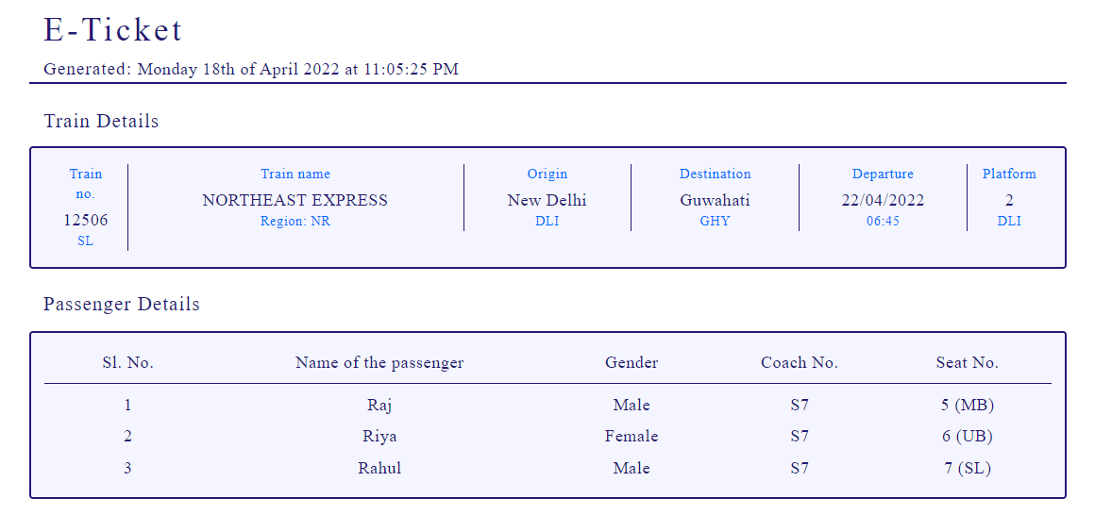

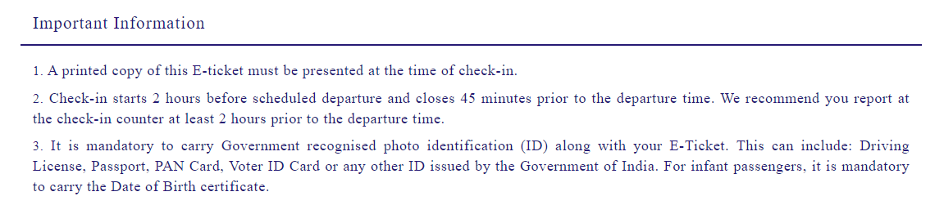

**Coding :**

<?php session_start();

if(!isset($_SESSION["username"]))

{

header("Location:blocked.php");

$_SESSION['url'] = $_SERVER['REQUEST_URI'];

}

?>

<!-- dumping the current page to buffer -->

<?php

ob_start();

?>

<!DOCTYPE html>

<html lang="en">

<!-- HEAD TAG STARTS -->

<head>

<meta charset="UTF-8">

<meta name="viewport" content="width=device-width, initial-scale=1.0"/>

<title>E-Ticket | tourism_management</title>

<link href="css/main.css" rel="stylesheet">

<link href="css/bootstrap.min.css" rel="stylesheet">

<link href="https://fonts.googleapis.com/css?family=Oswald:200,300,400|Raleway:100,300,400,500|Roboto:100,400,500,700" rel="stylesheet">

<link href="https://maxcdn.bootstrapcdn.com/font-awesome/4.7.0/css/font-awesome.min.css" rel="stylesheet">

<script src="js/jquery-3.2.1.min.js"></script>

<script src="js/main.js"></script>

<script src="js/bootstrap.min.js"></script>

</head>

<!-- HEAD TAG ENDS -->

<!-- BODY TAG STARTS -->

<body>

<div class="spacer">a</div>

<?php

date_default_timezone_set("Asia/Kolkata");

$date=date('l jS \of F Y \a\t h:i:s A');

$datePass=$_POST["dateHidden"];

$dayPass=$_POST["dayHidden"];

$class=$_POST["classHidden"];

$seatsClass = trim('seats'.$class);

$totalPassengers=$_POST["totalPassengersHidden"];

$trainID=$_POST["trainIDHidden"];

for($i=1; $i<=$totalPassengers; $i++) {

$name[$i]=$_POST["nameHidden$i"];

$gender[$i]=$_POST["genderHidden$i"];

}

$mode=$_POST["modeHidden"];

$fare=$_POST["fareHidden"];

$origin=$_POST["originHidden"];

$destination=$_POST["destinationHidden"];

?>

<?php

$servername = "localhost";

$username = "root";

$password = "";

$dbname = "projectmeteor";

// Creating a connection to MySQL database

$conn = new mysqli($servername, $username, $password, $dbname);

// Checking if we've successfully connected to the database

if ($conn->connect_error) {

die("Connection failed: " . $conn->connect_error);

}

if($mode=="train"){

$getBookedSeatsOutboundSQL = "SELECT noOfBookings FROM `trains` WHERE trainNo='$trainID'";

$getBookedSeatsOutboundQuery = $conn->query($getBookedSeatsOutboundSQL);

$bookedSeatsOutboundGet = $getBookedSeatsOutboundQuery ->fetch_array(MYSQLI_NUM);

$bookedSeatsOutbound = $bookedSeatsOutboundGet[0];

$newBookedSeats = $bookedSeatsOutbound+$totalPassengers;

//updating the no. of bookings

$outboundBookingUpdateSQL = "UPDATE `trains` SET noOfBookings='$newBookedSeats' WHERE trainNo='$trainID'";

$outboundBookingUpdateQuery = $conn->query($outboundBookingUpdateSQL);

$getSeatsAvailableOutboundSQL = "SELECT $seatsClass FROM `trains` WHERE trainNo='$trainID'";

$getSeatsAvailableOutboundQuery = $conn->query($getSeatsAvailableOutboundSQL);

$SeatsAvailableOutboundGet = $getSeatsAvailableOutboundQuery ->fetch_array(MYSQLI_NUM);

$seatsAvailableOutbound = $SeatsAvailableOutboundGet[0];

$newseatsAvailable = $seatsAvailableOutbound-$totalPassengers;

//updating the no. of seats available

$outboundSeatUpdateSQL = "UPDATE `trains` SET $seatsClass='$newseatsAvailable' WHERE trainNo='$trainID'";

$outboundSeatUpdateQuery = $conn->query($outboundSeatUpdateSQL);

}

?>

<div class="col-sm-12 generateTicket">

<div class="commonHeader">

<div class="col-sm-1"></div>

<div class="col-sm-7 text-left">

<div class="headingOne">

E-Ticket

</div>

<div class="dateTime">

<span class="generated">Generated: </span><?php echo $date; ?>

</div>

</div>

<div class="col-sm-3 text-right">

</div>

<div class="col-sm-1"></div>

<div class="col-sm-12"></div>

<div class="col-sm-1"></div>

<div class="col-sm-10 bar"></div>

<div class="col-sm-1"></div>

</div><!-- contains the header--->

<!-- changing contents of the page based on mode -->

<div class="col-sm-12"></div><!-- empty class -->

<div class="col-sm-1"></div>

<div class="col-sm-10">

<div class="subHeading">

Train Details

</div>

</div>

<div class="col-sm-12"></div><!-- empty class -->

<div class="col-sm-1"></div>

<div class="col-sm-10 boxCenter"><!-- outboundFlight Box -->

<?php

$outboundFlightSQL = "SELECT * FROM `trains` WHERE trainNo='$trainID'";

$outboundFlightQuery = $conn->query($outboundFlightSQL);

$row = $outboundFlightQuery->fetch_assoc();

?>

<div class="col-sm-1 borderRight text-center">

<div class="arrivesHeading">

Train no.

</div>

<div class="arrives">

<?php echo $row["trainNo"]; ?>

</div>

<div class="arrivesSubscript">

<?php echo $class; ?>

</div>

</div><!-- col-sm-4 -->

<div class="col-sm-4 borderRight text-center">

<div class="flightOperatorHeading">

Train name

</div>

<div class="flightOperator">

<?php echo $row["trainName"]; ?>

</div>

<div class="flightNo">

Region: <?php echo $row["region"]; ?>

</div>

</div><!-- col-sm-4 -->

<div class="col-sm-2 borderRight text-center">

<div class="originHeading">

Origin

</div>

<div class="origin">

<?php echo $origin; ?>

</div>

<div class="originSubscript">

<?php echo $row["originCode"]; ?>

</div>

</div><!-- col-sm-4 -->

<div class="col-sm-2 borderRight text-center">

<div class="destinationHeading">

Destination

</div>

<div class="origin">

<?php echo $destination; ?>

</div>

<div class="destinationSubscript">

<?php echo $row["destinationCode"]; ?>

</div>

</div><!-- col-sm-4 -->

<div class="col-sm-2 borderRight text-center">

<div class="departsHeading">

Departure

</div>

<div class="departs">

<?php echo $datePass;?>

</div>

<div class="departsSubscript">

<?php echo $row["originTime"]; ?>

</div>

</div><!-- col-sm-4 -->

<div class="col-sm-1 text-center">

<div class="arrivesHeading">

Platform

</div>

<div class="arrives">

<?php echo $row["originPlatform"]; ?>

</div>

<div class="arrivesSubscript">

<?php echo $row["originCode"]; ?>

</div>

</div><!-- col-sm-4 -->

</div><!-- outboundFlight Box -->

<div class="col-sm-12 spacer">a</div>

<div class="col-sm-1"></div>

<div class="col-sm-10">

<div class="subHeading">

Passenger Details

</div>

</div>

<div class="col-sm-12"></div><!-- empty class -->

<div class="col-sm-1"></div>

<div class="col-sm-12"></div><!-- empty class -->

<div class="col-sm-1"></div>

<div class="col-sm-10 boxCenter">

<div class="columnHeaders">

<div class="col-sm-2 borderBottom">

<div class="serialNoHeader text-center">

Sl. No.

</div>

</div>

<div class="col-sm-4 borderBottom">

<div class="passengerNameHeader text-center">

Name of the passenger

</div>

</div>

<div class="col-sm-2 borderBottom">

<div class="genderHeader text-center">

Gender

</div>

</div>

<div class="col-sm-2 borderBottom">

<div class="genderHeader text-center">

Coach No.

</div>

</div>

<div class="col-sm-2 borderBottom">

<div class="genderHeader text-center">

Seat No.

</div>

</div>

</div><!-- columnHeaders -->

<div class="col-sm-12"></div>

<!-- assigning coach numbers and seat numbers -->

<?php

if($class = "SL") {

$coachAvailable = array('S1','S2','S3','S4','S5','S6','S7','S8','S9','S10');

$coachSel = mt_rand(0,9);

$coach = $coachAvailable[$coachSel];

$seatNoSel = mt_rand(1,63);

}

elseif($class = "3AC") {

$coach = '3A';

$seatNoSel = mt_rand(1,55);

}

elseif($class = "2AC") {

$coach = '2A';

$seatNoSel = mt_rand(1,25);

}

elseif($class = "1AC") {

$coach = '1A';

$seatNoSel = mt_rand(1,15);

}

?>

<?php for($i=1; $i<=$totalPassengers; $i++) {?>

<div class="col-sm-2">

<div class="serialNo text-center">

<?php echo $i; ?>

</div>

</div>

<div class="col-sm-4">

<div class="passengerName text-center">

<?php echo $name[$i]; ?>

</div>

</div>

<div class="col-sm-2">

<div class="gender text-center">

<?php echo $gender[$i]; ?>

</div>

</div>

<div class="col-sm-2">

<div class="gender text-center coach">

<?php echo $coach; ?>

</div>

</div>

<div class="col-sm-2">

<div class="gender text-center seatNo">

<?php

$seatNo = $i+$seatNoSel-1;

echo $seatNo;

if($class = "SL") {

$lb = array(1,4,9,12,17,20,25,28,33,36,41,44,49,52,57,60,65,68);

$mb = array(2,5,10,13,18,21,26,29,34,37,42,45,50,53,58,61,66,69);

$ub = array(3,6,11,14,19,22,27,30,35,38,43,46,51,54,59,62,67,70);

$sl = array(7,15,23,31,39,47,55,63,71);

$su = array(8,16,24,32,40,48,56,64,72);

if($seatNo == in_array($seatNo, $lb)) {

echo " (LB)";

}

elseif($seatNo == in_array($seatNo, $mb)) {

echo " (MB)";

}

elseif($seatNo == in_array($seatNo, $ub)) {

echo " (UB)";

}

elseif($seatNo == in_array($seatNo, $su)) {

echo " (SU)";

}

elseif($seatNo == in_array($seatNo, $sl)) {

echo " (SL)";

}

}

elseif($class = "3AC") {

$lb = array(1,4,9,12,17,20,25,28,33,36,41,44,49,52,57,60);

$mb = array(2,5,10,13,18,21,26,29,34,37,42,45,50,53,58,61);

$ub = array(3,6,11,14,19,22,27,30,35,38,43,46,51,54,59,62);

$sl = array(7,15,23,31,39,47,55,63);

$su = array(8,16,24,32,40,48,56,64);

if($seatNo == in_array($seatNo, $lb)) {

echo " (LB)";

}

elseif($seatNo == in_array($seatNo, $mb)) {

echo " (MB)";

}

elseif($seatNo == in_array($seatNo, $ub)) {

echo " (UB)";

}

elseif($seatNo == in_array($seatNo, $su)) {

echo " (SU)";

} elseif($seatNo == in_array($seatNo, $sl)) {

echo " (SL)";

}

}

elseif($class = "2AC") {

$lb = array(1,3,7,9,13,15,19,21,25,27,31,33,37,39,43);

$ub = array(2,4,8,10,14,16,20,22,26,28,32,34,38,40,44);

$sl = array(5,11,17,23,29,35,41,45);

$su = array(6,12,18,24,30,36,42,46);

if($seatNo == in_array($seatNo, $lb)) {

echo " (LB)";

} elseif($seatNo == in_array($seatNo, $ub)) {

echo " (UB)";

}

elseif($seatNo == in_array($seatNo, $su)) {

echo " (SU)";

}

elseif($seatNo == in_array($seatNo, $sl)) {

echo " (SL)";

}

}

elseif($class = "1AC") {

$lb = array(1,3,5,7,9,11,13,15,17,19,21,23);

$ub = array(2,4,6,8,10,12,14,16,18,20,22,24);

if($seatNo == in_array($seatNo, $lb)) {

echo " (LB)";

}

elseif($seatNo == in_array($seatNo, $ub)) {

echo " (UB)";

}

}

?>

</div>

</div>

<?php } ?>

</div><!-- boxCenter -->

<div class="importantInfo">

<div class="col-sm-12"></div><!-- empty class -->

<div class="col-sm-12 spacer">a</div>

<div class="col-sm-12 spacer">a</div>

<div class="col-sm-1"></div>

<div class="col-sm-10">

<div class="subHeading">

Important Information

</div>

</div>

<div class="col-sm-1"></div>

<div class="col-sm-12"></div>

<div class="col-sm-1"></div>

<div class="col-sm-10 bar"></div>

<div class="col-sm-1"></div>

<div class="col-sm-12"></div>

<div class="col-sm-1"></div>

<div class="col-sm-10">

<div class="info">

<span class="strong">1.</span> A printed copy of this E-ticket must be presented at the time of check-in.

</div>

<div class="info">

<span class="strong">2.</span> Check-in starts 2 hours before scheduled departure and closes 45 minutes prior to the departure time. We recommend you report at the check-in counter at least 2 hours prior to the departure time.

</div>

<div class="info">

<span class="strong">3.</span> It is mandatory to carry Government recognised photo identification (ID) along with your E-Ticket. This can include: Driving License, Passport, PAN Card, Voter ID Card or any other ID issued by the Government of India. For infant passengers, it is mandatory to carry the Date of Birth certificate.

</div>

</div>

<div class="col-sm-1"></div>

<div class="col-sm-12 spacer">a</div>

<div class="col-sm-12"></div><!-- empty class -->

</div><!-- importantInfo -->

</div><!-- generateTicket -->

<div class="spacer">a</div>

</body>

<!-- BODY TAG ENDS -->

</html>

<!-- after user login system is built push the username using the curent session to the database -->

<?php

$user = $_SESSION["username"];

$dateFormatted=date("d-m-Y"); //formatting the date as DD-MM-YY

$bookingDataInsertSQL = "INSERT INTO `trainbookings`(username,date,cancelled,origin,destination,passengers) VALUES('$user','$dateFormatted','no','$origin','$destination','$totalPassengers')";

$bookingDataInsertQuery = $conn->query($bookingDataInsertSQL);

$bookingIDSQL = "SELECT * FROM `trainbookings` ORDER BY `bookingID` DESC LIMIT 1";

$bookingIDQuery = $conn->query($bookingIDSQL);

$bookingIDGet = $bookingIDQuery ->fetch_array(MYSQLI_NUM);

$latestBookingID = $bookingIDGet[0];

$currentBookingID = $latestBookingID;

?>

<!-- saving the file as temp.html -->

<?php

file_put_contents('tickets\trainTicket'.$currentBookingID.'.html', ob_get_contents());

?>

**Packages :**

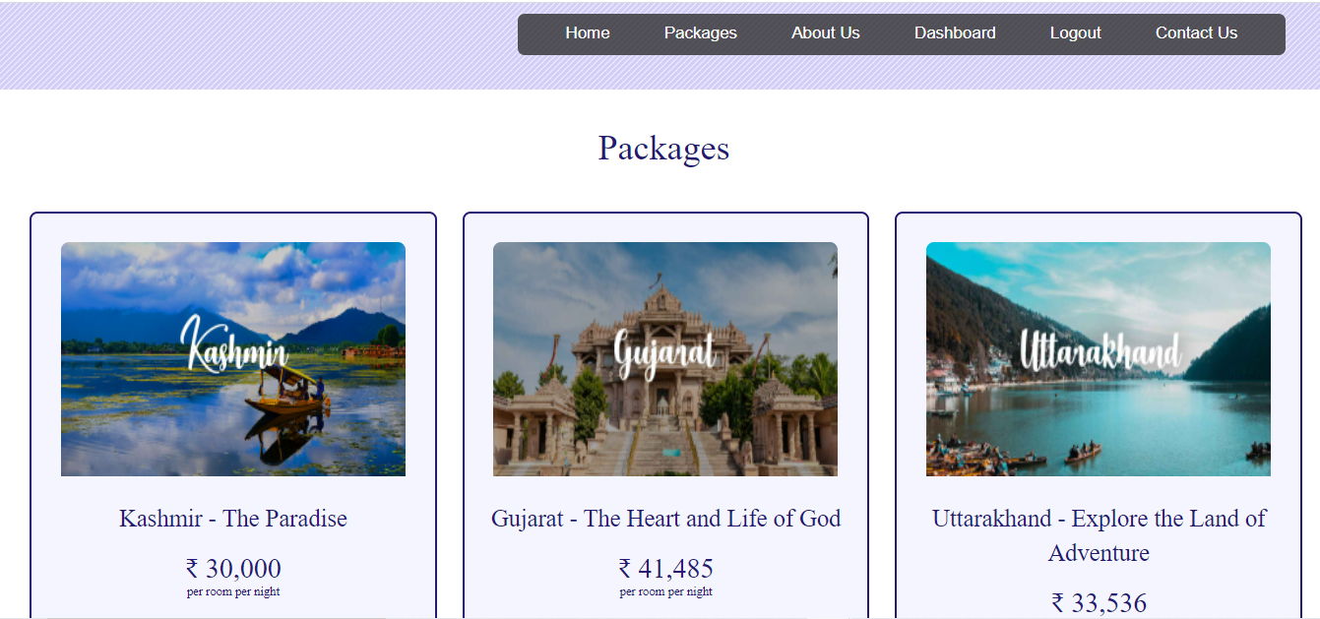

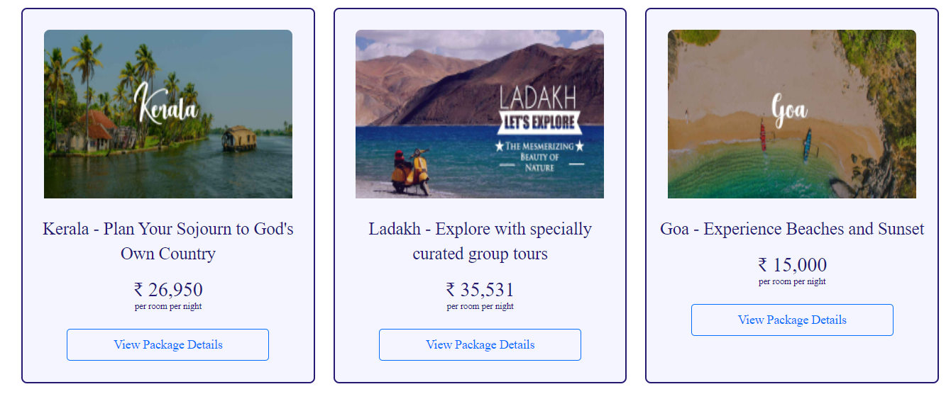



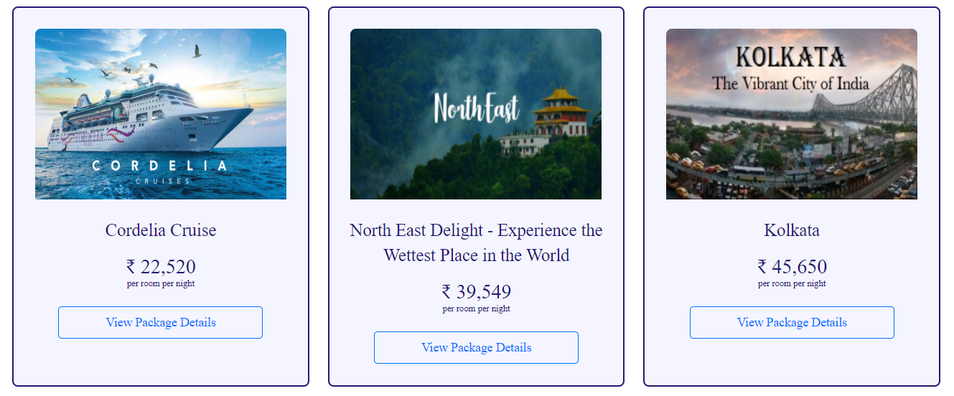

**Coding :**

<?php session_start();

if(!isset($_SESSION["username"]))

{

header("Location:blocked.php");

$_SESSION['url'] = $_SERVER['REQUEST_URI'];

}

?>

<!DOCTYPE html>

<html lang="en">

<!-- HEAD TAG STARTS -->

<head>

<meta charset="UTF-8">

<meta name="viewport" content="width=device-width, initial-scale=1.0"/>

<title>Hotel Search | tourism_management</title>

<link href="css/main.css" rel="stylesheet">

<link href="css/bootstrap.min.css" rel="stylesheet">

<link href="https://fonts.googleapis.com/css?family=Oswald:200,300,400|Raleway:100,300,400,500|Roboto:100,400,500,700" rel="stylesheet">

<link href="https://maxcdn.bootstrapcdn.com/font-awesome/4.7.0/css/font-awesome.min.css" rel="stylesheet">

<script src="js/jquery-3.2.1.min.js"></script>

<script src="js/main.js"></script>

<script src="js/bootstrap.min.js"></script>

</head>

<!-- HEAD TAG ENDS -->

<!-- BODY TAG STARTS -->

<body>

<?php include("common/headerLoggedIn.php"); ?>

<div class="spacer">a</div>

<div class="searchHotels">

<div class="query">

<h1>Packages</h1>

</div>

<?php

$servername = "localhost";

$username = "root";

$password = "";

$dbname = "projectmeteor";

// Creating a connection to MySQL database

$conn = new mysqli($servername, $username, $password, $dbname);

// Checking if we've successfully connected to the database

if ($conn->connect_error) {

die("Connection failed: " . $conn->connect_error);

}

$sql = "SELECT * FROM tbltourpackages";

$rowcount = mysqli_num_rows(mysqli_query($conn,$sql));

$result = $conn->query($sql);

if ($result->num_rows > 0) {

?>

</div><!-- search hotels -->

<div class="col-sm-12 searchHotels">

<?php

while($row = $result->fetch_assoc()) {

?>

<div class="col-sm-4 text-center">

<div class="col-sm-12 listItem">

<!-- hotel INFO STARTS -->

<div class="col-sm-12 imageContainer text-center">

<img src="pacakgeimages/<?php echo $row["PackageImage"]; ?>" alt="<?php echo $row["hotelName"] ?>">

</div>

<div class="col-sm-12 hotelName"><?php echo $row["PackageName"]; ?></div>

<div class="col-sm-12 priceContainer">

₹ <?php echo $row["PackagePrice"] ?>

</div>

<div class="col-sm-12 priceNote">

per room per night

</div>

<div class="col-sm-12 view">

<a href="package-details.php?pkgid=<?php echo $row["PackageId"];?>" ><input type="button" class="viewDetails" name="viewDetails" value="View Package Details"/></a>

</div>

</div><!-- listItem 1 -->

</div>

<?php

} ?>

</div>

<?php } else {

?>

<div class="col-sm-12 searchHotels">

<div class="noHotels">

No hotels found.

</div>

</div>

<?php

}

?>

<?php $conn->close(); //closing the connection to the database ?>

<div class="spacerLarge">.</div><!-- just a dummy class for creating some space -->

<?php include("common/footer.php"); ?>

</body>

<!-- BODY TAG ENDS -->

</html>

**Package Details :**

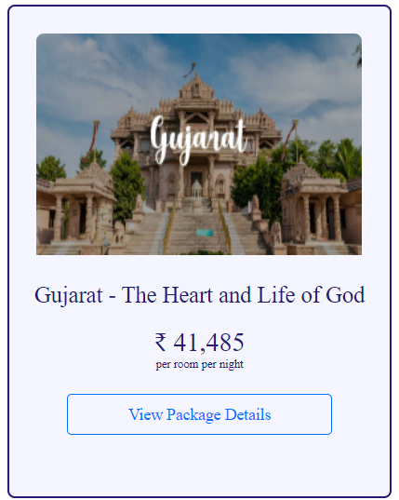

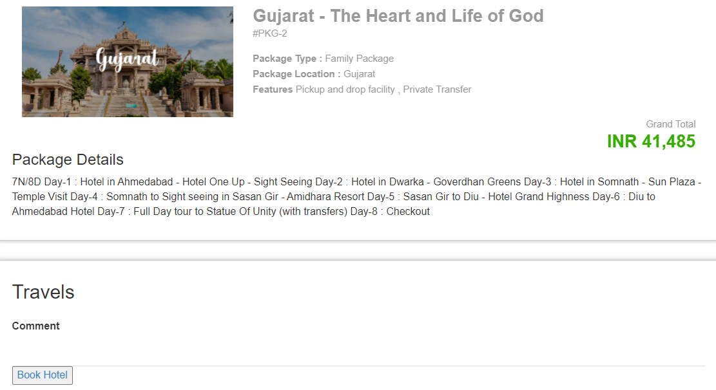

**Coding :**

<?php

session_start();

error_reporting(0);

include('includes1/config.php');

if(isset($_POST['submit2']))

{

$pid=intval($_GET['pkgid']);

$useremail=$_SESSION['login'];

$fromdate=$_POST['fromdate'];

$comment=$_POST['comment'];

$status=0;

$sql="INSERT INTO tblbooking(PackageId,UserEmail,FromDate,Comment,status) VALUES(:pid,:useremail,:fromdate,:comment,:status)";

$query = $dbh->prepare($sql);

$query->bindParam(':pid',$pid,PDO::PARAM_STR);

$query->bindParam(':useremail',$useremail,PDO::PARAM_STR);

$query->bindParam(':fromdate',$fromdate,PDO::PARAM_STR);

$query->bindParam(':comment',$comment,PDO::PARAM_STR);

$query->bindParam(':status',$status,PDO::PARAM_STR);

$query->execute();

$lastInsertId = $dbh->lastInsertId();

}

?>

<!DOCTYPE HTML>

<html>

<head>

<title>Staycation</title>

<meta name="viewport" content="width=device-width, initial-scale=1">

<meta http-equiv="Content-Type" content="text/html; charset=utf-8" />

<script type="applijewelleryion/x-javascript"> addEventListener("load", function() { setTimeout(hideURLbar, 0); }, false); function hideURLbar(){ window.scrollTo(0,1); } </script>

<link href="css1/bootstrap.css" rel='stylesheet' type='text/css' />

<link href="css1/style.css" rel='stylesheet' type='text/css' />

<link href='//fonts.googleapis.com/css?family=Open+Sans:400,700,600' rel='stylesheet' type='text/css'>

<link href='//fonts.googleapis.com/css?family=Roboto+Condensed:400,700,300' rel='stylesheet' type='text/css'>

<link href='//fonts.googleapis.com/css?family=Oswald' rel='stylesheet' type='text/css'>

<link href="css1/font-awesome.css" rel="stylesheet">

<!-- Custom Theme files -->

<script src="js1/jquery-1.12.0.min.js"></script>

<script src="js1/bootstrap.min.js"></script>

<!--animate-->

<link href="css1/animate.css" rel="stylesheet" type="text/css" media="all">

<script src="js1/wow.min.js"></script>

<link rel="stylesheet" href="css/jquery-ui.css" />

<script>

new WOW().init();

</script>

<script src="js1/jquery-ui.js"></script>

<script>

$(function() {

$( "#datepicker,#datepicker1" ).datepicker();

});

</script>

<style>

.errorWrap {

padding: 10px;

margin: 0 0 20px 0;

background: #fff;

border-left: 4px solid #dd3d36;

-webkit-box-shadow: 0 1px 1px 0 rgba(0,0,0,.1);

box-shadow: 0 1px 1px 0 rgba(0,0,0,.1);

}

.succWrap{

padding: 10px;

margin: 0 0 20px 0;

background: #fff;

border-left: 4px solid #5cb85c;

-webkit-box-shadow: 0 1px 1px 0 rgba(0,0,0,.1);

box-shadow: 0 1px 1px 0 rgba(0,0,0,.1);

}

</style>

</head>

<body>

<!-- top-header -->

<div class="banner-3">

<div class="container">

<h1 class="wow zoomIn animated animated" data-wow-delay=".5s" style="visibility: visible; animation-delay: 0.5s; animation-name: zoomIn;">Package Details</h1>

</div>

</div>

<!--- /banner ---->

<!--- selectroom ---->

<div class="selectroom">

<div class="container">

<?php if($error){?><div class="errorWrap"><strong>ERROR</strong>:<?php echo htmlentities($error); ?></div><?php }

else if($msg){?><div class="succWrap"><strong>SUCCESS</strong>:<?php echo htmlentities($msg); ?></div><?php }?>

<?php

$pid=intval($_GET['pkgid']);

$sql = "SELECT * from tbltourpackages where PackageId=:pid";

$query = $dbh->prepare($sql);

$query -> bindParam(':pid', $pid, PDO::PARAM_STR);

$query->execute();

$results=$query->fetchAll(PDO::FETCH_OBJ);

$cnt=1;

if($query->rowCount() > 0)

{

foreach($results as $result)

{ ?>

<form name="book" method="post">

<div class="selectroom_top">

<div class="col-md-4 selectroom_left wow fadeInLeft animated" data-wow-delay=".5s">

<img src="admin/pacakgeimages/<?php echo htmlentities($result->PackageImage);?>" class="img-responsive" alt="">

</div>

<div class="col-md-8 selectroom_right wow fadeInRight animated" data-wow-delay=".5s">

<h2><?php echo htmlentities($result->PackageName);?></h2>

<p class="dow">#PKG-<?php echo htmlentities($result->PackageId);?></p>

<p><b>Package Type :</b><?php echo htmlentities($result->PackageType);?></p>

<p><b>Package Location :</b><?php echo htmlentities($result->PackageLocation);?></p>

<p><b>Features</b><?php echo htmlentities($result->PackageFetures);?></p>

<div class="ban-bottom">

<div class="bnr-right">

</div>

</div>

<div class="clearfix"></div>

<div class="grand">

<p>Grand Total</p>

<h3>INR <?php echo htmlentities($result->PackagePrice);?></h3>

</div>

</div>

<h3>Package Details</h3>

<p style="padding-top: 1%"><?php echo htmlentities($result->PackageDetails);?></p>

<div class="clearfix"></div>

</div>

<div class="selectroom_top">

<h2>Travels</h2>

<div class="selectroom-info animated wow fadeInUp animated" data-wow-duration="1200ms" data-wow-delay="500ms" style="visibility: visible; animation-duration: 1200ms; animation-delay: 500ms; animation-name: fadeInUp; margin-top: -70px">

<ul>

<li class="spe">

<label class="inputLabel">Comment</label>

<input class="special" type="text" name="comment" >

</li>

<a href="hots.php" ><input type="button" class="viewDetails" name="viewDetails" value="Book Hotel"/></a>

<div class="clearfix"></div>

</ul>

</div>

</div>

</form>

<?php }} ?>

</div>

</div>

<!--- /selectroom ---->

<<!--- /footer-top ---->

<?php include('includes/footer.php');?>

<!-- signup -->

<?php include('includes/signup.php');?>

<!-- //signu -->

<!-- signin -->

<?php include('includes/signin.php');?>

<!-- //signin -->

<!-- write us -->

<?php include('includes/write-us.php');?>

</body>

</html>

**Package Hotels :**

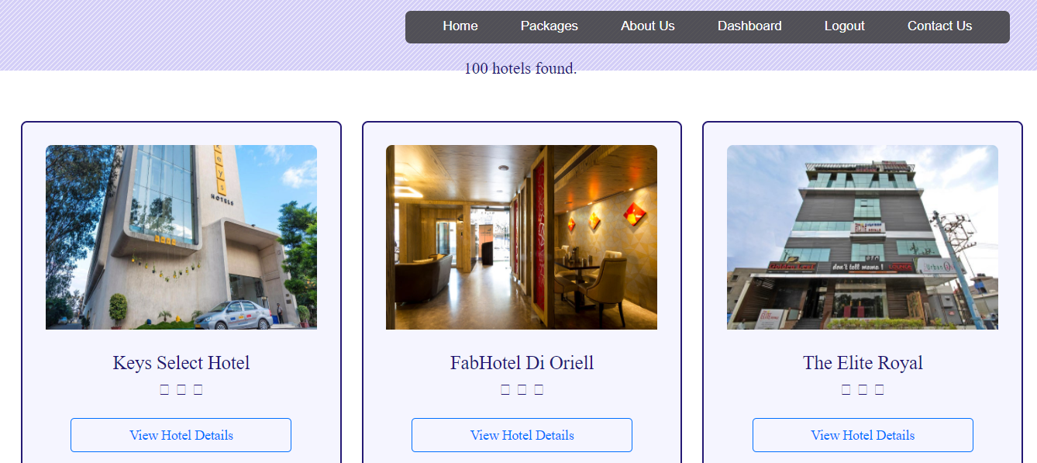

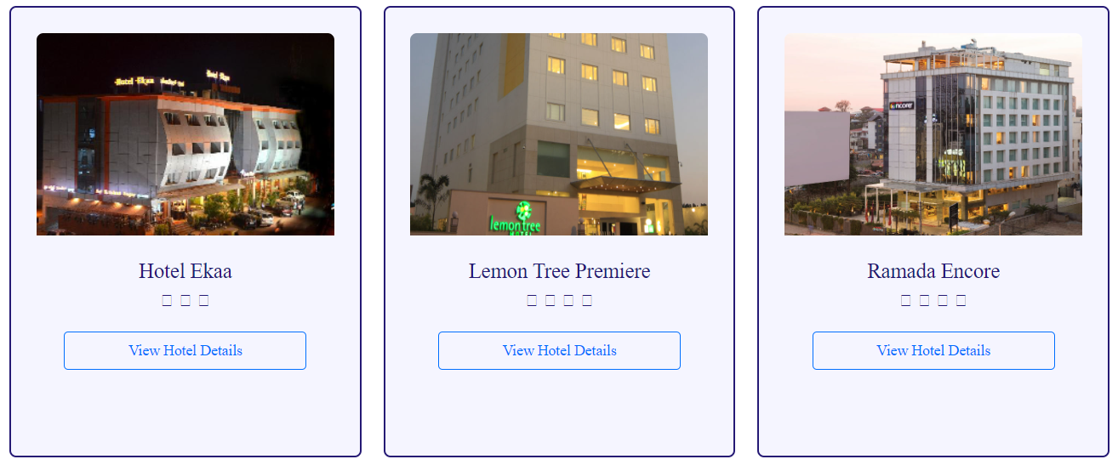

**Hotel Details :**

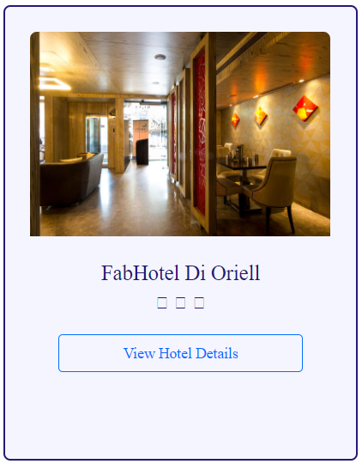

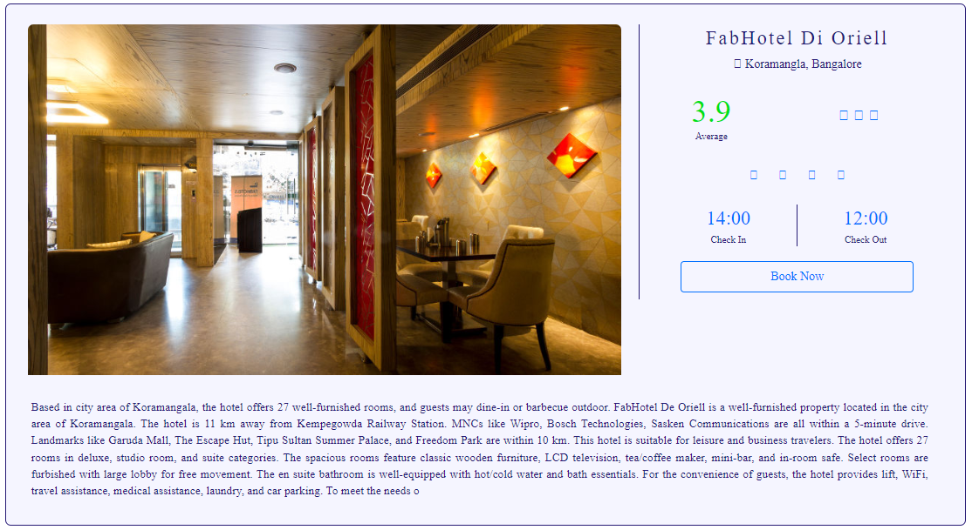

**Coding :**

<?php session_start();

if(!isset($_SESSION["username"]))

{

header("Location:blocked.php");

$_SESSION['url'] = $_SERVER['REQUEST_URI'];

}

?>

<!DOCTYPE html>

<html lang="en">

<!-- HEAD TAG STARTS -->

<head>

<meta charset="UTF-8">

<meta name="viewport" content="width=device-width, initial-scale=1.0"/>

<title>Hotel Details | tourism_management</title>

<link href="css/main.css" rel="stylesheet">

<link href="css/bootstrap.min.css" rel="stylesheet">

<link href="https://fonts.googleapis.com/css?family=Oswald:200,300,400|Raleway:100,300,400,500|Roboto:100,400,500,700" rel="stylesheet">

<link href="https://maxcdn.bootstrapcdn.com/font-awesome/4.7.0/css/font-awesome.min.css" rel="stylesheet">

<script src="js/jquery-3.2.1.min.js"></script>

<script src="js/hotelDetails.js"></script>

<script src="js/bootstrap.min.js"></script>

</head>

<!-- HEAD TAG ENDS -->

<!-- BODY TAG STARTS -->

<body>

<?php include("common/headerLoggedIn.php"); ?>

<?php

$hotelID=$_GET["hotelId"];

?>

<div class="spacer">a</div>

<div class="spacer">a</div>

<?php

$servername = "localhost";

$username = "root";

$password = "";

$dbname = "projectmeteor";

// Creating a connection to MySQL database

$conn = new mysqli($servername, $username, $password, $dbname);

// Checking if we've successfully connected to the database

if ($conn->connect_error) {

die("Connection failed: " . $conn->connect_error);

}

$sql = "SELECT * FROM hotels WHERE hotelID='$hotelID'";

$result = $conn->query($sql);

$row = $result->fetch_assoc()

?>

<div class="col-sm-1"></div><!-- empty div -->

<div class="col-sm-10 hotelDetails">

<div class="col-sm-12 listItem">

<div class="col-sm-8 leftBox">

<div class="col-sm-12 imageContainer">

<img src="<?php echo $row["mainImage"]; ?>" alt="Image not found" />

</div>

</div>

<div class="col-sm-4 rightBox borderLeft">

<div class="hotelName col-sm-12 text-center noMargin">

<?php echo $row["hotelName"]; ?>

</div>

<div class="location col-sm-12 text-center">

<span class="fa fa-map-marker"></span><?php echo $row["locality"].', '.$row["city"]; ?>

</div>

<div class="col-sm-5 text-center">

<div class="col-sm-12 rating noMargin">

<?php echo $row["rating"]; ?>

</div>

<div class="col-sm-12 ratingText noMargin">

<?php

$rating=$row["rating"];

if($rating>=4): ?>

Excellent

<?php

elseif($rating>=3 and $rating<4): ?>

Average

<?php

elseif($rating<3): ?>

Bad

<?php endif; ?>

</div>

</div>

<div class="col-sm-7 text-center">

<div class="col-sm-12 starContainer">

<?php

$noOfStars=$row["stars"];

for($i=0; $i<$noOfStars; $i++) {?>

<i class="fa fa-star"></i>

<?php } ?>

</div>

</div>

<div class="col-sm-12 amenities text-center">

<ul>

<?php if($row["wifi"]=="Yes") {?>

<li class="fa fa-wifi icons" id="wifi"></li>

<?php } ?>

<?php if($row["swimmingPool"]=="Yes") {?>

<li class="fa fa-life-buoy icons" id="pool"></li>

<?php } ?>

<?php if($row["parking"]=="Yes") {?>

<li class="fa fa-car icons" id="parking"></li>

<?php } ?>

<?php if($row["restaurant"]=="Yes") {?>

<li class="fa fa-cutlery icons" id="restaurant"></li>

<?php } ?>

<?php if($row["laundry"]=="Yes") {?>

<li class="fa fa-shirtsinbulk icons" id="laundry"></li>

<?php } ?>

<?php if($row["cafe"]=="Yes") {?>

<li class="fa fa-coffee icons" id="cafe"></li>

<?php } ?>

</ul>

</div><!-- amenities -->

<div class="col-sm-12 checkInOut text-center">

<div class="col-sm-6 checkIn">

<div class="col-sm-12 time">

<?php echo $row["checkIn"]; ?>

</div>

<div class="col-sm-12 timeTag">

Check In

</div>

</div>

<div class="col-sm-6 checkOut">

<div class="col-sm-12 time">

<?php echo $row["checkOut"]; ?>

</div>

<div class="col-sm-12 timeTag">

Check Out

</div>

</div>

</div><!-- checkInOut -->

<!-- creating a form -->

<form action="booking.php" method="POST">

<div class="col-sm-12 text-center">

<input type="submit" class="bookNow" value="Book Now" />

</div>

<input type="hidden" name="modeHidden" value="hotel" />

<input type="hidden" name="hotelIDHidden" value="<?php echo $hotelID; ?>" />

</form>

</div><!-- right box -->

<div class="col-sm-12 hotelDesc">

<?php echo $row["hotelDesc"]; ?>

</div>

</div>

</div>

<div class="col-sm-1"></div><!-- empty div -->

<div class="col-sm-12 spacer">.</div><!-- just a dummy class for creating some space -->

<div class="col-sm-12 spacer">.</div><!-- just a dummy class for creating some space -->

<div class="col-sm-12 spacer">.</div><!-- just a dummy class for creating some space -->

<?php include("common/footer.php"); ?>

</body>

<!-- BODY TAG ENDS -->

</html>

**Confirm Booking :**

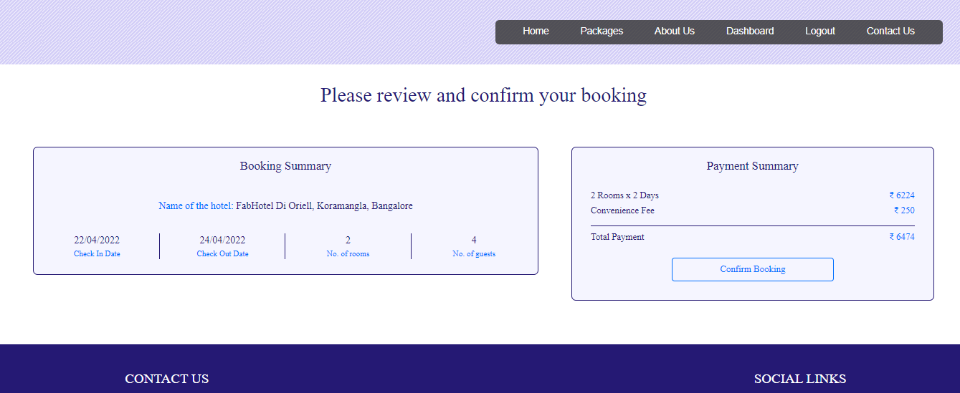

**Coding :**

<?php session_start();

if(!isset($_SESSION["username"]))

{

header("Location:blocked.php");

$_SESSION['url'] = $_SERVER['REQUEST_URI'];

}

?>

<!DOCTYPE html>

<html lang="en">

<!-- HEAD TAG STARTS -->

<head>

<meta charset="UTF-8">

<meta name="viewport" content="width=device-width, initial-scale=1.0"/>

<title>Booking | tourism_management</title>

<link href="css/main.css" rel="stylesheet">

<link href="css/bootstrap.min.css" rel="stylesheet">

<link href="https://fonts.googleapis.com/css?family=Oswald:200,300,400|Raleway:100,300,400,500|Roboto:100,400,500,700" rel="stylesheet">

<link href="https://maxcdn.bootstrapcdn.com/font-awesome/4.7.0/css/font-awesome.min.css" rel="stylesheet">

<script src="js/jquery-3.2.1.min.js"></script>

<script src="js/main.js"></script>

<script src="js/bootstrap.min.js"></script>

</head>

<!-- HEAD TAG ENDS -->

<!-- BODY TAG STARTS -->

<body>

<?php include("common/headerLoggedIn.php"); ?>

<?php

$mode=$_POST["modeHidden"];

?>

<?php

$servername = "localhost";

$username = "root";

$password = "";

$dbname = "projectmeteor";

// Creating a connection to MySQL database

$conn = new mysqli($servername, $username, $password, $dbname);

// Checking if successfully connected to the database

if ($conn->connect_error) {

die("Connection failed: " . $conn->connect_error);

}

?>

<div class="spacer">a</div>

<div class="bookingWrapper">

<div class="headingOne">

Please review and confirm your booking

</div>

<!-- changing contents of the page based on mode -->

<!----------------------------- ONE WAY FLIGHT --------------------------------->

<?php if($mode=="OneWayFlight"): ?>

<div class="col-sm-12 bookingOneWayFlight">

<?php

$type=$_POST["typeHidden"];

$class=$_POST["classHidden"];

$origin=$_POST["originHidden"];

$destination=$_POST["destinationHidden"];

$depart=$_POST["departHidden"];

$return=$_POST["returnHidden"];

$adults=$_POST["adultsHidden"];

$children=$_POST["childrenHidden"];

$noOfPassengers=(int)$adults+(int)$children;

if($type=="Return Trip") {

$flightNoOutbound=$_POST["flightNoOutboundHidden"];

$flightNoInbound=$_POST["flightNoInboundHidden"];

}

elseif($type=="One Way") {

$flightNoOutbound=$_POST["flightNoOutboundHidden"];

}

if($class=="Economy Class")

$className="Economy";

else

$className="Business";

$outboundFlightSQL = "SELECT * FROM `flights` WHERE flight_no='$flightNoOutbound'";

$outboundFlightQuery = $conn->query($outboundFlightSQL);

$row = $outboundFlightQuery->fetch_assoc();

?>

<div class="col-sm-7"><!-- departure container -->

<div class="col-sm-12">

<div class="boxLeftOneWayFlight">

<div class="col-sm-12 mode">Departure</div>

<div class="col-sm-4">

<div class="origin"><?php echo $origin; ?></div>

<div class="departs">Departs <?php echo $depart; ?> at: <?php echo $row["departs"]; ?></div>

</div>

<div class="col-sm-4">

<div class="arrow"></div>

</div>

<div class="col-sm-4">

<div class="destination"><?php echo $destination; ?></div>

<div class="arrives">Arrives <?php echo $depart; ?> at: <?php echo $row["arrives"]; ?></div>

</div>

<div class="col-sm-3 borderRight">

<div class="operator"><?php echo $row["operator"]; ?></div>

<div class="operatorSubscript">Operator</div>

</div>

<div class="col-sm-3 borderRight">

<div class="class"><?php echo $className; ?></div>

<div class="classSubscript">Class</div>

</div>

<div class="col-sm-3 borderRight">

<div class="adults"><?php echo $adults; ?></div>

<div class="adultsSubscript">Adults</div>

</div>

<div class="col-sm-3">

<div class="children"><?php echo $children; ?></div>

<div class="childrenSubscript">Children</div>

</div>

</div>

</div><!-- col-sm-7 Departure -->

</div>

<div class="col-sm-5"><!-- fare container -->

<div class="col-sm-12">

<div class="boxRightOneWayFlight">

<div class="col-sm-12 fareSummary">Fare Summary</div>

<div class="col-sm-8">

<div class="heading"><?php echo $adults; ?> Adults</div>

<div class="heading"><?php echo $children; ?> Children</div>

<div class="heading">Convenience Fee</div>

</div>

<div class="col-sm-4">

<div class="price"><span class="sansSerif">₹ </span><?php echo $adults*$row["fare"]; ?></div>

<div class="price"><span class="sansSerif">₹ </span><?php echo $children*$row["fare"]; ?></div>

<div class="price"><span class="sansSerif">₹ </span>250</div>

</div>

<div class="col-sm-12">

<div class="calcBar"></div>

</div>

<div class="col-sm-8">

<div class="headingTotal">Total Fare</div>

</div>

<div class="col-sm-4">

<div class="priceTotal"><span class="sansSerif">₹ </span><?php echo ($adults*$row["fare"])+($children*$row["fare"])+250; ?></div>

</div>

<form action="passengers.php" method="POST">

<div class="bookingButton text-center">

<input type="submit" class="confirmButton" value="Confirm Booking">

</div>

<?php $totalFare = ($adults*$row["fare"])+($children*$row["fare"])+250 ?>

<input type="hidden" name="fareHidden" value="<?php echo $totalFare; ?>">

<input type="hidden" name="typeHidden" value="<?php echo $type; ?>">

<input type="hidden" name="classHidden" value="<?php echo $class; ?>">

<input type="hidden" name="originHidden" value="<?php echo $origin; ?>">

<input type="hidden" name="destinationHidden" value="<?php echo $destination; ?>">

<input type="hidden" name="departHidden" value="<?php echo $depart; ?>">

<input type="hidden" name="returnHidden" value="<?php echo $return; ?>">

<input type="hidden" name="adultsHidden" value="<?php echo $adults; ?>">

<input type="hidden" name="childrenHidden" value="<?php echo $children; ?>">

<input type="hidden" name="flightNoOutboundHidden" value="<?php echo $row["flight_no"]; ?>">

<input type="hidden" name="modeHidden" value="<?php echo "OneWayFlight" ?>">

</form>

</div>

</div><!-- col-sm-5 Fare -->

</div><!-- fare container -->

</div><!-- bookingOneWayFlight -->

<!----------------------------- RETURN TRIP FLIGHT --------------------------------->

<?php elseif($mode=="ReturnTripFlight"): ?>

<div class="col-sm-12 bookingReturnTripFlight">

<?php

$type=$_POST["typeHidden"];

$class=$_POST["classHidden"];

$origin=$_POST["originHidden"];

$destination=$_POST["destinationHidden"];

$depart=$_POST["departHidden"];

$return=$_POST["returnHidden"];

$adults=$_POST["adultsHidden"];

$children=$_POST["childrenHidden"];

$noOfPassengers=(int)$adults+(int)$children;

if($type=="Return Trip") {

$flightNoOutbound=$_POST["flightNoOutboundHidden"];

$flightNoInbound=$_POST["flightNoInboundHidden"];

}

elseif($type=="One Way") {

$flightNoOutbound=$_POST["flightNoOutboundHidden"];

}

if($class=="Economy Class")

$className="Economy";

else

$className="Business";

$outboundFlightSQL = "SELECT * FROM `flights` WHERE flight_no='$flightNoOutbound'";

$outboundFlightQuery = $conn->query($outboundFlightSQL);

$rowOutbound = $outboundFlightQuery->fetch_assoc();

$inboundFlightSQL = "SELECT * FROM `flights` WHERE flight_no='$flightNoInbound'";

$inboundFlightQuery = $conn->query($inboundFlightSQL);

$rowInbound = $inboundFlightQuery->fetch_assoc();

?>

<div class="col-sm-7"><!-- departure return container -->

<div class="col-sm-12">

<div class="boxLeftOneWayFlight">

<div class="col-sm-12 mode">Departure</div>

<div class="col-sm-4">

<div class="origin"><?php echo $rowOutbound["origin"]; ?></div>

<div class="departs">Departs <?php echo $depart; ?> at: <?php echo $rowOutbound["departs"]; ?></div>

</div>

<div class="col-sm-4">

<div class="arrow"></div>

</div>

<div class="col-sm-4">

<div class="destination"><?php echo $rowOutbound["destination"]; ?></div>

<div class="arrives">Arrives <?php echo $depart; ?> at: <?php echo $rowOutbound["arrives"]; ?></div>

</div>

<div class="col-sm-3 borderRight">

<div class="operator"><?php echo $rowOutbound["operator"]; ?></div>

<div class="operatorSubscript">Operator</div>

</div>

<div class="col-sm-3 borderRight">

<div class="class"><?php echo $className; ?></div>

<div class="classSubscript">Class</div>

</div>

<div class="col-sm-3 borderRight">

<div class="adults"><?php echo $adults; ?></div>

<div class="adultsSubscript">Adults</div>

</div>

<div class="col-sm-3">

<div class="children"><?php echo $children; ?></div>

<div class="childrenSubscript">Children</div>

</div>

</div>

</div><!-- col-sm-7 Departure -->

<div class="col-sm-12">

<div class="boxLeftOneWayFlight">

<div class="col-sm-12 mode">Return</div>

<div class="col-sm-4">

<div class="origin"><?php echo $rowInbound["origin"]; ?></div>

<div class="departs">Departs <?php echo $return; ?> at: <?php echo $rowInbound["departs"]; ?></div>

</div>

<div class="col-sm-4">

<div class="arrow"></div>

</div>

<div class="col-sm-4">

<div class="destination"><?php echo $rowInbound["destination"]; ?></div>

<div class="arrives">Arrives <?php echo $return; ?> at: <?php echo $rowInbound["arrives"]; ?></div>

</div>

<div class="col-sm-3 borderRight">

<div class="operator"><?php echo $rowInbound["operator"]; ?></div>

<div class="operatorSubscript">Operator</div>

</div>

<div class="col-sm-3 borderRight">

<div class="class"><?php echo $className; ?></div>

<div class="classSubscript">Class</div>

</div>

<div class="col-sm-3 borderRight">

<div class="adults"><?php echo $adults; ?></div>

<div class="adultsSubscript">Adults</div>

</div>

<div class="col-sm-3">

<div class="children"><?php echo $children; ?></div>

<div class="childrenSubscript">Children</div>

</div>

</div>

</div><!-- col-sm-7 Return -->

</div><!-- departure return container -->

<div class="col-sm-5"><!-- fare container -->

<div class="col-sm-12">

<div class="boxRightOneWayFlight">

<div class="col-sm-12 fareSummary">Fare Summary</div>

<div class="col-sm-8">

<div class="heading"><?php echo $adults; ?> Adults</div>

<div class="heading"><?php echo $children; ?> Children</div>

<div class="heading">Convenience Fee</div>

</div>

<div class="col-sm-4">

<div class="price"><span class="sansSerif">₹ </span><?php echo $adults*($rowOutbound["fare"]+$rowInbound["fare"]); ?></div>

<div class="price"><span class="sansSerif">₹ </span><?php echo $children*($rowOutbound["fare"]+$rowInbound["fare"]); ?></div>

<div class="price"><span class="sansSerif">₹ </span>250</div>

</div>

<div class="col-sm-12">

<div class="calcBar"></div>

</div>

<div class="col-sm-8">

<div class="headingTotal">Total Fare</div>

</div>

<div class="col-sm-4">

<div class="priceTotal"><span class="sansSerif">₹ </span><?php echo ($adults*($rowOutbound["fare"]+$rowInbound["fare"]))+($children*($rowOutbound["fare"]+$rowInbound["fare"]))+250; ?></div><!-- CHANGE -->

</div>

<form action="passengers.php" method="POST">

<div class="bookingButton text-center">

<input type="submit" class="confirmButton" value="Confirm Booking">

</div>

<?php $totalFare = ($adults*($rowOutbound["fare"]+$rowInbound["fare"]))+($children*($rowOutbound["fare"]+$rowInbound["fare"]))+250 ?>

<!-- CHANGE -->

<input type="hidden" name="fareHidden" value="<?php echo $totalFare; ?>">

<input type="hidden" name="typeHidden" value="<?php echo $type; ?>">

<input type="hidden" name="classHidden" value="<?php echo $class; ?>">

<input type="hidden" name="originHidden" value="<?php echo $origin; ?>">

<input type="hidden" name="destinationHidden" value="<?php echo $destination; ?>">

<input type="hidden" name="departHidden" value="<?php echo $depart; ?>">

<input type="hidden" name="returnHidden" value="<?php echo $return; ?>">

<input type="hidden" name="adultsHidden" value="<?php echo $adults; ?>">

<input type="hidden" name="childrenHidden" value="<?php echo $children; ?>">

<input type="hidden" name="flightNoOutboundHidden" value="<?php echo $rowOutbound["flight_no"]; ?>">

<input type="hidden" name="flightNoInboundHidden" value="<?php echo $rowInbound["flight_no"]; ?>">

<input type="hidden" name="modeHidden" value="<?php echo "ReturnTripFlight" ?>">

</form>

</div>

</div><!-- col-sm-5 Fare -->

</div><!-- fare return container -->

</div><!-- bookingReturnTripFlight -->

<!----------------------------- HOTEL --------------------------------->

<?php elseif($mode=="hotel"): ?>

<div class="col-sm-12 bookingHotel">

<?php

$hotelID = $_POST["hotelIDHidden"];

$hotelSQL = "SELECT * FROM `hotels` WHERE hotelID='$hotelID'";

$hotelQuery = $conn->query($hotelSQL);

$row = $hotelQuery->fetch_assoc();

?>

<div class="col-sm-7"><!-- hotel summary container -->

<div class="col-sm-12">

<div class="boxLeftHotel">

<div class="col-sm-12 hotelMode">Booking Summary</div>

<div class="col-sm-12 hotelName">

Name of the hotel: <span class="nameText"><?php echo $row["hotelName"].', '.$row["locality"].', '.$row["city"]; ?></span>

</div>

<div class="col-sm-3 borderRight">

<div class="checkIn"><?php echo $_SESSION["checkIn"]; ?></div>

<div class="checkInSubscript">Check In Date</div>

</div>

<div class="col-sm-3 borderRight">

<div class="checkOut"><?php echo $_SESSION["checkOut"]; ?></div>

<div class="checkOutSubscript">Check Out Date</div>

</div>

<div class="col-sm-3 borderRight">

<div class="noOfRooms"><?php echo $_SESSION["noOfRooms"]; ?></div>

<div class="noOfRoomsSubscript">No. of rooms</div>

</div>

<div class="col-sm-3">

<div class="noOfGuests"><?php echo $_SESSION["noOfGuests"]; ?></div>

<div class="noOfGuestsSubscript">No. of guests</div>

</div>

</div><!-- boxLeft -->

</div><!-- col-sm-7 bookings -->

</div>

<div class="col-sm-5"><!-- fare container -->

<div class="col-sm-12">

<div class="boxRightHotel">

<div class="col-sm-12 fareSummary">Payment Summary</div>

<div class="col-sm-8">

<?php

$var1 = $_SESSION["checkIn"];

$var2 = $_SESSION["checkOut"];

$date1 = date_create(str_replace('/', '-', $var1));

$date2 = date_create(str_replace('/', '-', $var2));

$diff=date_diff($date1,$date2);

?>

<div class="heading"><?php echo $_SESSION["noOfRooms"]; ?> Rooms x <?php echo $diff->format("%a Days"); ?></div>

<div class="heading">Convenience Fee</div>

</div>

<?php $noOfDays = $diff->format("%a"); ?>

<div class="col-sm-4">

<div class="price"><span class="sansSerif">₹ </span><?php echo $_SESSION["noOfRooms"]*$row["price"]*$noOfDays; ?></div>

<div class="price"><span class="sansSerif">₹ </span>250</div>

</div>

<div class="col-sm-12">

<div class="calcBar"></div>

</div>

<div class="col-sm-8">

<div class="headingTotal">Total Payment</div>

</div>

<div class="col-sm-4">

<div class="priceTotal"><span class="sansSerif">₹ </span><?php echo ($_SESSION["noOfRooms"]*$row["price"]*$noOfDays)+250; ?></div>

</div>

<form action="payment.php" method="POST">

<div class="bookingButton text-center">

<input type="submit" class="confirmButton" value="Confirm Booking">

</div>

<?php $totalFare = ($_SESSION["noOfRooms"]*$row["price"]*$noOfDays)+250; ?>

<input type="hidden" name="fareHidden" value="<?php echo $totalFare; ?>">

<input type="hidden" name="hotelIDHidden" value="<?php echo $hotelID; ?>">

<input type="hidden" name="modeHidden" value="<?php echo "hotel" ?>">

</form>

</div>

</div><!-- col-sm-5 Fare -->

</div><!-- fare container -->

</div><!-- hotel -->

<!-------------------------------------------------train----------------------------------------->

<?php elseif($mode=="train"): ?>

<div class="col-sm-12 bookingTrain">

<?php

$trainID = $_POST["trainIdPass"];

$date=$_POST["dateHidden"];

$day=$_POST["dayHidden"];

$origin=$_POST["originHidden"];

$destination=$_POST["destinationHidden"];

$class=$_POST["classHidden"];

$noOfPassengers= $_POST["passengersHidden"];

$priceClass = trim('price'.$class);

$trainFinderSQL = "SELECT * FROM `trains` WHERE trainNo='$trainID'";

$trainFinderQuery = $conn->query($trainFinderSQL);

$row = $trainFinderQuery->fetch_assoc();

?>

<div class="col-sm-7"><!-- departure container -->

<div class="col-sm-12">

<div class="boxLeftBus">

<div class="col-sm-12 mode">Departure</div>

<div class="col-sm-4">

<div class="origin"><?php echo $origin; ?></div>

<div class="departs">Departs at: <?php echo $row["originTime"]; ?></div>

</div>

<div class="col-sm-4">

<div class="arrow"></div>

</div>

<div class="col-sm-4">

<div class="destination"><?php echo $destination; ?></div>

<div class="arrives">Arrives at: <?php echo $row["destinationTime"]; ?></div>

</div>

<div class="col-sm-3 borderRight">

<div class="class"><?php echo $date; ?></div>

<div class="classSubscript">Date of journey</div>

</div>

<div class="col-sm-5 borderRight">

<div class="operator"><?php echo $row["trainName"]; ?></div>

<div class="operatorSubscript">Name of the train</div>

</div>

<div class="col-sm-2 borderRight">

<div class="operator"><?php echo $class; ?></div>

<div class="operatorSubscript">Class</div>

</div>

<div class="col-sm-2">

<div class="adults"><?php echo $noOfPassengers; ?></div>

<div class="adultsSubscript">Passengers</div>

</div>

</div>

</div><!-- col-sm-7 Departure -->

</div>

<div class="col-sm-5"><!-- fare container -->

<div class="col-sm-12">

<div class="boxRightBus">

<div class="col-sm-12 fareSummary">Fare Summary</div>

<div class="col-sm-8">

<div class="heading"><?php echo $noOfPassengers; ?> Passengers</div>

<div class="heading">Convenience Fee</div>

</div>

<div class="col-sm-4">

<div class="price"><span class="sansSerif">₹ </span><?php echo $noOfPassengers*$row[$priceClass]; ?></div>

<div class="price"><span class="sansSerif">₹ </span>250</div>

</div>

<div class="col-sm-12">

<div class="calcBar"></div>

</div>

<div class="col-sm-8">

<div class="headingTotal">Total Fare</div>

</div>

<div class="col-sm-4">

<div class="priceTotal"><span class="sansSerif">₹ </span><?php echo ($noOfPassengers*$row[$priceClass])+250; ?></div>

</div>

<form action="passengers.php" method="POST">

<div class="bookingButton text-center">

<input type="submit" class="confirmButton" value="Confirm Booking">

</div>

<?php $totalFare = ($noOfPassengers*$row[$priceClass])+250; ?>

<input type="hidden" name="fareHidden" value="<?php echo $totalFare; ?>">

<input type="hidden" name="dateHidden" value="<?php echo $date; ?>">

<input type="hidden" name="dayHidden" value="<?php echo $day; ?>">

<input type="hidden" name="originHidden" value="<?php echo $origin; ?>">

<input type="hidden" name="destinationHidden" value="<?php echo $destination; ?>">

<input type="hidden" name="classHidden" value="<?php echo $class; ?>">

<input type="hidden" name="noOfPassengersHidden" value="<?php echo $noOfPassengers; ?>">

<input type="hidden" name="modeHidden" value="<?php echo "train"; ?>">

<input type="hidden" name="trainIDHidden" value="<?php echo $trainID; ?>">

</form>

</div>

</div><!-- col-sm-5 Fare -->

</div><!-- fare container -->

</div><!-- train -->

<?php endif; ?>

</div><!--bookingWrapper -->

<div class="spacerLarge">.</div><!-- just a dummy class for creating some space -->

<?php include("common/footer.php"); ?>

</body>

<!-- BODY TAG ENDS -->

</html>

**Payment :**

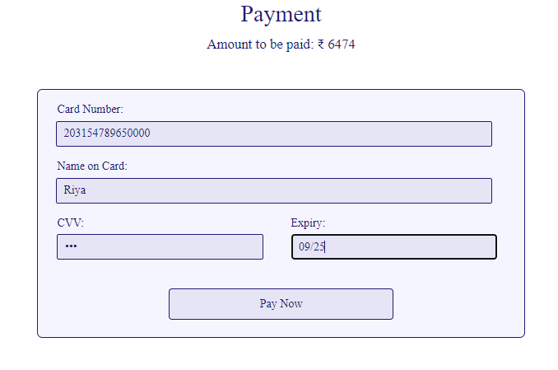

**Coding :**

<?php session_start();

if(!isset($_SESSION["username"]))

{

header("Location:blocked.php");

$_SESSION['url'] = $_SERVER['REQUEST_URI'];

}

?>

<!DOCTYPE html>

<html lang="en">

<!-- HEAD TAG STARTS -->

<head>

<meta charset="UTF-8">

<meta name="viewport" content="width=device-width, initial-scale=1.0"/>

<title>Payment | tourism_management</title>

<link href="css/main.css" rel="stylesheet">

<link href="css/bootstrap.min.css" rel="stylesheet">

<link href="https://fonts.googleapis.com/css?family=Oswald:200,300,400|Raleway:100,300,400,500|Roboto:100,400,500,700" rel="stylesheet">

<link href="https://maxcdn.bootstrapcdn.com/font-awesome/4.7.0/css/font-awesome.min.css" rel="stylesheet">

<script src="js/jquery-3.2.1.min.js"></script>

<script src="js/main.js"></script>

<script src="js/bootstrap.min.js"></script>

</head>

<!-- HEAD TAG ENDS -->

<!-- BODY TAG STARTS -->

<body>

<?php include("common/headerLoggedIn.php"); ?>

<?php

$mode=$_POST["modeHidden"];

if($mode=="ReturnTripFlight" or $mode=="OneWayFlight") {

$totalPassengers=$_POST["totalPassengersHidden"];

for($i=1; $i<=$totalPassengers; $i++) {

$name[$i]=$_POST["name$i"];

$gender[$i]=$_POST["gender$i"];

}

$fare=$_POST["fareHidden"];

$type=$_POST["typeHidden"];

$class=$_POST["classHidden"];

$origin=$_POST["originHidden"];

$destination=$_POST["destinationHidden"];

$depart=$_POST["departHidden"];

$return=$_POST["returnHidden"];

$adults=$_POST["adultsHidden"];

$children=$_POST["childrenHidden"];

$noOfPassengers=(int)$adults+(int)$children;

if($type=="Return Trip") { $flightNoOutbound=$_POST["flightNoOutboundHidden"];

$flightNoInbound=$_POST["flightNoInboundHidden"];

}

elseif($type=="One Way") {

$flightNoOutbound=$_POST["flightNoOutboundHidden"];

}

if($class=="Economy Class")

$className="Economy";

else

$className="Business";

} // for flights

elseif($mode=="hotel") {

$fare=$_POST["fareHidden"];

$hotelID=$_POST["hotelIDHidden"];

} //for hotels

//elseif($mode=="cabs") {

// $fare=$_SESSION["cabsFare"];

// $carID=$_SESSION["carID"];

//} //for hotels

//elseif($mode=="bus") {

// $totalPassengers=$_POST["totalPassengersHidden"];

// $fare=$_POST["fareHidden"];

// $busID=$_POST["busIDHidden"];

// $origin=$_POST["originHidden"];

// $destination=$_POST["destinationHidden"];

// for($i=1; $i<=$totalPassengers; $i++) {

// $name[$i]=$_POST["name$i"];

// $gender[$i]=$_POST["gender$i"];

// }

//} //for bus

elseif($mode=="train") {

$totalPassengers=$_POST["totalPassengersHidden"];

$fare=$_POST["fareHidden"];

$trainID=$_POST["trainIDHidden"];

$origin=$_POST["originHidden"];

$destination=$_POST["destinationHidden"];

$date=$_POST["dateHidden"];

$day=$_POST["dayHidden"];

$class=$_POST["classHidden"];

for($i=1; $i<=$totalPassengers; $i++) {

$name[$i]=$_POST["name$i"];

$gender[$i]=$_POST["gender$i"];

}

} //for train

?>

<div class="spacer">a</div>

<div class="col-sm-12 paymentWrapper">

<div class="headingOne">

Payment

</div>

<div class="totalAmount">

Amount to be paid: <span class="sansSerif">₹</span><?php echo $fare; ?>

</div>

<!--<div class="col-sm-3"></div>-->

<div class="col-sm-3"></div>

<div class="col-sm-6">

<div class="boxCenter">

<div class="col-sm-12 tag">

Card Number:

</div>

<div class="col-sm-12">

<input type="text" class="input" name="cardNumber" placeholder="Enter the card number" id="cardNumber"/>

</div>

<div class="col-sm-12 tag">

Name on Card:

</div>

<div class="col-sm-12">

<input type="text" class="input" name="nameOnCard" placeholder="Enter the name of the card holder" id="nameOnCard"/>

</div>

<div class="col-sm-6 tag">

CVV:

</div>

<div class="col-sm-6 tag">

Expiry:

</div>

<div class="col-sm-6">

<input type="password" class="inputSmall" name="cvv" placeholder="CVV" id="cvv"/>

</div>

<div class="col-sm-6">

<input type="text" class="inputSmall" name="expiry" placeholder="MM/YY" id="cardExpiry"/>

</div>

<!-- flights -->

<?php if($mode=="ReturnTripFlight" or $mode=="OneWayFlight"): ?>

<form action="generateTicket.php" method="POST">

<div class="col-sm-12 bookingButton text-center">

<input type="submit" class="paymentButton" value="Pay Now">

</div>

<input type="hidden" name="totalPassengersHidden" value="<?php echo $totalPassengers; ?>">

<input type="hidden" name="fareHidden" value="<?php echo $fare; ?>">

<input type="hidden" name="typeHidden" value="<?php echo $type; ?>">

<input type="hidden" name="classHidden" value="<?php echo $class; ?>">

<input type="hidden" name="originHidden" value="<?php echo $origin; ?>">

<input type="hidden" name="destinationHidden" value="<?php echo $destination; ?>">

<input type="hidden" name="departHidden" value="<?php echo $depart; ?>">

<input type="hidden" name="returnHidden" value="<?php echo $return; ?>">

<input type="hidden" name="adultsHidden" value="<?php echo $adults; ?>">

<input type="hidden" name="childrenHidden" value="<?php echo $children; ?>">

<input type="hidden" name="modeHidden" value="<?php echo $mode ?>">

<?php for($i=1; $i<=$totalPassengers; $i++) {?>

<input type="hidden" name="nameHidden<?php echo $i; ?>" value="<?php echo $name[$i]; ?>">

<input type="hidden" name="genderHidden<?php echo $i; ?>" value="<?php echo $gender[$i]; ?>">

<?php } ?>

<?php if($type=="Return Trip") { ?>

<input type="hidden" name="flightNoOutboundHidden" value="<?php echo $flightNoOutbound; ?>">

<input type="hidden" name="flightNoInboundHidden" value="<?php echo $flightNoInbound; ?>">

<?php } elseif($type=="One Way") { ?>

<input type="hidden" name="flightNoOutboundHidden" value="<?php echo $flightNoOutbound; ?>">

<?php } ?>

</form>

<!-- hotels -->

<?php elseif($mode=="hotel"): ?>

<form action="generateReceipt.php" method="POST">

<div class="col-sm-12 bookingButton text-center">

<input type="submit" class="paymentButton" value="Pay Now">

</div>

<input type="hidden" name="hotelIDHidden" value="<?php echo $hotelID; ?>">

<input type="hidden" name="fareHidden" value="<?php echo $fare; ?>">

</form>

<!--trains--->

<?php elseif($mode=="train"): ?>

<form action="generateTrainTicket.php" method="POST">

<div class="col-sm-12 bookingButton text-center">

<?php $date=$_POST["dateHidden"]; ?>

<input type="hidden" name="dateHidden" value="<?php echo $date; ?>">

<input type="hidden" name="dayHidden" value="<?php echo $day; ?>">

<input type="hidden" name="classHidden" value="<?php echo $class; ?>">

<input type="submit" class="paymentButton" value="Pay Now">

</div>

<input type="hidden" name="totalPassengersHidden" value="<?php echo $totalPassengers; ?>">

<input type="hidden" name="fareHidden" value="<?php echo $fare; ?>">

<input type="hidden" name="originHidden" value="<?php echo $origin; ?>">

<input type="hidden" name="destinationHidden" value="<?php echo $destination; ?>">

<input type="hidden" name="modeHidden" value="<?php echo $mode ?>">

<?php for($i=1; $i<=$totalPassengers; $i++) {?>

<input type="hidden" name="nameHidden<?php echo $i; ?>" value="<?php echo $name[$i]; ?>">

<input type="hidden" name="genderHidden<?php echo $i; ?>" value="<?php echo $gender[$i]; ?>">

<?php } ?>

<input type="hidden" name="trainIDHidden" value="<?php echo $trainID; ?>">

</form>

<?php endif; ?>

</div>

</div>

<div class="col-sm-3"></div>

</div><!-- paymentWrapper -->

<div class="spacerLarge">.</div><!-- just a dummy class for creating some space -->

<?php include("common/footer.php"); ?>

</body>

<!-- BODY TAG ENDS -->

</html>

**Booking Receipt :**

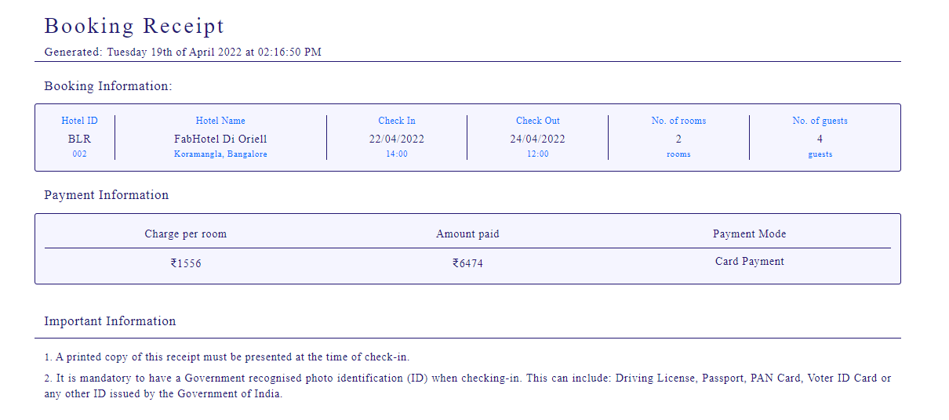

**Coding :**

<?php session_start();

if(!isset($_SESSION["username"]))

{

header("Location:blocked.php");

$_SESSION['url'] = $_SERVER['REQUEST_URI'];

}

?>

<!-- dumping the current page to buffer -->

<?php

ob_start();

?>

<!DOCTYPE html>

<html lang="en">

<!-- HEAD TAG STARTS -->

<head>

<meta charset="UTF-8">

<meta name="viewport" content="width=device-width, initial-scale=1.0"/>

<title>Receipt | tourism_management</title>

<link href="css/main.css" rel="stylesheet">

<link href="css/bootstrap.min.css" rel="stylesheet">

<link href="https://fonts.googleapis.com/css?family=Oswald:200,300,400|Raleway:100,300,400,500|Roboto:100,400,500,700" rel="stylesheet">

<link href="https://maxcdn.bootstrapcdn.com/font-awesome/4.7.0/css/font-awesome.min.css" rel="stylesheet">

<script src="js/jquery-3.2.1.min.js"></script>

<script src="js/main.js"></script>

<script src="js/bootstrap.min.js"></script>

</head>

<!-- HEAD TAG ENDS -->

<!-- BODY TAG STARTS -->

<body>

<div class="spacer">a</div>

<?php

date_default_timezone_set("Asia/Kolkata");

$date=date('l jS \of F Y \a\t h:i:s A');

$hotelID=$_POST["hotelIDHidden"];

$fare=$_POST["fareHidden"];

?>

<?php

$servername = "localhost";

$username = "root";

$password = "";

$dbname = "projectmeteor";

// Creating a connection to MySQL database

$conn = new mysqli($servername, $username, $password, $dbname);

// Checking if we've successfully connected to the database

if ($conn->connect_error) {

die("Connection failed: " . $conn->connect_error);

}

?>

<div class="col-sm-12 generateReceipt">

<div class="commonHeader">

<div class="col-sm-1"></div>

<div class="col-sm-7 text-left">

<div class="headingOne">

Booking Receipt

</div>

<div class="dateTime">

<span class="generated">Generated: </span><?php echo $date; ?>

</div>

</div>

<div class="col-sm-3 text-right">

</div>

<div class="col-sm-1"></div>

<div class="col-sm-12"></div>

<div class="col-sm-1"></div>

<div class="col-sm-10 bar"></div>

<div class="col-sm-1"></div>

</div><!-- contains the header -->

<div class="col-sm-12"></div><!-- empty class -->

<div class="col-sm-1"></div>

<div class="col-sm-10">

<div class="subHeading">

Booking Information:

</div>

</div>

<div class="col-sm-12"></div><!-- empty class -->

<div class="col-sm-1"></div>

<div class="col-sm-10 boxCenter"><!-- outboundFlight Box -->

<?php

$sql = "SELECT * FROM hotels WHERE hotelID='$hotelID'";

$result = $conn->query($sql);

$row = $result->fetch_assoc()

?>

<div class="col-sm-1 borderRight text-center">

<div class="flightOperatorHeading">

Hotel ID

</div>

<div class="flightOperator">

<?php $hotelID=$row["hotelID"];

echo substr($hotelID,0,3) ?>

</div>

<div class="flightNo">

<?php $hotelID=$row["hotelID"];

echo substr($hotelID,3) ?>

</div>

</div><!-- col-sm-4 -->

<div class="col-sm-3 borderRight text-center">

<div class="flightOperatorHeading">

Hotel Name

</div>

<div class="flightOperator">

<?php echo $row["hotelName"]; ?>

</div>

<div class="flightNo">

<?php echo $row["locality"].', '.$row["city"]; ?>

</div>

</div><!-- col-sm-4 -->

<div class="col-sm-2 borderRight text-center">

<div class="departsHeading">

Check In

</div>

<div class="departs">

<?php echo $_SESSION["checkIn"]; ?>

</div>

<div class="departsSubscript">

<?php echo $row["checkIn"]; ?>

</div>

</div><!-- col-sm-4 -->

<div class="col-sm-2 borderRight text-center">

<div class="arrivesHeading">

Check Out

</div>

<div class="arrives">

<?php echo $_SESSION["checkOut"]; ?>

</div>

<div class="arrivesSubscript">

<?php echo $row["checkOut"]; ?>

</div>

</div><!-- col-sm-4 -->

<div class="col-sm-2 borderRight text-center">

<div class="originHeading">

No. of rooms

</div>

<div class="origin">

<?php echo $_SESSION["noOfRooms"]; ?>

</div>

<div class="originSubscript">

rooms

</div>

</div><!-- col-sm-4 -->

<div class="col-sm-2 text-center">

<div class="destinationHeading">

No. of guests

</div>

<div class="origin">

<?php echo $_SESSION["noOfGuests"]; ?>

</div>

<div class="destinationSubscript">

guests

</div>

</div><!-- col-sm-4 -->

</div><!-- outboundFlight Box -->

<div class="col-sm-12 spacer">a</div>

<div class="col-sm-1"></div>

<div class="col-sm-10">

<div class="subHeading">

Payment Information

</div>

</div>

<div class="col-sm-12"></div><!-- empty class -->

<div class="col-sm-1"></div>

<div class="col-sm-12"></div><!-- empty class -->

<div class="col-sm-1"></div>

<div class="col-sm-10 boxCenter">

<div class="columnHeaders">

<div class="col-sm-4 borderBottom">

<div class="serialNoHeader text-center">

Charge per room

</div>

</div>

<div class="col-sm-4 borderBottom">

<div class="passengerNameHeader text-center">

Amount paid

</div>

</div>

<div class="col-sm-4 borderBottom">

<div class="genderHeader text-center">

Payment Mode

</div>

</div>

</div><!-- columnHeaders -->

<div class="col-sm-4">

<div class="serialNo text-center">

<span class="rupee">₹</span><?php echo $row["price"]; ?>

</div>

</div>

<div class="col-sm-4">

<div class="serialNo text-center">

<span class="rupee">₹</span><?php echo $fare ?>

</div>

</div>

<div class="col-sm-4">

<div class="serialNo text-center">

Card Payment

</div>

</div>

</div><!-- boxCenter -->

<div class="col-sm-1"></div>

<div class="importantInfo">

<div class="col-sm-12"></div><!-- empty class -->

<div class="col-sm-12 spacer">a</div>

<div class="col-sm-12 spacer">a</div>

<div class="col-sm-1"></div>

<div class="col-sm-10">

<div class="subHeading">

Important Information

</div>

</div>

<div class="col-sm-1"></div>

<div class="col-sm-12"></div>

<div class="col-sm-1"></div>

<div class="col-sm-10 bar"></div>

<div class="col-sm-1"></div>

<div class="col-sm-12"></div>

<div class="col-sm-1"></div>

<div class="col-sm-10">

<div class="info">

<span class="strong">1.</span> A printed copy of this receipt must be presented at the time of check-in.

</div>

<div class="info">

<span class="strong">2.</span> It is mandatory to have a Government recognised photo identification (ID) when checking-in. This can include: Driving License, Passport, PAN Card, Voter ID Card or any other ID issued by the Government of India.

</div>

</div>

<div class="col-sm-1"></div>

<div class="col-sm-12 spacer">a</div>

<div class="col-sm-12"></div><!-- empty class -->

</div><!-- importantInfo -->

</div><!-- generateTicket -->

<div class="spacer">a</div>

<center><a href="index.php"> Home </a></center>

<br>

<br>

</body>

<!-- BODY TAG ENDS -->

</html>

<!-- after user login system is built push the username using the curent session to the database -->

<?php

$user = $_SESSION["username"];

$dateFormatted = date("d-m-Y"); //formatting the date as DD-MM-YY

$hotelName = $row["hotelName"].', '.$row["locality"].', '.$row["city"];

$bookingDataInsertSQL = "INSERT INTO `hotelbookings`(hotelName,date,username,cancelled) VALUES('$hotelName','$dateFormatted','$user','no')";

$bookingDataInsertQuery = $conn->query($bookingDataInsertSQL);

$bookingIDSQL = "SELECT * FROM `hotelbookings` ORDER BY `bookingID` DESC LIMIT 1";

$bookingIDQuery = $conn->query($bookingIDSQL);

$bookingIDGet = $bookingIDQuery ->fetch_array(MYSQLI_NUM);

$latestBookingID = $bookingIDGet[0];

$currentBookingID = $latestBookingID;

?>

<!-- saving the file as temp.html -->

<?php

file_put_contents('receipts\receipt'.$currentBookingID.'.html', ob_get_contents());

?>

**ADMIN PANEL:**

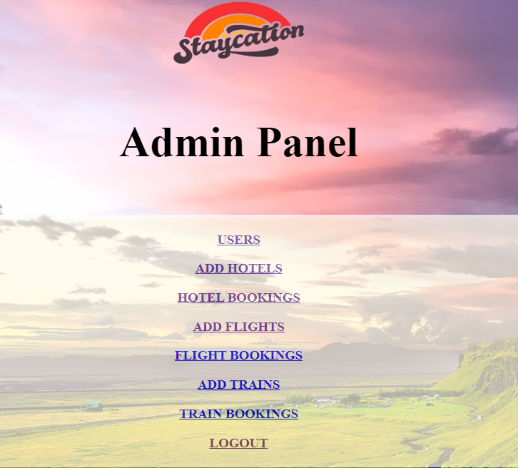

**CODING:**

<?php session_start();

if(!isset($_SESSION['username'])){

header('Location: adminLogin.php');

}

?>

<!DOCTYPE html>

<html lang="en">

<head>

<meta charset="UTF-8" />

<meta http-equiv="X-UA-Compatible" content="IE=edge" />

<meta name="viewport" content="width=device-width, initial-scale=1.0" />

<link

href="https://fonts.googleapis.com/css?family=Courgette"

rel="stylesheet"

/>

<link href="css/bootstrap.min.css" rel="stylesheet" />

<link

href="https://maxcdn.bootstrapcdn.com/font-awesome/4.7.0/css/font-awesome.min.css"

rel="stylesheet"

/>

<link rel="stylesheet" href="https://maxcdn.bootstrapcdn.com/bootstrap/3.3.7/css/bootstrap.min.css" integrity="sha384-BVYiiSIFeK1dGmJRAkycuHAHRg32OmUcww7on3RYdg4Va+PmSTsz/K68vbdEjh4u" crossorigin="anonymous">

<script src="js/bootstrap.min.js"></script>

<style>

body {

background-image: url('home1.jpg');

background-repeat:no-repeat;

}

h3{

text:white:

}

h1{

font-size: 60px;

font-family: Courgette;

text:black

}

.options{

background-color:#fffae6;

opacity: 0.7;

margin: 5%;

font-weight: bold;

border: 5px solid white;

}

a:hover {

color: #003366;

text-decoration: none;

}

</style>

<title>Admin Panel | Home</title>

</head>

<body >

<center>

<img src="stay.png" height="150" width="200">

<h1>Admin Panel</h1>

</center>

<div class="options">

<center>

<h3><a href="users_add.php">USERS</a></h3>

<h3><a href="hotels_add.php">ADD HOTELS</a></h3>

<h3><a href="hotelbookings_view.php">HOTEL BOOKINGS</a></h3>

<h3><a href="flights_add.php">ADD FLIGHTS</a></h3>

<h3><a href="flightbookings_view.php">FLIGHT BOOKINGS</a></h3>

<h3><a href="trains_add.php">ADD TRAINS</a></h3>

<h3><a href="trainbookings_view.php">TRAIN BOOKINGS</a></h3>

<h3><a href="adminLogout.php">LOGOUT</a></h3>

</center>

</div>

<center>

<button class="btn btn-secondary"><a href="\travel\index.php"><h5>Click here to go to user panel</h5></a></button>

</center>

</body>

</html>

**USER DATA:**

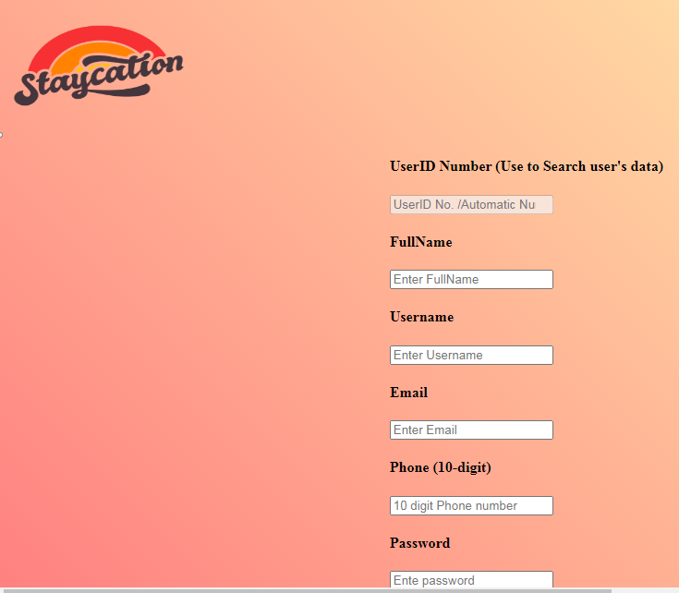

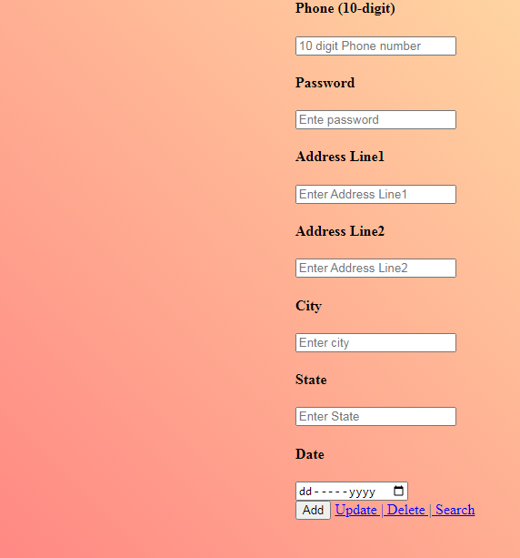

**CODING:**

<!Doctype html>

<html>

<head>

<meta charset="utf-8">

<title>Admin Panel | Users </title>

<meta name="viewport" content="width=device-width, initial-scale=1">

<link href="https://fonts.googleapis.com/css?family=Courgette" rel="stylesheet">

<link href="css/bootstrap.min.css" rel="stylesheet">

<link href="https://maxcdn.bootstrapcdn.com/font-awesome/4.7.0/css/font-awesome.min.css" rel="stylesheet">

<link rel="stylesheet" href="https://maxcdn.bootstrapcdn.com/bootstrap/3.3.7/css/bootstrap.min.css" integrity="sha384-BVYiiSIFeK1dGmJRAkycuHAHRg32OmUcww7on3RYdg4Va+PmSTsz/K68vbdEjh4u" crossorigin="anonymous">

<script src="js/bootstrap.min.js"></script>

<style>

body{

background: linear-gradient(45deg, #ff8080, #ffffb3);

height: 100%;

margin: 0;

background-repeat: no-repeat;

background-attachment: fixed;

width:100%;

}

</style>

</head>

<?php

$servername = "localhost";

$username="root";

$password="";

$dbname="projectmeteor";

$UserID="";

$FullName="";

$EMail="";

$Phone="";

$Username="";

$Password="";

$AddressLine1="";

$AddressLine2="";

$City="";

$State="";

$Date="";

mysqli_report(MYSQLI_REPORT_ERROR | MYSQLI_REPORT_STRICT);

//connect to mysql database

try{

$conn =mysqli_connect($servername,$username,$password,$dbname);

}catch(MySQLi_Sql_Exception $ex){

echo("Connection Error");

}

//get data from the form

function getData()

{

$data = array();

$data[1]=$_POST['FullName'];

$data[2]=$_POST['EMail'];

$data[3]=$_POST['Phone'];

$data[4]=$_POST['Username'];

$data[5]=$_POST['Password'];

$data[6]=$_POST['AddressLine1'];

$data[7]=$_POST['AddressLine2'];

$data[8]=$_POST['City'];

$data[9]=$_POST['State'];

$data[10]=$_POST['Date'];

return $data;

}

//search

if(isset($_POST['search']))

{

$info = getData();

$search_query="SELECT * FROM users WHERE UserID = '$info[0]'";

$search_result=mysqli_query($conn, $search_query);

if($search_result)

{

if(mysqli_num_rows($search_result))

{

while($rows = mysqli_fetch_array($search_result))

{

$UserID = $rows['UserID'];

$FullName = $rows['FullName'];

$EMail = $rows['EMail'];

$Phone = $rows['Phone'];

$Username = $rows['Username'];

$Password = $rows['Password'];

$AddressLine1 = $rows['AddressLine1'];

$AddressLine2 = $rows['AddressLine2'];

$City = $rows['City'];

$State = $rows['State'];

$Date = $rows['Date'];

}

}else{

echo("No data are available");

}

} else{

echo("Result error");

}

}

//insert

if(isset($_POST['insert'])){

$info = getData();

$insert_query="INSERT INTO `users`(`FullName`, `EMail`, `Phone`, `Username`,`Password`,`AddressLine1`,`AddressLine2`,`City`,`State`,`Date`) VALUES ('$info[1]','$info[2]','$info[3]','$info[4]','$info[5]','$info[6]','$info[7]','$info[8]','$info[9]','$info[10]')";

try{

$insert_result=mysqli_query($conn, $insert_query);

if($insert_result)

{

if(mysqli_affected_rows($conn)>0){

echo("Data inserted successfully");

}else{

echo("Data not inserted");

}

}

}catch(Exception $ex){

echo("error inserted".$ex->getMessage());

}

}

//delete

if(isset($_POST['delete'])){

$info = getData();

$delete_query = "DELETE FROM `users` WHERE UserID = '$info[0]'";

try{

$delete_result = mysqli_query($conn, $delete_query);

if($delete_result){

if(mysqli_affected_rows($conn)>0)

{

echo("Data deleted");

}else{

echo("Data not deleted");

}

}

}catch(Exception $ex){

echo("Error in deleting".$ex->getMessage());

}

}

//edit

if(isset($_POST['update'])){

$info = getData();

$update_query="UPDATE `users` SET FullName='$info[1]',EMail='$info[2]',Phone='$info[3]',Username='$info[4]',Password='$info[5]',AddressLine1='$info[6]',AddressLine2='$info[7]',City='$info[8]',State='$info[9]',Date='$info[10]' WHERE UserID = '$info[0]'";

try{

$update_result=mysqli_query($conn, $update_query);

if($update_result){

if(mysqli_affected_rows($conn)>0){

echo("Data updated");

}else{

echo("Data not updated");

}

}

}catch(Exception $ex){

echo("Error in updating".$ex->getMessage());

}

}

?>

<body>

<div class="container-fliud">

<nav class="navbar navbar-inverse">

<div class="container-fluid">

<div class="navbar-header">

<button type="button" class="navbar-toggle" data-toggle="collapse" data-target="#nav">

<span class="icon-bar"></span>

<span class="icon-bar"></span>

<span class="icon-bar"></span>

</button>

<img src="stay.png" height="150" width="200">

</div>

<div class="collapse navbar-collapse" id="nav">

<ul class="nav navbar-nav" style="float:right">

<li><a href="Home.php">HOME</a></li>

<li><a href="users_add.php">USERS</a></li>

<li><a href="hotels_add.php">ADD HOTELS</a></li>

<li><a href="hotelbookings_view.php">HOTEL BOOKINGS</a></li>

<li><a href="flights_add.php">ADD FLIGHTS</a></li>

<li><a href="flightbookings_view.php">FLIGHT BOOKINGS</a></li>

<li><a href="trains_add.php">ADD TRAINS</a></li>

<li><a href="trainbookings_view.php">TRAIN BOOKINGS</a></li>

<h3><a href="adminLogout.php">LOGOUT</a></h3>

</ul>

</div>

</div>

</nav>

</div>

<div class="container-fluid" >

<div class="row mx-5 my-5" style="display: flex;

justify-content: center;">

<div class="col-lg-4">

<form method ="post" action="">

<h4>UserID Number (Use to Search user's data)</h4>

<input type="number" name="UserID" class="form-control" placeholder="UserID No. /Automatic Number Genrates" value="<?php echo($UserID);?>" disabled>

<div class="form-group row">

<div class="col-xs-6">

<h4>FullName</h4>

<input type="text" name="FullName" class="form-control" placeholder="Enter FullName" value="<?php echo($FullName);?>" required>

</div>

<div class="col-xs-6">

<h4>Username</h4>

<input type="text" name="Username" class="form-control" placeholder="Enter Username" value="<?php echo($Username);?>" required>

</div>

<div class="col-xs-6">

<h4>Email</h4>

<input type="email" name="EMail" class="form-control" placeholder="Enter Email" value="<?php echo($EMail);?>" required>

</div>

<div class="col-xs-6">

<h4>Phone (10-digit)</h4>

<input type="tel" pattern="^\d{10}$" class="form-control" name="Phone" placeholder="10 digit Phone number" value="<?php echo($Phone);?>">

</div>

<div class="col-xs-6">

<h4>Password</h1>

<input type="password" name="Password" class="form-control" placeholder="Ente password" value="<?php echo($Password);?>" required>

</div>

<div class="col-xs-6">

<h4>Address Line1</h4>

<input type="text" name="AddressLine1" class="form-control" placeholder="Enter Address Line1" value="<?php echo($AddressLine1);?>" required>

</div>

<div class="col-xs-6">

<h4>Address Line2</h4>

<input type="text" name="AddressLine2" class="form-control" placeholder="Enter Address Line2" value="<?php echo($AddressLine2);?>" required>

</div>

<div class="col-xs-6">

<h4>City</h4>

<input type="text" name="City" class="form-control" placeholder="Enter city" value="<?php echo($City);?>" required>

</div>

<div class="col-xs-6">

<h4>State</h4>

<input type="text" name="State" class="form-control" placeholder="Enter State" value="<?php echo($State);?>" required>

</div>

<div class="col-xs-6">

<h4>Date</h4>

<input type="date" name="Date" class="form-control" placeholder="Enter date" value="<?php echo($Date);?>" required>

</div>

</div>

<div>

<input type="submit" class="btn btn-success btn-block btn-lg" name="insert" value="Add">

<a href="users_update.php"class="btn btn-info btn-block btn-lg">Update | Delete | Search</a>

</div>

</form>

</div>

</div>

<br>

<br>

<div class="col-lg-8">

<h1 class="text-danger text-center" style="font-weight:bold">USERS DATA</h1>

<hr>

<br>

<br>

<?php

$servername = "localhost";

$username = "root";

$password = "";

$dbname = "projectmeteor";

// Create connection

$conn = new mysqli($servername, $username, $password, $dbname);

// Check connection

if ($conn->connect_error) {

die("Connection failed: " . $conn->connect_error);

}

$sql = "SELECT UserID,FullName,EMail,Phone,Username,Password,AddressLine1,AddressLine2,City,State,Date FROM users";

$result = $conn->query($sql);

echo "<div class='col-xs-6'>

<table class='table table-striped table-bordered table-hover py-5' style='width:200%; border: 4px solid black; text:white; text-align: center;'>

<tr class='text-centre text-white'style='font-size:20px; background:black;'>

<th>UserID</th>

<th>FullName</th>

<th>EMail</th>

<th>Phone</th>

<th>Username</th>

<th>Password</th>

<th>AddressLine1</th>

<th>AddressLine2</th>

<th>City</th>

<th>State</th>

<th>Date</th>

</tr>

</div>";

if ($result->num_rows > 0) {

// output data of each row

while($row = $result->fetch_assoc()) {

echo "<tr>";

echo "<td>" . $row['UserID'] . "</td>";

echo "<td>" . $row['FullName'] . "</td>";

echo "<td>" . $row['EMail'] . "</td>";

echo "<td>" . $row['Phone'] . "</td>";

echo "<td>" . $row['Username'] . "</td>";

echo "<td>" . $row['Password'] . "</td>";

echo "<td>" . $row['AddressLine1'] . "</td>";

echo "<td>" . $row['AddressLine2'] . "</td>";

echo "<td>" . $row['City'] . "</td>";

echo "<td>" . $row['State'] . "</td>";

echo "<td>" . $row['Date'] . "</td>";

echo "</tr>";

}

} else {

echo "0 results";

}

$conn->close();

?>

</div>

</div>

</body>

</html>

**ADD HOTEL:**

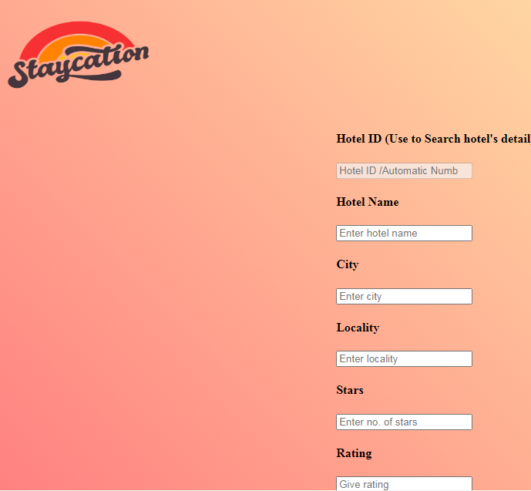

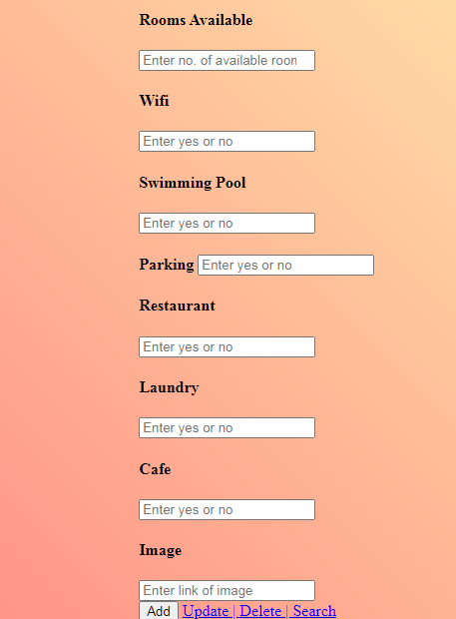

**CODING:**

<!Doctype html>

<html>

<head>

<meta charset="utf-8">

<title>Admin Panel | Hotels </title>

<meta name="viewport" content="width=device-width, initial-scale=1">

<link href="https://fonts.googleapis.com/css?family=Courgette" rel="stylesheet">

<link href="css/bootstrap.min.css" rel="stylesheet">

<link href="https://maxcdn.bootstrapcdn.com/font-awesome/4.7.0/css/font-awesome.min.css" rel="stylesheet">

<link rel="stylesheet" href="https://maxcdn.bootstrapcdn.com/bootstrap/3.3.7/css/bootstrap.min.css" integrity="sha384-BVYiiSIFeK1dGmJRAkycuHAHRg32OmUcww7on3RYdg4Va+PmSTsz/K68vbdEjh4u" crossorigin="anonymous">

<script src="js/bootstrap.min.js"></script>

<style>

body{

background: linear-gradient(45deg, #ff8080, #ffffb3);

height: 100%;

margin: 0;

background-repeat: no-repeat;

background-attachment: fixed;

width:100%;

}

</style>

</head>

<?php

$servername = "localhost";

$username="root";

$password="";

$dbname="projectmeteor";

$hotelID="";

$hotelName="";

$city="";

$locality="";

$stars="";

$rating="";

$hotelDesc="";

$checkIn="";

$checkOut="";

$price="";

$roomsAvailable="";

$wifi="";

$swimmingPool="";

$parking="";

$restaurant="";

$laundry="";

$cafe="";

$mainImage="";

mysqli_report(MYSQLI_REPORT_ERROR | MYSQLI_REPORT_STRICT);

//connect to mysql database

try{

$conn =mysqli_connect($servername,$username,$password,$dbname);

}catch(MySQLi_Sql_Exception $ex){

echo("Connection Error");

}

//get data from the form

function getData()

{

$data = array();

$data[1]=$_POST['hotelName'];

$data[2]=$_POST['city'];

$data[3]=$_POST['locality'];

$data[4]=$_POST['stars'];

$data[5]=$_POST['rating'];

$data[6]=$_POST['hotelDesc'];

$data[7]=$_POST['checkIn'];

$data[8]=$_POST['checkOut'];

$data[9]=$_POST['price'];

$data[10]=$_POST['roomsAvailable'];

$data[11]=$_POST['wifi'];

$data[12]=$_POST['swimmingPool'];

$data[13]=$_POST['parking'];

$data[14]=$_POST['restaurant'];

$data[15]=$_POST['laundry'];

$data[16]=$_POST['cafe'];

$data[17]=$_POST['mainImage'];

return $data;

}

//search

if(isset($_POST['search']))

{

$info = getData();

$search_query="SELECT * FROM hotels WHERE hotelID = '$info[0]'";

$search_result=mysqli_query($conn, $search_query);

if($search_result)

{

if(mysqli_num_rows($search_result))

{

while($rows = mysqli_fetch_array($search_result))

{

$hotelID = $rows['hotelID'];

$hotelName = $rows['hotelName'];

$city= $rows['city'];

$locality= $rows['locality'];

$stars = $rows['stars'];

$rating = $rows['rating'];

$hotelDesc = $rows['hotelDesc'];

$checkIn = $rows['checkIn'];

$checkOut = $rows['checkOut'];

$price = $rows['price'];

$roomsAvailable = $rows['roomsAvailable'];

$wifi = $rows['wifi'];

$swimmingPool = $rows['swimmingPool'];

$parking = $rows['parking'];

$restaurant = $rows['restaurant'];

$laundry = $rows['laundry'];

$cafe = $rows['cafe'];

$mainImage = $rows['mainImage'];

}

}else{

echo("No data are available");

}

} else{

echo("Result error");

}

}

//insert

if(isset($_POST['insert'])){

$info = getData();

$insert_query="INSERT INTO `hotels`(`hotelName`, `city`, `locality`, `stars`,`rating`,`hotelDesc`,`checkIn`,`checkOut`,`price`,`roomsAvailable`,`wifi`,`swimmingPool`,`parking`,`restaurant`,`laundry`,`cafe`,`mainImage`) VALUES ('$info[1]','$info[2]','$info[3]','$info[4]','$info[5]','$info[6]','$info[7]','$info[8]','$info[9]','$info[10]','$info[11]','$info[12]','$info[13]','$info[14]','$info[15]','$info[16]','$info[17]')";

try{

$insert_result=mysqli_query($conn, $insert_query);

if($insert_result)

{

if(mysqli_affected_rows($conn)>0){

echo("Data inserted successfully");

}else{

echo("Data not inserted");

}

}

}catch(Exception $ex){

echo("error inserted".$ex->getMessage());

}

}

//delete

if(isset($_POST['delete'])){

$info = getData();

$delete_query = "DELETE FROM `hotels` WHERE hotelID = '$info[0]'";

try{

$delete_result = mysqli_query($conn, $delete_query);

if($delete_result){

if(mysqli_affected_rows($conn)>0)

{

echo("Data deleted");

}else{

echo("Data not deleted");

}

}

}catch(Exception $ex){

echo("Error in deleting".$ex->getMessage());

}

}

//edit

if(isset($_POST['update'])){

$info = getData();

$update_query="UPDATE `hotels` SET hotelName='$info[1]',city='$info[2]',locality='$info[3]',stars='$info[4]',rating='$info[5]',hotelDesc='$info[6]',checkIn='$info[7]',checkOut='$info[8]',price='$info[9]',roomsAvailable='$info[10]',wifi='$info[11]',swimmingPool='$info[12]',parking='$info[13]',restaurant='$info[14]',laundry='$info[15]',cafe='$info[16]',parkingmainImage='$info[17]' WHERE hotelID = '$info[0]'";

try{

$update_result=mysqli_query($conn, $update_query);

if($update_result){

if(mysqli_affected_rows($conn)>0){

echo("Data updated");

}else{

echo("Data not updated");

}

}

}catch(Exception $ex){

echo("Error in updating".$ex->getMessage());

}

}

?>

<body>

<div class="container-fliud">

<nav class="navbar navbar-inverse">

<div class="container-fluid">

<div class="navbar-header">

<button type="button" class="navbar-toggle" data-toggle="collapse" data-target="#nav">

<span class="icon-bar"></span>

<span class="icon-bar"></span>

<span class="icon-bar"></span>

</button>

<img src="stay.png" height="150" width="200">

</div>

<div class="collapse navbar-collapse" id="nav">

<ul class="nav navbar-nav" style="float:right">

<li><a href="Home.php">HOME</a></li>

<li><a href="users_add.php">USERS</a></li>

<li><a href="hotels_add.php">ADD HOTELS</a></li>

<li><a href="hotelbookings_view.php">HOTEL BOOKINGS</a></li>

<li><a href="flights_add.php">ADD FLIGHTS</a></li>

<li><a href="flightbookings_view.php">FLIGHT BOOKINGS</a></li>

<li><a href="trains_add.php">ADD TRAINS</a></li>

<li><a href="trainbookings_view.php">TRAIN BOOKINGS</a></li>

<h3><a href="adminLogout.php">LOGOUT</a></h3>

</ul>

</div>

</div>

</nav>

</div>

<div class="container-fluid" >

<div class="row mx-5 my-5" style="display: flex;

justify-content: center;">

<div class="col-lg-4">

<form method ="post" action="">

<h4>Hotel ID (Use to Search hotel's detail)</h4>

<input type="number" name="hotelID" class="form-control" placeholder="Hotel ID /Automatic Number Genrates" value="<?php echo($hotelID);?>" disabled>

<div class="form-group row">

<div class="col-xs-6">

<h4>Hotel Name</h4>

<input type="text" name="hotelName" class="form-control" placeholder="Enter hotel name" value="<?php echo($hotelName);?>" required>

</div>

<div class="col-xs-6">

<h4>City</h4>

<input type="text" name="city" class="form-control" placeholder="Enter city" value="<?php echo($city);?>" required>

</div>

<div class="col-xs-6">

<h4>Locality</h4>

<input type="text" name="locality" class="form-control" placeholder="Enter locality" value="<?php echo($locality);?>" required>

</div>

<div class="col-xs-6">

<h4>Stars</h4>

<input type="int" name="stars" class="form-control" placeholder="Enter no. of stars" value="<?php echo($stars);?>" required>

</div>

<div class="col-xs-6">

<h4>Rating</h4>

<input type="text" class="form-control" name="rating" placeholder="Give rating" value="<?php echo($rating);?>"required>

</div>

<div class="col-xs-6">

<h4>Description</h4>

<input type="text" name="hotelDesc" class="form-control" placeholder="Enter description" value="<?php echo($hotelDesc);?>" required>

</div>

<div class="col-xs-6">

<h4>Check In</h4>

<input type="time" name="checkIn" class="form-control" placeholder="Enter checkin time" value="<?php echo($checkIn);?>" required>

</div>

<div class="col-xs-6">

<h4>Check Out</h4>

<input type="time" name="checkOut" class="form-control" placeholder="Enter checkOut time" value="<?php echo($checkOut);?>" required>

</div>

<div class="col-xs-6">

<h4>Price</h4>

<input type="number" name="price" class="form-control" placeholder="Enter price" value="<?php echo($price);?>" required>

</div>

<div class="col-xs-6">

<h4>Rooms Available</h4>

<input type="number" name="roomsAvailable" class="form-control" placeholder="Enter no. of available rooms" value="<?php echo($roomsAvailable);?>" required>

</div>

<div class="col-xs-6">

<h4>Wifi</h4>

<input type="text" name="wifi" class="form-control" placeholder="Enter yes or no" value="<?php echo($wifi);?>" required>

</div>

<div class="col-xs-6">

<h4>Swimming Pool</h4>

<input type="text" name="swimmingPool" class="form-control" placeholder="Enter yes or no" value="<?php echo($swimmingPool);?>" required>

</div>

<div class="col-xs-6">

<h4>Parking</41>

<input type="text" name="parking" class="form-control" placeholder="Enter yes or no" value="<?php echo($parking);?>" required>

</div>

<div class="col-xs-6">

<h4>Restaurant</h4>

<input type="text" name="restaurant" class="form-control" placeholder="Enter yes or no" value="<?php echo($restaurant);?>" required>

</div>

<div class="col-xs-6">

<h4>Laundry</h4>

<input type="text" name="laundry" class="form-control" placeholder="Enter yes or no" value="<?php echo($laundry);?>" required>

</div>

<div class="col-xs-6">

<h4>Cafe</h4>

<input type="text" name="cafe" class="form-control" placeholder="Enter yes or no" value="<?php echo($cafe);?>" required>

</div>

<div class="col-xs-6">

<h4>Image</h4>

<input type="text" name="mainImage" class="form-control" placeholder="Enter link of image" value="<?php echo($mainImage);?>" required>

</div>

</div>

<div>

<input type="submit" class="btn btn-success btn-block btn-lg" name="insert" value="Add">

<a href="hotels_update.php"class="btn btn-info btn-block btn-lg">Update | Delete | Search</a>

</div>

</form>

</div>

</div>

<br>

<br>

<div class="col-lg-8">

<h1 class="text-danger text-center" style="font-weight:bold">HOTELS DETAILS</h1>

<hr>

<br>

<br>

<?php

$servername = "localhost";

$username = "root";

$password = "";

$dbname = "projectmeteor";

// Create connection

$conn = new mysqli($servername, $username, $password, $dbname);

// Check connection

if ($conn->connect_error) {

die("Connection failed: " . $conn->connect_error);

}

$sql = "SELECT hotelID,hotelName,city,locality,stars,rating,hotelDesc,checkIn,checkOut,price,roomsAvailable,wifi,swimmingPool,parking,restaurant,laundry,cafe,mainImage FROM hotels";

$result = $conn->query($sql);

echo "<div class='col-xs-6'>

<table class='table table-striped table-bordered table-hover py-5' style='width:200%; border: 4px solid black; text:white; text-align: center;'>

<tr class='text-centre text-white'style='font-size:20px; background:black;'>

<th>Hotel ID</th>

<th>Hotel Name</th>

<th>City</th>

<th>Locality</th>

<th>Stars</th>

<th>Rating</th>

<th>Description</th>

<th>Check In</th>

<th>Check Out</th>

<th>Price</th>

<th>Rooms available</th>

<th>Wifi</th>

<th>Swimming Pool</th>

<th>Parking</th>

<th>Restaurant</th>

<th>Laundry</th>

<th>Cafe</th>

<th>Image</th>

</tr>

</div>";

if ($result->num_rows > 0) {

// output data of each row

while($row = $result->fetch_assoc()) {

echo "<tr>";

echo "<td>" . $row['hotelID'] . "</td>";

echo "<td>" . $row['hotelName'] . "</td>";

echo "<td>" . $row['city'] . "</td>";

echo "<td>" . $row['locality'] . "</td>";

echo "<td>" . $row['stars'] . "</td>";

echo "<td>" . $row['rating'] . "</td>";

echo "<td>" . $row['hotelDesc'] . "</td>";

echo "<td>" . $row['checkIn'] . "</td>";

echo "<td>" . $row['checkOut'] . "</td>";

echo "<td>" . $row['price'] . "</td>";

echo "<td>" . $row['roomsAvailable'] . "</td>";

echo "<td>" . $row['wifi'] . "</td>";

echo "<td>" . $row['swimmingPool'] . "</td>";

echo "<td>" . $row['parking'] . "</td>";

echo "<td>" . $row['restaurant'] . "</td>";

echo "<td>" . $row['laundry'] . "</td>";

echo "<td>" . $row['cafe'] . "</td>";

echo "<td>" . $row['mainImage'] . "</td>";

echo "</tr>";

}

} else {

echo "0 results";

}

$conn->close();

?>

</div>

</div>

</body>

</html>

**ADD FLIGHT:**

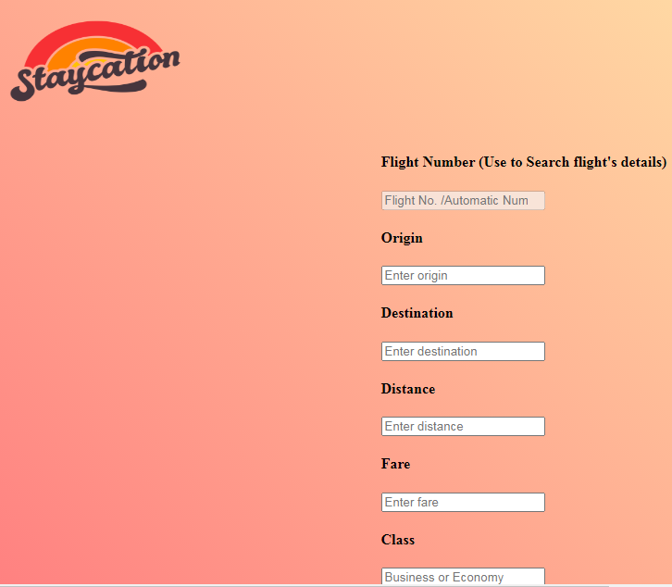

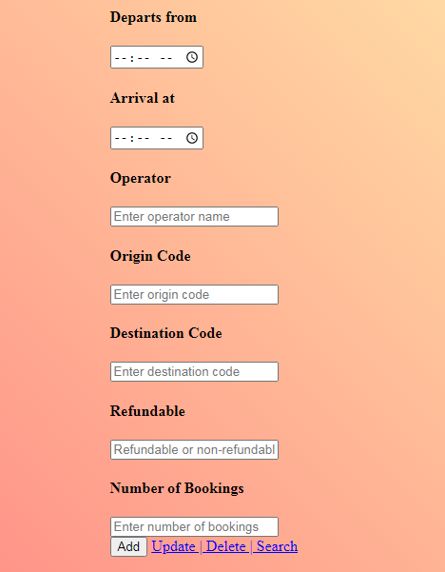

**CODING:**

<!Doctype html>

<html>

<head>

<meta charset="utf-8">

<title>Admin Panel | Flights </title>

<meta name="viewport" content="width=device-width, initial-scale=1">

<link href="https://fonts.googleapis.com/css?family=Courgette" rel="stylesheet">

<link href="css/bootstrap.min.css" rel="stylesheet">

<link href="https://maxcdn.bootstrapcdn.com/font-awesome/4.7.0/css/font-awesome.min.css" rel="stylesheet">

<link rel="stylesheet" href="https://maxcdn.bootstrapcdn.com/bootstrap/3.3.7/css/bootstrap.min.css" integrity="sha384-BVYiiSIFeK1dGmJRAkycuHAHRg32OmUcww7on3RYdg4Va+PmSTsz/K68vbdEjh4u" crossorigin="anonymous">

<script src="js/bootstrap.min.js"></script>

<style>

body{

background: linear-gradient(45deg, #ff8080, #ffffb3);

height: 100%;

margin: 0;

background-repeat: no-repeat;

background-attachment: fixed;

width:100%;

}

</style>

</head>

<?php

$servername = "localhost";

$username="root";

$password="";

$dbname="projectmeteor";

$flight_no="";

$origin="";

$destination="";

$distance="";

$fare="";

$class="";

$seats_available="";

$departs="";

$arrives="";

$operator="";

$origin_code="";

$destination_code="";

$refundable="";

$noOfBookings="";

mysqli_report(MYSQLI_REPORT_ERROR | MYSQLI_REPORT_STRICT);

//connect to mysql database

try{

$conn =mysqli_connect($servername,$username,$password,$dbname);

}catch(MySQLi_Sql_Exception $ex){

echo("Connection Error");

}

//get data from the form

function getData()

{

$data = array();

$data[1]=$_POST['origin'];

$data[2]=$_POST['destination'];

$data[3]=$_POST['distance'];

$data[4]=$_POST['fare'];

$data[5]=$_POST['class'];

$data[6]=$_POST['seats_available'];

$data[7]=$_POST['departs'];

$data[8]=$_POST['arrives'];

$data[9]=$_POST['operator'];

$data[10]=$_POST['origin_code'];

$data[11]=$_POST['destination_code'];

$data[12]=$_POST['refundable'];

$data[13]=$_POST['noOfBookings'];

return $data;

}

//search

if(isset($_POST['search']))

{

$info = getData();

$search_query="SELECT * FROM flights WHERE flight_no = '$info[0]'";

$search_result=mysqli_query($conn, $search_query);

if($search_result)

{

if(mysqli_num_rows($search_result))

{

while($rows = mysqli_fetch_array($search_result))

{

$flight_no = $rows['flight_no'];

$origin = $rows['origin'];

$destination= $rows['destinattion'];

$distance= $rows['distance'];

$fare = $rows['fare'];

$class = $rows['class'];

$seats_available = $rows['seats_available'];

$departs = $rows['departs'];

$arrives = $rows['arrives'];

$operator = $rows['operator'];

$origin_code = $rows['origin_code'];

$destination_code = $rows['destination_code'];

$refundable = $rows['refundable'];

$noOfBookings = $rows['noOfBookings'];

}

}else{

echo("No data are available");

}

} else{

echo("Result error");

}

}

//insert

if(isset($_POST['insert'])){

$info = getData();

$insert_query="INSERT INTO `flights`(`origin`, `destination`, `distance`, `fare`,`class`,`seats_available`,`departs`,`arrives`,`operator`,`origin_code`,`destination_code`,`refundable`,`noOfBookings`) VALUES ('$info[1]','$info[2]','$info[3]','$info[4]','$info[5]','$info[6]','$info[7]','$info[8]','$info[9]','$info[10]','$info[11]','$info[12]','$info[13]')";

try{

$insert_result=mysqli_query($conn, $insert_query);

if($insert_result)

{

if(mysqli_affected_rows($conn)>0){

echo("Data inserted successfully");

}else{

echo("Data not inserted");

}

}

}catch(Exception $ex){

echo("error inserted".$ex->getMessage());

}

}

//delete

if(isset($_POST['delete'])){

$info = getData();

$delete_query = "DELETE FROM `flights` WHERE flight_no = '$info[0]'";

try{

$delete_result = mysqli_query($conn, $delete_query);

if($delete_result){

if(mysqli_affected_rows($conn)>0)

{

echo("Data deleted");

}else{

echo("Data not deleted");

}

}

}catch(Exception $ex){

echo("Error in deleting".$ex->getMessage());

}

}

//edit

if(isset($_POST['update'])){

$info = getData();

$update_query="UPDATE `flights` SET origin='$info[1]',destination='$info[2]',distance='$info[3]',fare='$info[4]',class='$info[5]',seats_available='$info[6]',departs='$info[7]',arrives='$info[8]',operator='$info[9]',origin_code='$info[10]',destination_code='$info[11]',refundable='$info[12]',noOfBookings='$info[13]' WHERE flight_no = '$info[0]'";

try{

$update_result=mysqli_query($conn, $update_query);

if($update_result){

if(mysqli_affected_rows($conn)>0){

echo("Data updated");

}else{

echo("Data not updated");

}

}

}catch(Exception $ex){

echo("Error in updating".$ex->getMessage());

}

}

?>

<body>

<div class="container-fliud">

<nav class="navbar navbar-inverse">

<div class="container-fluid">

<div class="navbar-header">

<button type="button" class="navbar-toggle" data-toggle="collapse" data-target="#nav">

<span class="icon-bar"></span>

<span class="icon-bar"></span>

<span class="icon-bar"></span>

</button>

<img src="stay.png" height="150" width="200">

</div>

<div class="collapse navbar-collapse" id="nav">

<ul class="nav navbar-nav" style="float:right">

<li><a href="Home.php">HOME</a></li>

<li><a href="users_add.php">USERS</a></li>

<li><a href="hotels_add.php">ADD HOTELS</a></li>

<li><a href="hotelbookings_view.php">HOTEL BOOKINGS</a></li>

<li><a href="flights_add.php">ADD FLIGHTS</a></li>

<li><a href="flightbookings_view.php">FLIGHT BOOKINGS</a></li>

<li><a href="trains_add.php">ADD TRAINS</a></li>

<li><a href="trainbookings_view.php">TRAIN BOOKINGS</a></li>

<h3><a href="adminLogout.php">LOGOUT</a></h3>

</ul>

</div>

</div>

</nav>

</div>

<div class="container-fluid" >

<div class="row mx-5 my-5" style="display: flex;

justify-content: center;">

<div class="col-lg-4">

<form method ="post" action="">

<h4>Flight Number (Use to Search flight's details)</h4>

<input type="number" name="flight_no" class="form-control" placeholder="Flight No. /Automatic Number Genrates" value="<?php echo($flight_no);?>" disabled>

<div class="form-group row">

<div class="col-xs-6">

<h4>Origin</h4>

<input type="text" name="origin" class="form-control" placeholder="Enter origin" value="<?php echo($origin);?>" required>

</div>

<div class="col-xs-6">

<h4>Destination</h4>

<input type="text" name="destination" class="form-control" placeholder="Enter destination" value="<?php echo($destination);?>" required>

</div>

<div class="col-xs-6">

<h4>Distance</h4>

<input type="number" name="distance" class="form-control" placeholder="Enter distance" value="<?php echo($distance);?>" required>

</div>

<div class="col-xs-6">

<h4>Fare</h4>

<input type="number" name="fare" class="form-control" placeholder="Enter fare" value="<?php echo($fare);?>" required>

</div>

<div class="col-xs-6">

<h4>Class</h4>

<input type="text" class="form-control" name="class" placeholder="Business or Economy" value="<?php echo($class);?>"required>

</div>

<div class="col-xs-6">

<h4>Seats Available</h4>

<input type="number" name="seats_available" class="form-control" placeholder="Enter number of seats available" value="<?php echo($seats_available);?>" required>

</div>

<div class="col-xs-6">

<h4>Departs from</h4>

<input type="time" name="departs" class="form-control" placeholder="Enter departure" value="<?php echo($departs);?>" required>

</div>

<div class="col-xs-6">

<h4>Arrival at</h4>

<input type="time" name="arrives" class="form-control" placeholder="Enter arrival" value="<?php echo($arrives);?>" required>

</div>

<div class="col-xs-6">

<h4>Operator</h4>

<input type="text" name="operator" class="form-control" placeholder="Enter operator name" value="<?php echo($operator);?>" required>

</div>

<div class="col-xs-6">

<h4>Origin Code</h4>

<input type="text" name="origin_code" class="form-control" placeholder="Enter origin code" value="<?php echo($origin_code);?>" required>

</div>

<div class="col-xs-6">

<h4>Destination Code</h4>

<input type="text" name="destination_code" class="form-control" placeholder="Enter destination code" value="<?php echo($destination_code);?>" required>

</div>

<div class="col-xs-6">

<h4>Refundable</h4>

<input type="text" name="refundable" class="form-control" placeholder="Refundable or non-refundable" value="<?php echo($refundable);?>" required>

</div>

<div class="col-xs-6">

<h4>Number of Bookings</h4>

<input type="number" name="noOfBookings" class="form-control" placeholder="Enter number of bookings" value="<?php echo($noOfBookings);?>" required>

</div>

</div>

<div>

<input type="submit" class="btn btn-success btn-block btn-lg" name="insert" value="Add">

<a href="flights_update.php"class="btn btn-info btn-block btn-lg">Update | Delete | Search</a>

<br>

<br>

</div>

</form>

</div>

</div>

<div class="col-lg-8">

<h1 class="text-danger text-center" style="font-weight:bold">FLIGHTS INFORMATION</h1>

<hr>

<br>

<br>

<?php

$servername = "localhost";

$username = "root";

$password = "";

$dbname = "projectmeteor";

// Create connection

$conn = new mysqli($servername, $username, $password, $dbname);

// Check connection

if ($conn->connect_error) {

die("Connection failed: " . $conn->connect_error);

}

$sql = "SELECT flight_no,origin,destination,distance,fare,class,seats_available,departs,arrives,operator,origin_code,destination_code,refundable,noOfBookings FROM flights";

$result = $conn->query($sql);

echo "<div class='col-xs-6'>

<table class='table table-striped table-bordered table-hover py-5' style='width:200%; border: 4px solid black; text:white; text-align: center;'>

<tr class='text-centre text-white'style='font-size:20px; background:black;'>

<th>Flight No.</th>

<th>Origin</th>

<th>Destination</th>

<th>Distance</th>

<th>Fare</th>

<th>Class</th>

<th>Seats_Available</th>

<th>Departure</th>

<th>Arrival</th>

<th>Operator</th>

<th>Origin code</th>

<th>Destination code</th>

<th>Refundable</th>

<th>No. of bookings</th>

</tr>

</div>";

if ($result->num_rows > 0) {

// output data of each row

while($row = $result->fetch_assoc()) {

echo "<tr>";

echo "<td>" . $row['flight_no'] . "</td>";

echo "<td>" . $row['origin'] . "</td>";

echo "<td>" . $row['destination'] . "</td>";

echo "<td>" . $row['distance'] . "</td>";

echo "<td>" . $row['fare'] . "</td>";

echo "<td>" . $row['class'] . "</td>";

echo "<td>" . $row['seats_available'] . "</td>";

echo "<td>" . $row['departs'] . "</td>";

echo "<td>" . $row['arrives'] . "</td>";

echo "<td>" . $row['operator'] . "</td>";

echo "<td>" . $row['origin_code'] . "</td>";

echo "<td>" . $row['destination_code'] . "</td>";

echo "<td>" . $row['refundable'] . "</td>";

echo "<td>" . $row['noOfBookings'] . "</td>";

echo "</tr>";

}

} else {

echo "0 results";

}

$conn->close();

?>

</div>

</div>

</body>

</html>

**TRAIN BOOKING:**

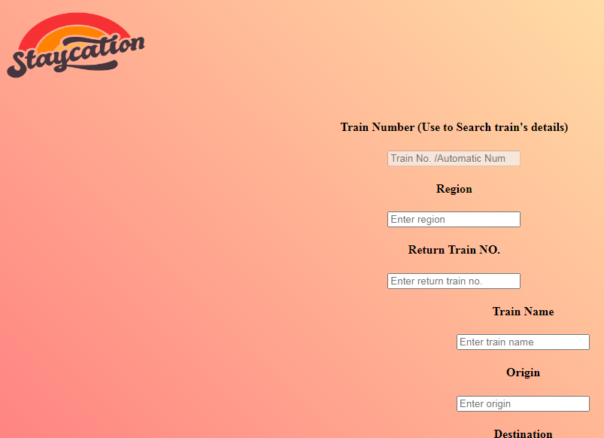

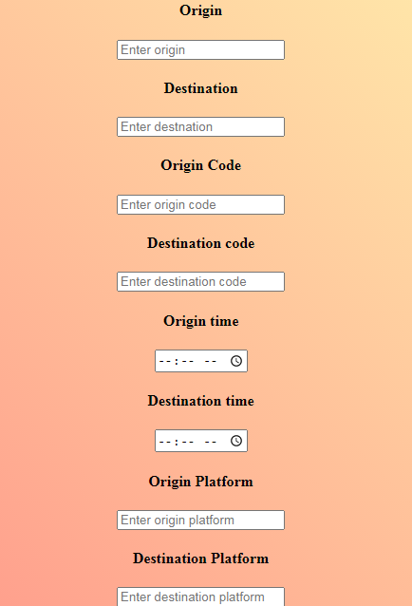

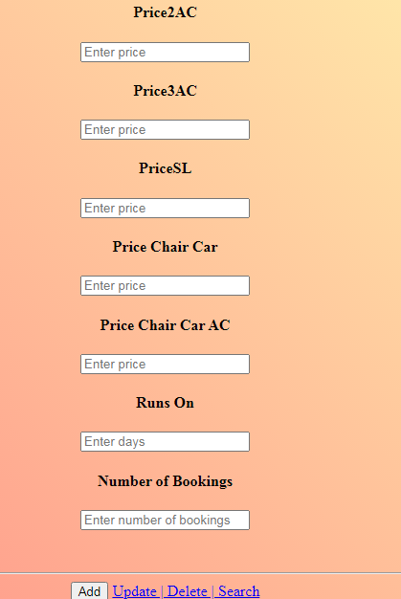

**CODING:**

<!Doctype html>

<html>

<head>

<meta charset="utf-8">

<title>Admin Panel | Trains </title>

<meta name="viewport" content="width=device-width, initial-scale=1">

<link href="https://fonts.googleapis.com/css?family=Courgette" rel="stylesheet">

<link href="css/bootstrap.min.css" rel="stylesheet">

<link href="https://maxcdn.bootstrapcdn.com/font-awesome/4.7.0/css/font-awesome.min.css" rel="stylesheet">

<link rel="stylesheet" href="https://maxcdn.bootstrapcdn.com/bootstrap/3.3.7/css/bootstrap.min.css" integrity="sha384-BVYiiSIFeK1dGmJRAkycuHAHRg32OmUcww7on3RYdg4Va+PmSTsz/K68vbdEjh4u" crossorigin="anonymous">

<script src="js/bootstrap.min.js"></script>

<style>

body{

background: linear-gradient(45deg, #ff8080, #ffffb3);

height: 100%;

margin: 0;

background-repeat: no-repeat;

background-attachment: fixed;

width:100%;

}

</style>

</head>

<?php

$servername = "localhost";

$username="root";

$password="";

$dbname="projectmeteor";

$trainNo="";

$region="";

$returnTrainNo="";

$trainName="";

$origin="";

$destination="";

$originCode="";

$destinationCode="";

$originTime="";

$destinationTime="";

$originPlatform="";

$destinationPlatform="";

$duration="";

$classes="";

$seats1AC="";

$seats2AC="";

$seats3AC="";

$seatsSL="";

$seatsChairCar="";

$seatsChairCarAC="";

$price1AC="";

$price2AC="";

$price3AC="";

$priceSL="";

$priceChairCar="";

$priceChairCarAC="";

$runsOn="";

$noOfBookings="";

mysqli_report(MYSQLI_REPORT_ERROR | MYSQLI_REPORT_STRICT);

//connect to mysql database

try{

$conn =mysqli_connect($servername,$username,$password,$dbname);

}catch(MySQLi_Sql_Exception $ex){

echo("Connection Error");

}

//get data from the form

function getData()

{

$data = array();

$data[1]=$_POST['region'];

$data[2]=$_POST['returnTrainNo'];

$data[3]=$_POST['trainName'];

$data[4]=$_POST['origin'];

$data[5]=$_POST['destination'];

$data[6]=$_POST['originCode'];

$data[7]=$_POST['destinationCode'];

$data[8]=$_POST['originTime'];

$data[9]=$_POST['destinationTime'];

$data[10]=$_POST['originPlatform'];

$data[11]=$_POST['destinationPlatform'];

$data[12]=$_POST['duration'];

$data[13]=$_POST['classes'];

$data[14]=$_POST['seats1AC'];

$data[15]=$_POST['seats2AC'];

$data[16]=$_POST['seats3AC'];

$data[17]=$_POST['seatsSL'];

$data[18]=$_POST['seatsChairCar'];

$data[19]=$_POST['seatsChairCarAC'];

$data[20]=$_POST['price1AC'];

$data[21]=$_POST['price2AC'];

$data[22]=$_POST['price3AC'];

$data[23]=$_POST['priceSL'];

$data[24]=$_POST['priceChairCar'];

$data[25]=$_POST['priceChairCarAC'];

$data[26]=$_POST['runsOn'];

$data[27]=$_POST['noOfBookings'];

return $data;

}

//search

if(isset($_POST['search']))

{

$info = getData();

$search_query="SELECT * FROM trains WHERE trainNo = '$info[0]'";

$search_result=mysqli_query($conn, $search_query);

if($search_result)

{

if(mysqli_num_rows($search_result))

{

while($rows = mysqli_fetch_array($search_result))

{

$trainNo = $rows['trainNo'];

$region = $rows['region'];

$returnTrainNo= $rows['returnTrainNo'];

$trainName= $rows['trainName'];

$origin = $rows['origin'];

$destination = $rows['destination'];

$originCode = $rows['originCode'];

$destinationCode = $rows['destinationCode'];

$originTime = $rows['originTime'];

$destinationTime = $rows['destinationTime'];

$originPlatform = $rows['originPlatform'];

$destinationPlatform = $rows['destinationPlatform'];

$duration = $rows['duration'];

$classes = $rows['classes'];

$seats1AC = $rows['seats1AC'];

$seats2AC = $rows['seats2AC'];

$seats3AC = $rows['seats3AC'];

$seatsSL = $rows['seatsSL'];

$seatsChairCar = $rows['seatsChairCar'];

$seatsChairCarAC = $rows['seatsChairCarAC'];

$price1AC = $rows['price1AC'];

$price2AC = $rows['price2AC'];

$price3AC = $rows['price3AC'];

$priceSL = $rows['priceSL'];

$priceChairCar = $rows['priceChairCar'];

$priceChairCarAC = $rows['priceChairCarAC'];

$runsOn = $rows['runsOn'];

$noOfBookings = $rows['noOfBookings'];

}

}else{

echo("No data are available");

}

} else{

echo("Result error");

}

}

//insert

if(isset($_POST['insert'])){

$info = getData();

$insert_query="INSERT INTO `trains`(`region`, `returnTrainNo`, `trainName`, `origin`,`destination`,`originCode`,`destinationCode`,`originTime`,`destinationTime`,`originPlatform`,`destinationPlatform`,`duration`,`classes`,`seats1AC`,`seats2AC`,`seats3AC`,`seatsSL`,`seatsChairCar`,`seatsChairCarAC`,`price1AC`,`price2AC`,`price3AC`,`priceSL`,`priceChairCar`,`priceChairCarAC`,`runsOn`,`noOfBookings`) VALUES ('$info[1]','$info[2]','$info[3]','$info[4]','$info[5]','$info[6]','$info[7]','$info[8]','$info[9]','$info[10]','$info[11]','$info[12]','$info[13]','$info[14]','$info[15]','$info[16]','$info[17]','$info[18]','$info[19]','$info[20]','$info[21]','$info[22]','$info[23]','$info[24]','$info[25]','$info[26]','$info[27]')";

try{

$insert_result=mysqli_query($conn, $insert_query);

if($insert_result)

{

if(mysqli_affected_rows($conn)>0){

echo("Data inserted successfully");

}else{

echo("Data not inserted");

}

}

}catch(Exception $ex){

echo("error inserted".$ex->getMessage());

}

}

//delete

if(isset($_POST['delete'])){

$info = getData();

$delete_query = "DELETE FROM `trains` WHERE trainNo = '$info[0]'";

try{

$delete_result = mysqli_query($conn, $delete_query);

if($delete_result){

if(mysqli_affected_rows($conn)>0)

{

echo("Data deleted");

}else{

echo("Data not deleted");

}

}

}catch(Exception $ex){

echo("Error in deleting".$ex->getMessage());

}

}

//edit

if(isset($_POST['update'])){

$info = getData();

$update_query="UPDATE `trains` SET region='$info[1]',returnTrainNo='$info[2]',trainName='$info[3]',origin='$info[4]',destination='$info[5]',originCode='$info[6]',destinationCode='$info[7]',originTime='$info[8]',destinationTime='$info[9]',originPlatform='$info[10]',destinationPlatform='$info[11]',duration='$info[12]',classes='$info[13]',seats1AC='$info[14]',seats2AC='$info[15]',seats3AC='$info[16]',seatsSL='$info[17]',seatsChairCar='$info[18]',seatsChairCarAC='$info[19]',price1AC='$info[20]',price2AC='$info[21]',price3AC='$info[22]',priceSL='$info[23]',priceChairCar='$info[24]',priceChairCarAC='$info[25]',runsOn='$info[26]',noOfBookings='$info[27]' WHERE trainNo = '$info[0]'";

try{

$update_result=mysqli_query($conn, $update_query);

if($update_result){

if(mysqli_affected_rows($conn)>0){

echo("Data updated");

}else{

echo("Data not updated");

}

}

}catch(Exception $ex){

echo("Error in updating".$ex->getMessage());

}

}

?>

<body>

<div class="container-fliud">

<nav class="navbar navbar-inverse">

<div class="container-fluid">

<div class="navbar-header">

<button type="button" class="navbar-toggle" data-toggle="collapse" data-target="#nav">

<span class="icon-bar"></span>

<span class="icon-bar"></span>

<span class="icon-bar"></span>

</button>

<img src="stay.png" height="150" width="200">

</div>

<div class="collapse navbar-collapse" id="nav">

<ul class="nav navbar-nav" style="float:right">

<li><a href="Home.php">HOME</a></li>

<li><a href="users_add.php">USERS</a></li>

<li><a href="hotels_add.php">ADD HOTELS</a></li>

<li><a href="hotelbookings_view.php">HOTEL BOOKINGS</a></li>

<li><a href="flights_add.php">ADD FLIGHTS</a></li>

<li><a href="flightbookings_view.php">FLIGHT BOOKINGS</a></li>

<li><a href="trains_add.php">ADD TRAINS</a></li>

<li><a href="trainbookings_view.php">TRAIN BOOKINGS</a></li>

<h3><a href="adminLogout.php">LOGOUT</a></h3>

</ul>

</div>

</div>

</nav>

</div>

<div class="container-fluid" >

<div class="row mx-5 my-5" style="margin-left:80px;text-align:center;">

<div class="col-lg-4">

<form method ="post" action="">

<h4>Train Number (Use to Search train's details)</h4>

<input type="number" name="trainNo" class="form-control" placeholder="Train No. /Automatic Number Genrates" value="<?php echo($trainNo);?>" disabled>

<div class="form-group row">

<div class="col-xs-6">

<h4>Region</h4>

<input type="text" name="region" class="form-control" placeholder="Enter region" value="<?php echo($region);?>" required>

</div>

<div class="form-group row">

<div class="col-xs-6">

<h4>Return Train NO.</h4>

<input type="number" name="returnTrainNO" class="form-control" placeholder="Enter return train no." value="<?php echo($returnTrainNo);?>" required>

</div>

<div class="form-group row">

<div class="col-xs-6">

<h4>Train Name</h4>

<input type="text" name="trainName" class="form-control" placeholder="Enter train name" value="<?php echo($trainName);?>" required>

</div>

<div class="form-group row">

<div class="col-xs-6">

<h4>Origin</h4>

<input type="text" name="origin" class="form-control" placeholder="Enter origin" value="<?php echo($origin);?>" required>

</div>

<div class="form-group row">

<div class="col-xs-6">

<h4>Destination</h4>

<input type="text" name="destination" class="form-control" placeholder="Enter destnation" value="<?php echo($destination);?>" required>

</div>

<div class="form-group row">

<div class="col-xs-6">

<h4>Origin Code</h4>

<input type="text" name="originCode" class="form-control" placeholder="Enter origin code" value="<?php echo($originCode);?>" required>

</div>

<div class="col-xs-6">

<h4>Destination code</h4>

<input type="text" name="destinationCode" class="form-control" placeholder="Enter destination code" value="<?php echo($destinationCode);?>" required>

</div>

<div class="form-group row">

<div class="col-xs-6">

<h4>Origin time</h4>

<input type="time" name="originTime" class="form-control" placeholder="Enter origin time" value="<?php echo($originTime);?>" required>

</div>

<div class="col-xs-6">

<h4>Destination time</h4>

<input type="time" name="destinationTime" class="form-control" placeholder="Enter destination time" value="<?php echo($destinationTime);?>" required>

</div>

<div class="form-group row">

<div class="col-xs-6">

<h4>Origin Platform</h4>

<input type="text" name="originPlatform" class="form-control" placeholder="Enter origin platform" value="<?php echo($originPlatform);?>" required>

</div>

<div class="col-xs-6">

<h4>Destination Platform</h4>

<input type="text" name="destinationPlatform" class="form-control" placeholder="Enter destination platform" value="<?php echo($destinationPlatform);?>" required>

</div>

<div class="col-xs-6">

<h4>Duration</h4>

<input type="text" name="duration" class="form-control" placeholder="Enter duration" value="<?php echo($duration);?>" required>

</div>

<div class="col-xs-6">

<h4>Classes</h4>

<input type="text" name="classes" class="form-control" placeholder="Enter available classes" value="<?php echo($classes);?>" required>

</div>

<div class="col-xs-6">

<h4>Seats1AC</h4>

<input type="number" class="form-control" name="seats1AC" placeholder="Enter no. of seats available" value="<?php echo($seats1AC);?>"required>

</div>

<div class="col-xs-6">

<h4>Seats2AC</h4>

<input type="number" class="form-control" name="seats2AC" placeholder="Enter no. of seats available" value="<?php echo($seats2AC);?>"required>

</div>

<div class="col-xs-6">

<h4>Seats3AC</h4>

<input type="number" class="form-control" name="seats3AC" placeholder="Enter no. of seats available" value="<?php echo($seats3AC);?>"required>

</div>

<div class="col-xs-6">

<h4>SeatsSL</h4>

<input type="number" class="form-control" name="seatsSL" placeholder="Enter no. of seats available" value="<?php echo($seatsSL);?>"required>

</div>

<div class="col-xs-6">

<h4>Seats Chair Car</h4>

<input type="number" class="form-control" name="seatsChairCar" placeholder="Enter no. of seats available" value="<?php echo($seatsChairCar);?>"required>

</div>

<div class="col-xs-6">

<h4>Seats Chair Car AC</h4>

<input type="number" class="form-control" name="seatsChairCarAC" placeholder="Enter no. of seats available" value="<?php echo($seatsChairCarAC);?>"required>

</div>

<div class="col-xs-6">

<h4>Price1AC</h4>

<input type="number" class="form-control" name="price1AC" placeholder="Enter price" value="<?php echo($price1AC);?>"required>

</div>

<div class="col-xs-6">

<h4>Price2AC</h4>

<input type="number" class="form-control" name="price2AC" placeholder="Enter price" value="<?php echo($price2AC);?>"required>

</div>

<div class="col-xs-6">

<h4>Price3AC</h4>

<input type="number" class="form-control" name="price3AC" placeholder="Enter price" value="<?php echo($price3AC);?>"required>

</div>

<div class="col-xs-6">

<h4>PriceSL</h4>

<input type="number" class="form-control" name="priceSL" placeholder="Enter price" value="<?php echo($priceSL);?>"required>

</div>

<div class="col-xs-6">

<h4>Price Chair Car</h4>

<input type="number" class="form-control" name="priceChairCar" placeholder="Enter price" value="<?php echo($priceChairCar);?>"required>

</div>

<div class="col-xs-6">

<h4>Price Chair Car AC</h4>

<input type="number" class="form-control" name="priceChairCarAC" placeholder="Enter price" value="<?php echo($priceChairCarAC);?>"required>

</div>

<div class="col-xs-6">

<h4>Runs On</h4>

<input type="text" class="form-control" name="runsOn" placeholder="Enter days" value="<?php echo($runsOn);?>"required>

</div>

<div class="col-xs-6">

<h4>Number of Bookings</h4>

<input type="number" name="noOfBookings" class="form-control" placeholder="Enter number of bookings" value="<?php echo($noOfBookings);?>" required>

</div>

<br>

<br>

<hr>

<div>

<input type="submit" class="btn btn-success btn-block btn-lg" name="insert" value="Add">

<a href="trains_update.php"class="btn btn-info btn-block btn-lg">Update | Delete | Search</a>

<br>

<br>

</div>

</form>

</div>

</div>

<div class="col-lg-8">

<h1 class="text-danger text-center" style="font-weight:bold">TRAINS INFORMATION</h1>

<hr>

<br>

<br>

<?php

$servername = "localhost";

$username = "root";

$password = "";

$dbname = "projectmeteor";

// Create connection

$conn = new mysqli($servername, $username, $password, $dbname);

// Check connection

if ($conn->connect_error) {

die("Connection failed: " . $conn->connect_error);

}

$sql = "SELECT trainNo,region,returnTrainNo,trainName,origin,destination,originCode,destinationCode,originTime,destinationTime,originPlatform,destinationPlatform,duration,classes,seats1AC,seats2AC,seats3AC,seatsSL,seatsChairCar,seatsChairCarAC,price1AC,price2AC,price3AC,priceSL,priceChairCar,priceChairCarAC,runsOn,noOfBookings FROM trains";

$result = $conn->query($sql);

echo "<div class='col-xs-6'>

<table class='table table-striped table-bordered table-hover py-5 ' style='width:200%; border: 4px solid black; text:white; text-align: center;float:left'>

<tr class='text-centre text-white'style='font-size:20px; background:black;'>

<th>Train No.</th>

<th>Region</th>

<th>Return Train No.</th>

<th>Train Name</th>

<th>Origin</th>

<th>Destination</th>

<th>Origin Code</th>

<th>Destination Code</th>

<th>Origin Time</th>

<th>Destination Time</th>

<th>Origin Platform</th>

<th>Destination Platform</th>

<th>Duration</th>

<th>Classes</th>

<th>Seats1AC</th>

<th>Seats2AC</th>

<th>Seats3AC</th>

<th>SeatsSL</th>

<th>SeatsChairCar</th>

<th>SeatsChairCarAC</th>

<th>price1AC</th>

<th>price2AC</th>

<th>price3AC</th>

<th>priceSL</th>

<th>priceChairCar</th>

<th>priceChairCarAC</th>

<th>runsOn</th>

<th>No. of bookings</th>

</tr>

</div>";

if ($result->num_rows > 0) {

// output data of each row

while($row = $result->fetch_assoc()) {

echo "<tr>";

echo "<td>" . $row['trainNo'] . "</td>";

echo "<td>" . $row['region'] . "</td>";

echo "<td>" . $row['returnTrainNo'] . "</td>";

echo "<td>" . $row['trainName'] . "</td>";

echo "<td>" . $row['origin'] . "</td>";

echo "<td>" . $row['destination'] . "</td>";

echo "<td>" . $row['originCode'] . "</td>";

echo "<td>" . $row['destinationCode'] . "</td>";

echo "<td>" . $row['originTime'] . "</td>";

echo "<td>" . $row['destinationTime'] . "</td>";

echo "<td>" . $row['originPlatform'] . "</td>";

echo "<td>" . $row['destinationPlatform'] . "</td>";

echo "<td>" . $row['duration'] . "</td>";

echo "<td>" . $row['classes'] . "</td>";

echo "<td>" . $row['seats1AC'] . "</td>";

echo "<td>" . $row['seats2AC'] . "</td>";

echo "<td>" . $row['seats3AC'] . "</td>";

echo "<td>" . $row['seatsSL'] . "</td>";

echo "<td>" . $row['seatsChairCar'] . "</td>";

echo "<td>" . $row['seatsChairCarAC'] . "</td>";

echo "<td>" . $row['price1AC'] . "</td>";

echo "<td>" . $row['price2AC'] . "</td>";

echo "<td>" . $row['price3AC'] . "</td>";

echo "<td>" . $row['priceSL'] . "</td>";

echo "<td>" . $row['priceChairCar'] . "</td>";

echo "<td>" . $row['priceChairCarAC'] . "</td>";

echo "<td>" . $row['runsOn'] . "</td>";

echo "<td>" . $row['noOfBookings'] . "</td>";

echo "</tr>";

}

} else {

echo "0 results";

}

$conn->close();

?>

</div>

</div>

</body>

</html>